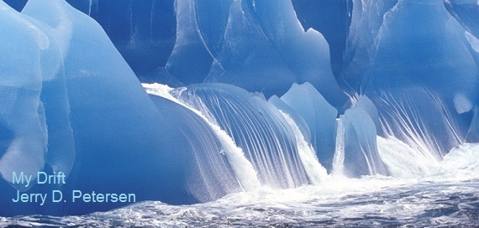

 | Antarctica  2 Oct 2015 | 212-2015-19

I have written articles about every continent except the Antarctica. There are seven (7) continents and five (5) major oceans in the world (see map on next page). Here is a list of the seven continents with a few of my articles:
1. North America: North to Alaska – Utah (12 articles) - Erie Pennsylvania - Wallace Idaho - The Great Lakes - Tornado Alley - New Hampshire - Native American Indians
2. South America: The Amazon River - Rio de Janeiro
3. Europe: Demark and Sweden
4. Africa: Africa (3 parts) – Morocco – The Nile River
5. Asia: Iraq History (2 parts) – Israel – North Korea – Itaewon South Korea - Siberia
6. Australia: The Outback
7. Antarctica: This article (See map on next page)

Hawaii is the only U.S. State that is not located in a continent. Oceania is the collective name for the lands of the Pacific Ocean, including New Zealand, Hawaii, French Polynesia, Melanesia, Micronesia, and Polynesia.

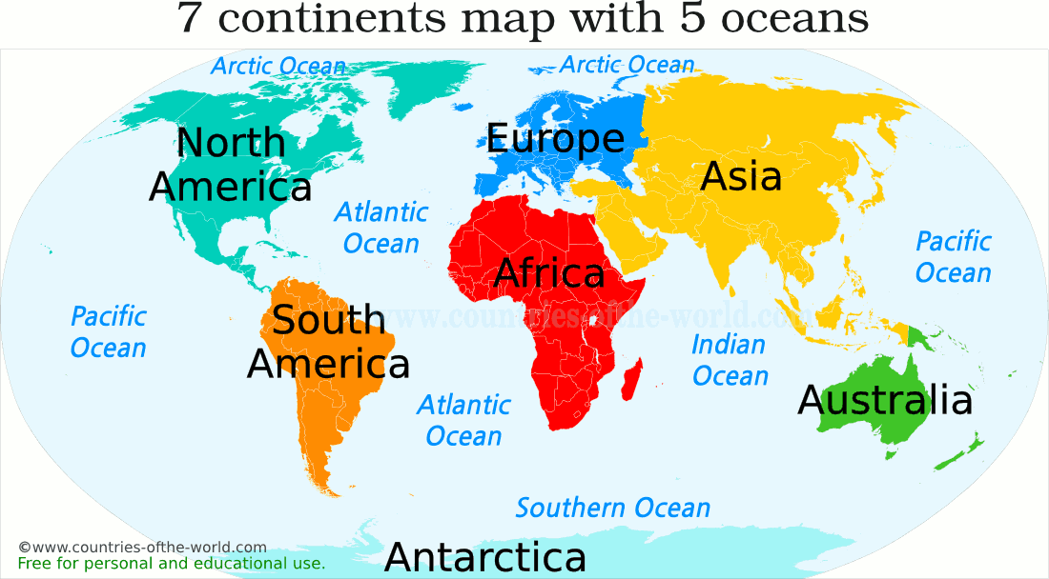

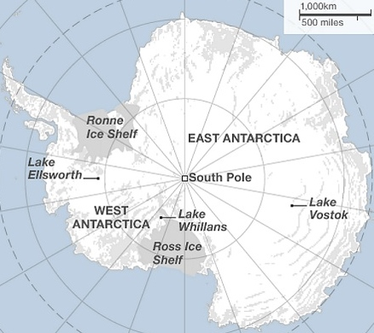

I have to admit that I didn’t know much about the Antarctica. I knew that there is a lot of ice, it is very cold, and the fact that there are a few research stations located there. That is about it! But, after researching this continent for a few days, I have learned many interesting things about Antarctica that I will share with you - my readers.

Who discovered the Antarctica?
Captain James Cook
The first well-documented evidence for the existence of a frozen southern continent came from the second expedition of Captain James Cook beginning in 1772. In 1773, James Cook and his crew crossed the Antarctic Circle for the first time but although they discovered nearby islands, they did not catch sight of Antarctica itself. It is believed he was as close as 150 miles from the mainland.

Yes, that is the same Captain Cook who on January 18, 1778, became the first European to discover the Hawaiian Islands when he sails past the island of Oahu. The islands have not been the same since.

Who first saw the mainland Antarctic?
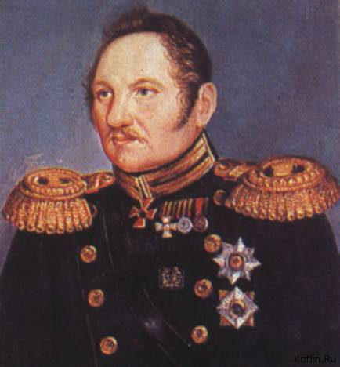  Fabian Gottlieb von Bellingshausen | The first confirmed sighting of mainland Antarctica cannot be accurately attributed to one single person. It can, however, be narrowed down to three individuals. According to various sources, three men all sighted the ice shelf or the continent within days or months of each other: Fabian Gottlieb von Bellingshausen, a captain in the Russian Imperial Navy; Edward Bransfield, a captain in the English Royal Navy; and Nathaniel Palmer, an American sealer out of Stonington, Connecticut. These first Antarctica sightings were in Jan-Feb 1820.

So, who first set foot on the Antarctica?
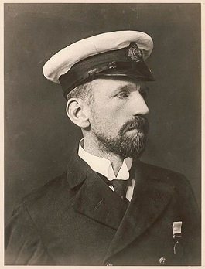  Captain John Davis  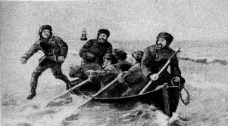 | American Captain John Davis (born in 1784 in Surrey, England) was a seal hunter from Connecticut who captained men who may have been the first to have set foot on Antarctica on 7 February 1821. This was shortly after the first sightings of the new continent.  The first undisputed landing on Antarctica did not occur for another 74 years, on 24 January 1895, when a group of men from the Norwegian ship Antarctic went ashore to collect geological specimens at Cape Adare. The first man off the boat was Carsten Egeberg who claimed to be the first person to set foot on Antarctica.

The race to be the first person to reach the South Pole?
In 1910, two men set out to be the first to reach the South Pole in a race that would be both heroic and tragic. The men had different reasons for their journeys, took different routes, and made different decisions that would ultimately seal their respective fates, and those of their teams. Below is a summary of their treacherous 1,800-mile marches to the center of Antarctica.

Robert Falcon Scott set off from Wales on July 15, 1910 on what was originally intended to be a primarily scientific expedition, but which quickly morphed into a quest to make history on behalf of the British Empire.

Meanwhile, Norwegian explorer Roald Amundsen, whose plan to reach the North Pole first had been thwarted by both Frederik Cook and Robert Peary, had secretly turned his sights on the South Pole. He left Oslo in June 3, 1910 with the intent of beating Scott to his goal.

In October, while docked in Melbourne, Australia, Scott received a telegram from Amundsen informing him simply that he was “proceeding to Antarctic.” The race was on.

Robert Falcon Scott

Scott’s party carried on its plans to do scientific research on Antarctica, completing several geological expeditions and one arduous winter trek to collect Emperor Penguin eggs. On Oct. 24, 1911, the team began heading to the pole.
In early January, Scott and four others left the rest of the group to make the final push. But when they reached the pole on Jan. 17, 1912, their celebration was ruined by the black Norwegian flags Amundsen and his team had placed there about five weeks earlier. | 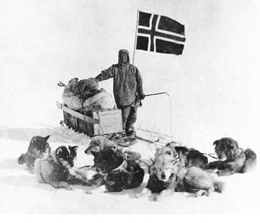  Roald Amundsen at the South Pole

The worst was yet to come for Scott, however. None of the team of five that reached the pole would survive the return trip. At a distance of 150 miles from their base camp, Scott and his companions died from a combination of exhaustion, starvation and extreme cold. But though he lost the race and his life, he won the hearts of his countrymen and inspired many throughout the world. Amundsen’s accomplishment was tarnished by the perception that he had ruthlessly taken from Scott what was rightfully his and for which the English expedition paid the ultimate price.

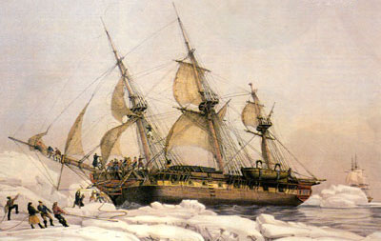
Between 1773 (Captain James Cook) and 1912 (Robert F. Scott reaches the South Pole), there were over 300 expeditions to the Antarctica using ships similar to the one above

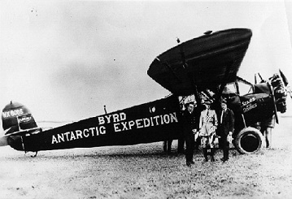 | Richard E. Byrd led several voyages to the Antarctic by plane in the 1930s and 1940s. He is credited with implementing mechanized land transport on the continent and conducting extensive geological and biological research. However, it was not until 31 October 1956 that anyone set foot on the South Pole again; on that day a U.S.
Navy group led by Rear Admiral George J. Dufek successfully landed an aircraft there. Since then, there have been many planes land on the ice of Antarctic including this U.S. Air Force plane.

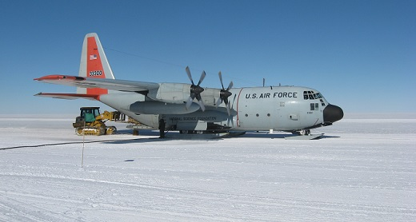
Geography
Antarctica is the southernmost continent and is completely surrounded by the Southern Ocean. It covers more than 5,400,000 square miles, making it the fifth-largest continent, about 1.3 times as large as Europe and about 2 times as large as Australia. The coastline measures 11,165 miles and is mostly characterized by ice formations (Floating ice, ice walls, and stream/outlet glaciers). This makes up about 95% of the coastline with rock making up the other 5%.

Antarctica is divided by the Transantarctic Mountains close to the neck between the Ross Sea and the Weddell Sea. The portion west of the Weddell Sea and east of the Ross Sea is called West Antarctica and the remainder is called East Antarctica. This is because they roughly correspond to the Western and Eastern Hemispheres relative to the Greenwich meridian.

About 98% of Antarctica is covered by the Antarctic ice sheet, a sheet of ice averaging more than one (1) mile thick. The continent has about 90% of the world's ice (and thereby about 70% of the world's fresh water). If all of this ice were to melt, sea levels would rise about 200 feet.

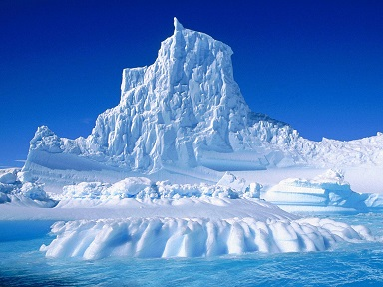 | 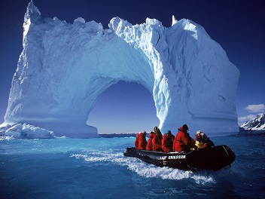

The Weather Conditions
Antarctica is the coldest, driest, and windiest continent. Antarctica is considered a desert, with annual precipitation of only about 8 inches along the coast and far less inland. Although little liquid falls from the sky, Antarctica still boasts colossal blizzards. Like sandstorms in the desert, the wind picks snow up from the ground and blows vast white blankets. Winds can reach up to 200 miles per hour. The Antarctica is the coldest place on earth! The lowest natural temperature ever directly recorded at ground level on Earth is −128.6 °F at the Soviet (now Russian) Vostok Station on July 21, 1983. Temperatures reach a minimum of between −112 °F and −130 °F) in the interior in winter and reach a maximum of between 41 °F and 59 °F near the coast in summer. The average annual temperature of the South Pole is -56 °F. Remember now that the seasons are the opposite of what we are used to: Jun-Jul-Aug is Winter: Sep-Oct-Nov is Spring: Dec-Jan-Feb is Summer: Mar-Apr-May is Fall.

The Antarctica also has the highest average elevation of all the continents which surprised me. You would think with all the high mountains in Colorado, Alaska, and Canada that North America would be the highest. Well, the North America Continent has an average elevation of 2,362 feet - Whereas the Antarctica Continent has an average elevation of 7,500 feet.

West Antarctica is covered by the West Antarctic Ice Sheet. The sheet has been of recent concern because of the small possibility of its collapse due to global warming. If the sheet were to break down, ocean levels would rise by several meters in a relatively short period of time, perhaps a matter of a century or two. Several Antarctic ice streams, which account for about 10% of the ice sheet, flow to one of the many Antarctic ice shelves.

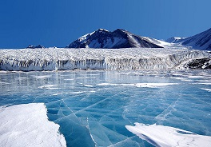 | 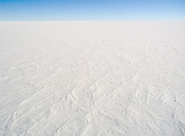

Mount Vinson Massif, the highest peak in the Antarctica at 16,050 feet, is located in the Ellsworth Mountains. Antarctica contains many other mountains, on both the main continent and the surrounding islands. Mount Erebus on Ross Island is the world's southernmost active volcano. Another well-known volcano is found on Deception Island, which is famous for a giant eruption in 1970. Minor eruptions are frequent and lava flows have been observed in recent years.
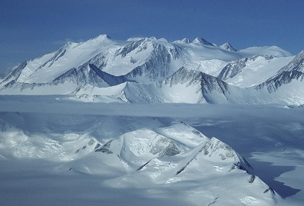 | 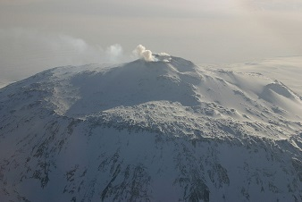
Mount Vinson Massif | Mount Erebus

Antarctica is home to more than 70 lakes that lie at the base of the continental ice sheet. Lake Vostok, discovered beneath Russia's Vostok Station in 1996, is the largest of these subglacial lakes. It was once believed that the lake had been sealed off for 500,000 to one million years but a recent survey suggests that, every so often, there are large flows of water from one lake to another.

What kind of life can be found on the Antarctica?
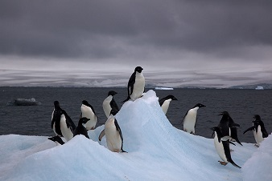 | Antarctica has no trees or bushes. Vegetation on the continent is composed of mosses, lichen, and algae. Penguins, whales, and seals live in and around Antarctica, as do fish and krill. The male Emperor penguin is the only warm-blooded animal to remain on the continent through the freezing winter while nesting on the single egg laid by its mate (the female spends nine weeks at sea and returns in time for the egg to hatch).

Are there any people living at the Antarctica?
There are no permanent residents living on this continent and there is no evidence that it was ever seen by humans until the 19th century. But there are now about 32 summer-only field camps and 42 year-round staffed research stations. The number of people carrying out different experiments in this continent varies between approximately 1,000 during the winter season and 4,000 during the summer.

What countries have research stations in the Antarctica?
A total of 30 countries, all part of the Antarctic Treaty, operate seasonal (summer) and/or year-round research stations on the continent. The number of research stations are in parentheses.

Argentina (7) | Ecuador (1) | Norway (2) | South Korea (2)
Australia (3) | Finland (1) | Pakistan (1) | Spain (2)
Belgium (1) | France (2) | Peru (1) | Sweden (2)
Brazil (1) | Germany (2) | Poland (1) | Ukraine (1)
Bulgaria (1) | India (3) | Romania (1) | United Kingdom (3)
Chile (5) | Italy (2) | Russia (9) | United States (5)
China (4) | Japan (4) | South Africa (1) | Uruguay (1)
Czech Republic (1) | New Zealand (1)

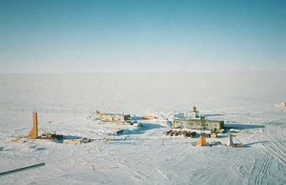 | 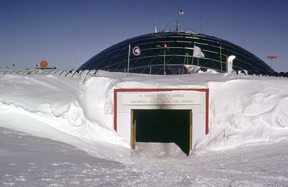
Vostok Station  Russia (Established in 1957) | Amundsen–Scott South Pole Station  United States of America (1957)
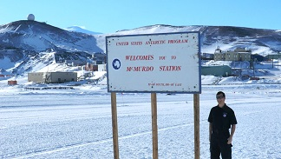 | 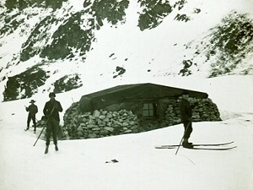
McMurdo Station  United States of America (1956) | Omond House* – First Station - 1903  Scottish National Antarctic Expedition

*The Scotland Omond House (the first Antarctic Research Station) that opened in 1903 is no longer in operation.
The oldest research station still in operation is Argentina's Orcadas Station that was established in 1904. The newest research stations are China’s Taishan Station and South Korea’s Jang Bogo Station – Both opened in 2014.

What do all these researchers and scientists do?
Scientists work on all kinds of unique projects in Antarctica, including penguins, Antarctic cod (they have a special antifreeze agent in their blood!), whales, seals, global warming, climatology, meteorites, glaciology, astronomy, volcanoes, UV radiation, and more. Scientists also study humans in Antarctica, doing research on how the human body adapts to cold and how the human mind and heart react to extreme isolation.

What countries claim territories in the Antarctica?
Seven countries maintain a territorial claim on eight territories in Antarctica. These countries have tended to their scientific observation and study facilities in Antarctica within their claimed territory. The Antarctic Treaty states, "No acts or activities taking place while the present Treaty is in force shall constitute a basis for asserting, supporting or denying a claim to territorial sovereignty in Antarctica. No new claim, or enlargement of an existing claim, to territorial sovereignty shall be asserted while the present Treaty is in force", hence neither deferring nor suspending existing claims.

Antarctica Map | Color |  |  | Territory Name | Country |  | Date
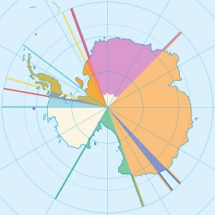 |  |  | Argentine Antarctica  Australian Antarctic Territory  Chilean Antarctic Territory  Adélie Land  Ross Dependency  Queen Maud Land  Peter I Island  British Antarctic Territory |  |  | Argentina  Australia  Chile  France  New Zealand  Norway  Norway  United Kingdom |  | 1942  1933  1940  1924  1923  1939  1929  1908

Tourism in Antarctica
Tourism in Antarctica started with sea tourism in the 1960s. Air overflights of Antarctica started in the 1970s with sightseeing flights by airliners from Australia and New Zealand, and were resumed in the 1990s. Private yacht trips started in the late 1960s. The (summer) tour season lasts from November to March. Tourism companies are required by the Antarctic Treaty to have a permit to visit Antarctica. Land activities include camping, snowshoeing, hiking and cross country skiing.

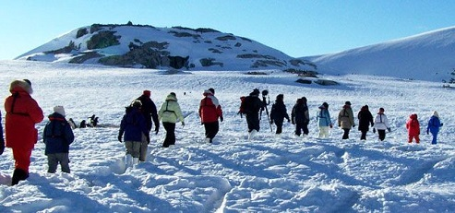

The number of tourist visiting the Antarctica has averaged about 40,000 per year in the last five years. The vast majority of these travelers - 73 percent - visit the coastal regions of the Antarctic Peninsula on ships carrying fewer than 500 passengers. A quarter (26 percent) of tourists did not set foot ashore in Antarctica because they were travelling on cruise-only vessels that don’t make landings. American and Australian visitors remained the most numerous, accounting for 34 percent and 11 percent of the total number, respectively.

A few more facts about Antarctica
- Catherine Mikkelson, the wife of a Norwegian whaling captain, became the first woman to visit Antarctica in 1935.
- As part of its effort to claim a portion of Antarctica, Argentina sent a pregnant woman to the continent. In January 1979, Emile Marco Palma became the first child born on the southernmost continent.
- Today, there are no huskies pulling sleds in Antarctica. As of 1994, no non-native species are allowed to be taken there. Motor-powered vehicles are the primary method of transportation across the ice.
- A volcano lies on Deception Island, off the Antarctic Peninsula. The island is a popular stop-off for tourists, who can bathe in the water warmed by the volcano while surrounded by ice.
- If you throw boiling water into the air in Antarctica, it will instantly vaporize. Most of the particles will turn into steam while others are instantly converted to small pieces of ice.
- Millions of years ago, Antarctica had a much warmer climate and boasted evergreen forests and a variety of animals. Fossils of this earlier period provide scientists with clues about life before Antarctica became a vast icy shelf.
- Lake Vostok, a lake hidden deep beneath the Antarctic surface, may house life. Expeditions from several countries are currently drilling the 13,100 feet to reach this hidden gem.
- The Dry Valleys in Antarctica are the driest places on earth. With such low humidity and moisture on this portion of the continent, snow and ice cannot even accumulate, which leaves the valleys as just a dusty expanse of dirt.
- There are 6 different species of penguin found in Antarctica (King, Adélie, Emperor, Chinstrap, Macaroni and Gentoo).
- The estimated average age of the ice in the ice shelf is 3 million years.
- There have been about 25,000 meteorites found in Antarctica, making it the best place in the world to find them.
- In the year 1899, the first human burial in Antarctica took place (on 14 October, following the death of the Norwegian zoologist Nicolai Hansen).
- In March of 2000, an ice chunk broke off the Ross Ice Shelf that was 170 miles long and 25 miles wide or roughly the size of the state of Connecticut.
- Because of the earth's tilt, the sun does not rise in Antarctica from the vernal equinox to the autumnal equinox, which means the continent remains dark throughout the entire winter season. Conversely, during the summer months the sun does not set in Antarctica, which means it actually receives more sunlight than the equator during the summer.

The Antarctica is a very interesting place. However, I don’t have any desire to go there – it is too darn cold! I do hope you learned something.

bigdrifter44@gmail.com

