 | BEES  27 February 2015 | 194-2015-01

There are over 20,000 known species of bee worldwide (about 4000 species in the U.S.) but the most recognized bees are the Bumblebee, Hornet, Yellow Jacket, and Honey Bee. The Honey Bee is by far the most common so we will be discussing it in this article.

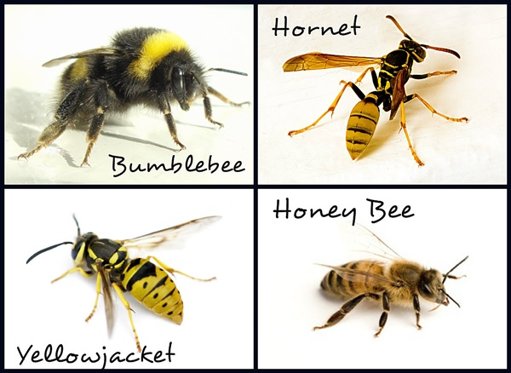

Actually, although related, the Yellowjacket and Hornet are Wasps – not Bees. The primary differences between a Bee and a Wasp is a Bee can only sting you once (leaving its stinger in you) whereas Wasps can sting you multiple times and Wasps don’t know how to make honey. So, if you are up the canyon or at the beach trying to have a picnic when a bunch of Bees come buzzing around and one stings you – there is a 90% chance that the Bee that stung you is a Wasp. Most Honey Bees are too busy making honey to be out looking for people to sting. Bees get blamed for a lot of bad things that they didn’t do.

There are six primary species of Honey Bees – Here is a comparison chart:
 | Italian | German | Carniolan | Buckfast | Caucasian | Russian
Color | Light | Dark | Black | Medium | Dark | Gray
Gentleness | Moderate | Aggressive | Gentle | Moderate | Gentle | Moderate
Honey Producing | Excellent | Okay | Good | Good | Low | Okay
Swarming | Okay | Okay | High | Low | Low | Okay
Wintering ability | Good | Excellent | Good | Good | Okay | Excellent

The most common and most popular Honey Bee in America is the Italian Bee.

A little bee history. Cave paintings in Europe indicate that early peoples were harvesting honey 8,000 years ago. The next step in human/honeybee relations came when people started keeping bees in man-made structures rather than just going out and searching for wild hives. The ancient Egyptians were beekeepers and their methods were copied throughout the Mediterranean and Middle East.

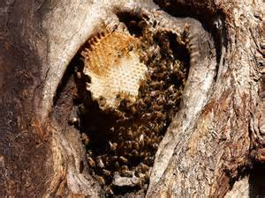
Beehive in the Wild | Beekeeper and Manmade Beehives

In the wild, Honey Bees like to nest in the cavities of trees, caves or buildings. Honeybee hives have long provided humans with honey and beeswax. Such commercial uses have spawned a large beekeeping industry, though many species still occur in the wild.

Honey Bees are not native to North America. The Indians had no bees! Like most of the livestock associated with American farms, honey bees were imported by European settlers. These bees came from England and arrived in Virginia in 1622. By 1639, colonies of honey bees were found throughout the woods in Massachusetts. Some of the colonists who arrived at Plymouth brought bees, as well as sheep, cows and chickens on the trip across the Atlantic. Once Honey Bees were established in America, the Indians called them “white man’s flies.” Like other insects, bees were able to increase their range by moving into new territory. Honey bees increase colony numbers by swarming. Swarms are able to fly several miles to establish a new colony.

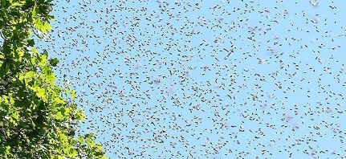
Honey Bee Swarm on the move looking for a place to establish a new Colony
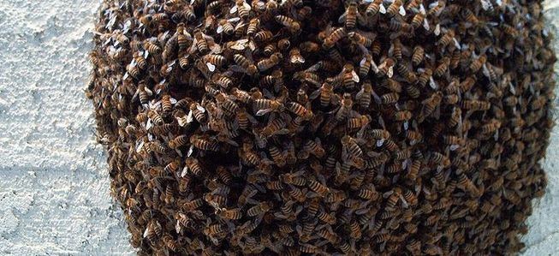
A Swarm Ball of Honey Bees

Bees live for two purposes: to reproduce themselves (produce a new colony) and to store honey in order to provide food during the winter months. Bees live on stored honey and pollen all winter, and cluster into a ball to conserve warmth. Larvae (baby bees) are fed from the stores during this season and, by spring, the hive is swarming with a new generation of bees.

All honeybees are social and cooperative insects. In the wild, they create elaborate nests called hives containing up to 20,000 bees during the summer months. (Domestic hives may have over 80,000 bees.) They work together in a highly structured social order. Each bee belongs to one of three specialized groups called castes. A hive's inhabitants are generally divided into three types: Queen, Drones and Workers.
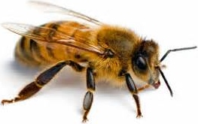 | Worker Bees are the only bees that most people ever see. These bees are females that are not sexually developed. Workers forage for food (pollen and nectar from flowers), build and protect the hive, clean, circulate air by beating their wings, and perform many other societal functions. The average worker bee lives for just five to six weeks.

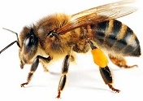 | The Queen Bee’s job is simple—laying the eggs that will spawn the hive's next generation of bees. There is usually only a single queen in a hive. If the queen dies, workers will create a new queen by feeding one of the worker females a special diet of a food called "royal jelly". This enables the worker to develop into a fertile queen. Queens also regulate the hive's activities by producing chemicals that guide the behavior of the other bees. The queen bee can live up to five years. She is busiest in the summer months, when she lays up to 2,500 eggs a day.

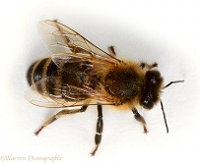 | Male bees are called drones—the third class of honeybee. Several hundred drones live in each hive during the spring and summer, but they are expelled for the winter months when the hive goes into a lean survival mode. At the most, drones may live for up to 4 months, however, they may only survive for just a few weeks. When a male Honeybee mates with the Queen, he dies immediately.

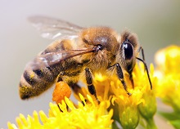 | The Honey Bee is probably the best known insect in the world. They are super-important pollinators for flowers, fruits and vegetables. This means that they help other plants grow! Bees transfer pollen between the male and female parts, allowing plants to grow seeds and fruit. More has been written about honeybees than any other species of insect. The human fascination with this insect began thousands of years ago when people discovered how good honey is!

Honey is a thick liquid produced by certain types of bees from the nectar of flowers. While many species of insects consume nectar, honeybees refine and concentrate nectar to make honey. Indeed, they make lots of honey so they will have plenty of food for times when flower nectar is unavailable, such as in the winter time. Unlike most insects, honeybees remain active through the winter, consuming and metabolizing honey in order to keep from freezing to death. Early humans probably watched the bears and other animals raid bee hives for honey and then decided to try it themselves. Once people found out what honey was, next they had to learn how to get it from the bees safely!

Honeybees have a bright color pattern to warn potential predators (or honey thieves!) They also have a weapon to defend themselves. Their weapon is a modified ovipositor (egg-laying tube). This is combined with a venom gland to create a stinger located at the end of the abdomen. Because the stinger is modified from a structure found only in females, male bees cannot sting. When the hive is threatened, female honeybees will swarm out and attack with their stingers to drive the enemy away.

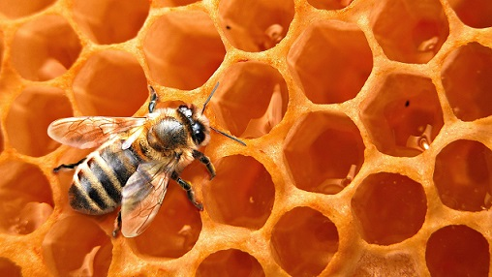
The Honeycomb

The central feature of the beehive is the honeycomb. This marvel of insect engineering consists of flat vertical panels of six-sided cells made of beeswax. Beeswax is produced from glands on the underside of the abdomens of worker bees when they are between 12 and 15 days old. House bees take the beeswax and form it with their mouths into the honeycomb. The cells within the comb are used to raise young and to store honey and pollen. The comb is two-sided, with cells on both sides. As you can see, the cells are perfectly uniform in shape. Not only that, but the combs are built a precise distance apart depending on whether they are meant to contain food or young bees. The nursery area of the hive is called the brood comb, and that is where the queen lays her eggs.

Purified and bleached beeswax is used in the production of candles, food, skin care, cosmetics, and pharmaceuticals. The three main types of beeswax products are yellow, white, and beeswax absolute. Yellow beeswax is the crude product obtained from the honeycomb, white beeswax is bleached yellow beeswax, and beeswax absolute is yellow beeswax treated with alcohol. In food preparation, it is used as a coating for cheese; by sealing out the air, protection is given against spoilage (mold growth). Beeswax may also be used as a food additive in small quantities acting as a glazing agent, which serves to prevent water loss or used to provide surface protection.

 | It is time for some fun facts about Honey Bees:
1. | Honey bees are great flyers. They can fly at a speed of over 16 miles per hour and they beat their wings 200 times per second!
2. | Each bee has 170 odorant receptors, which means they have an excellent sense of smell! They use this to communicate within the hive and to recognize different types of flowers when looking for food.
3. | Approximately one third of all the food Americans eat is directly or indirectly derived from honey bee pollination.
4. | The average worker bee lives for just five to six weeks. During this time, she’ll produce around a twelfth of a teaspoon of honey. Their most common cause of death is wearing their wings out.
5. | Flower nectar is one of two food sources used by honeybees. The other is pollen. Both are gathered by the field bees as they fly about on their daily foraging flights.
6. | Honey bees like to dance! To share information about the best food sources, they perform their ‘waggle dance’. When the worker returns to the hive, it moves in a figure-of-eight and waggles its body to indicate the direction of the food source.
7. | Sadly, over the past 15 years, colonies of bees have been disappearing, and the reason remains unknown. Referred to as 'colony collapse disorder', billions of Honey bees across the world are leaving their hives, never to return.
8. | We can all do our bit to support these brilliant insects! Why not plant flowers rich in nectar, such as lavender and bluebells, which will help bees find the food they need? Also, be sure to choose a local brand of honey which will support our Honey bees and their beekeepers!
9. | Bees have a special tongue that sucks up the nectar and two stomachs - one stomach for eating and the other special stomach is for storing nectar collected from flowers so that they can carry it back to their hive.
10. | Bees are classified as insects and they have six legs. Bees have five eyes - two compound eyes and three tiny ocelli eyes.
11. | Bees are the only insect in the world that make food that humans can eat.
12. | Honey has natural preservatives and bacteria can't grow in it. Honey was found in the tombs in Egypt and it was still edible! Honey is the only food substance that doesn’t spoil!
13. | A single beehive can make more than 100 pounds of extra honey. The beekeeper only harvests the extra honey made by the bees.
14. | Bees carry pollen on their hind legs called a pollen basket. Pollen is a source of protein for the hive and is needed to feed to the baby bees to help them grow.
15. | Bees maintain a temperature of 92-93 degrees Fahrenheit in their central brood nest (in the Beehive) regardless of whether the outside temperature is 110 or -40 degrees.
16. | Bees have been here on Earth for around 30 million years.

What about those Killer Bees? Do we need to worry?

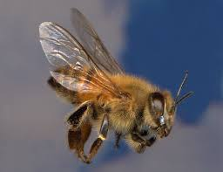 | More properly called Africanized Honeybees, these come from a subspecies of honeybee released accidentally in Brazil in 1957. They were imported from South Africa by a researcher who was attempting to produce a variety of honeybee better adapted to the tropics than the European Honeybee. Unfortunately, Africanized Honeybees not only produce honey better in hot climates, but they are also much more aggressive at defending the nest. Many people have been killed by mass stinging resulting from getting too close to a nest of
Africanized honeybees. The escaped bees did well in the wild and began reproducing and expanding their range across South America into Central America and Mexico. They were first found in Texas in October 1990, California in November 1994 and Oklahoma in 2004. Since then, they have been spotted in New Mexico, Arizona, Nevada, and southern Utah. Since they are adapted for tropical conditions, they may not expand their range beyond the southern part of the U.S., but that remains to be seen. They can tolerate up to 3 1/2 months of freezing weather. Maybe we need to start worrying!

Just how many bee stings does it take to kill you? Well, unless a person has a bee sting allergy, the average adult can withstand more than 1000 stings, although 500 stings could kill a child. Approximately 55 people die each year in the U.S. because of an allergic reaction from being stung by bees. If you are among three percent of the population who are allergic to bee stings, the symptoms from even minor stings can be severe and potentially life-threatening.

Utah is one of 16 states that have the Honeybee as the state insect. But, did you know that Utah is the only state with the nickname “The Beehive State”? Utahans relate the beehive symbol to industry and the pioneer virtues of thrift and perseverance. The beehive was chosen as the emblem for the provisional State of Deseret in 1848 and was maintained on the seal of the State of Utah when Utah became a state in 1896.

I hope you learned something about Bees. BUZZ!!

bigdrifter44@gmail.com

