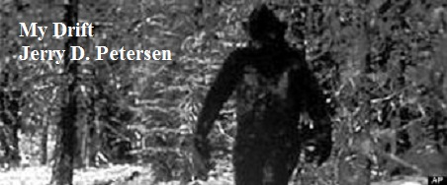

 | Bigfoot (or Sasquatch)  23 July 2014 | 181-2014-10

Let’s see now, if you have been following my articles, you would know that I believe in ghosts and UFOs – so I probably believe in Bigfoot and the Loch ness monster. Right? I will let you know later in this article.

Sasquatch is the "official" name of Bigfoot and is the name used in Canada and most other countries outside the United States. I like Bigfoot better.

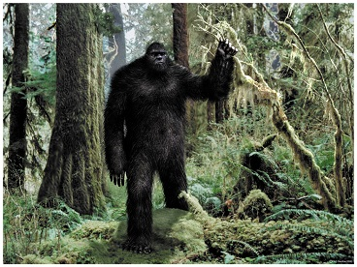 | 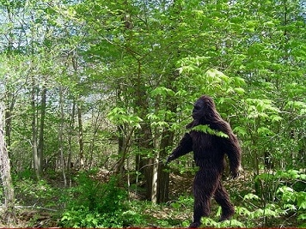

We have all heard about this ape-like creature called Bigfoot. But, if you were out wandering around in the woods and saw a big strange hairy man-like animal off in the distance, would you know it was a Bigfoot? Here is a little better description: The average Bigfoot is very big ranging in height from 7 to 10 feet tall and weighing around 800 pounds. They are covered with dark brown or reddish brown hair, have large eyes, a pronounced brow ridge, and a low-set forehead similar to the male gorilla. People that have got close to a Bigfoot have all reported it to have a strong, unpleasant odor (smell). As you might have guessed, Bigfoot has really BIG feet – up to 24 inches long and 8 inches wide. Most foot casts show that Bigfoot has five toes like an ape.
Bigfoot versus Man | 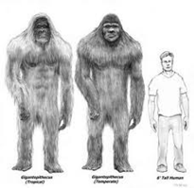 | 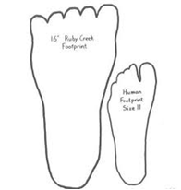
Experts claim that Bigfoot is omnivorous (eats everything) and mainly nocturnal (sleeps during the day and is most active at night). They believe the reason it has survived so long is due partly to its elusive, defensively aggressive isolationist behavior, but also its ability to hibernate for very long periods of time (like bears).

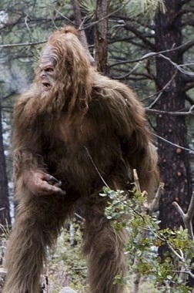 | 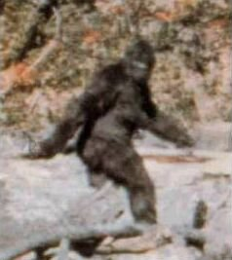 | 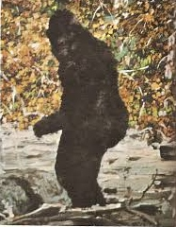

I haven’t seen one yet, but I was reading about a recent Bigfoot sighting up Provo Canyon in Utah. They have a YouTube (https://www.youtube.com/watch?v=MlDIEdRtca4) video of this sighting on the Internet. Provo Canyon is only a few miles from the city of Orem where my mother and sister live. There have been over 3,500 documented credible Bigfoot sightings in the US and Canada since they started keeping track about 90 years ago. Most of these sightings have occurred in the Pacific Northwest and British Columbia. There have also been many more sightings around the world. For example, there are hundreds of stories about the Yeti or Abominable Snowman in the Himalayas region of Nepal and Tibet. Then there’s the Wildman of Hubei in China. Experts think that there have been at least 10,000 unreported Bigfoot sightings. In the US, there have been Bigfoot sightings in every state except Hawaii. Check out the map on the next page. How do you non-believers explain all of these sighting?
Sightings - Statistics

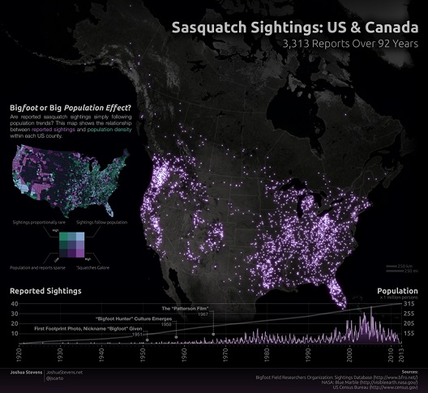

Number of sightings by state or province
State or Province  Washington  California  Florida  Ohio  Illinois  Oregon  Canada  British Columbia  Other Countries  Malaysia  China | Number  603  437  292  258  248  245  148  44  29 | Date of Last  Jul 2014  Mar 2014  May 2014  Apr 2014  May 2014  Jun2014  Jan 2014  Aug 2012  Oct 2010 | State or Province  Texas  Michigan  Colorado  Georgia  Pennsylvania  Utah  Ontario  Himalayan Region  Russia | Number  200  191  116  116  108  80  76  27  12 | Date of Last  Jun 2014  Jun 2014  May 2014  May 2014  Jan 2014  Dec 2013  Sep 2013  Jul 2013  May 2011
Stories - Bigfoot Sightings

Tibble Fork Lake, Utah County, Utah  My name is Jerom Ray Patterson and I live in Alpine, Utah. I have lived there my whole life. It’s a small valley surrounded by the Wasatch Mountains. My encounter happened when I was 19 years old - right before I left on a LDS mission for the Church of Jesus Christ of Latter Day Saints. There is a canyon no more than 10 minutes from where I live. It’s called American Fork Canyon. I was with two of my best friends, who also served LDS missions. I was about to leave for 2 years; I love the outdoors. So I wanted to spend | 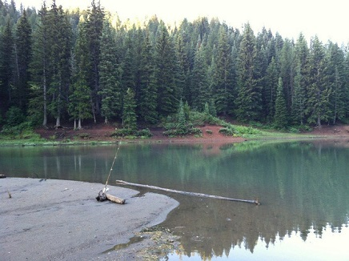  Tibble Fork Lake
the last couple of days camping up American Fork Canyon with friends.

It was Friday, June 27th 2008. We found a place to camp a little bit, north of Tibble Fork Lake. It was very peaceful and calm. It was getting dark and we just finished up fishing. My good friend Austin Hansen went to set up the fire. While his brother Alex and I went to the river below to clean the fish. I remember Austin later that night telling us that he saw SOMEONE, walking in the brush by our camping gear. He didn’t say anything; he just saw a big figure. He thought it was someone looking for something near our campsite.

We came back, and started cooking the fresh fish we just caught. We sat down, started talking about girls and our future. While we were talking, we heard a faint eerie whistling noise. We didn't think much of it, maybe thinking it was some kind of weird bird in the trees. Maybe we had camped too close to its nest and we were bothering its family. It was a far off distant sound. At times it sounded like it was behind a bush, listening to us. The closer it got, there was also a weird smell that accompanied it. It also felt to all of us, that eyes were on us; curious eyes watching listening. As if we didn't belong in this area.

As we were getting ready for bed, I walked off maybe 10 yards to where we were going to be sleeping, to go to the bathroom. I thought I saw someone maybe 40 yards away. It was walking right behind two big pine trees and it stayed there no longer than 30 seconds later; then I heard a stick hit a tree 2 times but the sound was coming off the north east from where I was standing.

That’s when I saw IT! Whatever you want to call it but I know what I saw. I saw a Sasquatch standing upright walking towards the trees. It stood at least 7 feet tall was not intimidated by any means. It looked at me or in my direction. My heart was pounding as the whistling noise got louder - very loud. I ran back to camp, telling my friends what I just saw. They believed me telling me they felt the same way - that we were being watched. Austin told us of the event earlier seeing a huge man, walking away from our camp. We got our things together and ran to the car. That Friday night camping trip is something that I will never forget as long as I live.
Other Bigfoot Sightings in Utah
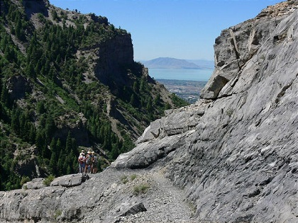 | 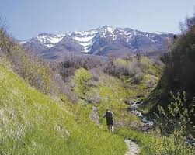

Grove Creek and Battle Creek Canyons above Pleasant Grove, Utah

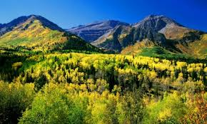 | 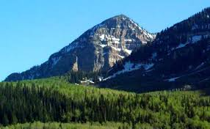
Sundance Ski Resort, Provo Canyon and Mt. Timpanogos, American Fork Canyon, Utah

There have been several recent Bigfoot sightings on Mt. Timpanogos which includes Provo Canyon on one side and American Fork Canyon on the other side. There have also been sightings near the base of Mt. Timpanogos on the trail between Grove Creek and Battle Creek Canyons in the mountains near Pleasant Grove, Utah. I picked a few of the Utah Bigfoot sightings because most of my family and “My Drift” readers are from either Hawaii or Utah. Since we don’t have any Bigfoots running around in Hawaii, I picked a few sighting in Utah. I’m surprised that with all the hiking we kids did while growing up in Pleasant Grove that we never did see a Bigfoot.

Nation-wide, the most Bigfoot sightings have been in Washington State. There are a lot of trees in Washington! Have you ever been to Washington? I mean once you leave Seattle, it is pretty much one big forest. It is a great place for the Bigfoot to live in a quiet, peaceful, and (for the most part) undisturbed environment. The only people that go deep into the mountain forests are a few hikers and hunters. A lot of Bigfoot stories come from the state of Washington. I will tell you about one of these that I thought was kind of interesting. It is titled, “Sasquatch and Horses”, and is written by Sheryl Jenkins who has encounter a Sasquatch on three separate occasions. I’m going to summarize this story because it is too long to include in this article.
Stories - Sasquatch and Horses
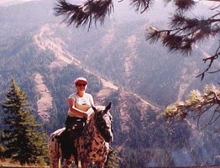 | 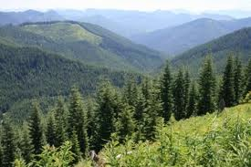
Photos: Sheryl Jenkins riding the forested Mill Creek Watershed in the Blue Mountain Range of Washington State...
Sheryl Jenkins had a mountain cabin on the edge of the Mill Creek Watershed for almost 20 years. For many of those years, she rode her horses along the trails and cross country in the area. Her horses were experienced mountain horses that had no fear of bears, cougars and were very used to seeing deer and elk. They did not spook nor react negatively to the usual animals in the area. One day Sheryl and two of her friends were out riding on the Watershed Trail when they heard something moving in the trees and brush below them. All three horses jumped at the noise which was a behavior unusual for these horses. The horses were nervous and wanting to leave. They decided to dismount and walk the horses out of the area. All 3 of the ladies were nervous turning to scared; the fear increased as they walked because they were definitely being followed; zero doubt! They could tell that whatever followed them was getting closer due to the branches/brush noises becoming closer and the horses became increasingly agitated, uneasy in their behavior. They all felt the need to start running!!
At one point they could SMELL whatever was behind them, no doubt the horses caught the scent on wind much sooner than the humans; it was obvious by their behavior. They could hear noise in the underbrush ever so often, but the smell by now was an overpowering a sickly sweet stench, intolerable and nauseating. One of the horses started rearing, moving around, shaking her head, snorting and bucking etc. Whatever was following them was, at this point, just out of view in the bushes/trees. They knew it was close and just out of sight; the horse's reaction confirmed it. Then she turned around and saw the Sasquatch clearly next to a tree across the way. They started running down the trail to a spot where they were finally able to mount the horse and return to the cabin as fast as possible.
The next day, Sheryl went back to where she had saw the Sasquatch. She just had to know, to reassure herself that what she had seen was real. What she saw frightened her even more. She expected to find nothing but there beside the tree were full imprints of a Sasquatch’s big feet. There was also imprints of where it had laid down full length in the grass, a fresh imprint longer than a horse. Its massive arms, legs, torso, head imprinted in the grass. On the other side of the tree were 2 square imprints where a big and a small Sasquatch had been sitting next to it. Then, all of a sudden her horse got a scent of another Sasquatch and took off in a wild bucking run leaving her in a cloud of dust. Sheryl was able to catch up to the horse and they made it back to the cabin safely. There were two more sightings while she was out riding her horses. One thing for sure – horses can’t stand the scent of a Sasquatch!!
Evidence
Okay, I have presented a lot of evidence that the Bigfoot does exist but 70% of the people in the United States don’t believe it does. Let’s examine the evidence objectively and in a little more detail. Bigfoot evidence can be broken down into four general types: eyewitness sightings, footprints, visual/audio recordings, and body samples (hair, bones, blood, and/or a Bigfoot body).

Eyewitness Sightings
Bigfoot believers
- Thousands of people have seen a Bigfoot
- “Where there’s smoke there’s fire” – something is out there
Non-believers
- Eyewitnesses can be mistaken

Footprints
Bigfoot believers
- These tracks and track casts are recognizable evidence
Non-believers
- These tracks are not consistent and could be fake

Visual and Audio Recordings
Bigfoot believers
- There are thousands of Bigfoot pictures, films, and digital images
- Bigfoot voice recordings are different from all known animals
Non-believers
- All of these pictures and recording could be fake

Body samples (hair, bone, blood, and/or a Bigfoot body)
Bigfoot believers
- DNA results have been inconclusive because there is nothing available to compare it against
- It is just a matter of time before a Bigfoot is captured or a body is found
Non-believers
- Most samples (hair, bone, blood) have turned out to be from elk, bear, cow or some other animal
- A Bigfoot body will never be found because they don’t exist

Conclusions
Bigfoots are always sighted in or near remote wooded, mountainous, or swampy areas. They are rarely seen far from the cover of trees. If they encounter humans during daylight hours they tend to retreat and vanish into the forest. They seem to be most active when humans are least active -- late at night. Unlike mountain gorillas, Bigfoots are never seen in large groups, and they don't stay in the same place for very long. After thousands of generations, they have developed some amazing evasion/defense mechanisms and behaviors, including night vision abilities. They also developed powerful vocal abilities, which allowed them to locate and interact with other Bigfoots. They make powerful loud screams and howls that could be heard for miles in the dead of night. Late hours allowed them to avoid various undesirables such as humans, overheating, water loss, and most insects.

Even though there have been a lot of cumulative sightings, the Bigfoot species is very rare. The estimated number of Bigfoots in North America is 1000. That is not very many. Even in Washington State where there has been about 600 sightings over the past 50 years – that is only 12 sightings a year. It is not surprising to me that no Bigfoot body has been found. Thousands of animals (some are large like elk and bear) die of natural causes every year in the wild. Our ecosystem (nature) has a way of cleaning up the dead bodies. What the scavengers (vultures, crows, coyotes, beetles, etc.) don’t get, decomposition will take care of the rest. How many dead animals have you seen while out hiking, hunting, fishing, or just having a picnic in the mountains?

I don’t think these people who have saw Bigfoot are lying. When a LDS missionary says he saw a Bigfoot – I believe him. Most of these creditable Bigfoot sightings have come from normal people like you and me. There is definitely something out there. Put me down as a Bigfoot believer!! No actual physical evidence has not stopped me from believing in ghosts and UFOs. I’m reserving judgment on the Loch ness monster, however, until I can do a little more research.

bigdrifter44@gmail.com

