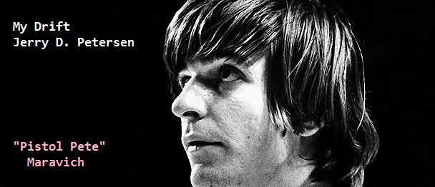

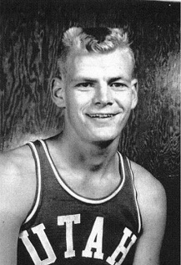 | Best College Basketball Players Ever  11 May 2014 | 176-2014-05

Who are the best college basketball players to ever play the game? My list of 44 players starts on the next page. I’m sorry to say that I didn’t make the list. I did play for the University of Utah (1958-1961) but I was just an average player. We did have one All-American player on our team named Billy “The Hill” McGill who was also the leading scorer in the country (38.8 points per game) in 1962. You will find him on my list in the 29th position just ahead of a player named Michael Jordan.

Have you ever looked at a basketball box score and wondered what all those abbreviations mean? Here is a legend that will explain these and also make it easier to understand my article and the player’s stats:
G = Games  PPG = Average Points Per Game  MIN = Average Minutes Played Per Game  FGM = Total Field Goals Made  FGA = Total Field Goals Attempted  FG% = Field Goal Percentage Made  3PM = Number of 3-Point Shots Made  3PA = Number of 3-Point Shots Attempted  3P% = 3-Point Shot Percentage Made | FTM = Total Free Throws Made  FTA = Total Free Throws Attempted  FT% = Free Throw Percentage Made  RPG = Average # of Rebounds Per Game  APG = Average # of Assists Per Game  TPG = Average # of Turnovers Per Game  BPG = Average # of Blocks Per Game  SPG = Average # of Steals Per Game

List of the TOP 44 Best College Basketball Players Ever
#44 Arnie Ferrin University of Utah (1944-1948) Guard/Forward Height: 6-2 Weight: 180
Stats: 13.7 PPG
Accomplishments: Ferrin won the NCAA Basketball Tournament MOP award in 1944 when the Utes won the NCAA Championship over Dartmouth. Ferrin also helped Utah win the 1947 NIT. He became the only four-time All-American at Utah.

#43 Dan Issel Kentucky (1968-1970) Center/Forward Height: 6-9 Weight: 235
Stats: 25.8 PPG, 13.0 RPG, 51.9 FG%, 73.8 FT%
Accomplishments: NCAA unanimous first-team All-American in 1970 and scored at least 40 points eight times in his senior season, including a school-record 53 at Ole Miss, to help UK become the most prolific scoring team in SEC history (96.8 points per game).

#42 Shaquille O’Neal Louisiana State (1990-1992) Center Height: 7-1 Weight: 325
Stats: 90 G, 21.6 PPG, 13.5 RPG, 61.0 FG%, 57.5 FT%
Accomplishments: Named national player of the year by AP and UPI in 1991. NCAA unanimous first-team All-American in 1991 and 1992. Led the nation in rebounding in 1991 between finishing 9th in 1990 and 2nd in 1992. Led the nation in blocked shots with 5.2 per game in 1992.

#41 Cazzie Russell Michigan (1964-1966) Forward Height: 6-5 Weight: 218
Stats: 27.1 PPG, 8.5 RPG, 50.5 FG%, 82.8 FT%
Accomplishments: Three-time All-American Russell averaged at least 24 points per game each of his three years in the NCAA tourney. He set a school record for most points in a regulation game with 48 against Northwestern. He had 23 outings with at least 30 points.

#40 David Robinson Navy (1984-1987) Center Height: 7-1 Weight: 235
Stats: 127 G, 21.0 PPG, 10.3 RPG, 61.3 FG%, 62.7 FT%
Accomplishments: Robinson was an All-American and national player of the year in 1987. He led the nation in rebounding (13.0) and blocked shots (5.9) in 1986. He averaged 28.6 points and 12.3 rebounds in seven NCAA Tournament games. He had 29 contests with at least 30 points.

#39 Calvin Murphy Niagara (1968-1970) Guard Height: 5’9” Weight: 165
Stats: 33.1 PPG, 4 RPG, 43.8 FG%, 84.9 FT%
Accomplishments: NCAA first-team All-American in 1969 and 1970 and second-team All-American in 1968. Ranked among the nation's top eight scorers in 1968 (2nd), 1969 (3rd) and 1970 (8th). Had 14 games with at least 42 points, including a school-record 68 against Syracuse.

#38 Darrell Griffith Louisville (1977-1980) Guard Height: 6-4 Weight: 190
Nickname: “Dr. Dunkenstein” Stats: 116 G, 20.1 PPG, 5.0 RPG, 52.3 FG%, 69.7 FT%
Accomplishments: Wooden Award winner and NCAA unanimous first-team All-American in 1980. He was Final Four Most Outstanding Player (57 points, 15 assists, 62.2 FG%). Griffith was the leading scorer for 1980 NCAA champion Louisville who had a 33-3 record.

#37 Rick Mount Purdue (1968-1970) Forward Height: 6-4 Weight: 185
Stats: 72 G, 32.3 PPG, 48.3 FG%, 84.3 FT%
Accomplishments: Mount was a two-time consensus first team All-American. In his senior year, he had two 53-point games plus a 61-point game against conference champ Iowa, which was the NCAA Division I single-game record at the time. 32 of his 61 points were scored in the first half alone. Later research found that if the 3-point line had existed in 1970 he would have scored 74 points in that game, credited with 13 three-point field goals.

#36 Glenn Robinson Purdue (1993-1994) Forward Height: 6-7 Weight: 225
Stats: 62 G, 27.5 PPG, 9.7 RPG, 48 FG%, 77 FT%
Accomplishments: Consensus two-time All-American and the 1994 Player of the Year. Robinson left Purdue after becoming the only Boilermaker to have more than 1,000 points, 500 rebounds, 100 steals, 100 assists and 50 blocked shots in a career during his two seasons at Purdue along with a school weightlifting record 309-pound clean-and-jerk.

#35 Chet Walker Bradley (1960-1962) Forward Height: 6-6 Weight: 212
Stats: 24.4 PPG, 12.8 RPG, 55.2 FG%
Accomplishments: Walker was ranked among the nation's leading scorers, highest field-goal percentage, and number of rebounds per game every year he played. He had 22 games with at least 30 points. He was a two-time consensus first team All-American (1961–1962).

#34 Xavier McDaniel Wichita State (1982-1985) Forward Height: 6-7 Weight: 205
Stats: 117 G, 18.4 PPG, 11.6 RPG, 56.4 FG%, 62.4 FT%
Accomplishments: McDaniel was a 1985 All-American and the first player to lead the nation in both rebounding (14.8) and scoring (27.2) in the same season. In college, McDaniel began to shave both his head and his eyebrows to look more intimidating. He continued this all throughout his pro career.

#33 J.J. Redick Duke (2003-2006) Guard Height: 6-4 Weight: 190
Stats: 139 G, 19.9 PPG, 2.7 RPG, 2.2 APG, 43.3 FG%, 91.2 FT%
Accomplishments: NCAA first-team All-American in 2005 and 2006. Ranked among the nation's leaders in free-throw percentage (over 90%), 3-point field-goal percentage (over 40%) and three-point field goals per game (3.3). Leading scorer for 2004 Final Four team (31-6 record). He averaged 15.9 points and 3.1 rebounds in 14 NCAA tournament games.

#32 Steve Alford Indiana (1984-1987) Guard Height: 6-2 Weight: 183
Stats: 125 G, 19.5 PPG, 2.8 RPG, 3.1 APG, FG% 53.3, FT% 89.8
Accomplishments: Alford was the only player to be named the team's MVP four times. He was a first team All-American in 1986 and 1987. Indiana won the NCAA championship in 1987. Playing for Bob Knight, Alford became the all-time leading scorer with 2,438 points.

#31 Tim Duncan Wake Forest (1994-1997) Center/Forward Height: 6’11” Weight: 250
Stats: 128 G, 16.5 PPG, 12.3 RPG, FG% 57.7, FT% 68.9
Accomplishments: Named national player of the year in 1997. NCAA unanimous first-team All-American in 1996 and 1997. Led the nation in rebounding in 1997 and ranked among the nation's leaders in blocked shots in 1994 through 1997.

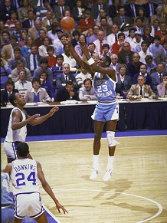 | #30 Michael Jordan Nicknames: “MJ” and “Air Jordan”  Guard-Forward Height = 6’6” Weight = 195  North Carolina 1982-1984 (3) – Team record = 88-13  G = 101 : PPG = 17.7 : RPG = 5.0 : FG% = 54.0 : FT% = 74.8  Jordan was very good but not great in college. He was a first team All-American in 1983 and 1984. Named national player of the year and won the Naismith Award and Wooden Award winner in 1984. Scored a college career-high 39 points in a 72-65 victory over Georgia Tech. North Carolina won the NCAA championship in 1982 when Jordan was a freshman.  Little known Fact: Jordan has an immense fear of water and is afraid of drowning – he cannot swim.

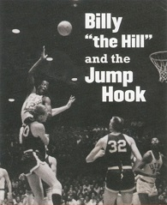 | #29 Billy “the Hill” McGill  Center Height = 6’9” Weight = 225  Utah 1960-1962 (3) – Team record = 72-14  G = 86 : PPG = 27.0 : RPG = 12.9 : FG% = 53.0  McGill was a two-time All-American and the NCAA scoring leader in the 1961-1962 season with 1,009 points in 26 games (38.8 points per game), a higher one-season average than any previous player except Frank Selvy in the 1953-1954 season. Utah went to the Sweet 16 his sophomore year and the Final Four his junior year and were 23-3 his senior year in 1962 and might have won it all if a Ute player hadn’t accepted a plane ticket from a booster and gotten the school banned from the national tournament. The Chicago Zephyrs made McGill the No. 1 pick in the 1962 NBA draft.  Little known Fact: He played for ten different NBA/ABA teams in 8 seasons before being dropped for good. One year later, he was broke and homeless living on the streets of Los Angeles.

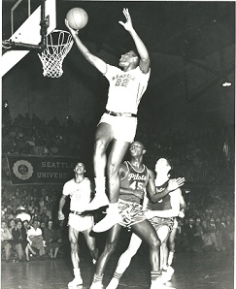 | #28 Elgin Baylor Nickname: “The man with a thousand moves”  Forward Height = 6’5” Weight = 225  Idaho 1955/Seattle 1957-1958 (3)  G = 54 : PPG = 31.3 : RPG = 19.8 : FG% = 50.0 : FT% = 78.4  In his three collegiate seasons, one at Idaho and two at Seattle, Baylor averaged 31.3 points per game. He led the NCAA in rebounds during the 1956-57 season. He led the Seattle Chieftains (now known as the Redhawks) to the NCAA championship game in 1958, falling to the Kentucky Wildcats, Seattle's last trip to the Final Four.  Little known Fact: Baylor had trouble in the classroom and dropped out of high school, filling his time with a job at a furniture store and playing hoops in various pickup games.

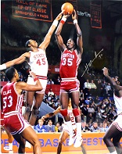 | #27 Akeem Olajuwon Nickname: “The Dream”  Center Height = 7’0” Weight = 255  Houston 1982-1984 (3) Team record = 88-16  G = 100 : PPG = 13.3 : RPG = 10.7 : BPG = 4.5 : FG% = 64.0  Born in Lagos, Nigeria, Olajuwon traveled from his home country to play for the University of Houston under Coach Guy Lewis. His college career for the Cougars included three trips to the Final Four. He and his teammates (including Clyde Drexler) formed what was dubbed "Phi Slama Jama", the first slam-dunking "fraternity", so named because of its above-the-rim prowess. Olajuwon is considered one of the greatest centers ever to play the game.  Little known Fact: Olajuwon did not play basketball until he was 15 years old.

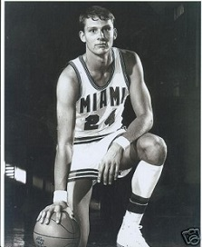 | #26 Rick Barry Nickname: “The Miami Greyhound”  Small Forward Height = 6’7” Weight = 205  Miami 1963-1965 (3) – Team record = 65-16  G = 77 : PPG = 29.8 : RPG = 16.5 : FG% = 52.2 : FT% = 85  As a senior in the 1964-65 season, Barry led the NCAA with a 37.4 points-per-game average. Barry and the Hurricanes did not take part in the NCAA Tournament, however, because the basketball program was on probation at the time. Barry led the Canes to records of 23-5, 20-7 and 22-4, the only three consecutive 20-win seasons in school history.  Little known Fact: Barry had an unorthodox but highly accurate underhanded free throw shooting style. He used this underhand method to shoot over 90 percent from the line during his 14-year professional career.

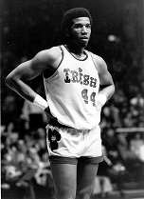 | #25 Adrian Dantley Nickname: “A.D.”  Forward Height = 6’5” Weight = 210  Notre Dame 1974-1976 (3) Team Record: 68-19  G = 86 : PPG = 25.8 : RPG = 9.8 : FG% = 56.0 : FT% = 80  Dantley was a consensus first-team All-American in 1974–75 and 1975–76. He ranks second on the Notre Dame career scoring list with 2,223 points and holds the school record for free throws made (615) and free throws attempted (769). He played an important role in one of the biggest games in college basketball history, Notre Dame's 1974 upset to end UCLA's record 88-game winning streak.  Little known Fact: Dantley was the leading scorer on the 1976 US Olympic team that captured the gold medal in Montreal.

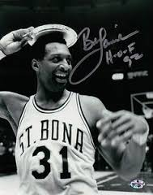 | #24 Bob Lanier Nickname: “Big Dobber”  Center Height = 6’11” Weight = 265  St. Bonaventure 1968-1970 (3) – Team record = 65-12  G = 75 : PPG = 27.6 : RPG = 15.7 : FG% = 58 : FT% = 67  Lanier was a three-time Converse All-America selection (1968–1970), and in 1970, he led St. Bonaventure to the NCAA Final Four, however, he was injured late in the regional championship game and did not participate in St. Bonaventure’s national semi-final loss to Artis Gilmore-led Jacksonville University.  Little known Facts: Lanier’s middle name was “Jerry” and he wore size 22 shoes. St. Bonaventure University is located Allegany, NY.

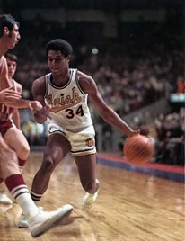 | #23 Austin Carr Nickname: “Mr. Cavalier”  Guard Height = 6’4” Weight = 200  Notre Dame 1969-1971 (3) – Team record = 61-24  G = 74 : PPG = 34.6 : RPG = 7.3 : FG% = 53.0 FT% = 81.4  Carr ended his three-year career at Notre Dame with 2,560 points ranking him fifth all-time in college basketball history at the time of his departure. Carr became only the second college player ever to tally more than 1,000 points in multiple seasons, joining Pete Maravich in that select group. Carr holds NCAA tournament records for most points in one game (61), most field goals in one game (25), and most field goals attempted in one game (44). His record scoring average of 41.7 points per game in seven NCAA playoff games may never be broken.  Little known Fact: Carr holds the record for the most points in a NCAA tournament game with 61 against Ohio State in 1970.

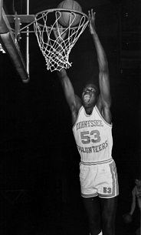 | #22 Bernard King  Guard/Forward Height = 6’7” Weight = 205  Tennessee 1975-1977 (3) – Team record = 61-20  G = 81 : PPG = 25.8 : RPG = 13.2 : FG% = 59 : FT% = 72  He was one of the best players in Southeastern Conference history, King donned the orange and white from 1975-77, earning first team All-America honors in each of his three seasons at Tennessee. King ranks second all-time at UT with 1,962 career points and 1,004 rebounds. He was one of the best scorers in the game with his lightning quick release, deadly mid-range game and unstoppable baseline jumper.  Little known Fact: King had a substance abuse problem and this led to him being arrested numerous times in the 1979-80 season while playing for the Utah Jazz.

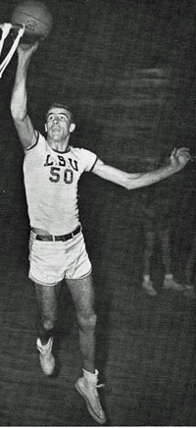 | #21 Bob Pettit  Forward Height = 6’9” Weight = 205  LSU 1952-1954 (3) – Team record = 59-15  G = 69 : PPG = 27.4 : RPG = 14.6 : FG% = 47 : FT% = 66  Pettit led the SEC in scoring all three seasons he played varsity basketball at LSU. Pettit averaged 31.4 points and 17.3 rebounds per game during his senior year and once again led LSU to an SEC Championship and garnered All-SEC and All-American honors. He set a then-SEC scoring record of 60 points against Louisiana College in his second game, and also the SEC record for scoring average, with both record later being broken by Pistol Pete Maravich.  Little known Fact: Pettit was a member of the Zeta Zeta Chapter of Delta Kappa Epsilon Fraternity at LSU.

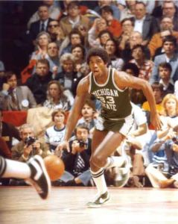 | #20 Earvin “Magic” Johnson  Guard Height = 6’8” Weight = 215  Michigan State 1978-1979 (2) – Team record 51-11  G = 62 : PPG = 17.1 : RPG = 7.6 : APG = 7.9  In 1978, the Spartans reached the Elite Eight but lost to eventual national champion Kentucky. During the 1979 season, Michigan State again qualified for the NCAA Tournament, where they advanced to the championship game and faced Indiana State, which was led by senior Larry Bird. In what was the most-watched college basketball game ever, Michigan State defeated Indiana State 75–64, and Johnson was voted Most Outstanding Player of the Final Four.  Little known Fact: Sports writer Jack Stabley gave Magic this name after he saw Magic play in a high school game, where Magic scored 46 points, 22 rebounds, and had 16 assists.

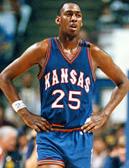 | #19 Danny Manning  Forward Height = 6’10” Weight = 230  Kansas 1985-1988 (4) – Team record = 113-34  G = 147 : PPG = 20.1 : RPG = 8.1 : FG% = 59 : FT% = 74  Manning left KU as its men's basketball program's all-time leading scorer and rebounder after leading the Jayhawks to the 1986 Final Four and the 1988 NCAA Men's Division I Basketball Tournament Championship. The 6-foot-10 forward was the all-time leading scorer in the Big Eight Conference with 2,951 career points. He named to the All-American team three times and won the Wooden, Naismith, and Eastman Awards as the college player of the year in 1988.  Little known Fact: The 1988 championship Kansas team was nicknamed "Danny and the Miracles".

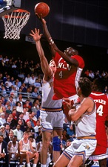 | #18 Larry Johnson Nickname: “Grandmama”  Forward Height = 6’6” Weight = 250  UNLV 1990-1991 (2) – Team record = 69-6  G = 75 : PPG = 21.6 : RPG = 11.2 : FG% = 64.0 : FT% = 79.0  Johnson transferred to UNLV to play under head coach Jerry Tarkanian. Alongside future NBA players Stacey Augmon and Greg Anthony, Johnson faced Duke Blue Devils in the title game of the 1990 NCAA Men's Division I Basketball Tournament. UNLV won the contest by a score of 103–73, with Johnson contributing 22 points and 11 rebounds. The Runnin' Rebels set NCAA records for the largest margin of victory and highest score in an NCAA Tournament championship game.  Little known Fact: Johnson began his collegiate career at Odessa College in Texas. He played there in the 1988 and 1989 seasons where he averaged over 25 points per game and became the only player ever to win the National Junior College Athletic Association Player of the Year award both years he played.

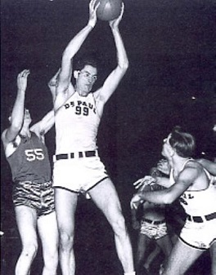 | #17 George Mikan Nickname: “Mr. Basketball”  Center Height = 6’10” Weight = 245  DePaul 1943-1946 (4) – Team record = 81-17  G = 98 : PPG = 19.1 : FG% = 71 : FT% = 68  The first great “big-man” basketball player. Mikan was named the NCAA College Player of the Year twice and an All-American three times, leading DePaul to the NIT title in 1945, which was more prestigious then the NCAA tournament at the time. Mikan led the nation in scoring with 23.9 points per game in 1945 and 23.1 in 1946.  Little known Fact: There was no goaltending rule back then so Mikan would jump up and swat the ball away before it could go into the basket.

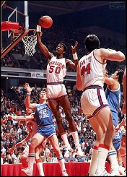 | #16 Ralph Sampson Nickname: “Stick”  Center Height = 7’4” Weight = 230  Virginia 1980-1983 (4) – Team record = 112-23  G = 132 : PPG = 16.9 : RPG = 11.4 : FG% = 57 : FT% = 66  Sampson led the Cavaliers to an NIT title in 1980, an NCAA Final Four appearance in 1981 and an NCAA Elite Eight appearance in 1983. The three time All-American earned three Naismith Awards as the National Player of the Year and an unprecedented pair of Wooden Awards. However, in 1982, a small college in Honolulu named Chaminade beat No. 1-ranked Virginia 77-72 in the biggest upset ever in college basketball.  Little known Fact: Sampson was the most heavily recruited college basketball prospect ever.

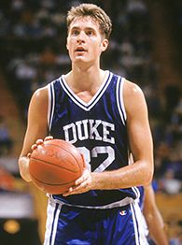 | #15 Christian Laettner Nickname: “Asshole”  Center-Forward Height = 6’11” Weight = 235  Duke 1989-1992 (4) – Team record = 123-28  G = 148 : PPG = 16.6 : RPG = 7.8 : FG% = 57.4 : FT% = 80.6  Laettner is the only player to ever start in four Final Fours. He owns the following NCAA Tournament Records: Most points scored (407) - Most free throws made (142) - Most free throw attempts (167) - Most games played (23). He is best known for his last-second, back-to-the-basket, turn-around, game-winning jump shot in Duke's dramatic 104–103 victory over Kentucky in the 1992 East regional final.  Little known Fact: He was the only college player selected to play for the men's Olympic basketball team, known as the "Dream Team", that went on to win the gold medal in 1992.

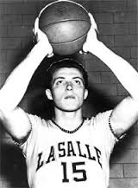 | #14 Tom Gola Nickname: “Mr. All-Around”  Forward Height = 6’6” Weight = 205  LaSalle 1952-1955 (4)  G = 115 : PPG = 20.9 : RPG = 18.7 : FG% = 40.7 : FT% = 74.5  Gola starred as a college freshman and led La Salle to the 1952 NIT championship. He paced the Explorers to the NCAA basketball championship in 1954 and was named Tournament MVP. That same season he was selected as National Player of the Year. As a senior, Gola helped La Salle finish as the runner-up in the 1955 NCAA Tournament. He averaged 20.9 points and 18.7 rebounds during 115 games and holds the NCAA record with 2,201 career rebounds.  Little known Fact: Tom Gola was one of only two players to win an NIT, NCAA and NBA championship.

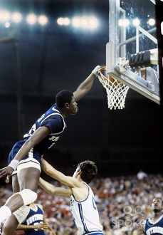 | #13 Patrick Ewing Nickname: “Hoya Destroya”  Center Height = 7’0” Weight = 240  Georgetown 1982-1985 (4) - Team record: 121-23  G = 143 : PPG = 15.3 : RPG = 9.2 : FG% = 62.0 : FT% = 63.5  Georgetown reached the championship game of the NCAA tournament three out of four years Ewing played there. They lost to North Carolina in 1983 – won the NCAA title by beating Houston 84-75 in 1984 – and in 1985 they lost the title to Villanova 66-64. Ewing was a first-team All-American for 3 straight years (1983-1985). He was the NCAA MOP in 1983 and the NCAA Player of the Year in 1985. He also won two Olympic gold medals in 1984 and 1992.  Little known Fact: Ewing was frequently forced to endure racist chants and abuse from white college students who also threw things at him.

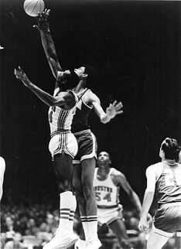 | #12 Elvin Hayes Nickname: “The Big E”  Forward Height = 6’9” Weight = 235  Houston 1966-1968 (3) – Team record = 81-12  G = 93 : PPG = 31.0 : RPG = 17.2 : FG% = 53.6 : FT% = 59.0  On January 20, 1968, the Big E and the Houston Cougars faced Lew Alcindor and the UCLA Bruins in the first-ever nationally televised regular season college basketball game. In front of a record 52,693 fans at the Houston Astrodome, Hayes scored 39 points and had 15 rebounds while limiting Alcindor to just 15 points as Houston beat UCLA 71–69 to snap the Bruins' 47-game winning streak in what has been called the "Game of the Century". He was a 2-time All-American and the Player of the Year in 1968.  Little known Fact: The Big E’s number 44 was retired by the University of Houston.

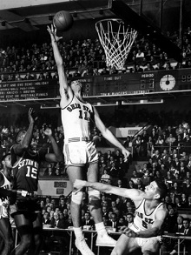 | #11 Jerry Lucas Nicknames: “Luke” and “Dr. Memory”  Forward/Center Height = 6’8” Weight = 230  Ohio State 1960-1962 (3) – Team record = 78-6  G = 82 : PPG = 24.3 : RPG = 17.2 : FG% = 62.4 : FT% = 77.7  Lucas and Ohio State won the 1959-1960 NCAA Championship. However, Utah beat Ohio State 97-92 that year in Salt Lake City. During the 1961 NCAA Tournament, Lucas became the only player ever to record a '30-30 ', 33 points and 30 rebounds in a single tournament game, versus Kentucky. He was a three-time All-American, a two-time Final Four MOP, and two-time College Player of the Year.  Little known Fact: Lucas had 150+ athletic scholarships to choose from but said he was staying in Ohio and insisted on taking an academic scholarship, making his basketball play optional in an effort to control his college career.

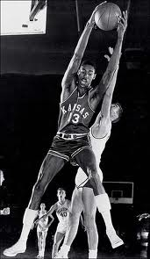 | #10 Wilt Chamerlain Nicknames: "Wilt the Stilt", "Goliath", and his favorite, "The Big Dipper"  Center Height = 7’1” Weight = 275  Kansas 1957-1958 (2) Team record = 42-8  G = 48 : PPG = 29.9 : RPG = 18.3 : FG% = 47.0 : FT% = 62  In his first varsity game, Wilt scored 52 points and grabbed 31 rebounds, breaking both all-time Kansas records. Kansas lost to North Carolina 54-53 in the 1957 NCAA championship game by triple teaming Wilt. Chamerlain was a 2-time All-American and the Most Outstanding Player of the Final Four.  Little known Fact: Wilt played other sports at Kansas - He ran the 100-yard dash in 10.9 seconds, shot-putted 56 feet, triple jumped more than 50 feet, and won the high jump in the Big Eight track and field championships three straight years.

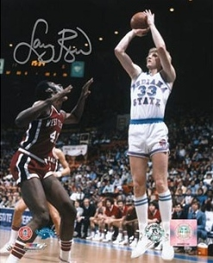 | #9 Larry Bird Nickname: “The Hick from French Lick”  Forward Height = 6’9” Weight = 220  Indiana State 1977-1979 (3) – Team record = 81-13  G=94:PPG=30.3:RPG=13.3:APG=4.6:FG%= 53.3:FT%=82.2  Bird was a two-time All-American and Player of the Year. He led the Sycamores to the NCAA championship game (in Salt Lake City) only to lose to Magic and Michigan State by the score of 75-64. Bird had a pretty good basketball career considering that he was a slow running white guy that couldn’t jump – he could shoot and pass quite well, however.  Little known Fact: Bird received a scholarship to play college basketball for the Indiana Hoosiers in 1974 but he didn’t like the big college or Coach Bobby Knight so he went home.

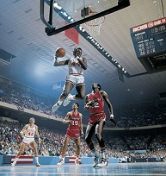 | #8 David Thompson Nickname = "Skywalker”  Guard/Small Forward Height = 6’4” Weight = 195  North Carolina State 1973-1975 (3) – Team record = 79-7  G = 86 : PPG = 26.8 : RPG = 8.1 : FG% = 55.5 : FT% = 76.3  After leading North Carolina State to an undefeated season (27-0) in 1973, he then led the Wolfpack to a 30-1 season and the NCAA Division I Basketball Championship in 1974, defeating the reigning national champions, UCLA. Thompson was a 3-time All-American, Final Four MOP, and the College Player of the year in 1975.  Little known Fact: Thompson was known as the “Skywalker” because of his incredible 48” vertical leap – he was only 6’4” but could touch the top of the backboard.

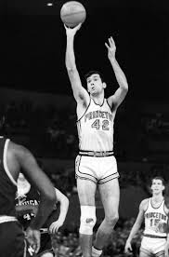 | #7 Bill Bradley Nickname: “Dollar Bill”  Small Forward Height = 6’5” Weight = 205  Princeton 1963-1965 (3) Team record = 62-21  G = 83 : PPG = 30.2 : FT% = 87.4  Bradley was offered 75 college scholarships, but declined them all to attend Princeton University. In the 1965 Final Four, Bradley scored 41 points in an 80–78 loss to Michigan but he scored a record 58 points in the consolation game to lead the team to victory against Wichita State and earn himself the Final Four MVP. He was awarded the 1965 James E. Sullivan Award, presented annually to the United States' top amateur athlete, the first basketball player to win the honor. Bradley was one of three chosen unanimously for the Olympic team, the youngest chosen, and the only undergraduate. The 1964 Olympic team won its sixth consecutive gold medal.  Little known Fact: Bradley hit .316 as a first baseman for the Princeton baseball team.

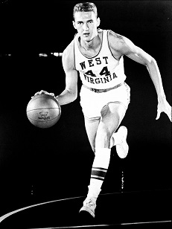 | #6 Jerry West Nicknames: "Zeke from Cabin Creek",  "Mr. Clutch", and “The Logo”  Guard Height = 6’2” Weight = 175  West Virginia 1958-1960 (3) – Team record = 81-12  G = 93 : PPG = 24.8 : RPG = 13.3 : FG% = 50.8 : FT% = 73.2  In the 1958–59 season, West was the leading scorer and rebounder in every West Virginia game, including getting 28 points and 11 rebounds in a 71–70 loss to California in the NCAA final. West was named Most Outstanding Player of that year's Final Four. A two-time All-American, West and Oscar Robertson co-captained the U.S. men's basketball team at the 1960 Summer Olympics and won the gold medal.  Little known Fact: That is Jerry West’s silhouette you see on NBA logo. Number 44 West was my favorite player during my basketball playing days.

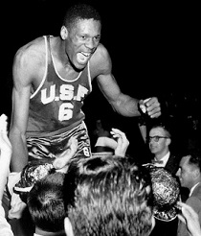 | #5 Bill Russell Nickname: “Lord of the Rings”  Center Height = 6’9” Weight = 215  San Francisco 1954-1956 (3) – Team record = 71-8  G = 79 : PPG = 20.7 : RPG = 20.3 : FG% = 51.6 : FT% = 55%  Russell led the University of San Francisco to two consecutive NCAA championships (1955, 1956). He also won a gold medal at the 1956 Summer Olympics as captain of the U.S. national basketball team. He is considered to be the best rebounder and defensive player in college (and pro) history. Russell was also a 2-time All-American and 2-time NCAA Player of the Year.  Little known Fact: Russell was ignored by college recruiters and did not receive a single letter of interest until the University of San Francisco (USF) offered him a scholarship.

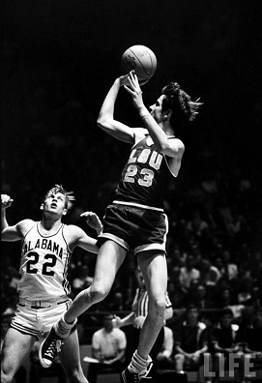 | #4 “Pistol” Pete Maravich  Guard Height = 6’5” Weight = 197  Louisiana State (LSU) 1968-1970 (3) Team record = 49-35  G = 83 : PPG = 44.2 : RPG = 6.5 : FG% = 43.8 : FT% = 77.5  In 3 years playing at LSU, Maravich scored 3,667 points while averaging 43.8, 44.2 and 44.5 points per game. In his college career, he averaged 44.2 points per game in 83 contests and led the NCAA in scoring each season. Pistol Pete was a 3-time All-American and a 2-time NCAA Player of the Year.  Little known Fact: It is calculated that if the NCAA had the 3-point line when Pistol Pete played, he would have averaged thirteen 3-point scores per game, lifting his career average to 57 points per game. On January 5, 1988, Pete Maravich collapsed and died at age 40 of heart failure while playing in a pickup basketball game.

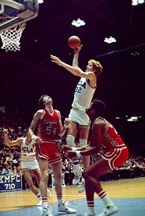 | #3 Bill Walton Nickname: “The Big Redhead”  Center Height = 6’11” Weight = 210  UCLA 1972-1974 (3) – Team record = 86-4  G = 87 : PPG = 20.3 : RPG = 15.7 : FG% = 65.1 : FT% = 64.2  The Coach John Wooden/Bill Walton-led UCLA team had two consecutive 30–0 seasons and were a big part of UCLA's NCAA men's basketball record 88-game winning streak. Walton's performance in the 1973 title game, in which he missed just one of 23 shots in route to 44 points, is considered one of the greatest individual efforts in college history. Walton was a three-time All-American and Player of the Year.  Little known Fact: Walton played with severe back and foot pain for most of his adult playing career.

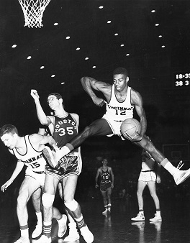 | #2 Oscar Robertson Nickname: The “Big O”  Forward Height = 6’5” Weight = 205  Cincinnati 1958-1960 (3) – Team record = 79-9  G = 88 : PPG = 33.8 : RPG = 15.2 : FG% = 53.5 : FT% =78%  The “Big O” stands atop the Bearcats' record book - he still holds the record for points in one game, 62; career triple-doubles, 10; career rebounds per game, 15.2; and career points, 2,973. Robertson had a scoring average of 33.8 points per game, the third highest in college history. In each of his three years, he won the national scoring title, was named an All-American, and was chosen College Player of the Year, while setting 14 NCAA and 19 school records.  Little known Fact: Robertson's high school team won two state championships and 45 straight games. Robertson himself was named All-State three times.

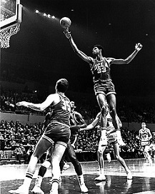 | #1 Lew Alcindor Nickname: "The Big Fella"  Center Height = 7’2” Weight = 225 Jersey #33  UCLA 1967-1969 (3) – Team record = 88-2  G = 90 : 26.4 PPG – 15.5 RPG : FG% = 64.0 : FT% = 63.0  Lew Alcindor played for coach John Wooden, contributing to the team's three-year record of 88 wins and only two losses. Lew Alcindor had the greatest college basketball career in history:  - UCLA won three NCAA championships  - Three times the NCAA Final Four Most Outstanding Player  - Three times the National college player of the year  - Three times a Consensus first team All-American  Little known Fact: The dunk was banned in college basketball after the 1967 season, primarily because of Alcindor's dominant use of the shot. It was not allowed again until 1976.

Here is a quick statistical summary and a few “Big Drifter” awards for these 44 great players:
- There are no “one and done” players on my list and only a few (Wilt Chamerlain, Magic Johnson, Larry Johnson, and Glenn Robinson) that played only two years.
- Most of these great college players played back in my day (the 1950’s, 1960’s, 1970’s, and 1980’s) when student athletes went to college for four years with the intention of graduating. The only player on my list to play in the 2000’s is J.J. Redick. The only players still playing in the NBA are Redick and Tim Duncan.
- Most of these great players played for three years because freshman were not allowed to play varsity basketball from 1954 until 1972. Colleges had both freshman and varsity teams during this period.
- 28 of the players are black and 16 are white. There are 19 forwards – 13 centers – 12 guards.
- Lew Alcindor (AKA Kareem Abdul-Jabbar) had the greatest career (personal and team) success of any player. Bill Walton, also from UCLA, had the next greatest success.
- Oscar Robertson was the best all-around college player ever. He still holds the record for most career triple doubles with 10. He was the all-time career leading NCAA scorer (33.8) until Pistol Pete Maravich come along with an average of 44.2 points per game.
- Bill Russell was the greatest rebounder and defensive player ever. He is also the only college player to average over 20 points and 20 rebounds a game over his college career.
- “Pistol” Pete Maravich was the greatest scorer, passer, and dribbler in college basketball history.
- List of players to average 30 or more points in their college careers:
Pistol Pete Maravich  Bill Bradley  Elgin Baylor | Oscar Robertson  Larry Bird  Rick Mount | Elvin Hayes  Austin Carr  Calvin Murphy
- List of players to average 35 or more point in a season: Pistol Pete Maravich (3 times), Oscar Robertson, Rick Barry, and Billy McGill.
- List of players to score 60 or more point in a game: Pistol Pete Maravich (10 times), Calvin Murphy, Oscar Robertson, Lew Alcindor, Austin Carr, Rick Mount, and Billy McGill.
- Best 3-point shooter was J.J. Redick who made 457 of them shooting 40.6%. He was also the best free throw shooter (over 90%) for his career.
- List of players to grab over 1500 rebounds during their college careers: Tom Gola, Bill Russell, Elvin Hayes, Tim Duncan, and Ralph Sampson.
- List of players to average more than 20 rebounds in a season: Bill Russell, Elgin Baylor, and Jerry Lucas.
- Leading one game rebounders: Elgin Baylor (37) and Wilt Chamberlain (36).
- Jerry West and Larry Bird were probably the best shooters. The Big Drifter award for best “Clutch” shooter goes to #44 Jerry West.
- David Thompson could jump the highest.
- Wilt Chamerlain was the most dominate and the best overall athlete.
- Ralph Sampson was the tallest.
- Calvin Murphy was the shortest.
- Jerry Lucas and Bill Bradley were probably the smartest.
- Bradley was the only superstar to play his college career without a scholarship.
- My best college coach award is a tie – John Wooden and Mike Krzyzewski.

College basketball rules have changed a lot over the years. Here are some that had the greatest effect on the game and the players:
1944-1945 Defensive goal tending is banned.
Five personal fouls disqualifies a player; no extra foul is permitted.
Unlimited substitution is allowed.
Offensive players cannot stand in the free throw lane for more than 3 seconds.
1954-1955 College freshman are ineligible for playing varsity basketball.
The one-and-one free throw is introduced allowing a player to take a second free throw if the first one is made.
1954-1955 Games are changed from 10 minute quarters to two 20 minutes halves.
1956-1957 The free throw lane is increased from 6 feet to 12 feet.
1956-1957 Grasping the rim is ruled unsportsmanlike conduct.
1957-1958 Offensive goaltending is now banned.
1967-1968 The dunk is made illegal during the game and during warm-ups.
1972-1973 An official can charge a technical foul on a player for unsportsmanlike conduct if the official deems the player 'flopped' to get a charging call.
1972-1973 Freshman are now eligible to play varsity basketball.
1976-1977 The dunk is made legal again.
1981-1982 The jump ball is eliminated except for the start of the first and second half, and overtime if necessary. An alternating arrow will indicate possession of the ball in jump-ball situations in a game.
1982-1983 When a closely guarded player is guarded for 5 seconds, a jump ball is no longer required. Instead a turnover is created and the ball goes to the other team.
1983-1984 Two free throws are issued if a foul occurs in the last two minutes of a half or in overtime.
1985-1986 The 45 second shot clock is introduced.
1985-1986 If a shooter is intentionally fouled and the basket is missed, the shooter will get two free throws and the team will get possession of the ball.
1986-1987 A three point shot was introduced at 19'9".
1987-1988 Each intentional personal foul carries two free throws and the team possession of the ball.
1990-1991 Beginning with the teams 10th foul in a half, two free throws are to be awarded for each personal foul.
1990-1991 Three free throws are awarded when a shooter is fouled from three point range and misses the shot.
1993-1994 The shot clock is reduced from 45 seconds to 35 seconds.
1997-1998 Timeouts can be made by players on the court or the head coach.
2006-2007 A timeout will not be recognized by an airborne player falling out of bounds.
2008-2009 Three point arc extended to 20' 9".
2008-2009 Referees may use instant replay to determine if a flagrant foul has been committed and who started the incident.

Some thoughts on student-athlete issues:
- Athletes (that are good enough) should be able to go straight from high school to the pros. Why waste everybody’s time and money for one or two years in college if there is no intention to graduate?
- Athletes who don’t meet the college entrance requirements should not be given a special exemption to attend a university just because they are good at sports.
- All scholarships should be issued for four years. Coaches should not be able to take away your scholarship just because they found a better player.
- College players should not belong to a union or be paid extra money to play football or any other sport. Athletes in all sports (women and men) should be treated equally and going to college should not be considered a job.
- All student-athletes should be happy to have a scholarship to help pay for their college education. They are no better or no worse than the other students attending the university.
- There should be a pay limit for coaches. Coaches should not make more money than the university president or be the highest paid public employee in the state.
- Where is all the money going that the NCAA tournaments bring in? Especially basketball and football. This money should be going back to the universities general fund to help all students and not in some “fat cat’s” pocket.

I wish they would have had the 3-point shot when I played basketball. I liked to shoot from all-over the court.

bigdrifter44@gmail.com

