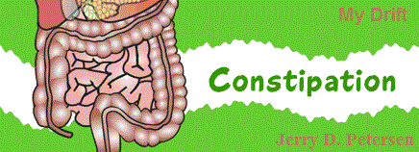

 | Constipation  10 September 2014 | 184-2014-13

In my last article we talked about pain. Well, here is another cheery subject – constipation. I’ve finally reached the stage in my life where I’m experiencing both of these conditions on a semi-regular basis. I’m waking up in the morning with a stiff and sometimes painful lower back. Every 2 or 3 months, I have a problem with constipation that causes me to feel uncomfortable for a few days. So, in this article, I’m going to find out what causes constipation, the symptoms, how to treat it, and the best way for me to stay regular. But before we get into the constipation details, let’s refresh our memories on how our digestive system is supposed to work.

My wife has baked a pumpkin pie and it has just come out of the oven. Just the sight and smell of it are enough to make me start salivating. I’m also thinking about that pecan ice cream we have in the freezer. There is nothing better than pumpkin pie with 3 or 4 scoops of pecan ice cream on top. Even before I have taken a bite, my digestive system has swung into action. After the first morsel enters my mouth, the many organs of my digestive tract kick into high gear. Here's a look at how our digestive system works, from top to bottom.

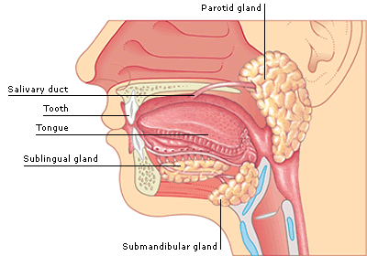 | Mouth and salivary glands  After you take the first bite of pie, your salivary glands produce saliva — a mixture of secretions that help lubricate and break down food. Besides the salivary glands in the lining of your mouth, you have three pairs of larger salivary glands — the parotid, sublingual and submandibular glands. You produce about 2 pints of saliva a day. As you savor the bite of pie, your teeth work to break it down while your tongue mixes it with saliva. This action transforms it into a soft, moist, rounded mass called bolus that is suitable for swallowing.

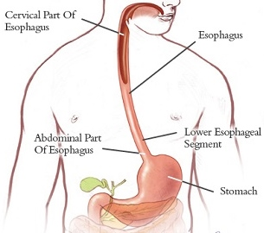 | Throat – Esophagus - Stomach  As you swallow the bite of pie, muscles in your mouth and throat propel it to your upper esophagus, the tube that connects your throat to your stomach. Muscles in the wall of your esophagus create synchronized waves — one after another — that propel the pie into your stomach. In this process, muscles behind the bolus of pie contract, squeezing it forward, while muscles ahead of it relax, allowing it to advance without resistance. When the bolus reaches the lower end of your esophagus, pressure from the food signals a muscular valve — the lower esophageal sphincter — to relax and let the food enter your stomach.

After entering your stomach, the pie and ice cream are broken down further. With its powerful muscles, the stomach begins churning and mixing the food into smaller and smaller pieces. Your digestive glands in your stomach lining produce stomach acid and enzymes, which mix with the food to form a murky semifluid or paste called chyme. Once the chyme is well-mixed, waves of muscle contractions propel it through a valve called the pylorus into the first section of your small intestine (duodenum).

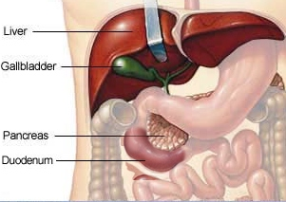 | Pancreas - Liver - Gallbladder  In your duodenum, the digestion continues as chyme from the stomach mixes with a variety of digestive juices from your pancreas, liver and gallbladder:  - The pancreas produces digestive enzymes that help break down proteins, carbohydrates and fats.  - The liver produces bile, a solution that helps you digest fats.  - The gallbladder stores bile. As fatty food enters the upper portion of your small intestine (the duodenum), the gallbladder squeezes bile into the small intestine through the bile ducts.

Small intestine
As bile and pancreatic digestive juices mix with other juices secreted by the wall of your small intestine, digestion continues. What was once pumpkin pie and ice cream is propelled into the second portion of your small intestine, the jejunum. Here it's further broken down
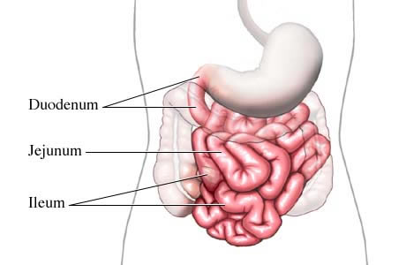 | into smaller molecules of nutrients that can be absorbed. Then it moves into the final and longest portion of your small intestine — the ileum — where virtually all of the remaining nutrients are absorbed through the lining of the ileum's wall.  What remains of the food when it reaches the end of the ileum is a combination of water, electrolytes — such as sodium and chloride — and waste products, such as plant fiber and dead cells shed from the lining of your digestive tract.

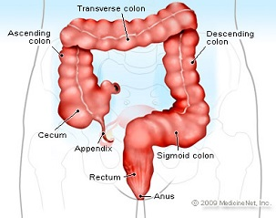 | Large intestine – Colon – Rectum - Anus  As this residue passes through the colon, nearly all of the water is absorbed, leaving a usually soft but formed substance called stool. Muscles in the wall of your colon separate the waste into small segments that are pushed into your lower colon and rectum. As the rectal walls are stretched, they signal the need for a bowel movement.  When the sphincter muscles in your anus relax, the rectal walls contract to increase pressure. These coordinated muscle contractions expel the stool.

That pumpkin pie and pecan ice cream was sure good while it lasted.

That is how your digestive system works but sometimes things don’t go so smoothly and you don’t have a bowel movement for several days. This condition is very common among seniors - it is called constipation.

What is constipation?
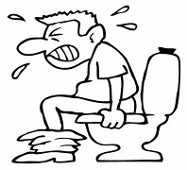 | Constipation is defined medically as fewer than three stools per week and severe constipation as less than one stool per week. Chronic constipation is infrequent bowel movements or difficult passage of stools that persists for several weeks or longer. The number of bowel movements generally decreases with age. Most adults have bowel movements between three and 21 times per week, and this would be considered normal. The most common pattern is one bowel movement a day (seven per week), but this is the case seen in less than half of all seniors.

What are constipation symptoms?
- Passing fewer than three stools a week
- Straining to have bowel movements
- Having lumpy or hard stools
- Feeling as though you can't completely empty the stool from your rectum
- Lower abdominal discomfort or bloating
- Needing help to empty your rectum, such as using a finger to remove stool from your rectum
- Anal bleeding or fissures from the trauma caused by hard stools
- Aggravation, bleeding, or swelling of your hemorrhoid veins
- Psychological distress and/or obsession with having bowel movements
- And lastly, sitting on the toilet for long periods of time  Constipation may be considered chronic if you've experienced two or more of the above symptoms for at least three months. Causes of chronic constipation include:  - Blockages in the colon or rectum  - Bowel obstruction  - Narrowing of the colon  - Colon or rectum cancer  - Problems with the nerves around the colon and rectum  - Difficulty with the muscles involved in stool movement  - Conditions or diseases that affect a person’s hormones | 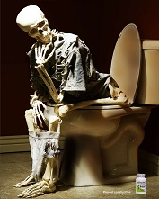
Here are some of the causes for occasional constipation:
- Just being a senior increases your risk
- Eating a diet that's low in fiber
- Getting little or no physical activity
- Being dehydrated
- Taking certain medications such as medicine to lower blood pressure

When should a person go to the doctor? If you have chronic constipation, you should talk to your doctor about it.

Your doctor may recommend one or more of the following tests and/or procedures used to diagnose chronic constipation:
- Examination of the rectum and lower colon (sigmoidoscopy). In this procedure, your doctor inserts a lighted, flexible tube into your anus to examine your rectum and the lower portion of your colon.
- Examination of the rectum and entire colon (colonoscopy). This diagnostic procedure allows your doctor to examine the entire colon with a flexible, camera-equipped tube.
- Evaluation of anal sphincter muscle function (anorectal manometry). In this procedure, your doctor inserts a narrow, flexible tube into your anus and rectum and then inflates a small balloon at the tip of the tube. The device is then pulled back through the sphincter muscle. This procedure allows your doctor to measure the coordination of the muscles you use to move your bowels.
- Evaluation of how well food moves through the colon (colonic transit study). In this procedure, you'll swallow a capsule containing markers that show up on X-rays taken over several days. Your doctor will look for signs of intestinal muscle dysfunction and how well food moves through your colon.
- An X-ray of the rectum during defecation (defecography). During this procedure, your doctor inserts a soft paste made of barium into your rectum. You then pass the barium paste as you would stool. The barium shows up on X-rays and may reveal a prolapse or problems with muscle function and muscle coordination.

To tell you the truth, I don’t like the sound of any of these tests!!

Constipation treatments and drugs include:
- Increase your fiber intake
- Get more exercise
- Don't ignore the urge to have a bowel movement
- Laxatives
- Prescription medications such as lubiprostone (Amitiza) or linaclotide (Linzess) that draw water into your intestines to speed up the movement of stool
- Surgery

I hope to control my occasional constipation using the top three treatments on this list.

Is colon cleansing a good thing to do?
I tried a colon cleansing product once but I’m not sure it did any good or not. The theory behind colon cleansing is the belief that undigested meat and other foods cause mucus buildup in the colon. This buildup produces toxins which can enter the blood's circulation, poisoning the body. Colon cleansing companies say that it improves health by removing toxins, promoting healthy intestinal bacteria, boosting your energy and enhancing your immune system. Well, both the Mayo Clinic and WebMD state that it is very unlikely that poisonous toxins can get into the blood stream from the colon. They go on to say that there is little evidence that colon cleansing produces any of these desired effects. In fact, colon cleansing can sometimes be harmful. It can increase your risk of dehydration, lead to bowel perforations, and increase the risk of infection. No more colon cleansing for me!

The other most common digestive system problem is diarrhea. No, I’m not going to discuss the “runny” details of diarrhea in this article - maybe later. But one thing for sure, I’m definitely going to look for a more uplifting subject for my next article.

bigdrifter44@gmail.com

