 | My Drift | Jerry D. Petersen | Fruits and Vegetables  December 18, 2013  (171-2013-21)

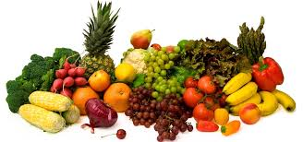

The U.S. Department of Agriculture (USDA) and other food experts recommend that we all eat 8 to 10 servings of fruits and vegetables every day. That’s 4 or 5 servings of fruit and 4 or 5 servings of vegetables. You need to use a little common sense on what constitutes a serving. For example, one banana or one apple or one cup of cherries equals a serving of fruit – one-half cup of cooked vegetables or two cups of leafy lettuce equals a serving. That seems like an awful lot of fruit and vegetables to be eating in one day. I might eat that much in a week if we count the V8 juice I drink once in a while. And I’m not alone since several surveys find that the average American eats about one-half cup of vegetables and one cup of fruits per day.

These “so-called” food experts say we need all these fruits and vegetables to stay healthy. Here are some of the health benefits:
- Eating a diet rich in vegetables and fruits as part of an overall healthy diet may protect against certain types of cancers.
- Diets rich in fiber (most vegetables and fruits) may reduce the risk of heart disease, stroke, obesity, and type 2 diabetes. Vegetables and fruits don’t contain any cholesterol.
- Eating vegetables and fruits rich in potassium (like Bananas, Potatoes, Beans, and Spinach) as part of an overall healthy diet may lower blood pressure, reduce the risk of developing kidney stones and help to decrease bone loss.
- Vegetables and fruits are lower in calories than most other foods so they may help to lower your weight.
- Fruits and vegetables are good sources of many essential nutrients that are under-consumed, including potassium, dietary fiber, vitamin C, and folic acid.

Raw vegetables contain a lot of nutrients which help you maintain a healthy body. Vegetables play a vital role in our diets, as they support the normal functioning of the different body systems. They do so by providing our cells with vitamins, minerals, fiber, essential oils and phytonutrients. While eating cooked vegetables is healthy for you, in certain instances it is advantageous to eat raw vegetables. This is because cooking destroys essential nutrients such as vitamin C and also kills vital enzymes that help your body to digest food.

Okay, I agree that most fruits and vegetables are good for you. But, do you really have to eat like a rabbit to stay healthy? I’m 73 years old and have no major health issues. How is this possible with my eating habits? If large volumes of fruits and vegetables are required in order to stay healthy, I should have kicked the bucket a long time ago. So, the purpose of this article is find out more about the benefits of fruits and vegetables to help me determine if I should start eating more of them.

There are about two thousand different types of vegetables and about two thousand different types of fruits in the world. I’m only going to talk about some of the ones I eat or have heard of. On the next page is an alphabetical list of these fruits and vegetables.

Some of my favorite fruits include:
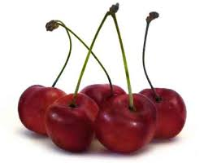  Cherries | 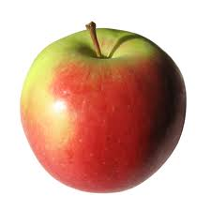  Apple | 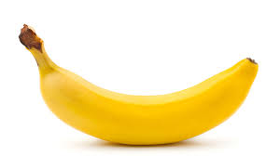  Banana | 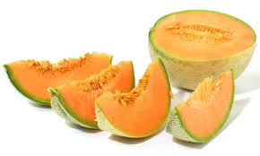  Cantaloupe
Some of my favorite vegetables include:
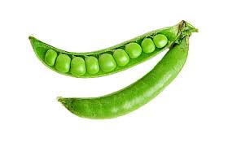  Peas | 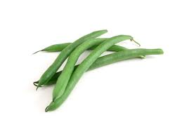  Green Beans | 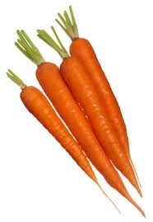  Carrots | 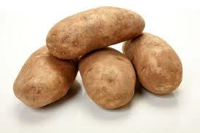  Potatoes

Some of my favorite fruit and vegetable juices include:
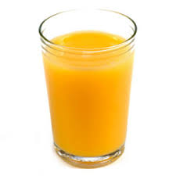  Orange | 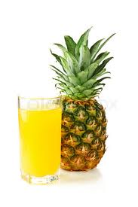  Pineapple | 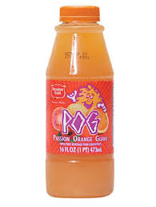  POG | 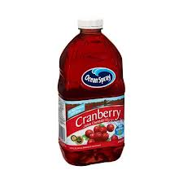  Cranberry | 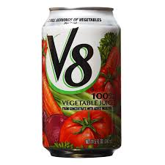  V8
COMMON FRUITS AND VEGETABLES (THAT I RECOGNIZE)
FRUITS | VEGETABLES
Apple  Apricot  Avocado  Banana  Berry (Blackberry, Blueberry, Boysenberry,  Cranberry, Elderberry Goji berry,  Gooseberry, Huckleberry, Mulberry,  Raspberry, and Strawberry)  Breadfruit  Cantaloupe  Currant  Cherry  Coconut  Date  Eggplant  Fig  Grape (Red, White, and Puple)  Grapefruit  Guava  Kiwi fruit  Kumquat  Lemon  Lime  Lychee  Mandarin  Mango  Melon (Honeydew, Japanese, Korean, and  *Watermelon)  Nectarine  Olive  Orange  Papaya  Passion fruit  Peach  Peppers (Bell and Chili)  Pear  Persimmon  Plum/Prune  Pineapple  Pomegranate  Star fruit  Tangerine | Artichoke  Asparagus  Beans (Black Green, Kidney, Lima, Navy,  Pinto, and Soy)  Beet  Bok choy  Broccoli  Cabbage  Carrots  Cauliflower  Celery  Chard  Collard greens  *Corn  *Cucumber  *Eggplant  Garlic  Herbs and spices  Jalapenos  Lettuce  Mushrooms  Mustard greens  Onion  Peas  Parsley  Parsnip  *Peppers (Green, Red, and Yellow)  Potato  Pumpkin  Rhubarb  Radish  Spinach  Sprouts (Alfalfa, Bean, and Brussels)  *Squash  Sweet potato  Taro  *Tomato  Turnip  Water chestnut  Watercress  Yam  *Zucchini
*These fruits and vegetables may be listed in the wrong column.
The Fruits in red and the vegetables in green are the ones I like to eat in one form or another.

Fruit or Vegetable? What is the definition?
According to botanists who study plants, a fruit is the part of the plant that develops from a flower. It's also the section of the plant that contains the seeds. The other parts of plants are considered vegetables. These include the stems, leaves and roots — and even the flower bud. Fruits are usually sweet and juicy and are eaten as a dessert or snack. A Vegetable is the edible part of a plant such as the root of the beet, the leaf of spinach, or the flower buds of broccoli or cauliflower. Vegetables have no seeds and are less sweet. They are usually eaten as part of our regular meals.

Another determining factor is how fruit and vegetables are used in cooking (culinary) and how different cultures prepare them. Technically speaking, all of the vegetables listed in the above chart with an asterisk are fruits – not vegetables. But, since we treat them as vegetables, I’m not going to change the list and I will think of them as vegetables. For example, the yellow corn kernels are really a fruit but the rest of the corn (husk and cob) are vegetables. Most people know that a tomato is actually a fruit but it is eaten as a vegetable. Let’s face it, if they can put it on your sandwich at Subway, it has got to be a vegetable.

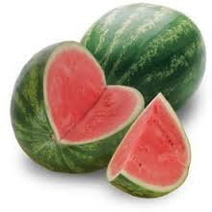 | We all know that watermelon is a fruit, right? It has seeds, it is sweet and juicy and is eaten as a dessert. It will always be a fruit in my book regardless of what the people in Oklahoma say. Yes, the watermelon is the state vegetable of Oklahoma. I think all those tornadoes have screwed up their leader’s brains. Actually, in some cultures, they throw away the red juicy part and fry up the rinds like vegetables. These people are also crazy! I think watermelon is delicious – the red part. Just for the record, the state fruit of Oklahoma is the strawberry.

Some health experts want to re-classify the potato as a starch and not as a vegetable. They say that you cannot count the potato as one of your 8 to 10 servings a day. I say that potatoes are good for you and I could (and do) eat them for breakfast, lunch, and dinner. I never did listen to the health experts – if you did everything they say, you will probably die from worrying about getting all those vegetables they say you must eat every day.

The difference between fruits and vegetables often overlap and, in many cases, come down to cultural distinctions. Nutritionally speaking, fruits and vegetables are very similar. So, if you think a food item is a vegetable or a fruit - that is what it is - period.

Okay, let’s face it, you cannot live on fruits and vegetables alone. We all need to eat a balanced diet which means getting the right types and amounts of foods and drinks to supply nutrition and energy for maintaining body cells, tissues, and organs, and for supporting normal growth and development. The Food Pyramid Chart on the next page shows the different food groups and how many servings of each per day the average person needs in order to stay healthy. If my arithmetic is correct, they say we need between 15 and 26 serving of these food items every day – and that doesn’t even include your big bowl of ice cream every night.

The Food Pyramid
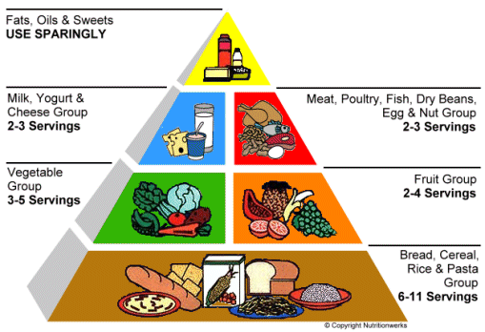

Some food experts state that you should eat 5 or 6 small meals a day instead of 3 normal ones. Again, I don’t agree with the experts - I think that we should reduce the number of meals we eat every day instead of eating more. Two meals and 2 snacks a day should be enough for anybody. A big breakfast, a snack for lunch, an early normal sized dinner, and a late night dessert is just right. I think that people who eat all day long are putting an extra strain on their digestive system and other organs – plus they will probably get fat no matter what they are eating.

Okay, the Food Pyramid structure looks good to me and I only have a few suggested changes to the food groups and servings:
- Since bread and beer would fall into the large bottom group, 12 servings a day should be sufficient.
- Since I count potatoes and V8 juice as vegetables, 3-5 servings a day is good.
- Now days I get most of my fruit from some kind of fruit juice – one bottle of 100% juice a day should be good enough.
- I like milk and cheese, so 2-3 servings a day is good.
- I have eggs for breakfast and some kind of meat for breakfast and dinner so 3-4 servings is good.
- I think that we should all treat our self to one or two desserts every day.

The average “moderately active” adult female needs about 2000 calories of food/drink intake a day and a male needs about 2400 calories. My theory is - if you find yourself getting too skinny, eat more food. If you find yourself gaining weight and getting fat, eat less food and get more exercise. Set a reasonable weight for your size, age, and gender, and then try to stay within 5 or 6 pounds of that goal. You need to figure out how many calories you need to eat in order to maintain this weight. This is not rocket science - it is not that hard to do. In my case, I have never been on a diet and have weighed about 230 pounds my entire adult life. I wouldn’t mind losing a few pounds in my old age - like going down to around 220 pounds to reduce the stress on my back and knee joints. Oh, oh, I just looked at the ideal weight chart that the health experts publish and they say a medium frame 6’4” man should weigh about 180 pounds. I’m bordering on being obese! I haven’t weighed 180 pounds since junior high school. I think you need a little meat on your bones in order to stay healthy. These experts must be making these weight charts for African Marathon runners!

You hear some people complaining about hardly eating anything and still putting on weight. I don’t buy this for a second – you cannot possibly get fat without eating too much food! Then you see other people load their plates up with “local” food and then order a diet soda so they can lose weight. Remember – moderation is the “key” to the amount of food and drinks you should consume each day.

I do have some strange eating habits and my ideas or theories on what to eat and how to stay healthy might be wrong but they seem to work for me. I’m going to list some of these below. I know that most of you (I do have about 10 regular readers) will disagree with many of my statements but that is okay. I think:
- Beer is good for you. I’m pretty sure that you could live longer on just beer than you would just eating fruits and vegetables. One thing for sure – the beer drinker would be much happier!
- Salt is good for you. People who cut out all the salt in their diets may have low blood pressure but it doesn’t matter since they will be dead soon. I have researched and wrote about the benefits of water and salt - Sodium enforces the osmotic needs of the fluid environment outside and around the cells of the body and is vitally important to the brain. Salt is not bad for you and it does not raise blood pressure unless taken in massive doses. I like to eat salt right out of the shaker with my beer.
- Water is the most important thing you need in order to stay healthy and alive. Water plays an important role in preventing many health conditions and ailments such as heart disease, stroke, infection, asthma, allergies, high blood pressure, diabetes, back pain, headaches, gout, depression, sleep disorders, lack of energy, obesity, various addictions, osteoporosis, leukemia, attention deficit, bad memory, skin problems and constipation. We all need 6 to 8 glasses of water a day.
- Too much soda (especially diet) and those “energy drinks” are bad for you. I think you get more energy from a candy bar than from one of those little bottles of 5-hour Energy. I prefer to drink water, juice, and beer.
- Cooked vegetables taste better and are safer to eat than raw vegetables. Every day millions of people in the world get sick from eating raw vegetables that have harmful bacteria and dangerous toxins on it. At home you can wash your fruits and vegetables thoroughly but when eating out – who knows?
- The best raw fruits and vegetables that I can remember eating are the peas in the garden and the cherries on the two trees at my parent’s house while growing up in Pleasant Grove, Utah.
- The number of different food items I like to eat is very limited. I’m not a very adventurous eater and I don’t try too many new and different kinds of food. I pretty much still eat the same food I ate growing up in Utah. Since I have traveled all over the world while in the Navy and working for the Federal Government, this is one area where I wished I was a little better eater.
- I’m a fussy eater! I don’t like mustard, ketchup, mayonnaise, or any kind of salad dressing. Yes, I like to eat everything plain. When I order a hamburger at a fast food restaurant, I special order just the burger and the bun – nothing else. If possible, I will put butter on the bun and a little black pepper on the burger. When I eat a sandwich at Subway, I usually get the “Cold-cut Combo” with American cheese, lettuce, and onion. Nothing else and I always request that they don’t cut my sandwich in half since they don’t clean the knife very good and I can taste the “nasty” stuff from the previous sandwich.
- Taking a multivitamin every day is good for you – especially if you are a poor eater like me. Since I don’t eat enough fruits and vegetables, I need to get my vitamins somehow. I currently take one Centrum Silver 50+ Men’s multivitamin a day.
- Intermittent Fasting (missing a few meals here and there) is a healthy choice. Like I mentioned before, eating all day long (extra meals) is not good for you. Giving your body organs and digestive system a rest might actually be beneficial. Researchers conducted a study with two groups of rats. The first group had food and water every day and the other group got their food taken away every third day. The result: the second group of rats lived twice as long as the “fat” rats in the first group. I rest my case!
- Regardless of your eating habits, we all need regular exercise. I have been playing sports or taking a daily walk my whole life. I think that getting some exercise is more important than what you eat in the big game of life (staying healthy and living longer). Keeping up with my two Rottweiler dogs is doing wonders for my current exercise program.

So, should I start eating more fruits and vegetables? Yes, I probably should but I probably won’t because I’m too old and too set in my ways to change now.

bigdrifter44@gmail.com

http://bigdrifter.com/

