My Drift Jerry D. Petersen
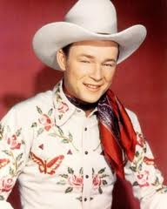  Roy Rogers | 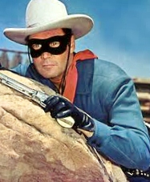  The Lone Ranger | 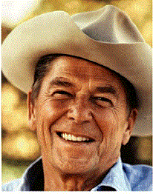  Ronald Reagan | 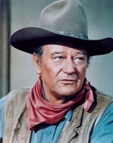  John Wayne | 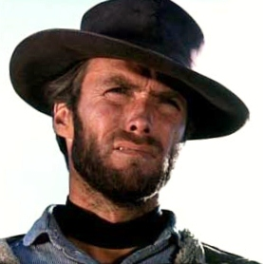  Clint Eastwood

 | Men’s Hats  August 31, 2011 | 1441108

I was recently reading an article in a magazine about baseball 60 years ago and it showed several pictures of the people in the stands. I found it interesting to see how baseball fans dressed back in the old days. Most of the men in the stands wore suits and ties and had hats on their heads – and these hats were not baseball caps. Then it hit me – hey, I was 11 years old when these pictures were taken. What in the world would I have been wearing if I had attended a baseball game back then? Who knows since I didn’t attend a professional baseball game until I was much older. But, I’m sure it would not have been a suit!

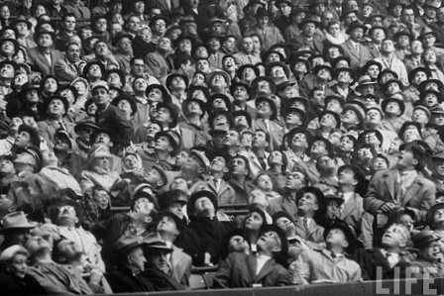 | 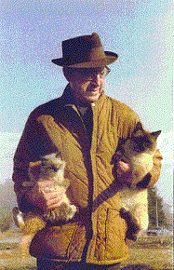 | 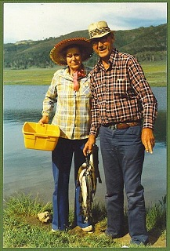
Fans at a 1951 Baseball Game | My Dad with our Cats | Mom and Dad Fishing

Then I got thinking about the hats my dad used to wear. I’m pretty sure he had at least three hats – one for working – one for fishing and hunting – and one for going out. His work and fishing hats are shown above. Nobody back then wore baseball caps and now it is the most popular hat in the world.

HAT QUIZ: See how many of the 40 hats you can identify on the next page.
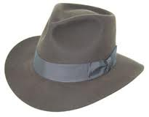 |  | 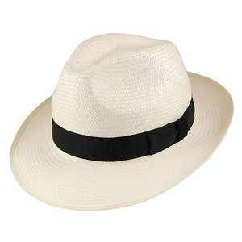 | 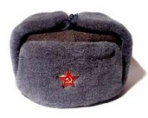 | 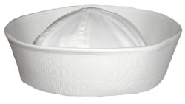 |  | 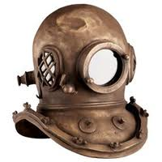
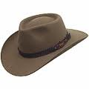 |  | 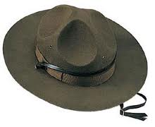 | 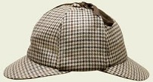 | 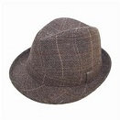 |  | 
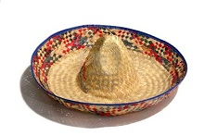 |  | 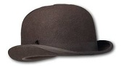 | 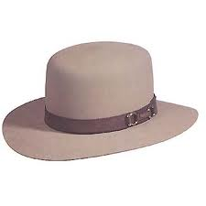 | 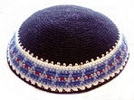 |  | 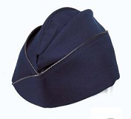
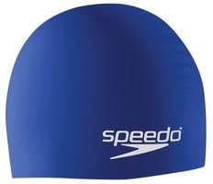 |  | 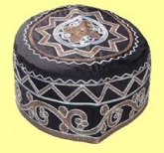 | 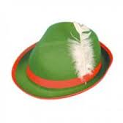 | 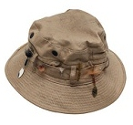 |  | 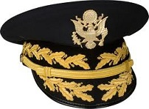
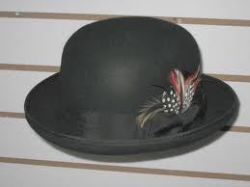 |  | 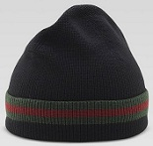 | 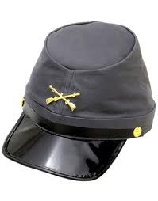 | 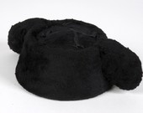 |  | 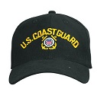
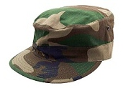 | 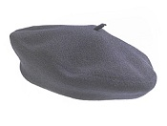 |  | 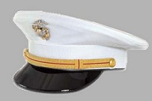 | 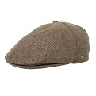 | 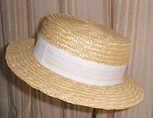
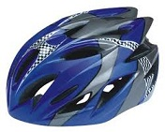 | 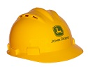 |  | 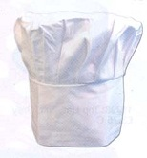 | 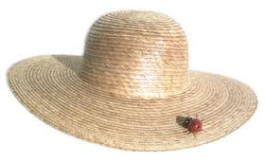 | 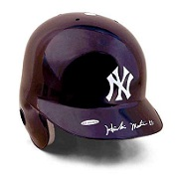
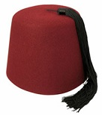 | 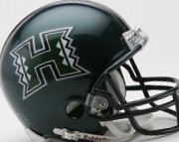 |  | 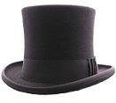 | 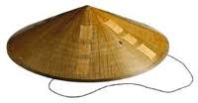 | 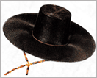
Here are the answers to the HAT QUIZ with a short description of each:
1. Fedora - A fedora is a men's felt hat that is typically creased lengthwise down the crown and pinched in the front on both sides. The fedora was popular from the early 1920s to the mid-1960s in the United States. By-the-way, this is the type of hat my dad used to wear.
2. Panama - A Panama hat is a traditional brimmed hat of Ecuadorian origin that is made from the plaited leaves of the toquilla straw plant. The hats are woven in Ecuador and like many other 19th and early 20th century South American goods, were shipped first to Panama before sailing for their destinations in Asia, the Americas and Europe. The Panama seems to be one of the few hats to survive the test of time. Many men world-wide can still be seen sporting a Panama.
3. Ushanka or Russian - An Ushanka (Literally meaning "ear hat”) is a Russian fur cap with ear flaps that can be tied up to the crown of the cap, or tied at the chin to protect the ears, jaw and lower chin from the cold. The thick dense fur also offers protection against blunt impacts to the head should the wearer fall and hit his or her head against the ice or packed snow.
4. Sailor - The white hat worn today originated in the 1880's as a low, rolled brim item made of wedge shaped pieces of canvas. Canvas material was replaced by cotton as a cheaper, more comfortable material. During World War II this navy hat was dubbed the “Dixie-cup” because it resembled the paper cup of the same name.  On the right is a picture of me in my Navy Uniform taken in 1965. | 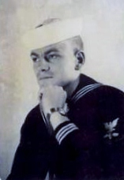
5. Diver’s Helmet - German-born inventor Augustus Siebe, known as the father of diving, invented the Diving Helmet in the year 1837. The helmet seals the whole diver's head from the water, allows the diver to see clearly underwater, provides the diver with breathing air, protects the diver's head when doing heavy or dangerous work, and usually provides voice communications with the surface (and possibly other divers).
6. Akubra or Australian – The Akubra or Australian bush hat whose wide-brimmed styles are a distinctive part of Australian culture. The name is derived from an Aboriginal word for head covering. Akubra hats are made from rabbit fur and usually have drawstrings to help keep them on the wearer's head on windy days.  On the right is a picture of golfer Greg Norman in his Akubra Shark Hat. | 
7. Campaign or Ranger - The origins of this hat can be traced to the 1840s when army troops posted in the west took to wearing civilian hats which were far more practical than the Kepis hat. The hat picked up the Campaign title during an African campaign in 1896. This hat is still popular with Army Drill instructors, the New Zealand Army, the Royal Canadian Mounted Police, Boy Scout Leaders, and the Utah Highway Patrol.
8. Deerstalker - A Deerstalker is a type of hat that is typically worn in rural areas, often for hunting, especially deer stalking. The most famous wearer of this kind of hat was the fictional character Sherlock Holmes.
9. Trilby - A trilby hat is a type of hat that is distinguished by a very narrow brim that is sharply turned up in the back and a short crown, which is pinched in the front and indented into a teardrop shape in the center. This hat has remained popular with both sexes into the 2010s. A notable wearer of the trilby was Frank Sinatra.
10. Mortarboard or Academic - The square academic cap, often called a mortarboard because of its similarity in appearance to the hawk used by bricklayers to hold mortar. The cap, together with the gown, is the customary uniform of a university graduate.
11. Sombrero - The Sombrero is a wide-brimmed hat originating in Mexico. In Spanish, the word "sombra" means "shade". The extra-wide brim is broad enough to cast a shadow over the head, neck and shoulders of the wearer. It usually has a chin string to hold it in place. The Mexican sombrero has become a national and cultural symbol and is used in traditional Mexican celebrations, especially by communities outside Mexico.
12. Bowler or Derby - The bowler hat, also known as a derby, is a hard felt hat with a rounded crown originally created in 1849 in England. The bowler hat was popular with the working class during the Victorian era.
13. Boss of the Plains - John B. Stetson Hat Company was born in 1865 and a year later the "Hat of the West" or the now famous "Boss of the Plains" hat was born and the name Stetson was on its way to becoming the primary maker of cowboy hats.
14. Kippah - A kippah is a hemispherical or platter-shaped head cover, usually made of cloth, often worn by Orthodox Jewish men to fulfill the customary requirement that their head be covered at all times.
15. Air Force Cap – Part of the US Air Force uniform since 1947.
16. Swimming Cap - Swim Caps are made of tightly fitted silicone or latex that hugs the skull of its user, providing cover for his or her hair. This reduces drag in the water caused by loose hair. Some facilities require the wearing of swim caps, in order to protect filters from becoming clogged with loose hairs. Caps are also used to keep the hair relatively dry or free from chlorinated water.
17. Kufi – A kufi cap is a brimless, short, rounded cap worn by many populations in West Africa. It is worn by Christians, Muslims, and African Jews.
18. Tyrolean or Bavarian - The Tyrolean or Bavarian is a hat named for the Tyrol in the Alps. These hats are made of felt with a cord wrapped around the base of the crown and a feather or brush on the side as trim.
19. Bucket or Fishing - A bucket or fishing hat is a soft cotton hat with a wide and downwards sloping brim which is worn by both men and women. The brim offers shade from the sun for the eyes and face.  Pictured is an unknown person wearing a Bucket Hat. | 
20. General – Military General’s hats typically have leaf-shaped embellishments (scrambled eggs) on the visors.
21. Homburg - A homburg is a felt hat characterized by a single dent running down the center of the crown and a brim fixed in a tight, upwards curl. It was popularized by Edward VII after he visited Brad Homburg in Hesse, Germany. In formality, the homburg ranks just below the top hat.
22. Tuque or Ski Cap - A tuque or ski cap is a knitted cap, originally of wool though now often of synthetic fibers, that is designed to provide warmth in winter.
23. Kepi - In the United States, the Kepi is most often associated with the American Civil War era (Union Soldiers), and continued into the Indian Wars.
24. Montera or Bull Fighter – This is the hat that bullfighters wear.
25. Coast Guard – Enlisted Coast Guard working cap.
26. Army – Informal Army hat.
27. Beret - The Beret is a soft, round, flat-crowned hat, usually of woven or hand-knitted wool or wool felt or acrylic fiber. The modern beret is derived from the traditional hat of Pyrenean shepherds in France and Spain. Berets are worn as part of the uniform of many military and police units worldwide.
28. Marine – Dress hat of U.S. Marines.
29. Gatsby or Newsboy Cap - This cap is a casual-wear cap similar in style to the flat cap but the body of the cap is rounder, fuller, and paneled with a button on top.
30. Boater - The Boater is made of straw and is a kind of men's formal summer hat.
31. Cycling Helmet - Helmet is designed to lessen impacts to the skull of a cyclist in falls while minimizing side effects such as interference with peripheral vision. A cycle helmet is light in weight and provides ample ventilation.
32. Hard Hat - A hard hat is predominantly used at construction sites to protect the head from falling objects.
33. Toque or Chef - The chef's hat (Toque - French for "white hat") has been around for more than 400 years. Interesting fact: The taller the hat and the more pleats it has means a higher status symbol in cooking world.
34. Garden – Wide brimmed straw hat designed to protect wearer from the sun while working in the yard or garden.
35. Batting Helmet - A batting helmet is the protective headgear worn by batters in the game of baseball or softball. It is meant to protect the batter's head from errant pitches thrown by the pitcher. Major League Baseball made helmet mandatory in 1971.
36. Fez – The Fez is a felt hat in the shape of a short cylinder and it usually has a tassel. Originally, a Greek headgear fashionable among the inhabitants of the Aegean Islands, it was widely adopted in the Ottoman Empire in the early 19th century as a symbol of religion, progress and modernity.
37. Football Helmet – American football players wear protective head gear to reduce the chance of injury. The first “head harness” was invented in 1896. The “leather helmet” started being used in 1915. The football helmet was not a mandatory piece of equipment in college ball until 1939 and it was not made mandatory in the National Football League until 1943. The plastic helmet was made legal in 1949 and this was the beginning of the end for leather helmets. In 1955, the face mask which was a single bar design was first used. In 1976, because of concern for safety, four point chin straps were required in college ball. These kept the helmet firmly in place. Space age rigid Polycarbonate alloy plastic helmets and vinyl coated steel alloy face masks were the norm by the 1980's.  Pictured on the right (top) is my 1958 Pleasant Grove High School football picture. Notice that we had no face masks back then. Pictured below me is my son Mike who played offensive line for the University of Hawaii from 1992-1996. | 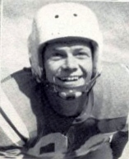  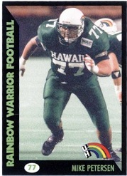

38. Top Hat - A Top Hat is formal silk hat with a cylinder or chimney looking top. It was predominantly worn from the latter part of the 18th to the middle of the 20th century. Now, it is usually worn only as a fashion statement. The top hat is associated with the upper class.  Fred Astaire often wore a Top Hat during his dance routines. | 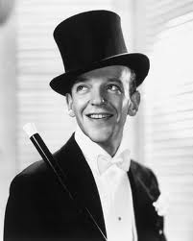
39. Conial Asian - This simple style of conical hat originated in East and Southeast Asia, particularly Indonesia, Vietnam, China, Japan and Korea. It is kept on the head by a cloth (often silk) chin strap and also has an internal band of the same material that keeps the hat itself from resting on the wearer's head. This style of hat is used primarily as protection from the sun and rain.
40. Gat - Traditional Korean hat worn by men.

As you can see, there are a lot of different men’s hats. In this article, I’m only looking at 43 different types of men’s hats. There are actually hundreds of hats for men and I’m not even looking at the many hats for women. Two hats not pictured in my little quiz are the Cowboy Hat and the Baseball Cap.

Cowboy Hats are pictured at the top of this article. The concept of a broad-brimmed hat with a high crown worn by a rider on horseback can be seen as far back as the Mongolian horsemen of the 13th century. Today it is worn by many people - ranch workers in the western and southwestern United States, western Canada and northern Mexico, along with country-western singers, and for participants in the North American rodeo circuit. It is recognized around the world as part of Old West cowboy lore. The tall crown provides insulation and the wide brim provides shade. In many hot, sunny climates, these hats evolved to have even wider brims like the sombrero of Mexico. Yes, the Cowboy Hat is my favorite hat.

The Baseball Cap is the most popular hat in the world. A baseball cap is a type of soft cap with a long, stiff brim that may either be curved or flat. The front of the cap typically contains designs or logos of sports teams. The back of the cap may be "fitted" to the wearer's head size. Since 1900, the baseball cap has been part of the traditional baseball uniform. Now days, the cap is often seen in everyday casual wear.  Yes, that is me again wearing a UH Football “Baseball” Cap. | 

Inquiring minds are probably wondering what that 43rd type of hat is??  Well, if you didn’t get at least 20 hats correct on the Hat Quiz, please put on the “Dunce Hat” and go stand in the corner for an hour. | 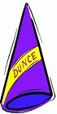
Why do people wear hats? I think we have learned that a hat is a head covering worn for protection against the elements, for ceremonial or religious reasons, for safety, or as a fashion accessory. In the past in the U.S. and still in many countries, hats are an indicator of social status. In the military, they may denote nationality, branch of service, and rank.

A hat may consist of six main parts:
• Crown, the portion of a hat covering the top of the head.
• Visor or Bill, a stiff projection at the front, to shade or shield the eyes from sun and rain.
• Brim, an optional projection of stiff material from the bottom of the hat's crown horizontally all around the circumference of the hat
• Hatband, a ribbon or band that runs around the bottom of the crown above the brim.
• Sweatband, the strip of leather (or sometimes ribbon) attached to the inner circumference of the hat to stop sweat from soiling the main body of the hat.
• Lining, for some hats there is a silk lining, often bearing the maker's name and label.

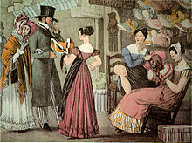 | Companies that make hats are called hat makers or hatters. People who design and make hats are called milliners. One of the first hat makers is pictured on the left - It is called The Paris Millinery and it was established in 1822. There is a lot of physical proof that people were wearing hats way before this. I guess back then, people had to go out and kill a bear and make their own hats. The most famous hat makers of our day are James Lock & Co of St James's Street in London and John B. Stetson is a well-known American hat company that made cowboy hats.

You are now a hat expert!! Sorry, make that an expert on men’s hats. I almost forgot that there are a lot more women’s hat types then men. Someday I may attempt to do an article on women’s hats just to be fair.

bigdrifter44@gmail.com

http:// bigdrifter.com/

