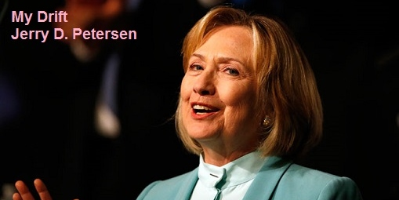

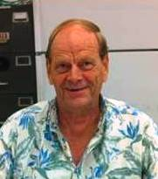 | Hillary Rodham Clinton  4 May 2015 | 201-2015-08

On April 12, 2015, Hillary Rodham Clinton became the first Democratic candidate to enter the 2016 presidential election by declaring “I’m running for president” in a video pitch aimed at the middle class. “Everyday Americans need a champion, and I want to be that champion,” she said. The video prominently features a black couple expecting a child, a young Asian-American woman, and two men who say they are getting married. It also shows plenty of the white, working-class people who were crucial to her previous White House bid and signals that she intends to make helping the middle class and reducing income inequality major themes of her campaign.

I think that the only person in America that would make a worse president than Barack Hussein Obama is Hillary Rodham Clinton!! So, the above announcement didn’t exactly trill me. But to be fair, I decided to do a little research and report what I found out in this article – the good, the bad, and the ugly. If you are a big fan and supporter of Hillary and don’t want to read anything bad about her, you can stop reading now.

This article runs a little long but contains a lot of information you need to know about Hillary Rodham Clinton. Article is broken up into five sections:

1. BIO 2. Scandals 3. Rumors 4. Death Pool 5. Secret Service Views
Hillary Diane Rodham Clinton BIO

BIO – the Early Years
She was born Hillary Diane Rodham on October 26, 1947, in Chicago, Illinois. She was raised in Park Ridge, Illinois, a suburb of Chicago. Hillary was the firstborn child of Hugh Rodham, a prosperous fabric store owner, and Dorothy Emma Howell Rodham; she has two younger brothers, Hugh Jr. (born 1950) and Anthony (born 1954).

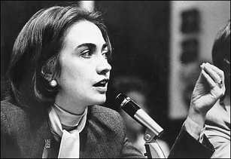 | As a young woman, Hillary was active in young Republican groups and campaigned for Republican presidential nominee Barry Goldwater in 1964. She was inspired to work in some form of public service after hearing a speech in Chicago by the Reverend Martin Luther King Jr., and became a Democrat in 1968.

Hillary attended Wellesley College in Wellesley, Massachusetts, where she was active in student politics and was elected senior class president before graduating in 1969. She then attended Yale Law School, where she met Bill Clinton. After graduating with honors in 1973, she went on to enroll at the Yale Child Study Center, where she took courses on children and medicine and completed one year of post-graduate study.

During her summers as a college student, Hillary worked at a variety of jobs. In 1971, she first came to Washington, D.C. to work on U.S. Senator Walter Mondale's subcommittee on migrant workers. In the summer of 1972, she worked in the western states for the campaign of Democratic presidential nominee George McGovern. In the spring of 1974, Rodham became a member of the presidential impeachment inquiry staff, advising the Judiciary Committee of the House of Representatives during the Watergate scandal. After President Richard M. Nixon resigned in August, she became a faculty member at the University of Arkansas, School of Law in Fayetteville, where her Yale classmate and boyfriend Bill Clinton was teaching as well.

BIO - Marriage to Bill Clinton
Hillary married Bill Clinton on October 11, 1975, at their home in Fayetteville. Before their engagement, Bill secretly purchased a small house that Hillary had once remarked that she liked. When he proposed marriage to her and she accepted, he revealed that they owned the house. Their daughter, Chelsea Victoria, was born on February 27, 1980.

In 1976, Hillary worked on Jimmy Carter's successful campaign for president while husband Bill was elected attorney general of Arkansas. Bill Clinton was elected governor of Arkansas in 1978 at age 32, lost reelection in 1980, but came back to win in 1982, 1984, 1986 (when the term of office was expanded from two to four years) and 1990.

BIO - First Lady
Hillary joined the Rose Law Firm in Little Rock and, in 1977, was appointed to part-time chairman of the Legal Services Corporation by President Carter. As first lady of Arkansas for a dozen years, she chaired the Arkansas Educational Standards Committee, co-founded the Arkansas Advocates for Children and Families, and served on the boards of the Arkansas Children's Hospital and the Children's Defense Committee. The National Law Journal named her one of the 100 most powerful lawyers in America.

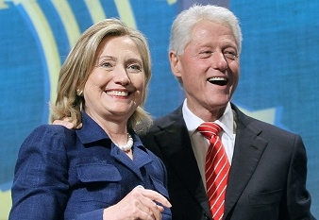 | During Bill Clinton's 1992 presidential campaign, Hillary emerged as a dynamic partner, and during his subsequent presidency, she took on far more than the traditional role of the first lady. In 1993 Bill selected her to head the Task Force on National Health Care Reform. The controversial commission produced a complicated plan that never came to the floor of either house. It was abandoned in September 1994. It was a failure.

Hillary also used her influence as first lady to support various women's causes. Working with then attorney general Janet Reno, in 1995 she helped create the “Violence Against Women” Office in Department of Justice, and working with then secretary of state Madeline Albright she traveled extensively to nations around the world to promote equal rights for women. But Hillary's tenure as first lady was not without its controversies and scandals. We will talk about these later in this article.

BIO - Senate and First Presidential Bid
With her husband limited to two terms in the White House, Hillary Clinton decided she would seek the U.S. Senate seat from New York, held by outgoing Democrat Daniel Patrick Moynihan, who was retiring after four terms. Despite early problems, and charges of carpet bagging, Clinton beat popular Republican Rick Lazio by a surprisingly wide margin - 55 percent to 43 percent. When she was sworn in on January 3, 2001, Clinton became the first wife of a president to seek and win national office and the first woman to be elected to the U.S. Senate from New York. During her first term, she picked up where she left off, devoting her efforts to health care and children's and women's rights.

In 2006, she easily won reelection to a second term in the Senate. Early the following year, however, she announced plans to make a new addition to the list of firsts on her political résumé—to be elected the first female president of the United States. After beginning her campaign as the front-runner for the nomination during the Democratic primaries, she was eventually edged out by Barack Obama in June 2008 and ended her campaign several days later. Obama won the general election that November.

BIO - U.S. Secretary of State
Shortly after winning the U.S. presidential election, Barack Obama nominated Hillary Clinton as secretary of state. She accepted the nomination and was officially approved by the Senate as the 67th U.S. secretary of state on January 21, 2009. During her tenure as secretary of state, Clinton used her position to make women's rights and human rights a central talking point of U.S. initiatives. She became one of the most traveled secretaries of state in American history and promoted the use of social media to convey the country's positions.

But as was the case during her time as first lady, in 2012 Clinton faced scandal once again, when the State Department came under investigation following a deadly attack on a U.S. diplomatic post in Benghazi, Libya, that killed U.S. ambassador Christopher Stevens and three others. An independent panel issued a report about the Benghazi attack, which found "systematic failures and leadership and management deficiencies" at the State Department.

BIO - Benghazi Testimony and Resignation
Clinton's testimony on the Benghazi attack came on January 23, 2013. Speaking to members of the House Foreign Relations Committee, she tried to defend her actions but failed to convince anybody that she took the proper actions during this attack. She officially stepped down from her post at the State Department on February 1, 2013. More on the Benghazi terrorist attack later in this article.

Hillary Clinton has been pretty quiet until her recent announcement to run for president in 2016.

BIO - Hillary Clinton’s Accomplishments
- She was the First lady of Arkansas while her husband served as the governor.
- She was the First lady of the United States while her husband served as the president.
- She is regarded as the most empowered First Lady except for Eleanor Roosevelt.
- She has served two terms as a US Senator and ran for the presidential office in 2008.
- She has worked hard in favor of creating a universal health care plan.
- Her failed health care plan laid the ground work for what we have today, the Affordable Healthcare Act – Obamacare.
- She played a leading role in the development of State Children’s Health Insurance Program.
- She was instrumental in the creation of the Adoption and Safe Families Act and the Foster Care Independence Act.
- She helped create the office on Violence Against Women.
- She was instrumental in working out a bi-partisan compromise to address civil liberty abuses for the renewal of the U.S. Patriot Act.
- She was the most-traveled Secretary of State in history - visiting 112 countries during her four-year tenure.

Hillary Clinton Scandals

As Hillary Clinton begins her run up to the 2016 presidential election, we the American voting public would do well to use our brains for a moment and recall the many scandals that Hillary created during her years married to Bill.

“How fortunate for governments that the people they administer don’t think.” — Adolph Hitler

Health-Care Gate
In 1997, federal judge Royce Lamberth levied $286,000 in sanctions against Bill Clinton’s administration for “running amok” in a “cover-up” of Hillary Clinton’s health-care task force. The scandal began when deputy White House counsel Vincent Foster made contradictory assertions about the first lady’s job status, in an attempt to keep the work of the task force secret. Foster later committed suicide, and a Secret Service agent saw Hillary Clinton’s chief of staff, Margaret Williams, carry boxes of papers out of Foster’s office before investigators showed up to seal it.

File Gate
The confidential FBI files of up to 900 former Reagan and Bush appointees were sent over to White House security chief Craig Livingstone. Deputy White House counsel William Kennedy, a close friend of Hillary Clinton’s from their days at the Rose Law Firm, would frequently call up the FBI and have someone’s files sent over on his say-so.

Then–FBI director Louis Freeh called it “an egregious violation of privacy.”

Cattle-Futures Gate
Hillary Clinton came under scrutiny when, during her tenure as first lady of Arkansas when she managed to turn a $1,000 investment in cattle futures into a profit of nearly $100,000 in only nine months. She claimed she had learned how to trade by reading the Wall Street Journal.

Travel Gate
Catherine Cornelius, a 25-year-old cousin of Bill's was allegedly promised the position of director of the travel office. Hillary Clinton then (indirectly) fired seven employees from the White House travel office and replaced them with associates from Arkansas. Records were either nowhere to be found or incorrectly filed. And, there's a reported attempt to give a White House airline contract to a friend. Hillary had the FBI investigate Billy Dale, the head of the travel office, ruining his career, who was found to have done nothing wrong, but was then audited by the IRS for three years after.

"Billy Dale and his family went through hell thanks to the Clintons, Attorney General Janet Reno, the FBI and the IRS," A White House staff member wrote. "Hillary's greatest crime was not perjury, it was trying to send an innocent man to prison to justify having fired him and all of his staff without cause."

“A memorandum by a former Presidential aide depicts Hillary Rodham Clinton as the central figure in the 1993 travel office dismissals, a politically damaging episode that the aide said had resulted from a climate of fear in which officials (including the FBI) did not dare question Mrs. Clinton's wishes."

“Billy Dale was escorted out of the White House by the FBI, put into a paneled van with no seats and told to sit on the floor the day the Clintons removed him,” Linda Tripp vividly recalled. “And I watched Hillary orchestrate that whole thing; siccing the FBI on them.” “Get them the f*** out of here” screamed Hillary.

The abrupt travel office firings were triggered by what the Clinton White House claimed were allegations of sloppy accounting. In December 1994, Billy Dale was indicted on two counts of embezzlement. He was found innocent of all charges. In its aftermath, five of the staffers were reinstated, and in a self-critical report, the White House admitted it “erred and would never again short-circuit proper legal channels by bypassing the Justice Department in seeking an FBI investigation.”

The late New York Times columnist Bill Safire concluded after Travelgate, that Hillary Clinton was “a congenital liar, ruthless, and also lawless.”

Whitewater Gate
The tangled web of Bill and Hillary Clinton’s Whitewater real-estate dealings in Arkansas prompted Attorney General Janet Reno to appoint a special prosecutor to investigate.

Jim McDougal, a Clinton business partner who went to jail over Whitewater, famously described the Clintons as “sort of like tornadoes moving through people’s lives.”

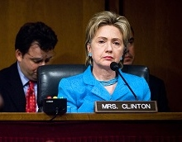 | First led by Robert Fiske, then by Ken Starr, the special prosecutor’s office was deeply disturbed by the lack of candor from the Clintons when they were deposed under oath.

Hickman Ewing, Starr’s deputy, testified in court that after he heard Hillary Clinton say “I don’t recall” some 50 times in one deposition, he gave her an F grade for her truthfulness.

Billing-Records Gate
The records of Hillary Clinton’s clients at the Rose Law Firm in Arkansas were subpoenaed for years by investigators looking into Whitewater. They were finally discovered on a coffee table in her private quarters at the White House. No one ever explained how they got there.

In March 2008, as Hillary Clinton was running for president, Jerry Zeifman — the chief counsel to the House Judiciary Committee at the time of Nixon’s impeachment and a lifelong Democrat — expressed his profound disappointment with her work on the committee. Among her transgressions were lying, removing files from the committee offices without permission, and arguing that Nixon shouldn’t be allowed any legal counsel before the committee.

“I terminated her employment on the Nixon impeachment staff,” Zeifman said. “My only regret was I had not reported her unethical practices to the appropriate bar associations. I could not recommend her for any subsequent position of public or private trust.”

The Monica Lewinsky Scandal
The Lewinsky scandal was a political sex scandal emerging in 1998, from a sexual relationship between 49-year-old president Bill Clinton and a 22-year-old White House employee, Monica Lewinsky. The news of this extra-marital affair and the resulting investigation eventually led to the impeachment of President Clinton in 1998 by the U.S. House of Representatives and his subsequent acquittal on all impeachment charges of perjury and obstruction of justice in a 21-day Senate trial.

This relationship became public after Monica confided details to her friend and Defense Department co-worker Linda Tripp, who secretly recorded their telephone conversations. Tripp gave the tapes to Kenneth Starr, the Independent Counsel who was investigating Clinton in the Paula Jones case and on other matters, including the Whitewater scandal, the White House FBI files controversy, and the White House travel office controversy.

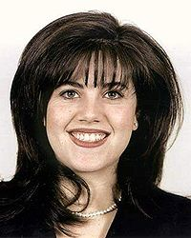 | Lewinsky claimed to have had sexual encounters with Bill Clinton on nine occasions from November 1995 to March 1997. According to her published report, First Lady Hillary Clinton was at the White House for at least seven of those times.

China Gate
The Clinton-Gore campaign in 1996 allegedly took bribes from Chinese banks and their government to help their dwindling poll numbers. The Chinese embassy in D.C. helped siphon funds into the Democratic National Committee (DNC). Secretary of Commerce Ron Brown (who was killed in a plane crash), and at Hillary’s instruction reportedly sold seats on department trade missions to China. Joint congressional hearings were canceled after Democrats threatened to bring up Republican campaign issues and then the Monica Lewinsky scandal actually saved this scandal from media attention.

Looter Gate
Hillary Clinton started to ship White House furniture to their personal home in Chappaqua, N.Y. The Clintons claimed they were donated to them, but only some were proven to be donated and they were meant to stay in the White House. The Clintons returned some of the furniture after pressure was put on them to do so.

Broke Gate
In an interview with ABC’s Diane Sawyer, Hillary Clinton claimed her and Bill were 'dead broke' when they left the White House - despite having more than a million dollars in assets and both charging six figures for speeches. Most Americans would love to be ‘dead broke’ like poor old Hillary and Bill.

Drug Dealer Donor Scandal
Convicted drug trafficker Jorge Cabrera apparently made such a big donation to the Clinton’s campaign that he was invited to the White house without Secret Service present.

Ponzi Scheme and Political Favor Scandal
Norman Yung Yuen Hsu was a convicted pyramid investment promoter, and major Democratic donor. He contributed an undisclosed amount to Hillary Clinton’s 2008 campaign.

“He was sentenced to more than 24 years in prison in 2009 by a judge who accused him of funding his fraud by manipulating the political process in a way that 'strikes at the very core of our democracy.”

Obama/Clinton Benghazi Scandal
Many people in government believe that the Benghazi cover-up was about two presidential campaigns: Barack Obama’s 2012 reelection campaign and Hillary Clinton’s 2016 presidential campaign.

Why else would Hillary Clinton personally send out lies about Benghazi within hours, and then keep on pushing these lies until the truth could no longer be ignored? The truth about an attack by an al Qaeda group that killed our ambassador and three other brave Americans in the days before Obama’s reelection would not only have put Obama at risk of losing, but also would have potentially dashed the hopes of his successor-in-waiting, Hillary Rodham Clinton.

The desperation by Obama, Clinton, and their political teams must have been potent. It was so potent that they – rather than admitting that they caused an Islamist conflagration in Libya by ousting and killing Gadhafi – preferred to ignore pleas for increased security from Ambassador Stevens; to abandon him and his colleagues to rampaging terrorists; refused to follow up with force against those who attacked us; and to lie to the American people about the nature of the attack. Rather than admit that it was a planned attack by a terrorist group in league with al Qaeda, the Obama/Clinton machine knowingly put out the lie that the killings were the result of a spontaneous demonstration in response to an obscure Internet video supposedly offensive to radical Islamists.

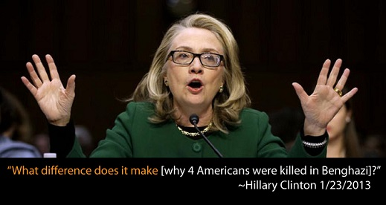

The message: don’t blame us – blame those who offend Islamists (conservatives, Republicans, etc.). Indeed, rather than sending our military to eliminate the enemy in Libya, the Obama administration arrested the poor sap who made the offending video.

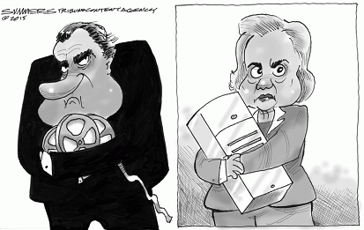

Email scandal
Hillary Clinton has been on the defensive recently over the revelation that she exclusively used a private email account while serving as secretary of state. The 2016 democratic presidential candidate has tried to douse the flames, but several key questions about the controversy remain unanswered.

1. Where are the missing emails? Two months ago, a team of Clinton people combed through a vast stack of her emails – from the period covering 2009 to 2013, when she served as America’s top diplomat. Having reviewed the emails, they handed over 55,000 pages to the State Department. It is believed that there were more than 100 thousand pages on that server.
2. How many pages did she not hand over? More importantly, what did they contain? 50,000 or more pages - Who knows?
3. Who decided which emails to hand over to the state department? Hillary Clinton’s advisors.
4. Where are the missing emails? Were they deleted? Who knows? Probably.
5. Why was email vetting even permitted? Hillary does whatever she wants to do. However, US government rules are very clear on this subject. The National Archives and Records Administration stated categorically that “agencies that allow employees to send and receive official electronic mail messages using a system not operated by the agency must ensure that Federal records sent or received on such systems are preserved in the appropriate agency recordkeeping system.”
6. So, why did senior State Department officials allow Clinton to override clear official rules? Who knows? Hillary does whatever she wants to do.
7. Was this secret server secure? Experts tested it and say, “No”.
We now know that Team Clinton set up its own domain name, ClintonEmail.com, shortly before Hillary Clinton took the job as secretary of state. It was linked to a “homebrew” server at her home in Chappaqua, New York. Experts tested it and said that the security software was nothing special. Hackers could easily get access to this server and steal her emails.
8. Why would Hillary Clinton decide, in effect, to privatize her own official emails? The most likely explanation of her intent seems clear – she created a system designed to avoid accountability, potentially in violation of the law.

Hillary Clinton Rumors

Rumor: Hillary Clinton is a lesbian or bisexual
Hillary became a practicing lesbian at the “all girl” Wellesley College. Later, Hillary entered into a sham marriage with Bill Clinton to cover up the truth. At one point, a former classmate moved to Little Rock to continue an affair with Hillary.

In her autobiography, one time Clinton lover Gennifer Flowers details what Bill told her about Hillary. He said that he had known for a long time that Hillary was attracted to women, and it didn’t really bother him. His first clue came from her lack of enjoyment of sex with him. Sex with her became a duty; nothing more.” Bill went on to say that Hillary had more women brought to the White House for sex than he did. Bill and Hillary lived in separate wings of the White House and did their own thing.

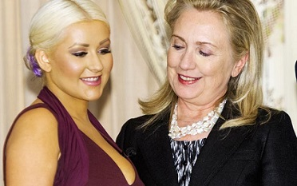 | 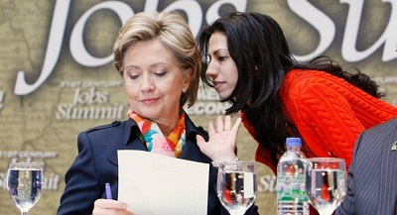
Christina Aguilera has a fan | With top aid and lover Huma Abedin
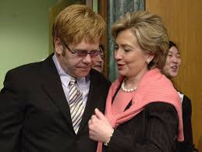 | 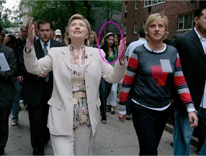
With gay friend Elton John | With lesbian friend Ellen DeGeneris

Rumor: Vince Foster didn't commit suicide
Former Clinton White House chief of staff Vince Foster didn't commit suicide in Virginia's Fort Marcy Park. He died of a gunshot wound to the head. Foster was a colleague of Hillary Clinton at Little Rock’s Rose Law firm and moved to Washington DC with the Clintons. Many insiders say that he was killed because he was having an affair with Hillary Clinton and knew too much about her shady deals.

Rumor: Hit Man Admits To Murdering People on command for the Clintons
Larry Nichols worked for the Clintons for 10 years. On The Pete Santilli Show, he admitted that he had actually murdered people after being ordered to do so directly by Hillary or Bill. I did it for the money and I didn’t care about the women I beat up and the men I murdered. Nichols said the Clintons are bad people, and involved in many dirty, illegal doings.

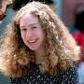 | Rumor: Chelsea Clinton is the biological daughter of Webb Hubbell, NOT Bill Clinton!  That’s the explosive claim of former Clinton aide Larry Nichols – who further claims that Bill confirmed long-standing rumors that Chelsea’s real dad is Webster Hubbell, Hillary’s former law partner and lover in Little Rock, Arkansas.

Rumor: Hillary Clinton is helping create the Muslim Sisterhood
Clinton and top aide and alleged lover Huma Abedin (Muslim wife of ex-Rep. Anthony Weiner (D-N.Y.)) are in cahoots with the ladies' auxiliary of the Muslim Brotherhood.

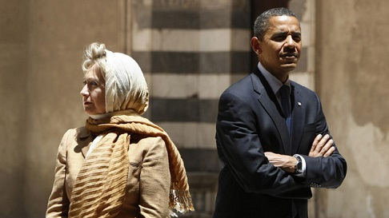
Hillary Clinton with fellow Muslim sympathizer Barack Obama in Cairo
The Clinton Death Pool

Knowing Bill or Hillary Clinton could be dangerous to your health!! The people on the list below had connections with the Clintons and they are now all dead. The current Clinton Death Pool body count is 47 and counting plus there are four others that survived the beatings or attempted murders.

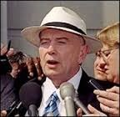  James McDougal | 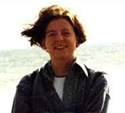  Mary Mahoney | 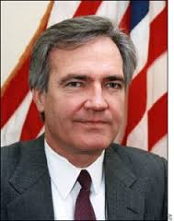  Vince Foster | 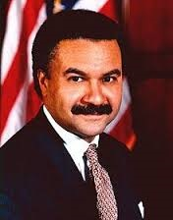  Ron Brown

1. James McDougal - Clinton's convicted Whitewater partner died of an apparent heart attack, while in solitary confinement. He was a key witness in Ken Starr's investigation.
2. Mary Mahoney - A former White House intern was murdered July 1997 at a Starbucks Coffee Shop in Georgetown. The murder happened just after she was to go public with her story of sexual harassment in the White House.
3. Vince Foster - Former deputy White House counsel, and colleague of Hillary Clinton at Little Rock's Rose Law firm. Died of a gunshot wound to the head, ruled a suicide.
4. Ron Brown - Secretary of Commerce for the Clinton administration. Reported to have died by impact in a plane crash. A pathologist close to the investigation reported that there was a hole in the top of Brown's skull resembling a gunshot wound. At the time of his death Brown was being investigated, and spoke publicly of his willingness to cut a deal with prosecutors. The rest of the people on the plane also died. A few days later the air Traffic controller committed suicide
5. C. Victor Raiser II - Raiser, a major player in the Clinton fund raising organization died in a private plane crash in July 1992.
6. Paul Tulley - Democratic National Committee Political Director found dead in a hotel room in Little Rock, September 1992. Described by Clinton as a "Dear friend and trusted advisor".
7. Ed Willey - Clinton fund raiser, found dead November 1993 in the Virginia back woods of a gunshot wound to the head. Ruled a suicide. Ed Willey died on the same day his wife Kathleen Willey claimed Bill Clinton groped her in the oval office in the White House. Ed Willey was involved in several Clinton fund raising events.
8. Jerry Parks - Head of Clinton's gubernatorial security team in Little Rock. Gunned down in his car at a deserted intersection outside Little Rock. Park's son said his father was building a dossier on Clinton. He allegedly threatened to reveal this information. After he died the files were mysteriously removed from his house.
9. James Bunch - Died from a gunshot suicide. It was reported that he had a "Black Book" of people which contained names of influential people who visited prostitutes in Texas and Arkansas.
10. James Wilson - Was found dead in May 1993 from an apparent hanging suicide. He was reported to have ties to Whitewater.
11. Kathy Ferguson - Ex-wife of Arkansas Trooper Danny Ferguson, was found dead in May 1994, in her living room with a gunshot to her head. It was ruled a suicide even though there were several packed suitcases, as if she were going somewhere. Danny Ferguson was a co-defendant along with Bill Clinton in the Paula Jones lawsuit. Kathy Ferguson was a possible corroborating witness for Paula Jones.
12. Bill Shelton - Arkansas State Trooper and fiancée of Kathy Ferguson. Critical of the suicide ruling of his fiancée, he was found dead in June, 1994 of a gunshot wound also ruled a suicide at the grave site of his fiancée.
13. Gandy Baugh - Attorney for Clinton's friend Dan Lassater, died by jumping out a window of a tall building in January, 1994. His client was a convicted drug distributor.
14. Florence Martin - Accountant & sub-contractor for the CIA, was related to the Barry Seal Mena Airport drug smuggling case. He died of three gunshot wounds.
15. Suzanne Coleman - Reportedly had an affair with Clinton when he was Arkansas Attorney General. Died of a gunshot wound to the back of the head, ruled a suicide. Was pregnant at the time of her death.
16. Paula Grober - Clinton's speech interpreter for the deaf from 1978 until her death December 9, 1992. She died in a one car accident.
17. Danny Casolaro – Reporter investigating Mena Airport and Arkansas Development Finance Authority. He slit his wrists, apparently, in the middle of his investigation.
18. Paul Wilcher - Attorney investigating corruption at Mena Airport with Casolaro was found dead on a toilet June 22, 1993 in his Washington DC apartment. Had delivered a report to Janet Reno three weeks before his death.
19. Jon Parnell Walker - Whitewater investigator for Resolution Trust Corp. Jumped to his death from his Arlington, Virginia apartment balcony August 15, 1993. He was investigating the Morgan Guaranty scandal.
20. Barbara Wise - Commerce Department staffer. Worked closely with Ron Brown and John Huang. Cause of death unknown. Died November 29, 1996. Her bruised, nude body was found locked in her office at the Department of Commerce.
21. Charles Meissner - Assistant Secretary of Commerce who gave John Huang special security clearance, died shortly thereafter in a small plane crash.
22. Dr. Stanley Heard - Chairman of the National Chiropractic Health Care Advisory Committee died with his attorney Steve Dickson in a small plane crash. Dr. Heard, in addition to serving on Clinton's advisory council, personally treated Clinton's mother, stepfather and brother.
23. Barry Seal - Drug running pilot out of Mena, Arkansas. His death was no accident – he was murdered.
24. Johnny Lawhorn Jr. - Mechanic, found a check made out to Bill Clinton in the trunk of a car left at his repair shop. He was found dead after his car had hit a utility pole.
25. Stanley Huggins - Investigated Madison Guaranty. His death was a purported suicide and his report was never released.
26. Hershell Friday - Attorney and Clinton fund raiser died March 1, 1994 when his plane exploded.
27. Kevin Ives & Don Henry - Known as "The boys on the track" case. Reports say the boys may have stumbled upon the Mena Arkansas airport drug operation. A controversial case, the initial report of death said, due to falling asleep on railroad tracks. Later reports claim the two boys had been slain before being placed on the tracks. Many linked to the case died before their testimony could come before a Grand Jury. Governor Bill Clinton knew about this and there is evidence that he covered up for those involved.

The following people had information on the Ives/Henry case:
28. Keith Coney - Died when his motorcycle slammed into the back of a truck in July 1988.
29. Keith McMaskle - Died after being stabbed 113 times in Nov 1988.
30. Gregory Collins - Died from a gunshot wound January 1989.
31. Jeff Rhodes - He was shot, mutilated and found burned in a trash dump in April 1989.
33. James Milan - Found decapitated. However, the Arkansas Coroner ruled his death was due to "natural causes".
34. Jordan Kettleson - Was found shot to death in the front seat of his pickup truck in June 1990.
35. Richard Winters - A suspect in the Ives / Henry deaths. He was killed in a set-up robbery July 1989.

The following Clinton bodyguards are dead:
36. Major William S. Barkley Jr.
37. Captain Scott J . Reynolds
38. Sgt. Brian Hanley
39. Sgt. Tim Sabel
40. Major General William Robertson
41. Col. William Densberger
42. Col. Robert Kelly
43. Spec. Gary Rhodes
44. Steve Willis
45. Robert Williams
46. Conway LeBleu
47. Todd McKeehan

The following Clinton associates survived attempted murders and/or beatings:
1. Larry Nichols - Former marketing director of ADFA. Responsible for bringing forth more evidence and witnesses on Clinton corruption than any other source. Very public about his claims against Clinton. He has suffered six beatings and an arrest on trumped up charges.
2. Gary Johnson - Former attorney for Larry Nichols was severely beaten and left for dead.
3. L.J. Davis – A reporter investigating the Clinton scandals - he was attacked in his hotel room and his notes were taken. He survived the beating.
4. Dennis Patrick - Had millions of dollars laundered through his account at Lasater & Co. without his knowledge. There have been several attempts on his life, all unsuccessful.

It is a well-known “joke” around Washington DC that "If you attack the Clintons publicly, make sure all your friends know that you are not planning to commit suicide."

Secret Service Agents Perspective of U.S. Presidents

Below are excerpts from a book by Ronald Kessler called “In The President’s Secret Service,” which was published in 2009. In it, Kessler interviews retired or former Secret Service agents who protected U.S. Presidents from JFK to Obama. I know this is a little bit off of the subject, but I find it very interesting to obtain some insight into the character of the presidents (and first ladies) we have elected since I started voting in 1960.

John Kennedy, codenamed Lancer, was a philanderer of the highest order. Agents assigned to guard President Kennedy quickly realized that he led a double life. The charismatic leader was “a cheating, reckless husband whose aides snuck women into the White House to appease his sexual appetite.”
Jackie Kennedy tried hard to make the people who worked for the First Family feel appreciated. When she learned that the Secret Service agents assigned to them had to work on Christmas, she insisted they bring their families along. She sent handwritten thank-you notes to the White House chef and his staff after every official or formal dinner.

Lyndon Johnson (LBJ), codenamed Volunteer, was “uncouth, nasty and often drunk.” The agent said that after being caught by his wife having sex with a secretary in the Oval Office, Johnson ordered the Secret Service to install a buzzer to warn him. The agent said that Mrs. Johnson was well aware of what was going on.

Richard Nixon, codenamed Searchlight, was a moral man but very paranoid, odd and weird. He had a horrible relationship with his family, and “seemed to have no relationship with his wife, Pat, who was quiet most of the time.”

Agents found President Gerald Ford, codenamed Passkey, to be a “decent man who valued their service.” Betty Ford was a nice person but did suffer from alcoholism but eventually found sobriety and in 1982 founded the Betty Ford Center.

Agents assigned to Jimmy Carter, codenamed Deacon, described Carter as a “moody and mistrustful” person who distanced himself from the agents who were sworn to protect him and his family. Agents were instructed not to speak to President Carter unless he spoke to them first.

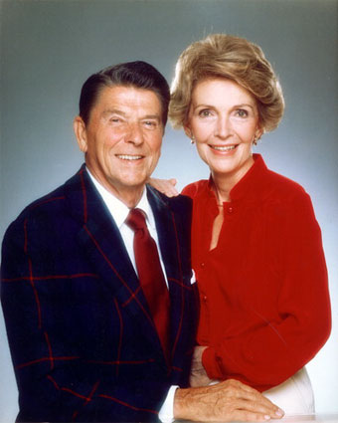 | Ronald Reagan, codename Rawhide, was moral, honest, respectful, and dignified. The Reagan’s treated Secret Service and everyone else with respect and honor. Nancy Reagan was nice but very protective of the President.

George H. Bush, codename Timberwolf, and his wife Barbara were extremely kind, considerate and always respectful towards Secret Service agents. They took great care in making sure the agents’ comforts were taken care of and even brought them meals. Barbara Bush once gave a warm hat to a Secret Service agent while he was protecting the Bush’s at their Kennebunkport home in Maine.

Bill Clinton’s, codename Eagle, term in office was one giant party - he was not trustworthy, adulterous and was only nice because he wanted everyone to like him. Hillary Clinton was another phony whose personality would change the instant cameras or somebody important were near. Hillary treated her staff very badly – she was constantly angry, yelling, swearing, and being sarcastic to everybody around her including Bill. She hated with open disdain the military and the Secret Service.

Hillary Clinton was arrogant and orally abusive to her security detail. She forbade her daughter, Chelsea, from exchanging pleasantries with them. But, sometimes Chelsea, miffed at her mother's obvious conceit and mean spiritedness, ignored her demands and exchanged pleasantries regardless, but never in her mother's presence. Chelsea really was a nice, kindhearted, and lovely young lady. Hillary Clinton was continuously rude and abrasive to those who were charged to protect her life. Her security detail dutifully did their job, as professionals should, but they all loathed her and wanted to be on a different detail.

Hillary Clinton was despised by the Secret Service as a whole. Former President Bill Clinton was much more amiable than his wife. Often the Secret Service would cringe at the verbal attacks Hillary would use against her husband. They were embarrassed for his sake by the manner and frequency in which she verbally insulted him, sometimes in the presence of the Secret Service, and sometimes behind closed doors. Even behind closed doors Hillary Clinton would scream and holler so loudly that everyone could hear what she was saying. Many felt sorry for President Clinton and most wondered why he tolerated it instead of just divorcing his "attack dog" wife. It was crystal clear that the Clinton's neither liked nor respected each other and this was true long before the Monica Lewinsky scandal. Theirs was genuinely a "marriage of convenience."

George W., codenamed Trailblazer, and Laura Bush were loved by the Secret Service. The President was also the most physically “in shape” and had a very strict workout regimen. The Bushes made sure their entire administrative and household staff understood to respect and be considerate of the Secret Service. Laura Bush was one of the nicest First Ladies, if not the nicest ever; she never had any harsh word to say about anyone.

Barack, codename Renegade, and Michelle Obama look down on the Secret Service and hate the military. He is egotistical, cunning and untrustworthy and has temper tantrums. Michelle is a complete bitch, who hates anybody who is not black; hates the military; and looks at the Secret Service as servants.

So, what presidents and first ladies treated the Secret Service and their personal staff the best? Jackie Kennedy, Ronald and Nancy Reagan, George H. and Barbara Bush, and George W. and Laura Bush.

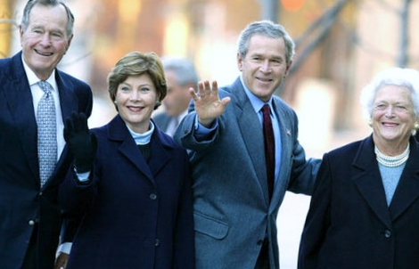
The Bush Presidents with their Wives

What presidents and first ladies treated the Secret Service and their personal staff the worst? Presidents Lyndon Johnson (LBJ), Jimmy Carter, and Barack Obama. First Ladies Hillary Clinton and Michelle Obama.

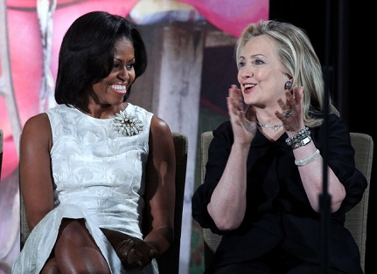
Worst First Lady in U.S. History? – Take Your Pick!

Summary

Hillary Clinton belongs in jail - not back in the White House for another four or eight years! Do we really want Hillary as the Commander and Chief of our military? I learned a long time ago that where there is smoke, there is usually a fire close by – the Clintons have been involved in one scandal after another ever since they entered public service.

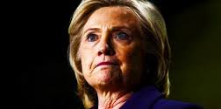  Do we really want to elect this person to be the President of the United States? | - Pathological liar  - Ruthless and lawless  - Involved in one scandal after another  - Treats staff and other people badly  - Hates the military  - Suspected Lesbian or bisexual  - Muslim sympathizer  - Rumored to hire goons to kill foes  - Does whatever she wants to do!

Hillary says that she want to be the champion of everyday Americans. Do you really think Hillary Clinton cares about low and middle class citizens? Hillary only cares about Hillary and gaining more power.

The 2016 presidential election is very important to the future of our country. Go on the Internet and learn about the character of the people running for office. Don’t vote for a candidate just because she or he is a democrat or a republican. Don’t vote for a candidate just because she is a women. Don’t vote for a candidate just because he is tall and handsome. Don’t vote for a candidate just because he or she promises you a bunch of free stuff. Use your brain – let’s elect somebody with good character and morals. Take voting seriously and get out to vote.

Lastly, I have no intention of committing suicide any time soon, so if they find me dead somewhere out in a Wahiawa pineapple field with a bullet in my head, Hillary Clinton is responsible!!

bigdrifter44@gmail.com

