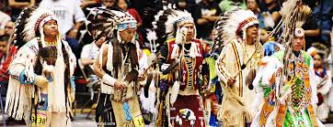

 | My Drift  Jerry D. Petersen  Native American Indians  15 July 2014 | 180-2014-09

Okay, I know that “My Drift” article readers (all 10 of you) are pretty smart. Grab a piece of paper and a pen and write down all of the different Indian tribes you can think of. If you got past 10, you are doing better than most people. Well, here is a fact I bet you didn’t know: There are 565 federally recognized and over 400 non-federally recognized Indian Nations (called tribes, nations, bands, pueblos, communities, rancherias and native villages) in the United States. Almost a thousand Indian tribes!! We are only going to talk about the recognized Indians. Approximately 229 of these tribes are located in Alaska; the other 336 tribes are located in 33 other states. There are only three major Indian tribes in Alaska -the largest tribe with some 12,000 members is the Athabascans who live in the interior part of Alaska near Fairbanks. Alaska Natives are mostly made up of the following cultures: Iñupiat, Yupik, Aleut, Eyak, Tlingit, Haida, Tsimshian, and Eskimo. I don’t think these people are real Indians – they are more like the Native Hawaiians who are not yet federally recognized. There are no Indian tribes in Hawaii! The Indian tribes living in my home state of Utah include the Ute, Paiute, Goshute, Shoshone, and Navajo (about 50,000 Indians).

What are the benefits of being a federally recognized Indian Nation?
“The United States Constitution recognizes that Indian Nations are sovereign governments just like Canada. The Supreme Court, Congress, US Presidents, and hundreds of treaties have reaffirmed that Indian Nations retain their inherent powers of self-government. Treaties and laws have created a fundamental contract between Indian Nations and the United States. The Indian Nations ceded millions of acres of land that made the United States what it is today, and in return received, among other guarantees, the right of continued self-government on their own lands.”

This means the state governments cannot tell the Indian people living on their own land (reservations) what to do. They are not bound by state laws. They are eligible for a number of unique federal programs, including those offered by the Department of Indian Affairs and the Indian Health Services. But mostly, it means they can build casinos on their land and make lots of money.

How many total Indians are there in the U.S.?
There are about 5 million people of Indian ancestry including those of more than one race for about 1.5% of the total U.S. population (which is approximately 314 million).

Which tribes have the most Indians?
Tribe | Population | Tribe | Population
Navajo  Cherokee  Sioux  Chippewa  Choctaw | 308,000  285,500  131,000  116,000  89,000 | Apache  Pueblo  Iroquois  Creek  Blackfeet | 65,000  60,000  48,500  44,000  24,000

Which states have the most Indians? (List of states with over 100,000)
State | Population | State | Population
California  Oklahoma  Arizona  Texas  New Mexico  New York | 627,500  392,000  292,500  215,500  191,500  171,500 | Washington  North Carolina  Michigan  Alaska  Florida | 159,000  132,000  124,500  119,000  118,000

Which states have the most Indian tribes? (I’m not counting Alaska)
State | Tribes | State | Tribes
California  Oklahoma  Washington  New Mexico  Arizona | 106  38  29  23  21 | Nevada  Michigan  Wisconsin  Oregon  South Dakota | 19  14  12  10  10

What tribes have the largest reservations and where are they located?
Reservation Name | Size in Sq. Miles | Location
Navajo Nation  Ute and Ouray  Tohono O’odham  Cheyenne River  Standing Rock  Crow  Wind River | 27,100  6,825  4,454  4,420  3,663  3,607  3,532 | Arizona/New Mexico/Utah  Utah  Arizona  South Dakota  South Dakota/North Dakota  Montana  Wyoming

What are the smallest reservations?
The two smallest reservations are the Seminole Trust Land in Broward County, Florida at 1.3 acres and the Likely Rancheria in Modoc County, California at 1.5 acres.

What is the total land area used by Indian reservations?
Approximately 87,000 square miles or 55,700,000 acres – this is about 2.3% of the total land area of the 48 contiguous states.

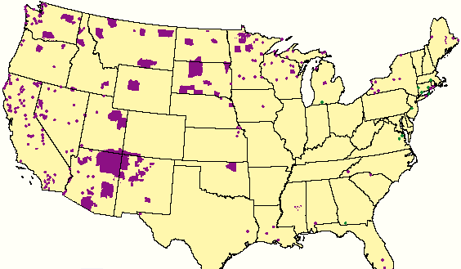
The purple colored areas indicate the locations of the larger Indian reservations

There are 470 Indian gaming or casino operations in the United States. These are owned by 242 of the nation's 565 federally-recognized tribes and operate in 28 of the 50 states. The total annual revenue from Indian gaming is nearing $30 billion – this is more than Las Vegas and Atlantic City combined. The states with the most casinos are:
- Oklahoma has 99 Indian casinos owned by 30 tribes
- California has 68 Indian Casinos and 90 Poker Casinos owned by 62 tribes
- Washington State has 32 Indian casinos owned by 23 tribes
- Arizona has 25 Indian casinos owned by 16 tribes
- Michigan has 19 Indian casinos owned and operated by 14 tribes

The two largest casinos in the World are Indian casinos. Foxwoods Resort Casino is a hotel casino in Ledyard, CT on the Mashantucket Pequot Indian Reservation. A complex of six casinos, the resort covers an area of 4,700,000 sq. feet. The casinos have more than 380 gaming tables for blackjack, craps, roulette, and poker and have more than 6,300 slot machines. There are several restaurants within the casinos, among them, is a Hard Rock Cafe. Foxwoods has 2,266 hotel rooms and a two-story arcade for children and teens. It is now the second largest casino in the World behind the WinStar World Casino in Thackerville, Oklahoma on the Chickasaw Nation reservation. It has over 7,200 electronic games, 46 table poker rooms, 76 table games, Off-track betting, High Limit Room, Keno, and Bingo. The WinStar also features a 27-hole golf course, an RV park with 200-spaces, and a bull riding arena.

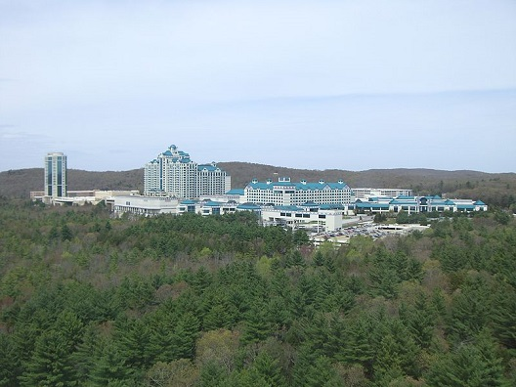 | 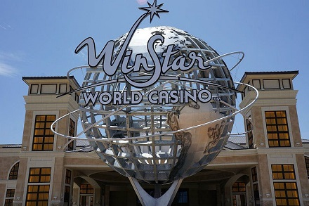
Foxwoods Resort Casino | WinStar World Casino

Alright – enough statistics!! Let’s refresh our memories a little on Native American history and what happened to these people (who were already here) when the “white man” come to North America. It has been mostly very bad!!

The first humans migrated to America from Siberia over 12,000 years ago during the last ice age. This migration was made possible by a land bridge named Beringia that connected North America (Alaska) to Eurasia across what is now the Bering Strait. It is believed that three distinct waves of migration took place across this land bridge. These prehistoric people eventually populated the Americas and formed hundreds of distinct tribes each having their own unique traditions and languages.

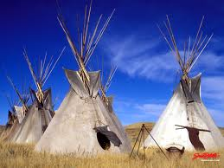 | 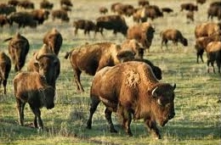
Native American Teepees | Bison (Buffalo) Herd

These Native American tribes lived off the land by gathering food and following herds of Buffalo for meat. The tribes used as much of the animal as they could. Meat was used for food. Furs and skins were used for clothing and shelters. The stomach was used to carry and hold water. Bones were used for needles and weapons. Later in history, they began planting crops and were able establish villages that were permanent. The most important Native American food crop was corn, or what they called maize. Other crops included squash, potatoes, wild rice, tomatoes, sweet potatoes, beans, pumpkins, sunflowers, peanuts, and peppers. Native American tribes also ate a lot of meat including bison (buffalo), caribou, rabbit, deer, elk, salmon, fish, ducks, turkeys, geese, pheasant, porcupines and snakes.

Native Americans did not know about the wheel yet, so they used a travois to transport their goods while following the buffalo herds. A travois was made from two large branches joined to one end and diverging to the other. The travois was attached through harnesses to the back of a horse or a dog. It was dragged on the ground and cargo was place on the skins that was stretched across it.

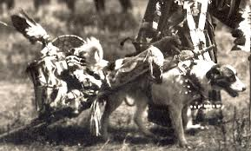 | 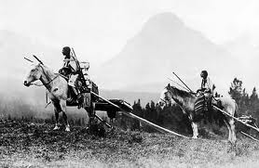

Indian Travois using a Dog and a Horse

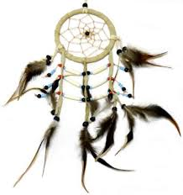  Indian Dream Catcher | These people were very spiritual and they had many religious customs and rituals. They also had many gods and a special relationship with nature. For most, the Sun was the supreme God. They worshiped the sun because they needed it to grow their crops. They also needed rain, so many had a Rain god. Other elements in nature were also worshipped. Most tribes believed in the power of their dreams which they considered to be revelations made by the gods. Most tribes had an important religious leader which some called Shaman, or medicine man, or witch doctor.

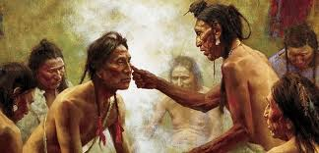
Indian Medicine Man

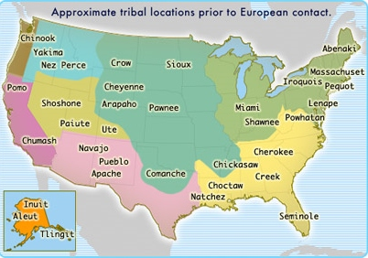

There were about 50 million Native Americans in America at the time of the first European arrivals. They had lived on the land for many, many years before the white man set foot on their soil. Christopher Columbus (an Italian explorer) is credited with discovering American in 1492. Actually, Columbus first landed near the coast of what is today known as Watling Island in the Bahamas. When Columbus got back to Europe, he told everybody about the new land he discovered and many more Europeans followed. Most of the first settlers were from England but it was not long before people from France, Spain, and Portugal begin arriving. The first permanent English settlement was at Jamestown, Virginia in 1607. The Pilgrims arrived in the present-day Plymouth, Massachusetts in 1620 – they were seeking religious freedom and thought they could find it in America. By-the-way, the name “Indian” was given to the Native Americans by Christopher Columbus who mistakenly believed he had landed in the East Indies. The name stuck!

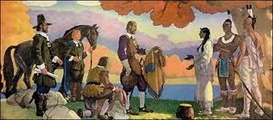
The Early Settlers Meet the Indians

Even before the “white man” started killing and pushing the Indians off of their own land, millions of Native Americans died from the diseases the European settlers brought to America, which the Native Americans had no resistance. The colonists and explorers brought measles, smallpox, cholera, yellow fever, and many more devastating diseases. The Europeans also brought guns – the Indians only had bow and arrows, spears, and hand-made knifes. Whenever the Indians resisted and there was a conflict, their weapons were no match to the white man’s guns and they were killed.

Things got worse!! The arrogant attitude of the ever-growing whites led to the Indian Wars where approximately 30,000 Indians (and 19,000 white men) were killed. Then the United States of America Government passed the Indian Removal Act (1830) where they basically made it legal to kill all Indians that didn’t move to the designated reservations. In 1890, one of the worst massacres ever, occurred at Wounded Knee, South Dakota. Here, about 300 Indian warriors, women, and children were slaughtered by the U.S. Cavalry. The Relocation Programs resulted in the now famous Trail of Tears march where hundreds of Cherokee Indians died from starvation, exposure, and illnesses. Many Europeans hated the Indians and thought they were evil, bloodthirsty savages. The new laws didn't even see them as human beings. The Native American peoples were not only reduced in number but taken from their homes, stripped of their customs, and even forbidden to speak their native languages. Their children were taken from the Indian parents and sent to schools to “civilize” them. Basically, the Indians were forced to abandon every aspect of their heritage. Then, the U.S. government forced them to live on reservations where many Native Americans still reside today.

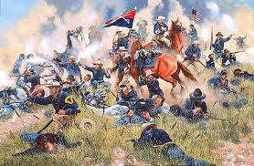
The Battle of Little Bighorn

The Indians did win a few battles. The Battle of Little Bighorn occurred in 1876 and is commonly referred to as “Custer’s Last Stand”. The battle took place between the U.S. Cavalry and northern tribe Indians, including the Cheyenne, Sioux, and Arapaho. Chief Sitting Bull decided to wage war against the whites for their refusal to stay off of tribal lands in the Black Hills. The U.S. Cavalry was attempting to force the Indians back to their reservations. Lt. General George Custer decided to attack the Indians but didn’t realize that the Indian forces outnumbered his troops three to one. While waiting for aid from the other Cavalry forces, another group of Indian forces, led by Crazy Horse, effectively trapped Custer and his men. In a desperate attempt to hold off the Indian warriors, Custer ordered his men to shoot their horses and stack their bodies to form a barricade to protect them from the Indians. It took less than an hour for the arrows and bullets of the Indians to wipe out General Custer and his men. Despite having won this battle, the Indians were not victorious in the long run. Outrage over the death of the popular Custer led the U.S. government to redraw the boundaries of the Black Hills so that the land would not be part of reservation property.

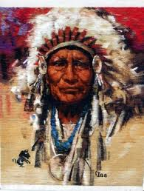 | 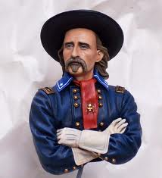 | 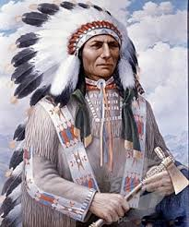
Chief Sitting Bull | Gen. George Armstrong Custer | Chief Crazy Horse

Indian reservations are considered some of the most poverty-ridden areas in the United States. Unemployment is 5 times higher than the general U. S. population, according to the Bureau of Indian Affairs. As with many defeated, oppressed people, they have suffered tremendously from the plagues of alcoholism and suicide. These Native Americans were once a vibrant and resourceful people. They have been robbed, humiliated, and removed from all they knew. Over the years, however, many Indians have adapted to the American way of life and went on to be very successful. Today, only 22% of all Native Americans live on reservations. Most Native Americans are very proud of their heritage.

Growing up in Utah where there are a lot of Indians, I never felt sorry for them. They discovered oil out on the Ute Reservation and most of the Indians I heard about seemed to be doing okay. However, after doing the research for this article, I now understand a little better the Native American history and the hardships they have endured ever since the “white man” come to America. I have also learned more about the effort to get Federal Recognition for Native Hawaiians. I have always been against this because I didn’t really understand what the Hawaiians wanted. I thought they wanted this recognition so that they could force us non-Hawaiians “haoles” out of our homes and kick us off of the Hawaiian Islands. Well, this is what they really want to do but the Federal Recognition Agreement would not allow that. I’m now in favor of this recognition since it will allow the Hawaiians to build a few casinos and maybe a horse racing track. This would be great!!

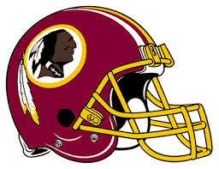  Washington Redskins | What do I think about the “outrage” and the effort to get the Washington Redskins a more civilized nickname and logo? I think it is a bunch of crap!  This whole thing was started by a few civil rights and “bleeding heart” liberals in our government. None of which were Indians! They say the word “Redskin” is offensive and is a harmful form of ethnic stereotyping. They say it is a racial slur and the same as calling a black man the N-word. I say, “Bull”.  It might be the same as calling black men the “black skins” or white men the “white skins” or Asian men the “yellow skins”. Now what is wrong with that?

Most Native Americans are proud of the Indian nicknames our sports teams use including the Washington Redskins. Over 90% of all Native Americans surveyed said that they had no problem with the name. Actually, more Native Americans have an issue with the name “Indian” then they do with the name “Redskins”. They are not overly thrilled with good ole Christopher Columbus and what happened to them after he discovered America.

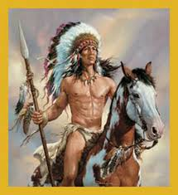 | Okay, what color is an Indian’s skin?  Most Indians have Mongolic features with coarse, straight black hair, dark brown eyes, sparse body hair, and a skin color that is mostly brown but ranges in color from a yellowish-brown to a reddish-brown. Some Indian Tribes actually painted themselves red using Ochre - a natural earth pigment. The war paint Indians used came in multiple Ochre colors.

Did you notice that I wrote this article in RED ink? I’m I a racist?
I do wish the very best for all Native Americans. They have suffered long enough.

bigdrifter44@gmail.com

