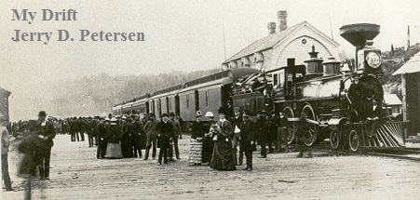

 | Inventions That Changed the World (Part 2 of 4)  22 October 2014 | 187-2014-16

Can you believe that there has been more inventions in the last 214 years than in all of history since humans lived on the planet earth – more than 3 million years? Well, it’s true and I will list some of the more important ones in this article. I will also try to give you a brief history of what’s going on in U. S. and the World (in red). If you missed part 1, you can find it on my website.

The Modern Era (1801 to 1900) – the 19th Century

Invention | Date | Description and Comments |  | Pictures
The Battery  Steam Locomotive  (Train)  Steamboat | 1800  1801  1803  1804  1807  1812 | - U.S. Population is 5.3 million  - There were 895,000 slaves in the U.S.  - The two largest cities are New York City (61,000) and Philadelphia (41,000)  - There are 16 states  - U. S. capital is moved from Philadelphia to Washington, D.C.  Alessandro Volta of Italy discovered the first practical method of generating electricity. Count Volta also made discoveries in electrostatics, meteorology and pneumatics. His most famous invention, however, is the first battery.  U.S. negotiates Louisiana Purchase from France for $15 million.  Richard Trevithick of the United Kingdom invented the first full-scale working railway steam locomotive.  Lewis and Clark begin their expedition to map the northwest United States.  Robert Fulton makes first successful steamboat trip.  The War of 1812 - British soldiers burn down the White House and Capitol. |  | 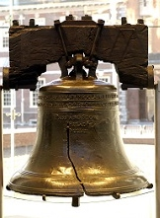  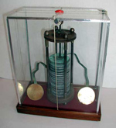  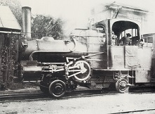  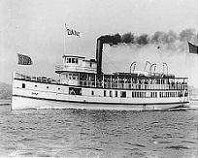
Typewriter  Sewing Machine  Telegraph  Postage Stamp  Rubber Tires  Bicycle  Camera  Elevator  Pasteurization  Steel  Toilet Paper | 1829  1830  1831  1835  1837  1839  1840  1840  1846  1848  1850  1856  1857 |  | American W.A. Burt invents the typewriter.  Church of Jesus Christ of Latter-day Saints formed by Joseph Smith.  American Isaac Singer invents a new and improved sewing machine.  First bank robbery in U.S. history occurs at the City Bank of New York.  P.T. Barnum begins his first circus tour of the U.S.  American Samuel Morse invents the telegraph.  English schoolmaster Rowland Hill invents the postage stamp.  Charles Goodyear invents vulcanized rubber.  Kirkpatrick Macmillan, a Scottish blacksmith, invents the bicycle.  American Alexander Wolcott invents the Camera.  U.S. declares war on Mexico.  James Marshall discovers gold near Sutter's Fort which was the beginning of the California Gold Rush.  - U.S. Population is 17 million  - The two largest cities are New York City (313,000) and Baltimore (103,000)  - There are now 26 states  - Life expectancy is about 40 years  Elisha Graves Otis invented the  safety elevator.  French scientist Louis Pasteur invents pasteurization.  Mass production of steel was invented by English inventor Henry Bessemer.  C. Gayetty of New York first packaged toilet paper in the U.S. | 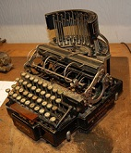  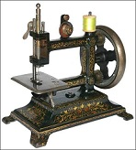  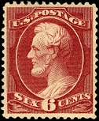  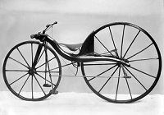

Toilet Paper (or Bathroom Tissue for you politically correct people) is another one of those great inventions that makes you wonder what people used before it was invented. Well, use your imagination – what would you use if you had to do your business out back behind a bush or in an outhouse? People mostly used grass, leaves, or any paper product they could find. Pages torn from newspapers and magazines were commonly used in the early American West. The Sears catalog was well-known as the “Rears and Sore Butt" catalog. The Farmer's Almanac even had a hole in it so it could be hung on a hook and the pages torn off easily.

The ancient Greeks used stones and pieces of clay. Those smart ancient Roman engineers invented a sponge on the end of a stick that they kept in jugs filled with salt water. Mid-easterners (Arabs) used their left hand, which is still considered unclean in the Arabian region.

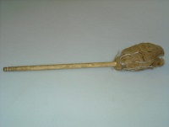 |  | 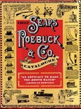
Roman Toilet Sponge | Leaf | Sears Roebuck Catalog

Invention | Date | Description and Comments | Pictures
Washing Machine  Combustion Engine  Machine Gun  Dynamite  Telephone  Phonograph  Motion Picture Camera  The Light Bulb  Cash Register  Automobile  Motorcycle  Radar  Diesel Engine  The Zipper  Vacuum Cleaner  X-ray  Radio  Radium and Polonium. | 1858  1860  1861  1862  1866  1875  1876  1878  1881  1883  1885  1886  1887  1892  1893  1895  1896  1897  1898  1900 | American Hamilton Smith invents the first rotary washing machine.  Lincoln elected President – He was shot and killed in 1864.  Belgian engineer developed the first internal combustion engine.  U.S. Civil War (1861–65) between the Northern states (the Union) and the Southern states that seceded from the Union and formed the Confederacy.  American Richard Gatling invents the machine gun.  Swedish industrialist Alfred Nobel invents dynamite.  First Kentucky Derby.  Alexander Graham Bell was a Scottish-born scientist, inventor, and engineer who invented the telephone.  Sioux kill GEN George A. Custer and 264 troopers at Little Big Horn River  American Thomas Edison Invents the phonograph, the motion picture camera, and first long-lasting, practical electric light bulb.  American saloon owner invents the first working mechanical cash register.  Brooklyn Bridge opens in New York.  German Karl Benz invents the first practical automobile.  German engineer Gottlieb Daimler invents the motorcycle.  The Statue of Liberty is dedicated on October 28, 1886 – this was a gift to the United States from the people of France.  German physicist Heinrich Hertz invents radar.  German engineer Rudolf Diesel invents the diesel-fueled internal combustion engine.  American Whitcomb Judson invents the zipper.  American John Thurman invents the motor-driven vacuum cleaner.  X-rays discovered by German physicist Wilhelm Roentgen.  Italian Gugliemo Marconi invented what he called “the wireless telegraph”.  First modern Olympics were held in Athens, Greece.  Spanish-American War begins.  Oldsmobile was the first car company in the U.S. - Olds Motor Vehicle Co.  French scientists Pierre and Marie Curie discover radium and polonium.  Eastman Kodak invents a low-priced, point-and-shoot, hand-held camera.  - U.S. Population is 76.2 million  - There are now 45 states  - The two largest cities are:  New York City with 3.4 million  Chicago with 1.7 million  - Life expectancy is about 47 years  46 years for men and 48 for women | 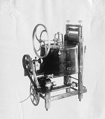  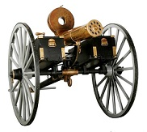  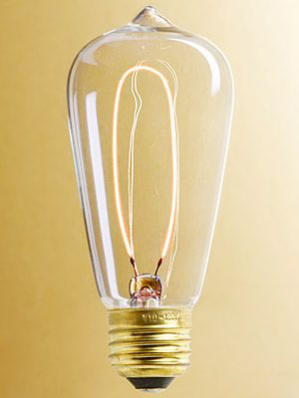  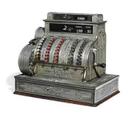  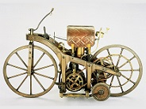  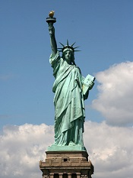  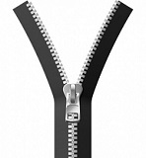  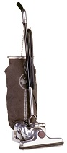  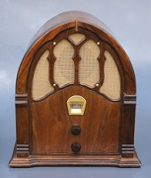

Well, here we are in the year 1900 and life is not all that easy for most people living in the United States. Only some of the bigger cities had electrical power. Most of rural America didn’t get electricity until the mid to late 1930s. Indoor plumbing, toilets, and running water came during this same period. People living in eastern cities were much better off than the folks living out there in “wild” west. Back then, St. Louis was the big city that divided the eastern and western U.S. Here are the 1900 populations of a few of the bigger cities in the west:

St. Louis  San Francisco  Los Angeles  Seattle  Salt Lake City | 575,000 (Fourth largest city in US)  343,000  103,000  81,000  54,000

Just in case you were wondering how big Las Vegas was in the year 1900, it had a zero (0) population since it didn’t become a city until 1905.

Modes of Travel during the 1800s
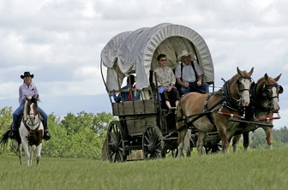 | 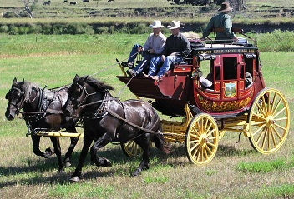
Early 1800s – The Covered Wagon | Middle 1800s – The Stagecoach
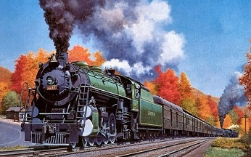
Late 1800s – The Passenger Train (This is still my favorite mode of transportation)

I was wondering how and how long it took for people to get from the east coast to the west coast (approximately 3000 miles) back in the 1800s? Remember now, there were no airplanes and no cars and very few roads back then.

During the early 1800s, people traveled out west in covered wagons – the trip took a year or more. In 1827, the first stagecoach begin running from St. Louis to San Francisco. There were about 150 stations (rest stops) where people could get something to eat and spent the night. The trip took about a month. Actually, the stagecoach stayed in service until it was replaced by the automobile in the early 1900s. Then in 1869, the First Transcontinental Railroad was completed across the United States connecting the Central Pacific and Union Pacific railroads at Promontory Summit, Utah Territory. The train could make the trip across the country in about 20 days and was the primary means of travel during this period - it was also a big reason for many people to move out west.

See “Inventions That Changed the World Part 3” for all the great inventions between the years 1901 through 1950.

bigdrifter44@gmail.com

