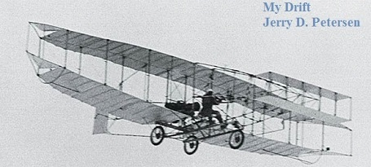

 | Inventions That Changed the World (Part 3 of 4)  29 October 2014 | 188-2014-17

We began the 20th century with the infancy of radio, automobiles, and airplanes when those inventions dazzled us with their novelty and wonder. In the middle of the 20th century we are introduced to something called television or TV. We end the 20th century with computers, spaceships, cell phones, email, and the Internet. We now take all of these technologies for granted.

The Modern Era (1901 to 1950) – the first half of the 20th Century

Date/Invention | Pictures
1901  • Gillette invents the double-edged safety razor  1902  • Willis Carrier invents the air conditioner  • James Mackenzie invents the lie detector or polygraph machine  • George Claude invented the neon light  1903  • The Wright brothers invent the first manned airplane  • Edward Binney and Harold Smith co-invent crayons  • Mary Anderson invents windshield wipers  • The Teddy Bear is introduced  • First license plates are issued in the U.S.  • First Silent Movie, The Great Train Robbery  • First baseball world series  1904  • Benjamin Holt invents a farm tractor  • New York City subway opens  1905  • Albert Einstein invents the Theory of Relativity (E = mc2)  • Mary Anderson invents windshield wipers  1906  • William Kellogg invents Cornflakes  • Lewis Nixon invents sonar  • San Francisco earthquake  1907  • Leo Baekeland invents synthetic plastic  • Auguste and Louis Lumiere invent color photography  • First electric washing machine  1908  • Elmer Sperry invents the gyrocompass  • Jacques E. Brandenberger invents cellophane  • Ford Motors sells the first Model T car  • J W Geiger and W Müller invent the Geiger counter  1909  • G. Washington invents instant coffee  • Robert Peary becomes the first to reach the North Pole  1910  • Thomas Edison invents the first talking motion picture  • Boy Scouts established in U.S.  1911  • Roald Amundsen reaches the South Pole  1912  • Australian inventor De La Mole invents the military tank  • The parachute is invented  • The Titanic sinks  1913  • Arthur Wynne invents the crossword puzzle  • Mary Phelps Jacob invents the bra  • Henry Ford invents the first moving assembly line  • Personal Income Tax is introduced in U.S.  1914  • Garrett A. Morgan invents the gas mask  • World War I Begins  • Panama Canal opens  1915  • Nation-wide telephone service in U.S.  1916  • The radio tuners is invented that receives different stations  • Henry Brearly invents stainless steel  1917  • U.S. enters World War I  1918  • Charles Jung invented fortune cookies  1919  • Charles Strite invents the pop-up toaster  • Short-wave radio invented  • The arc welder invented  • World War I ends  1920  • John T Thompson invents the tommy gun  • Earle Dickson invents the Band-Aid  • Women granted the right to vote in U.S.  1921  • Artificial life begins -- the first robot built  1922  • Sir Frederick Grant Banting invents insulin  • The first 3-D movie is released  1923  • Garrett A. Morgan invents the traffic signal  • John Harwood invented the self-winding watch  • Clarence Birdseye invents frozen food  1924  • Notebooks with spiral bindings invented  • First Olympic Winter Games  1925  The Grand Ole Opry is founded  1926  • Robert H. Goddard invents liquid-fueled rockets  1927  • Philo Taylor Farnsworth invents the electronic TV system  • Technicolor invented  • Lindbergh flies solo across the Atlantic Ocean  1928  • Scottish biologist Alexander Fleming invents penicillin  • Walter E. Diemer invents bubble gum  • Jacob Schick invents the electric shaver  • Sliced bread invented  1929  • American Paul Galvin invents the car radio  • The Yo-Yo is invented  • The Great Depression begins  • Stock market crashes  1930  • 3M engineer Richard G. Drew invents scotch tape  • Clarence Birdseye invents the frozen food process  • Frank Whittle and Dr Hans von Ohain invent the jet engine  1931  • Empire State Building is completed  1932  • Edwin Herbert Land invents polaroid photography  • The zoom lens and the light meter are invented  • Carl C. Magee invents the first parking meter  • Air Conditioning invented  • Amelia Earhart is first woman to fly solo across the Atlantic  1933  • Stereo records are invented  • Richard M. Hollingshead invents the drive-in movie theater  • The Loch Ness Monster first spotted  • Prohibition ends in the U.S.  1934  • Charles Darrow invents the game of Monopoly  • Joseph Begun invents the first tape recorder  • The Dust Bowl devastates the Great Plains  1935  • Wallace Carothers and DuPont Labs invents nylon  • The first canned beer made  • Robert Watson-Watt invents radar  1936  • Bell Labs invents the voice recognition machine  • Samuel Colt patents the Colt revolver  • Hoover Dam completed  1937  • Chester F. Carlson invents the photocopier  • The first jet engine is built  • Golden Gate Bridge opened  • Hindenberg disaster at Lakehurst, NJ  • Japan invades China  1938  • Ladislo Biro invents the ballpoint pen  • Roy J. Plunkett invents Teflon  • Freeze-dried coffee invented  • The first working turboprop engine is invented  • Superman first appears in comic books  • Volkswagen Beetle first produced  1939  • Igor Sikorsky invents the first successful helicopter  • The electron microscope invented  • World War II begins  • First commercial flight over the Atlantic  1940  • Peter Goldmark invents modern color television  • Karl Pabst invents the jeep.  • First Nazis concentration and death camp (Auschwitz) opens  • First McDonald’s opens  1941  • Lyle Goodloe and W.N. Sullivan invent aerosol spray cans  • Japanese attack Pearl Harbor  • Mount Rushmore completed  1942  • The T-shirt is invented  1943  • Synthetic rubber invented  • Emile Gagnan and Jacques Cousteau invent the aqualung  1944  • Willem Kolff invents the kidney dialysis machine  • Normandy Invasion D-Day  1945  • The atomic bomb invented  • Division of Korea into North and South  • Germany surrenders and Hitler commits suicide  • Atomic bombings of the cities of Hiroshima and Nagasaki  1946  • Percy Spencer invents the microwave oven  • First Bikinis are introduced  • First mainframe computer built - ENIAC  1947  • Bardeen, Brattain, and Shockley invent the transistor  • Earl Silas Tupper invent Tupperware  • Polaroid cameras invented  1948  • Walter Morrison and Warren Franscioni invents the Frisbee  • State of Israel founded  1949  • Cake mix invented  • China becomes Communist  • First Non-Stop flight around the World  1950  • First credit card introduced – Diners Club  • First organ transplant  • First "Peanuts" cartoon strip  • Korean War Begins | 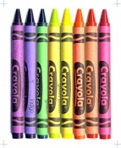  Crayons  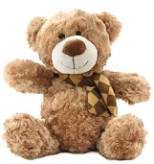  Teddy Bear  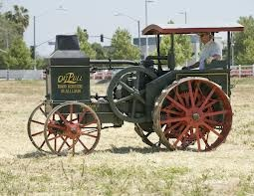  Farm Tractor  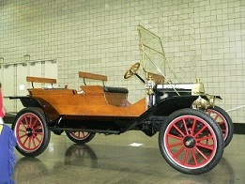  1910 Model T Ford  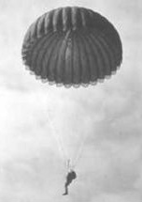  Parachute  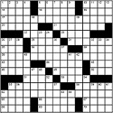  Cross-Word Puzzle  1910  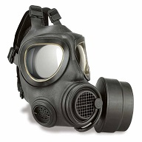  Gas Mask  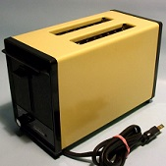  Popup Toaster  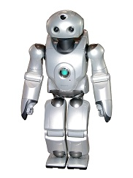  Robot  Traffic Light  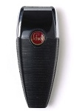  Electric Shaver  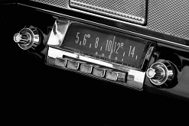  Car Radio  Yoyo  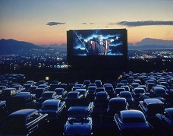  Drive-in Theater  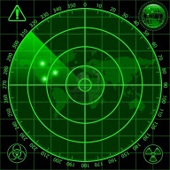  Radar  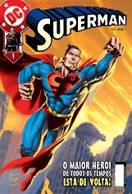  Superman  Comic Book  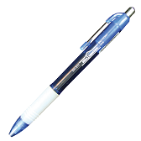  Ballpoint Pen  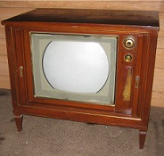  Television  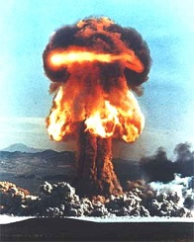  Atomic Bomb  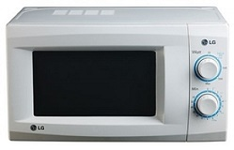  Microwave Oven  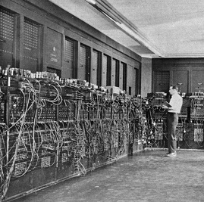  Mainframe Computer  (ENIAC)  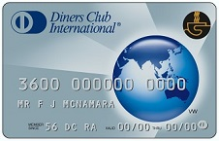  Credit Card

1950 Facts and Figures
- U.S. Population is 151 million
- There are now 48 states (Alaska and Hawaii come later)
- The five largest cities are:
1 New York New York 7,900,000
2 Chicago Illinois 3,600,000
3 Philadelphia Pennsylvania 2,100,000
4 Los Angeles California 2,000,000
5 Detroit Michigan 1,800,000
- Life expectancy is about 68 years
65.6 years for men and 71.1 for women
- Cost of Living:
The average family income: $3,300 a year
The average car cost: (Ford) $1,800
The median home price: $8,500

Two of the world’s greatest inventions that affected all of our lives are the automobile and the airplane. During the 1900s (the 20th century), people in the United States went from having no cars and no airplanes to what we have today. It is hard to believe how far we have come in just over a hundred years. Let’s take a brief look at the automobile and airplane history timeline up to 1950.

Automobile | Aircraft History
Even though Germans Gottlieb Daimler and Karl Benz invented the first car in the late 1800s, there were no cars on U.S. streets until 1901.  The first automobile produced for the masses in the US was the 3-horsepower Oldsmobile - 425 of them were sold in 1901 and 5,000 in 1904.  Henry Ford formed the Ford Motor Company in June 1903 and sold its first car on the July 23rd. The success of the automobile was facilitated by Henry Ford who did two important things. First he priced his car to be affordable to the average American and he paid his workers enough to be able to purchase the cars they were manufacturing.  In 1905, the USA produces 25,000 cars, more than any other country in the world. The US had about 2,000 firms producing cars.  In 1908, Buick is the largest car manufacturer in the world, selling 9,000 cars versus Ford's 6,000. Billy Durant founds General Motors in Detroit and acquires Buick, Oldsmobile, and Cadillac.  In 1911, Swiss-born racing driver Louis Chevrolet begins making Chevrolets in Detroit. Other major US car makers are Studebaker and Packard.  In 1913, the Lincoln Highway is completed and becomes the first transcontinental highway (New York to San Francisco).  In 1914, Ford's market share of the car market is 48%. Dodge introduces its first car.  In 1916, Charles Nash forms Nash Motor Company and the 1917 Nash Model 671 was the first vehicle produced. Ford produces more than 700,000 Model Ts.  In 1921, the USA passes the Federal Highway Act for building an interstate system of highways, and there are more than 10 million cars on the road. Ford owns 61% of the car market versus General Motors 12%. There was one car for every 10 people in the USA.  In 1924, the first Chrysler car was priced at $1,565 and featured a high-compression six-cylinder engine.  In 1926, GM renames the Oakland car brand to Pontiac.  In 1927, GM sells more than one million cars and moves head of Ford in car sales.  In 1929, Chrysler becomes the third largest car manufacturer in the USA after General Motors and Ford.  In 1938, Nash introduces the first "Conditioned Air System". Ford introduces the Mercury, a low-entry luxury car to compete with General Motors' Buick.  In 1939, Ford introduces the luxury convertible Lincoln Continental. GM’s Oldsmobile introduces the first automatic transmission.  In 1948, Chrysler introduces the ignition key  System. Goodrich introduces tubeless tires.  In 1949, the first Volkswagen is sold in the USA.  In 1950, the USA has 40 million cars on the road.  Some popular 1950 car models that are no longer around: Nash, Studebaker, Packard, Hudson, Crosley, and Kaiser.  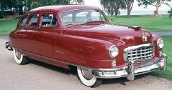  1950 Nash  Two of my favorite cars are also not around today – Oldsmobile and Pontiac. How can GM get rid of its oldest car model? | From the beginning of mankind, humans have been fascinated with the idea of being able to fly. If birds can fly – why can’t I? There have been many injuries to people who have strapped on wings and jumped off of a cliff flapping their arms like crazy.  The first aircrafts were kites flown by the Chinese a couple of thousand years ago. The first people to actually get up into the sky did it in hot air balloons in the late 1800s. Unmanned balloons were first used in warfare during the Civil War.  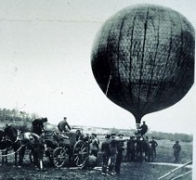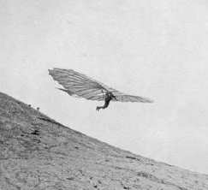  Hot Air Balloon and Hang Glider  German pioneer of aviation Otto Lilienthal became known as the Glider King. He invented the Hang Glider in the 1880s and died in a glider crash in 1896.  In 1903, Orville and Wilbur Wright made the first successful manned flights near Kitty Hawk in North Carolina. See picture at top of this article.  World War I brings about better airplanes (1914-1918).  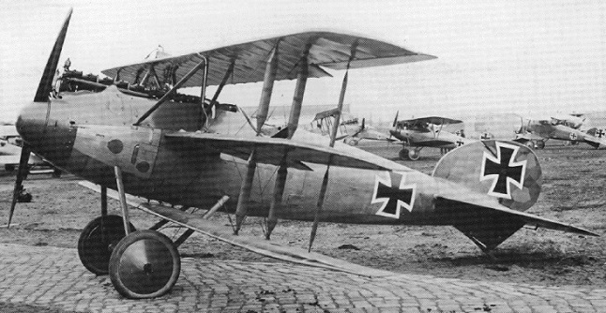  World War I Airplane  In 1915, the first air-to-air combat and first German aerial bombing of Great Britain by Zeppelins occurred.  In 1918, the United States Postal Service began using airplanes to deliver mail across the country.  In 1919, the US Navy made some of the first flights across the Atlantic Ocean.  In 1927, Charles Lindbergh made the first solo flight across the Atlantic Ocean. He flew from New York to Paris by himself.  In 1932, Amelia Earhart solos across the Atlantic. In 1935, she flew from Hawaii to California.  In 1933, the first passenger planes are made - Boeing made the 247 plane. It could seat up to 10 people.  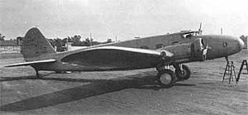  Boeing 247  In 1937, the jet engine was invented by Frank Whittle.  In 1939, Igor Sikorsky invents the first modern helicopter.  Also in 1939, the first turbojet aircraft to fly was the Heinkel He 178 prototype of the German Air Force.  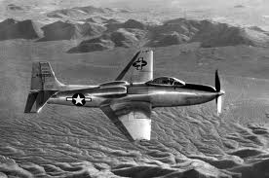  World War II Airplane  In 1947, Chuck Yeager flew 670 mph, faster than the speed of sound.  The United States Air Force became a separate military service in 1947.

Don’t miss Part 4 where we will have much more information on cars, airplanes, computers, and spaceships.

bigdrifter44@gmail.com

