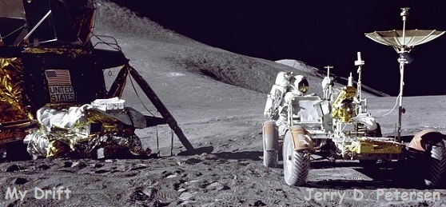

 | Inventions That Changed the World (Part 4 of 4)  12 November 2014 | 189-2014-18

Well, we have finally reached a point in time (the 1950s) where most of us old people can remember some of these inventions and historical events happening. The 1950s were the last socially conservative period. Think about it. People who grew up during the 1940s and 50s were not influenced as much by television, computers, email, the Internet, the World Wide Web, Facebook, and Twitter. When we were kids, we didn’t have any of these things except for TV which was just starting to show up in people’s homes. We went outside to play! The 50s were my school years - I did manage to learn a few things.

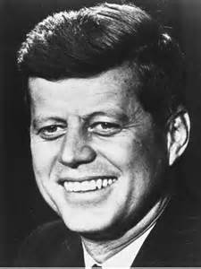  John F. Kennedy | The 1960s are described by historians as the ten years having the most significant changes in history. We had a popular president (John F. Kennedy) who supported the space program. By the end of the 60s, humanity had entered the space age by putting a man on the moon. The 60s were influenced by the youth of the post-war baby boom - a generation with a fondness for change and far-out gadgets.  I began the 60s attending the University of Utah, then 4 years and 4 months in the Navy, and ended the 60s living in Tooele, Utah working for the Government at Tooele Army Depot. I was single, old enough to drink beer, and traveled around the world – yes, this was probably the most fun period in my life.

The 1970s were a tumultuous time. Women, African Americans, Native Americans, gays and lesbians and other marginalized people continued their fight for equality, and many Americans joined the protest against the ongoing war in Vietnam. Many Americans, particularly the working class and middle class whites, responded to this turbulence by embracing a new kind of conservative populism. Sick of what they interpreted as spoiled hippies and whining protestors, tired of an interfering government that, in their view, coddled poor people and black people at taxpayer expense, these individuals formed what political strategists called a “silent majority.” By the end of the decade, President Richard Nixon had resigned and the Vietnam War was over.

I moved to Hawaii in June 1970 and got married in December 1972. It was time to settle down and raise a family.

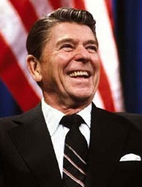  Ronald Reagan | By the end of Jimmy Carter’s presidency, the idealistic dreams of the 1960s were worn down by inflation, foreign policy turmoil and rising crime. In response, many Americans embraced a new conservatism in social, economic and political life during the 1980s, characterized by the policies of President Ronald Reagan. Once he took office, he set about making good on his promises to get the federal government out of Americans’ lives and pocketbooks. He advocated for industrial deregulation, reductions in government spending and tax cuts for both individuals and corporations, as part of an economic plan he and his advisors referred to as “supply-side economics.” Rewarding
success and allowing people with money to keep more of it, the thinking went, would encourage them to buy more goods and invest in businesses. The resulting economic growth would “trickle down” to everyone. Reagan made the military strong again and brought pride back to all Americans. President Reagan was responsible for the collapse of the Soviet Union, tearing down the Berlin Wall, and putting an end to the Cold War. Yes, I think Ronald Reagan was the most popular president ever in U.S. history.

During the 1980s, information technology was changing rapidly. I had a great job supporting the IBM mainframe operating system for the Army in the Pacific including the sites in Korea, Japan, and Hawaii. I got to travel to Korea and Japan twice a year and also to IBM training on the mainland U.S. at least twice a year. These were good but busy years for me since I also had a part-time job working for a computer company in Honolulu.

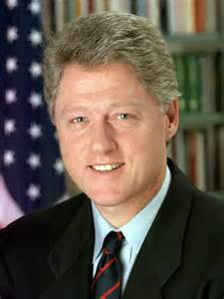  Bill Clinton | The 1990s was a great decade – America was at peace for most it. This is the longest period in U.S. history that we went without fighting in a war or some kind of conflict. The Soviet Union collapsed and the Cold War ended bringing a halt to years of costly military competition.  During the nineties, the American economy recovered from a recession and grew strong. Inflation and unemployment were low. There were new developments in medicine and technology. The Internet began to evolve from a defense project mainly linking researchers into a new way for the world to communicate.
America grew by almost thirty-three million people during the nineteen nineties -- the largest increase of any decade in its history. By the end of the nineties more than two hundred eighty-million people were living in the United States.

During the decade of the 90s, there was a large increase in immigration from Latin America, the Caribbean and Asia. For the first time in seventy years, one in ten Americans was born in another country. At the same time, the population was getting older. Divorce rates in the United States had begun to grow sharply in the nineteen seventies. By the nineties those rates were starting to drop. But there were millions of children living with only one parent, or with their grandparents. Single-parent families are more likely to be poor. In nineteen eighty, single-parent households represented about twenty percent of all households in the United States with children. By nineteen ninety that number had reached twenty-four percent, and was continuing to rise.

The 1990s were good for me but by 1995, new technology had made it possible to replace the mainframe computers with servers. Our last mainframe computer was removed at Taegu, Korea in 1999 – it was a sad day. My regular trips to Korea and Japan were over and I had to start doing a new job.

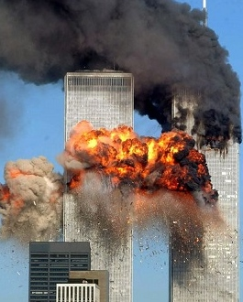 | 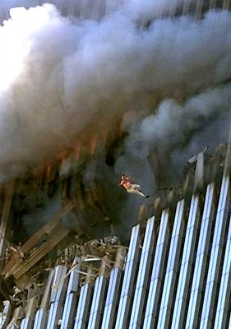 | 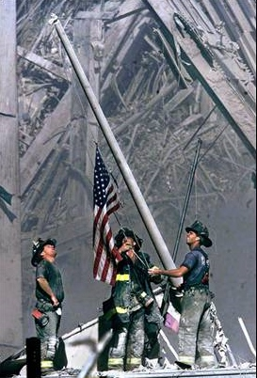

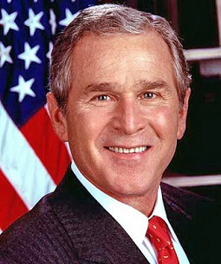  George W. Bush | September 11, 2001 - Islamic terrorists hijack four U.S. airliners and crashed them into the Pentagon and the World Trade Center in New York City. The attack of two planes levels the World Trade Center and the crash of one plane inflicts serious damage to the Pentagon in Arlington, Virginia, causing nearly 3,000 deaths. The fourth plane is heroically crashed by passengers into a Shanksville, Pennsylvania cornfield when they learn of the plot, preventing destruction of another structure in Washington, D.C., supposed to be the White House or the Capitol building. The plot is attributed to the Al-Qaeda organization led by Osama Bin Laden.

Since that day, the world has become a more dangerous place. On October 7, 2001 the U.S. and Britain commence the first attack in the War on Terrorism on the Taliban and Al-Qaeda in Afghanistan. On March 19, 2003 the War in Iraq begins with the bombing of Baghdad. Saddam Hussein, former leader of Iraq, was captured on December 13, 2003. I was going to list some of the terrorist attacks but that’s when I learned that in the year 2013 alone, there were 9,707 terrorist attacks world-wide that killed 17,891 and wounded 32,577 people. Never forget 911!! We cannot lose the war on terrorism or else we will all be dead.

After 25 years of supporting the mainframe computer, I had to change jobs. I was the Project Manager for the Army’s Y2K efforts in the Pacific. I then become a website designer and programmer for a few years and then spent my last few years with the government as a Project Coordinator for a special Task Force called ACENET that was formed to greatly accelerate the installation and implementation of the latest Information Technology systems. I retired in December 2010 with 49 years of government service and went to work for a private computer company.

Go to the next page for inventions, historic events, wars, disasters, movies, TV shows, and some other stuff that happened during the 1950s, 1960s, 1970s, 1980s, 1990s, and the 2000s.

(The rest of this page is blank)

1950s
Inventions 1951 - Power steering, Video tape recorder 1952 - Hydrogen bomb, Bar Code, Diet Soda 1953 – Airplane flight recorder, Transistor radio 1954 – The Pill, Nonstick Teflon 1955 – Fiber Optics 1956 – Computer hard disk 1957 - Fortran (computer language) 1958 – Computer modem, Hula hoop 1959 – Pacemaker, Microchip  Cars, Airplanes, and Spacecraft 1953 – First Chevy Corvette Dream Car 1955 - Boeing B-52 long-range jet bomber 1956 - Interstate Highway System Act 1957 - Boeing 707 first commercial jet airplane 1957 - The Soviet Union launches Sputnik 1 1957 – First Chevy bel air convertible 1958 - Douglas DC-8 jet airliner  Wars and Conflicts Cold War (United States and Soviet Union) Korean War (1950-1953) Cuban Revolution (1953–1959) Vietnam War Starts (1959)  Disasters Hurricane Diane (1955) hits Northeast US Hurricane Audrey (1957) hits Louisiana Typhoon Vera (1959) hits Japan  TV and Films Films – North by Northwest, Ben-Hur, Vertigo, On the Waterfront, Some Like it Hot, Rebel without a Cause, Bridge on the River Kwai TV Shows – I Love Lucy, The Ed Sullivan Show, Gunsmoke, Dragnet, The Honeymooners, The Twilight Zone, Ozzie and Harriet, and the Tom and Jerry cartoon  Music, Singers and Songs Frank Sinatra – Come Fly with Me Pat Boone – Love Letters in the Sand Johnny Cash – I Walk the Line Tennessee Ernie Ford – You Load 16 Tons Everly Brothers – All I have to do is Dream Fats Domino – Blueberry Hill Elvis Presley – Hound Dog  Sports Rocky Marciano wins the boxing championship by knocking out Jersey Joe Walcott Famous Baseball Players: Hank Aaron, Willie Mays, Mickey Mantle, and Duke Snider  Business and Government Anheuser-Busch, Inc. becomes the largest brewer Dwight D. Eisenhower wins Presidency in 1952 McDonalds opens (1954)–The fast food era begins | Hula Hoop  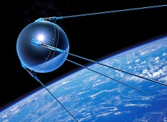  Sputnik 1 Satellite  (Space Era begins)  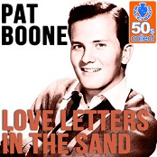  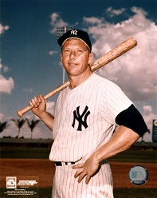  Mickey Mantle  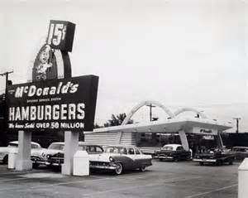  McDonalds

1960s
Inventions 1960 – The laser, Halogen lamp, Etch A Sketch 1961 – Valium, Non-dairy creamer 1962 - Audio cassette, light-emitting-diode (LED) 1963 – Zip code, Touch tone telephone 1964 - Permanent press clothes, 8-track cartridge 1965 – Astroturf, Contact lenses, Compact disk 1966 - Bullet proof vest, Fiber optics 1967 - Handheld calculator, Heart transplant 1968 - Computer mouse, Random access memory 1969 – Artificial heart, Barcode Scanner, ATM  Cars, Airplanes, and Spacecraft 1960 – Weather Satellite 1961 - Cosmonaut Yuri Gagarin orbited earth 1964 - Ford Mustang - Douglas DC9-30 1966 - First front-wheel drive cars 1966 - First electric car 1967 - Boeing 727 is introduced 1968 - Boeing 737 is introduced 1968 - Lunar Module built for Apollo program 1969 - Neil Armstrong walks on the moon 1969 - Jumbo jet Boeing 747 goes into service  Wars and Conflicts The Cold War and Vietnam War continue The Cuban Missile Crisis (1962) More than 500,000 troops in Vietnam in 1966 Six Days War (1967) – Israel against the Arabs China has a hydrogen bomb by 1967  Disasters Hurricane Donna (1960) hits US East seaboard Floods in Bangladesh (1960) kills about 10,000 Kennedy was assassinated in Dallas, Texas (1963) Hong Kong Flu kills 34,000 Americans (1968)  TV and Films Films – The Good, the Bad and the Ugly, Dr. No, Easy Rider, Psycho, Bonnie and Clyde, Butch Cassidy and the Sundance Kid, The Graduate TV Shows – Bonanza, Star Trek, Hogan’s heroes, Gilligan’s Island, The Flintstones, Batman  Music, Singers and Songs The Beatles – She Loves You Engelbert Humperdinck – Release Me Elvis Presley – It’s Now or Never Frank Sinatra – My Way Jim Reeves – I Love You Because Tom Jones – It’s Not Unusual  Sports Best Basketball Players: Wilt Chamberlain, Bill Russell, Oscar Robertson, Jerry West, Bob Pettit, Elgin Baylor, and Jerry Lucas | 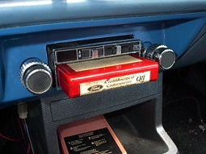  8-Track Tape Player  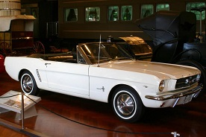  Ford Mustang  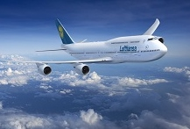  Boeing 747  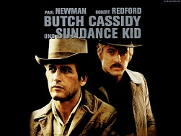  Computer Mouse  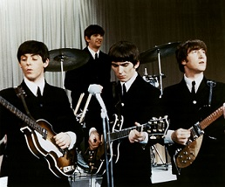  The Beatles

1970s
Inventions 1970 – Computer floppy disks, Memory chip 1971 – Microprocessor, VCR, Dot-matrix printer 1972 - Pocket calculators, First video game (Pong) 1973 – Ethernet, Disposable lighter 1974 – Post-it Notes, Liposuction, Rubik’s cube 1975 – First supercomputer, Laser Printer 1976 - First Apple computer, Ink Jet printer 1977 – Commodore PC, Apple II computer 1978 - Artificial heart, Space Invaders game 1979 – Cell Phones, Walkman, Atari microcomputer  Cars, Airplanes, and Spacecraft Between 1969 and 1972, six Apollo missions landed men on the Moon. The Soviet Union conducted two successful unmanned missions that deployed rovers and returned rock/dirt samples to Earth. 1970 – Japan starts selling Datsun & Toyota in U.S. 1971 – McDonnell Douglas DC-10 1972 – Lockheed L-1011 TriStar 1976/1978 – F-15 Eagle and F-16 Fighting Falcon  World Events 1970 - Palestinian Terrorists Hijacks Five Planes 1970 – Kent State Shootings 1972 - Terrorists Attack at Munich Olympic Games 1972 - Watergate Scandal Begins 1973 - U.S. Pulls Out of Vietnam 1974 - President Nixon Resigns 1976 - Ebola Virus outbreaks strike Sudan and Zaire 1977 - Trans-Alaska Pipeline System Finished 1979 - Iran Takes American Hostages in Tehran  Disasters 1970 - Bangladesh cyclone kills 300,000 1972 - China earthquake (8.2) kills 240,000 1979 - Three Mile Island nuclear accident  TV Shows and Movies Movies – The Godfather, One Flew Over the Cuckoo Nest, Jaws, The Exorcist, Rocky, Airport, Patton TV Shows – M*A*S*H, Hawaii Five-O, All in the Family, Carol Burnett Show, Mary Tyler Moore  Music Singers and Songs Debby Boone - “You Light Up My Life” Simon & Garfunkel -“Bridge Over Troubled Water” Bee Gees - “Night Fever” Paul McCartney and Wings - “My Love” Captain & Tennille - “Love Will Keep Us Together” Three Dog Night - “Joy to the World”  Sports Best Pro Football Players: Roger Staubach (QB), OJ Simpson (RB), Walter Payton (RB), Lynn Swan (WR), Drew Pearson (WR), Dave Casper (TE) | 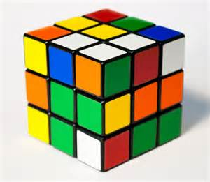  Rubik’s Cube  Pong Video Game  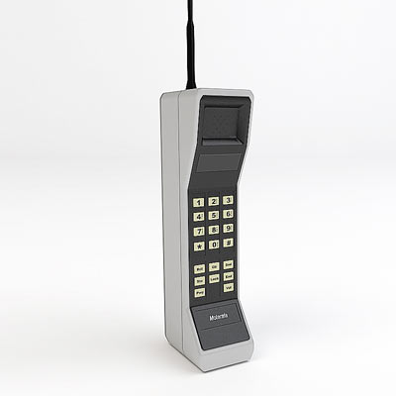  Cell Phone  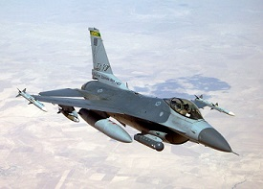  F-16 Fighter Jet  Alaska Pipeline  (Yes, that’s me!)

1980s
Inventions 1980 – Hepatitis-B vaccine 1981 – MS-DOS, IBM-PC 1982 – Camcorder, Apple Lisa 1983 – Human growth hormone 1984 – CD-ROM, Apple Macintosh, DNA profile 1985 – Microsoft Windows 1986 - Super conductor, Disposable camera 1987 – 3-D video games, Disposable contact lenses 1988 - Digital cell phone, Prozac 1989 – High-definition television  Cars, Airplanes, and Spacecraft 1980 – Ford stops making the Pinto 1981 - Strike by 13,000 US air traffic controllers 1981 – Boeing 757 1982 – F-16XL Stealth Jet 1982 – GM introduces the Chevrolet Camaro 1982 – Space Shuttle goes into service 1983 – Boeing 767 1986 – Space Shuttle Challenger explodes  World Events 1980 - Ronald Reagan wins Presidency in a landslide 1980 - John Lennon Assassinated 1981 – New Plague Identified as AIDS 1982 - Vietnam War Memorial in Washington, DC 1983 - U.S. Embassy in Beirut Bombed 1984 - PG-13 Movie Rating Created 1985 - Terrorists Hijack TWA Flight 847 1986 - Iran-Contra Scandal Unfolds 1987 - DNA First Used to Convict Criminals 1988 – Pan Am Flight 103 Bombed Over Lockerbie 1989 - Berlin Wall Falls  Disasters 1980 - Mount St. Helens Erupts 1986 - Chernobyl Nuclear Disaster 1989 - Loma Prieta/San Francisco earthquake 1989 - Hurricane Hugo (Cat 4) hits Southeast U.S.  TV Shows and Movies Movies – Indiana Jones, ET, Raging Bull, Shining, Die Hard, Ghostbusters, Karate Kid, The Terminator TV Shows – Cheers, Happy Days, Night Court, Taxi, Magnum PI, Dallas, Miami Vice, The Simpsons  Music Singers and Songs Michael Jackson, "Billie Jean" and “Beat It” Joy Division, "Love Will Tear Us Apart" Talking Heads, "Once in a Lifetime” Madonna, "Like a Prayer" Cyndi Lauper, "Time After Time”  Sports 1980 - Miracle on Ice: "Do you believe in Miracles?" | 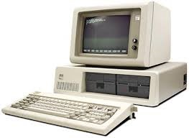  IBM PC  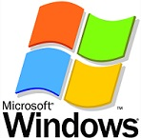  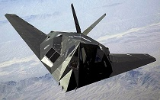  Stealth Jet  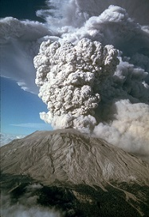  St. Helens  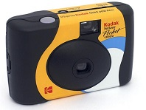  Disposable Camera
1990s
Inventions 1990 – World Wide Web, Internet protocol, HTML 1991 – Digital answering machine 1992 – The Smart Pill 1993 – The Pentium processor 1995 – Java computer language, DVD 1996 - Web TV 1997 – Gas-powered fuel cell 1998 - Viagra comes on the market 1999 – Tekno Bubbles is patented  Cars, Airplanes, and Spacecraft 1990 – Hubble Telescope Launched Into Space 1992 – Space Shuttle Endeavour lifts off 1994 – Channel Tunnel Opens - Britain and France 1995 – Boeing 777 starts flying 1995 - Cosmonaut Valeriy Polyakov returns to Earth after a 438-day mission aboard space station Mir 1995 - Space Shuttle Atlantis docks with Mir 1997 - Mars Pathfinder Lands on Mars  World Events 1990 - East and West Germany reunited 1991 - Collapse of the Soviet Union 1991 - Operation Desert Storm begins 1992 - Official End of the Cold War 1993 - World Trade Center Bombed 1995 - Sarin Gas attack in Tokyo subway 1995 - Oklahoma City Bombing 1996 - Mad Cow Disease hits Britain and U.S. 1997 - Hong Kong returned to China 1998 - India and Pakistan Test Nuclear Weapons 1999 - Killing spree at Columbine High School 1999 - Fear of the Y2K Bug  Natural Disasters 1992 - Hurricane Andrew strikes South Florida 1993 - “Storm of the Century” kills over 250 in U.S. 1994 - Northridge earthquake in Los Angeles 1995 - The Great Hanshin earthquake in Kobe Japan 1996 - The Blizzard of 1996 in the eastern U.S. 1999 – F5 tornado hits Oklahoma City  TV Shows and Movies Movies – Pulp Fiction, Forrest Gump, Jurassic Park, Goodfellas, Silence of the Lambs, Titanic TV Shows – Seinfeld, Friends, Roseanne, The X-files, Murder She Wrote, Frasier, ER  Music Singers and Songs Alan Jackson, “Gone Country” - Tim McGraw, “I Like It I Love It” - Faith Hill, “This Kiss” - George Strait, “Check Yes Or No” - Shania Twain, “You’re Still The One” - Brooks & Dunn, “My Maria”  Sports Michael Jordan dominates Pro Basketball | 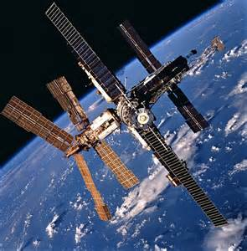  Space Station Mir  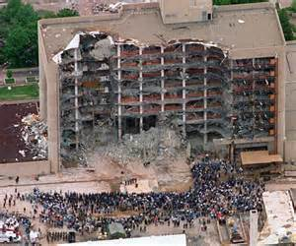  OKC Bombing  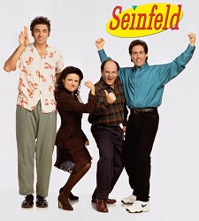  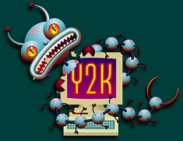

Year 2000 Facts and Figures
There are now 50 states (Alaska and Hawaii joined in 1959)

U.S. Population is about 282 million

States with the most population are:
1 California 34 Million
2 Texas 21 Million
3 New York 19 Million
4 Florida 16 Million
5 Illinois 12.4 Million
6 Pennsylvania 12.3 Million
7 Ohio 11.4 Million
8 Michigan 10 Million

The ten largest cities are:
1 New York New York 8.0 Million
2 Los Angeles California 3.7 Million
3 Chicago Illinois 2.9 Million
4 Houston Texas 2.0 Million
5 Philadelphia Pennsylvania 1.5 Million
6 Phoenix Arizona 1.3 Million
7 San Diego California 1.2 Million
8 Dallas Texas 1.2 Million
9 San Antonio Texas 1.1 Million
10 Detroit Michigan 950,000

Life expectancy is about 77 years
74.3 years for men and 79.7 for women

Cost of Living:
Average Cost of new house $134,150.00
Average Income per year $40,343.00
Average Monthly Rent $675.00
Cost of a gallon of Gas $1.26
Average cost of new car $24,750.00
US Postage Stamp .33
1 LB of Bacon $2.97
Ground Coffee per pound $3.44
Loaf of Bread $1.72
Dozen Eggs .89
Barrel Of Oil $30.00

2000 to 2014
Inventions 2000 – The Segway 2001 – iPod, Artificial liver, Self-cleaning windows 2002 – Camera phone, Virtual keyboard 2003 – MySpace, FluMist nasal spray 2004 – Facebook, Translucent Fiber Concrete 2005 – YouTube, USB flash drive 2006 - Twitter, Military robot, Nintendo 2007 – Apple iPhone, Google Street View 2008 - Camera Pill, Flying wind turbines, Kindle 2009 – 3D scanners, Mind control video games 2010 – iPad, First Synthetic Cell 2011 – The Medical Mirror DIDO - eliminates the need for cell phone towers 2012 – Home HIV test kit, Google Glass, Indoor Cloud 2013 – Alcoholic Coffee, Atomic clocks 2014 - Thermal radar system, Cryogenic Engine  Cars, Airplanes, Spacecraft, and Space 2000 - Concorde crashes in France killing 113 Toyota's Hybrid Car Prius 2001 – 100th US space walk 2003 - China launches its first manned space mission Space Shuttle Columbia disaster 2004 - Mars Exploration Rovers Cassini probe arrives at the planet Saturn GM stops making Oldsmobile (My favorite car) 2006 - Pluto is demoted to "dwarf planet" status 2009 - Water is discovered on the Moon Air France Flight 447 disappears off coast of Brazil Chrysler and GM files for bankruptcy 2010 – Driverless cars, Jetpack GM stops making Pontiac 2011 - Final Flight of the US Space Shuttle Program  World Events 2000 – Terrorists bomb US Navy ship Cole in Yemen World celebrates the turn of the millennium Vladimir Putin is elected president of Russia 2001 – George W Bush is sworn in as President 911 terrorist attacks leaves 3,000 dead in U.S. 2002 - The Euro enters circulation Israeli tanks and warplanes attack West Bank towns U.S. and Russia reach landmark arms agreement 2003 – The invasion of Iraq Saddam Hussein is captured by American troops 2006 - North Korea conducts its first nuclear test North Korea test fires missiles over the Sea of Japan India test-launches missile with range of 1,800 miles West African black rhino is declared extinct Saddam Hussein is executed The US population reaches 300 million 2007 – Benazir Bhutto is assassinated in Pakistan Romania and Bulgaria join the European Union 2008 - Dmitry Medvedev elected president of Russia Oil prices hit a record high Tribal violence erupts in Kenya kills 800 people 2009 – Barack Obama is sworn in as 44th president Shooting at the Fort Hood kills 13 and injures 29 Senator Edward "Ted" Kennedy dies at age 77 2010 – An explosion on a BP oil drilling rig off the coast of Louisiana creates giant oil spill 2011 – Gabrielle Giffords is among 17 shot by a gunman in Arizona 2012 – 26 people are killed at Sandy Hook Elementary School, in Newtown, Connecticut 2013 – Multiple bombs explode near the finish line of the Boston Marathon  Natural Disasters 2003 - Record heatwaves kills thousands in Europe 2004 - First recorded hurricane in the South Atlantic Indian Ocean earthquake kills 250,000 people Four hurricanes devastate Florida 2005 - Hurricane Katrina floods New Orleans 7.6 earthquake hits Kashmir region killing 80,000 2008 - Cyclone Nargis devastates Burma 2010 - 7.0 magnitude earthquake devastates Port-au- Prince, Haiti An 8.8 magnitude earthquake hits Chile killing 750 Explosion in the Eyjafjallajokull volcano in Iceland 2012 - Hurricane Sandy causes at least 132 deaths  TV Shows and Movies Movies – Lord of the Rings, There will be Blood, The Departed, No Country for Old Men, Children of Men TV Shows – Deadwood, Sopranos, NCIS, CSI, Lost, 24, Survivor, Criminal Minds  Music Singers and Songs Michael Jackson dies in 2009 Comment: I liked the songs in the 1950s and 1960s the best.  Sports Pat Tillman Passes up NFL Career for the Military, he Dies in Action (2004) Lakers with Shaq & Kobe Three-Peat (2000 – 2002) The Red Sox defeated the Cardinals 4 games to 0 in the best-of-seven series ending the "Curse of the Bambino” (2004) | Segway  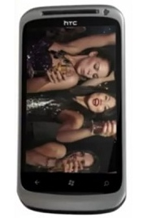  Smart Phone  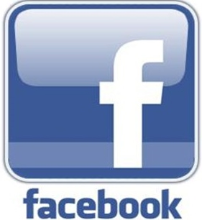  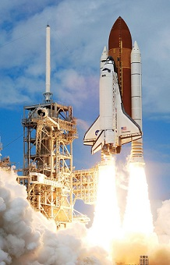  Space Shuttle  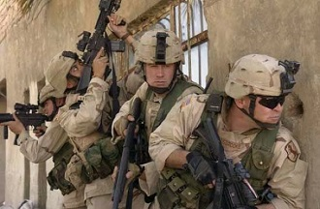  Iraq War  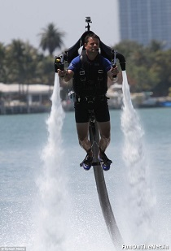  Jetpack  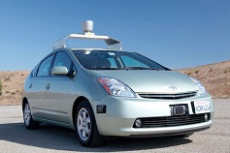  Driverless Car  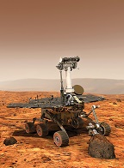  Mars Rover  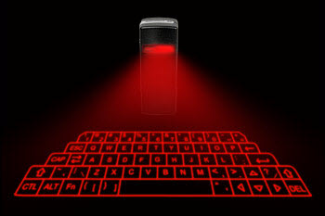  Virtual Keyboard

Year 2014 Facts and Figures
U.S. Population is about 319 million

States with the most population (over 10 million) are:
1 California 38.4 Million
2 Texas 26.5 Million
3 New York 19.7 Million
4 Florida 19.6 Million
5 Illinois 12.9 Million
6 Pennsylvania 12.8 Million
7 Ohio 11.5 Million

The ten largest cities are:
1 New York New York 8.4 Million
2 Los Angeles California 3.9 Million
3 Chicago Illinois 2.8 Million
4 Houston Texas 2.2 Million
5 Philadelphia Pennsylvania 1.5 Million
6 Phoenix Arizona 1.5 Million
7 San Antonio Texas 1.4 Million
8 San Diego California 1.4 Million
9 Dallas Texas 1.3 Million
10 San Jose California 1.0 Million

Life expectancy is about 78.8 years
76.4 years for men and 81.2 for women

Cost of Living: U.S. Hawaii
Average Cost of new house $260,000.00 $724,000.00
Average Household Income per year $52,000.00 $68,000.00
Average Monthly Rent $720.00 $2,200.00
Cost of a gallon of Gas $3.48 $4.22
Average cost of new car $32,000.00 $33,000.00

Okay, I admit that I got a little carried away in these four articles. I originally planned to write about my picks for the ten world’s greatest inventions. It was supposed to be only one article. But, as I researched this topic, I became more and more interested in the history of man (and woman) and the progress made over the years. This led me to adding more stuff to the article which led to more articles. So, anyway, I hope that everybody that reads these learns a thing or two.

It is now time for my top 20 inventions of all-time or at least since us humans roamed the earth.

20. Plow
19. Gun Powder and the Gun
18. Cotton Gin
17. Camera
16. Compass
15. Refrigeration
14. Clock and Calendar
13. Paper and the Printing Press
12. Immunization and Antibiotics (Penicillin)
11. Steam Engine and the Train
10. Telephone
9. Computer and the Internet
8. Radio and Television
7. Boat and Ship
6. Indoor Plumbing (Toilet) with Running Water
5. Airplane
4. Gas Engine and the Automobile
3. Fire (controlling it for heat and cooking)
2. Wheel
The greatest invention in the history of the World is:
1. Electricity

Honorable Mention: BEER

Okay, I know that most of you thought I would have beer as the #1 invention of all time. It is pretty high on my list. What does your list of the 20 greatest inventions look like?

bigdrifter44@gmail.com

