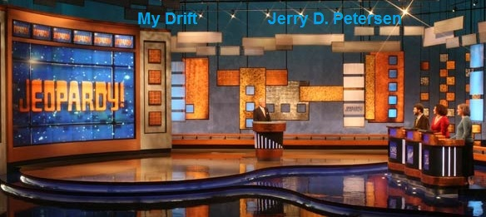

 | Jeopardy!  15 April 2015 | 199-2015-06

The show that I have watched the most on TV is Jeopardy! It is on two times a day every week night and once on Saturdays. I have been watching it for the past 30 years or so. Jeopardy! is a trivia quiz show with a twist. You get the answer clue and have to come up with the correct question. I try to figure out the answers (I mean questions) before any of the three contestants do. This show really tests your overall knowledge of various subjects and keeps your brain active. Although I’m pretty smart, I’m afraid that I would not do that well as a contestant on the show.

History
Merv Griffin created the Jeopardy! quiz game show in 1964. The original daytime version debuted on NBC on March 30, 1964, and aired until January 3, 1975. A weekly nighttime syndicated edition aired from September 1974 to September 1975, and a revival, The All-New Jeopardy! ran on NBC from October 1978 to March 1979. A daily syndicated version premiered on September 10, 1984, and is still on the air.

Both NBC versions and the weekly syndicated version were hosted by Art Fleming. Don Pardo served as the announcer until 1975, and John Harlan announced for the 1978–79 show. Since its inception in 1984, the current daily syndicated version has featured Alex Trebek as host and Johnny Gilbert as the announcer. They are now in their 31st season.

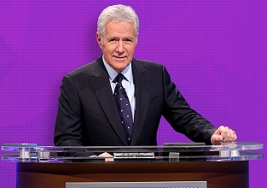 | 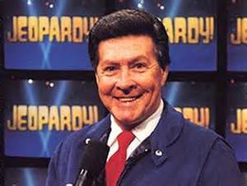
Alex Trebek | Johnny Gilbert

With over 6,000 episodes aired, Jeopardy! has won a record 31 Daytime Emmy Awards and is the only game show to be honored with the Peabody Award. In 2013, the program was ranked No. 45 on TV Guide '​s list of the 60 greatest shows in American television history. Jeopardy! has also gained a worldwide following with regional adaptations in many other countries.

The Jeopardy! Clue Crew, introduced on September 24, 2001, is a team of roving correspondents who appear in videos, recorded around the world, to narrate some of the clues.
The current Clue Crew (Sarah Whitcomb Foss, Jimmy McGuire, and Kelly Miyahara) are pictured on the left.
The Clue Crew has traveled to over 280 cities worldwide, spanning all 50 of the United States, all 7 continents, and at least 44 other countries. In addition to appearing in Jeopardy! clue videos, the team's members also travel to meet fans of the show and future contestants.

How the game is played
Three contestants each take their place behind a lectern, with the returning champion occupying the leftmost lectern (from the viewer's perspective). The contestants compete in a quiz game comprising of three rounds: Jeopardy!, Double Jeopardy!, and Final Jeopardy! The material for the questions covers a wide variety of topics, including history and current events, the sciences, the arts, popular culture, literature, and languages. Category titles often feature puns, wordplay, or shared themes, and the host will regularly remind contestants of topics or place emphasis on category themes before the start of the round.

The Jeopardy! and Double Jeopardy! rounds each feature six categories, each of which contains five clues, which are valued by difficulty. Clue values have risen over time: on the original Jeopardy! series, clue values in the first round ranged from $10 to $50; then from $25 to $125; then from $100 to $500; and since November 2001, they have been from $200 to $1000.

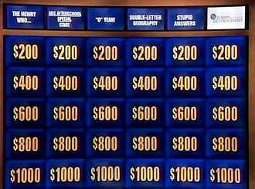
The Jeopardy! Board

The Jeopardy! round begins when the returning champion selects a clue, which may be from any position on the game board. The clue is revealed and read aloud by the host, after which any contestant may ring in using a hand-held signaling device. The first contestant to ring in successfully is prompted to provide a response to the clue, phrased in the form of a question.

The second round, Double Jeopardy!, features six new categories of clues. Clue values are doubled from the Jeopardy! round. The contestant with the least money at the end of the Jeopardy! round makes the first selection in Double Jeopardy!; if there is a tie, the tied contestant standing at the leftmost lectern selects first. One clue hidden on the Jeopardy! board, and two on the Double Jeopardy! board, are called "Daily Doubles", taking their name and inspiration from a horse racing term. Only the contestant who selected the Daily Double clue may respond to that clue. Before the clue is revealed, the contestant must decide how much of their current score to wager, from a minimum of $5 to a maximum of their entire amount (known as a "true Daily Double") or the highest clue value available in the round, whichever is greater. Whether or not the contestant gives a correct question for the Daily Double, the contestant maintains control of the board.

During the Jeopardy! round, except in response to the Daily Double clue, contestants are not penalized for forgetting to phrase their response in the form of a question, although the host will remind contestants to watch their phrasing in future responses. In the Double Jeopardy! round, the phrasing rule is followed more strictly, but contestants are still permitted to correct themselves before their time runs out. If it is determined that a previous response was wrongly ruled to be correct or incorrect, the scores are adjusted at the first available opportunity. If, after a game is over, a ruling change is made that would have significantly altered the outcome of the game, the affected contestant(s) are invited back to compete on a future show.

A contestant who finish Double Jeopardy! with $0 or a negative score is automatically eliminated from the game at that point and awarded the third place prize of $1000. In the event that all three contestants finished Double Jeopardy! with $0 or less, there is no Final Jeopardy! round and the contestants are given no money. This has happened only four times since 1984. Three new contestants are brought in for the next game.

Final Jeopardy!
The Final Jeopardy! round features a single clue. At the end of the Double Jeopardy! round, the host announces the Final Jeopardy! category, and a commercial break follows. During the break, barriers are placed between the contestant lecterns, and each contestant makes a final wager between $0 and their current score (amount). Contestants enter their wagers using a light pen to write on an electronic display on their lectern. After the break, the Final Jeopardy! clue is revealed and read by the host. The contestants have 30 seconds to write their responses on the electronic display, while the show's iconic "Think!" music plays in the background.

Contestants' responses are revealed in order of their pre-Final Jeopardy! scores, beginning with the lowest score. Contestants who provide the correct response receive the values of their wagers, while contestants who fail to provide the correct response, or to phrase their response in the form of a question (even if correct), have that amount subtracted from their scores. The contestant with the highest score at the end of the round is that day's winner. If there is a tie for first place, the tying contestants are co-champions.

Winnings
The top scorer(s) in each game retain the value of their winnings in cash, and return to play in the next match. Non-winners receive consolation prizes. Since May 16, 2002, consolation prizes have been $2,000 for the second-place contestant(s) and $1,000 for the third-place contestant. Since the show does not generally provide airfare or lodging for contestants, cash consolation prizes alleviate contestants' financial burden. The show does provide airfare for returning champions who must make multiple flights to Los Angeles.

Prior to 1984, all three contestants received their winnings in cash. This was changed in order to make the game more competitive, and avoid the problem of contestants who would stop participating in the game, or avoid wagering in Final Jeopardy! rather than risk losing the money they had already accumulated.

Returning Champions
The winner of each episode returns to compete against two new contestants on the next episode. Originally, a contestant who won five consecutive days retired undefeated and was guaranteed a spot in the Tournament of Champions; the five-day limit was eliminated at the beginning of Season 20 on September 8, 2003. If multiple contestants tie for first place, they are declared co-champions; each retains his or her winnings and returns on the following episode.

If no contestant finishes Final Jeopardy! with a positive total, there is no winner. This has happened in a few episodes and three new contestants appear on the following show, and participate in a backstage draw to determine their lectern positions.
Greatest Jeopardy! Champions
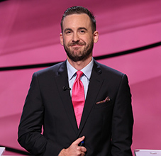  Brad Rutter  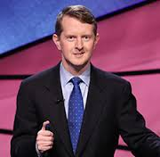  Ken Jennings  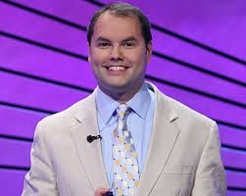  Roger Craig  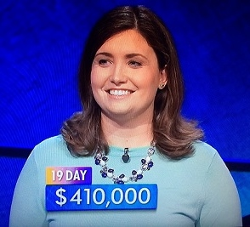  Julia Collins | Brad Rutter first appeared on Jeopardy! in October 2000, when the rules stipulated that a contestant who won five consecutive days retire undefeated and was guaranteed a spot in the Tournament of Champions. Rutter retired as an undefeated 5-day champion with $55,102 in winnings. The rules would be changed in 2003, before Ken Jennings' run of 74 consecutive days in 2004, making Jennings the all-time Jeopardy! money winner. As a 5-day champion, Rutter was invited to several Tournament of Champions where he defeated all other champions. Later he won the Million Dollar Masters Tournament and became the new all-time money winner in Jeopardy! history. In 19 regular season and tournament games, Rutter has never lost a Jeopardy! match against a human opponent. His total winnings so far are $3,385,702.  Ken Jennings won 74 Jeopardy! games (in a row) before he was defeated by challenger Nancy Zerg on his 75th appearance. His total earnings on Jeopardy! so far are $3,196,300 – second most.  Roger Craig holds the all-time record for single-day winnings on Jeopardy! with $77,000. He also hold the highest 5-game total with $195,801. He also holds the record for the largest true daily double bet of $18,000 – that he won. However, when he went up against Rutter and Jennings in the Tournament of Champions – he lost.  Julia Collins had the show's second-longest winning streak after Ken Jennings's record. She won $428,100 for her first 20 games and $1,000 for the 21st, which she lost. She became the biggest female money-winner in show history with her eleventh win.

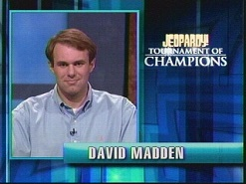 | 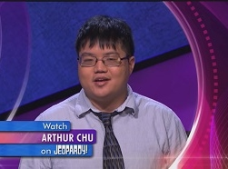 | 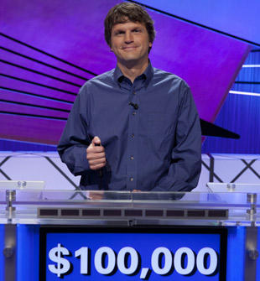
Dave Madden  $430,400 | Arthur Chu  $297,200 | Tom Nissley  $235,405

Watson the IBM Computer
These are all great champions, however, none of them could beat Watson!!!

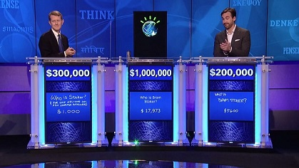 | Watson  IBM Super Computer

Yes, Rutter and Jennings lost big to IBM’s Super Computer named Watson (who was named after the company's founder Thomas J Watson). It consisted of ten racks of ten Power 750 servers that had to be kept apart from the human contestants because of the roar of its cooling system. It was represented at the podium by an avatar of IBM's Smarter Planet logo, whose moving lines would go green when Watson had cracked a thorny problem, orange when the answer was wrong.

While Watson had the questions delivered in text rather than by listening to the host, he played the game like his human counterparts: puzzle over the question, buzz in and give the answer that's most likely to be right. And Watson was right most of the time. He won the game with $77,147 leaving Rutter and Jennings in the dust with $21,600 and $24,000 respectively.

It turned out that the real Jeopardy winning machine was, well, a machine. Three nights, two people, one machine and $1 million to the winner: the victory of IBM's Watson over two human contestants on Jeopardy was the first, and possibly only, time the machine impressed itself on the general public's consciousness.

Watson began life five years before its TV appearance, when IBM Research execs were searching for the next "Grand Challenge" for the company. IBM periodically runs these Grand Challenges, selected projects that pit man against machine, have international appeal, are easy to grasp and attract people into working in science and maths fields. Along with Watson, the Grand Challenges spawned Deep Blue, the machine that famously beat grand master Garry Kasparov at chess.

Other Memorable Moments

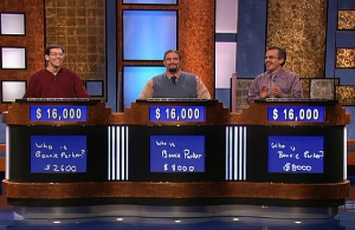
Three-Way Tie
Up until this point, there had never been a three-way tie (that didn't include scores of zero) at the end of Final Jeopardy. But on March 16th 2007, returning champion Scott Weiss figured out his wager to tie the score if both of his competitors bet all of their money and ended up with the correct answer during Final Jeopardy, which they did. All three contestants finished with $16,000, and all three returned for the next show, which was won by Jamey Kirby.

Ken Jennings Loses Game #75 to Nancy Zerg
Those of us who kept watching each week as Ken Jennings kept on winning game after game wondered how it would all end. Would Jennings go down in a blaze of glory, being beaten by thousands of dollars? Would be become overconfident and wager too much? As it happened, it came down to a question that many of us were able to figure out, but eluded the Jeopardy! champion. The question was, "Most of this firm's 70,000 seasonal white-collar employees work only 4 months a year." Jennings was in the lead going into the final round, but answered, "What is Fedex?" The correct answer was H&R Block, which contestant Nancy Zerg answered correctly. Zerg's wager was just enough to beat Jennings, ending his run as the greatest Jeopardy! contestant ever.

Brad Rutter Wins the Ultimate Tournament of Champions
The Jeopardy! Ultimate Tournament of Champions was a huge undertaking that brought in almost 150 past champions and lasted 15 weeks. Ken Jennings got an automatic pass to the finals based on his record-setting streak, where he faced Brad Rutter and Jerome Vered. Rutter had previously won five regular Jeopardy! games, a Tournament of Champions, and a special Million Dollar Masters Tournament. His winnings on Jeopardy! totaled $3,255,102, including the two million he received as the Ultimate Tournament of Champions winner.

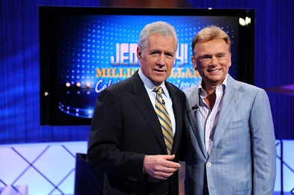
Pat Sajak Hosts Jeopardy!
On April Fool's Day 1997, Pat Sajak and Alex Trebek swapped shows for the day. Sajak held his own on Jeopardy!, and seemed to have a lot of fun with it. Trebek on Wheel of Fortune was also quite good, but it was a relief to see him back on Jeopardy! in the following episode.

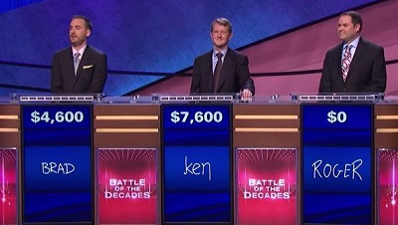
The Battle of the Decades
Jeopardy's Battle of the Decades was a fantastic tournament that brought back contestants from the first 30 seasons of the show (in its current format). It was great to catch up with players that we hadn't seen in years, and watch all of them play once again. In the end, the finalists were Ken Jennings, Brad Rutter, and Roger Craig, and the ultimate winner was Brad Rutter -- which came as no real surprise to anyone.

One Contestant for Final Jeopardy!
As they completed the final question in Double Jeopardy, a woman named Kristin Sausville was in first place by a mile with a total of $8,400. Her second-place competitor Brad was in the red with negative $200, while an unlucky contestant Stephanie took a far third with negative $4,800. "So it's you all by yourself, Kristin," Trebek told the last woman standing. "I think you're going to win the game — it all depends how you handle this Final Jeopardy category: The U.S. Government." The clue: “On August 15, 1994, 59 years after FDR signed the original ACT, Bill Clinton made this an independent agency.” In a particularly anticlimactic moment, Kristin didn't even answer the Final Jeopardy question correctly, losing her wager of $1,600 when she guessed FDIC instead of the Social Security Administration.

Tournaments and other events
Starting in 1985, the show has held an annual Tournament of Champions featuring the top fifteen champions who have appeared on the show since the last tournament. The top prize awarded to the winner was originally valued at $100,000, and increased to $250,000 in 2003. Other regular tournaments include the Teen Tournament, with a $75,000 top prize; the College Championship, in which undergraduate students from American colleges and universities compete for a $100,000 top prize; and the Teachers Tournament, where educators compete for a $100,000 top prize. Each tournament runs for ten consecutive episodes in a format devised by Trebek himself, consisting of five quarter-final games, three semifinals, and a final consisting of two games with the scores totaled. Winners of the College Championship and Teachers Tournament are invited to participate in the Tournament of Champions.

Non-tournament events held regularly on the show include Celebrity Jeopardy! in which celebrities and other notable individuals compete for charitable organizations of their choice; and Kids Week, a special competition for school-age children aged 10 through 12.

How do you become a contestant on JEOPARDY!?
The four basic steps to qualify as a contestant are:
1. Qualify for an "in-person" audition by either passing the Online Test or attending another authorized Jeopardy! contestant event and passing the qualifying test.
2. If you pass the online or other qualifying test and are invited to an "in-person" audition, you will then take another 50 question written test. Your application will be judged based on your “in-person” test score as well as your other test score.
3. Everyone at the audition will play a short version of JEOPARDY! - Three at a time, just like on the actual show, complete with buzzers!
4. Participate in a brief personality interview.

Alex Trebek Bio
Did you know that Alex Trebek is one day older than me? It’s true – he was born on July 22, 1940 in Sudbury, Ontario, Canada. His real name is George Alexander Trebek. A native of Canada, he became a naturalized United States citizen in 1998. | 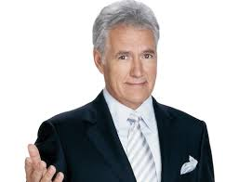

Trebek graduated from Lisgar Collegiate Institute in 1957 before graduating from Toronto's Malvern Collegiate Institute in 1958, and later the University of Ottawa with a degree in philosophy in 1961. As a student at the University of Ottawa, he was a member of the English Debating Society. Interested in a career in broadcast news, he began his broadcasting career working for the CBC as a newscaster and sportscaster.

In 1973, he moved to the United States and went to work for NBC as a game show host. I was surprised how many game shows he hosted over the years – some at the same time he did Jeopardy!. Here is the list:
- The Wizard of Odds (1973-1974)
- Concentration (1973-1978)
- Double Dare (1976-1977)
- The $128,000 Question (1976-1978)
- Pitfall (1981-1982)
- Battlestars (1981-1983)
- Starcade (1982-1984)
- Jeopardy! (1984-Present)
- High Rollers (1987-1988)
- To Tell the Truth (1991)

I don’t remember all of these – besides Jeopardy!, I remember To Tell the Truth and Concentration. I remember the $64,000 Question but not the $128,000 Question.

Trebek has been married to Jean Currivan Trebek since 1990 and they have two children, Matthew and Emily. His former wife is Elaine Callei (1974-1981) – they didn’t have any children.

On January 30, 2004, Trebek escaped major injury after falling asleep behind the wheel of his pickup truck while driving alone on a rural road in the Central Coast town of Templeton, California, returning from a family home in Lake Nacimiento. The truck sideswiped a string of mailboxes, flew 45 feet over an embankment, and came to rest against a utility pole in a ditch. Trebek was not cited for the accident and returned to work taping Jeopardy! the following Tuesday.

On December 11, 2007, Trebek was admitted to Cedars-Sinai Medical Center after suffering a minor heart attack in his home. He was released on December 15, 2007. Trebek returned to the production of Jeopardy! as scheduled on 14 January 2008, to tape the Teen Tournament.

Trebek was robbed in a hotel room in San Francisco on July 27, 2011. While hosting the National Geographic World Championship he told a crowd at Google's HQ that he "snapped an Achilles tendon early Wednesday morning, while chasing a burglar at a San Francisco hotel." He woke up to sounds of a woman in his room going through his things. He said he then got out of bed, put on some clothes and chased the robber down the hall. During the chase, Trebek was injured, but he hobbled back to his room to call security, and the woman was apprehended. He was in a cast for close to six weeks.

Trebek suffered a second mild heart attack on June 23, 2012. However, he returned to the Jeopardy! set on July 24 for filming of the 29th season, after recovery from his heart attack. The 29th season began airing on September 17, 2012.

The Future of Jeopardy!
Alex Trebek currently makes about $10 million dollars a year and is talking about retirement. However, I just heard that Alex Trebek plus Pat Sajak and Vanna White, the hosts of "Wheel of Fortune," all signed a new 2-year contract with Sony Pictures Television keeping them on the air through mid-2018. Just in case you were wondering – Pat Sajak makes about $12 million and Vanna White about $8 million dollars a year.

This is great news!! The two episodes of Jeopardy! are on TV in Hawaii between 4PM and 5PM. The Wheel of Fortune is on at 6:30PM. Me and the dogs like to watch both shows while we are outside in the patio every evening.

Final Jeopardy!
Category: Game Shows
Clue: $15,000 versus $30,000
Correct Response: What is the average total winnings per episode on Jeopardy! versus The Wheel of Fortune?

Some Suggestions
The show Jeopardy! seems to be a little cheap when comparing it to The Wheel of Fortune. They need to start paying airfare and lodging for all contestants. Stop giving consolation prizes of $2000 for second place and $1000 for third place. Give all contestants the money they won. I don’t think there will be a problem with contestants not trying to win when the winner is brought back (expense free) and could go on to win millions of dollars. Make some of the questions (clues) a little easier so that there is a near zero chance of having one contestant or no contestants left for Final Jeopardy!

Did you know that it is possible to win Jeopardy! with $1 dollar if the other two contestants have zero? What is not right about this is he or she will get $2000 for second place and $1000 for third place based on their totals from Double Jeopardy!. The winner only gets $1 dollar. Period!! I think that there should be a “house minimum” where the winner would get at least $3000, second place at least $2000 and third place at least $1000. If all three contestants end up with zero, they each get $1000 dollars.

One more thing that I don’t like during Final Jeopardy! is the “Spelling Rule” on contestant’s written response to the clue. I have seen several contestants lose because of spelling errors even though they knew the correct response. There does not seem to be any written rule that I can find on the Internet, but I have heard Alex Trebek state, “While your spelling can be incorrect, what you have spelled should be possible to pronounce in the same way as the intended correct response.” Sometimes they discriminate against bad spellers like me. I think if you can tell for sure what the contestant wrote down is the correct response, it should be allowed. Make a written rule and let the Jeopardy! judges have the final say.

It is still a great show!

bigdrifter44@gmail.com

