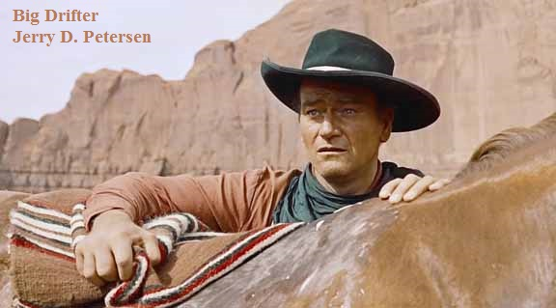

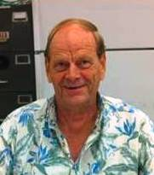 | John Wayne  17 December 2014 | 192-2014-21

Back when I was a kid, western movies and TV shows were very popular. Yes, I grew up in the 1940s and 1950s watching great western shows and I still like them to this day. However, for the past 40 years or so, it has been hard to find a good western on TV or at the movies. I think all of these “reality” TV shows are a bunch of garbage and the last movie I went to in a theater was E.T. the Extra-Terrestrial in 1982. There have been a few good movies come out but I either see them while traveling on airplanes or I wait until they come on TV. Yes, I miss all those exciting cowboy and Indian westerns. One of my favorite actors has always been John Wayne. He is bigger than life, always plays the good guy, and always punches and/or kills the bad guys.

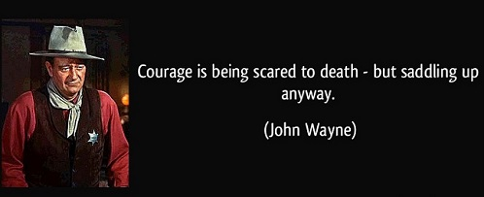

This article will be a John Wayne biography but I hope to dig up a few interesting facts about “The Duke” that maybe you didn’t know.

John Wayne was born Marion Robert Morrison in Winterset, Iowa, on 26 May 1907. He weighed 13 pounds at birth. The home where he was born still exists and has been a museum dedicated to John Wayne for many years, as well as a popular tourist location for Wayne fans from around the world. There has long been some confusion as to John Wayne’s actual birth name. Some claim it was Marion Mitchell Morrison, other claim it was Marion Michael Morrison, and yet others say it was Marion Robert Morrison. John Wayne’s birth certificate, which is on display at the John Wayne Birthplace Museum shows that his birth name was Marion Robert Morrison. When John Wayne’s brother was born, he was named Robert Emmett Morrison, and Wayne’s mother wanted to change Wayne’s middle name to Michael. But his name was never legally changed. He was born Marion Robert Morrison and that was his legal name throughout his entire life. His stage name was John Wayne and he went by this name most of his adult life.

Wayne's family moved west to Palmdale, California in 1916, and then to Glendale, California later that year. A fireman at the station on Marion’s route to school started calling him "Little Duke" because he never went anywhere without his huge Airedale Terrier, “Big Duke”. He preferred "Duke" to "Marion" and the name stuck. Wayne attended Wilson Middle School in Glendale. As a teen, he worked in an ice cream shop for a man who shod horses for Hollywood studios. He was also active as a member of the Order of DeMolay, a youth organization associated with the Freemasons. He played football for the 1924 champion Glendale High School team.

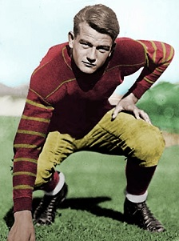 | Wayne applied to the U.S. Naval Academy, but was not accepted. Instead, he attended the University of Southern California (USC) on a football scholarship. He majored in pre-law. He was also a member of the Trojan Knights and Sigma Chi fraternities. He played tackle on the USC football team under Coach Howard Jones. However, a broken collarbone injury curtailed his promising athletic career. Wayne later noted he was too terrified of Jones's reaction to reveal the actual cause of his injury, a bodysurfing accident at Newport Beach. He lost his athletic scholarship and had to leave school. As a favor to the Southern Cal football coach, who had given them free tickets to USC games, director John Ford and silent western film star Tom Mix hired Wayne as a prop boy and as an extra.

By 1926, Wayne had become good friends with director John Ford who started providing him uncredited bit parts in several movies. While working for Fox Film Corporation, Wayne met and became a big fan of Wyatt Earp who he credits for his walk, talk and persona. Wayne also studied the western star Harry Carey’s slow, soulful manner, and the lessons he learned from the accomplished stuntman Yakima Canutt, a former rodeo star. (“I studied him for many weeks, the way he walked and talked and rode a horse and pulled a gun.”) While working in bit roles, his first on-screen credit name was "Duke Morrison" in the film Words and Music (1929). Up to this point, his name was still Marion Morrison with most of his friends calling him “The Duke”.

Wayne’s first breakthrough came in 1930 when director Raoul Walsh cast him in his first starring role in The Big Trail (1930). For his screen name, Walsh suggested "Anthony Wayne", after Revolutionary War general "Mad" Anthony Wayne. Fox Studios Chief Winfield Sheehan rejected it as sounding "too Italian". Walsh then suggested "John Wayne". Sheehan agreed, and the name was set. Wayne was not even present for the discussion. His pay was raised to $105 a week. Marion Morrison liked his new name.

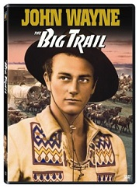 | The Big Trail was the first big-budget outdoor spectacle of the sound era, made at a staggering cost of over $2 million, using hundreds of extras and wide vistas of the American southwest, still largely unpopulated at the time. To take advantage of the breathtaking scenery, it was filmed in two versions, a standard 35-mm version and another in the new 70-mm Grandeur film process, using an innovative camera and lenses. Many in the audience who saw it in Grandeur stood and cheered. Unfortunately, only a handful of theaters were equipped to show the film in 70-mm widescreen format, and the effort was largely wasted. Despite being highly regarded by modern critics, the film was considered a huge box office flop at the time.

After the commercial failure of The Big Trail, Wayne was relegated to bit part roles in small budget pictures, including Columbia's The Deceiver (1931), in which he played a corpse. He appeared in the serial The Three Musketeers (1933) and about 80 horse operas (as Wayne called them) from 1930 to 1939. In Riders of Destiny (1933) he became one of the first singing cowboys of film, albeit via dubbing. John Wayne could not sing! He was mentored by stuntmen in riding and other western skills. Wayne and famed stuntman Yakima Canutt developed and perfected riding stunts and onscreen fisticuffs techniques still used today.

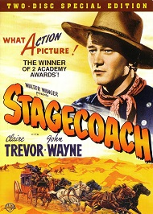 | 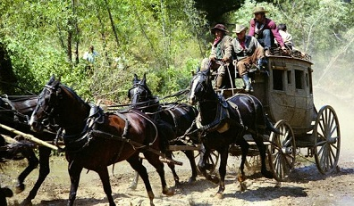

Wayne's big breakthrough lead role came with director John Ford's classic Stagecoach (1939). Stagecoach was a huge financial success and Wayne became a mainstream star. Ford said at the time that Wayne would become the biggest star ever because of his appeal to the common person. This was the start of a long and very successful acting career. From 1929 to 1976, John Wayne acted in about 250 movies including 153 feature films and played the lead in 142 of them. Guinness World Records lists John Wayne as the actor who has the most leading roles in films. Wayne is known for his western movies (84 of them) but he also starred in several war movies (20 of them – 14 are World War II films). He also starred in several disaster, romantic comedy, adventure, and drama movies. I have picked 13 of the Duke’s best movies and listed them below (Stagecoach is above):

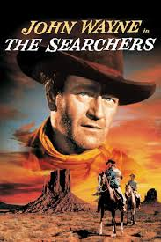 | 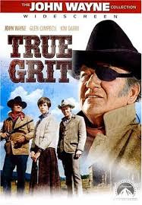 | 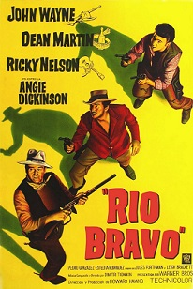 | 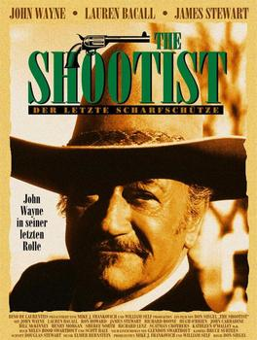
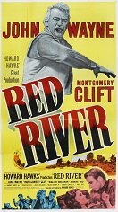 | 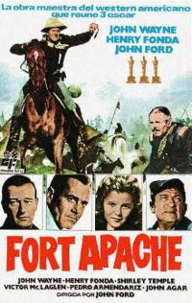 | 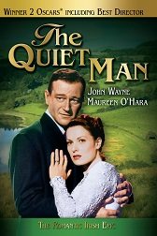 | 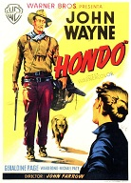
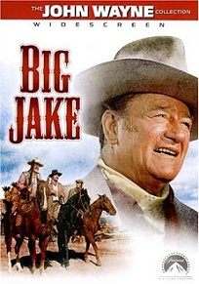 | 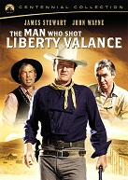 | 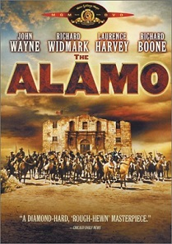 | 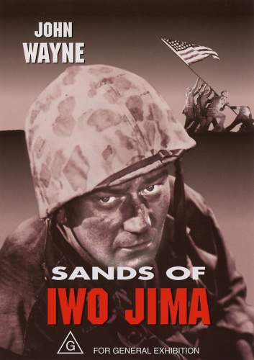

All of these movies are westerns except “The Quiet Man” which is a romantic comedy-drama and the “Sands of Iwo Jima” which is a World War II film.

Below is a little more information about each of these movies:
1. The Searchers (1956) with Natalie Wood and Vera Miles – This is director John Ford’s epic widescreen Western where Ethan Edwards (John Wayne) returns home to Texas after the Civil War only to find out that several members of his family have been killed or abducted by Comanche Indians - he vows to track down his surviving relatives and bring them home. Eventually, Edwards gets word that his niece Debbie (Natalie Wood) is alive so he embarks on a dangerous mission to find her, journeying deep into Comanche territory.
2. True Grit (1969) with Kim Darby and Glen Campbell - As Rooster Cogburn, Wayne won his only best-actor Oscar for this movie. After hired hand Tom Chaney (Jeff Corey) murders the father of 14-year-old Mattie Ross (Kim Darby), she seeks vengeance and hires U.S. Marshal "Rooster" Cogburn (John Wayne), a man of "true grit," to track Chaney into Indian Territory. As the two begin their pursuit, a Texas Ranger, La Boeuf (Glen Campbell), joins the manhunt in hopes of capturing Chaney for the murder of a Texas senator and collecting a substantial reward. The three clash on their quest of bringing to justice the same man. Here is a famous Wayne line in the movie. Bad guy: “I call that bold talk for a one-eyed fat man!” Cogburn: “Fill your hand, you son of a bitch!”
3. Stagecoach (1939) co-stars Claire Trevor, Andy Devine, and John Carradine - Wayne’s breakthrough role came in this landmark John Ford Western playing the Ringo Kid. This movie revolves around an assorted group of colorful passengers aboard the Overland Stagecoach bound for Lordsburg, New Mexico, in the 1880s. An alcoholic philosophizer (Thomas Mitchell), a lady of ill repute (Claire Trevor) and a timid liquor salesman (Donald Meek) are among the motley crew of travelers who must contend with an escaped outlaw, the Ringo Kid (John Wayne), and the ever-present threat of an Apache attack as they make their way across the Wild West.
4. Rio Bravo (1959) with Dean Martin, Ricky Nelson, Walter Brenan, and Angie Dickinson - One of Wayne’s greatest comic performances - typically quiet and light on its feet. He plays a sheriff in charge of a prisoner that a powerful gang wants to break out. Director Howard Hawks has a motley bunch of co-stars (including Dean Martin as a drunkard, a pretty, sharp-shooting Ricky Nelson, Walter Brennan as an old, cranky cripple and a flirty Angie Dickinson) line up to help Wayne, who wants none of it but can’t stop them. This is a completely ridiculous and fun film.
5. The Shootist (1976) with Lauren Bacall and Ron Howard - J.B. Books (John Wayne, in his final film role) is an aging gunfighter diagnosed with cancer who comes to Nevada at the turn of the 20th century. Renting a room from widowed Bond Rogers (Lauren Bacall) and her son Gillom (Ron Howard), Books is confronted by several people of questionable motives, including a man seeking to avenge his brother's death and a few who are looking to profit from Books' notoriety. Not wanting to die a quiet, painful death, Books devises a plan to go out with a bang.
6. Red River (1948) with Montgomery Clift, Walter Brennan and Joanne Dru - One of Wayne’s rare roles as a villain (Tom Dunson), the Captain Bligh of an epic cattle drive staged memorably by Howard Hawks in the great outdoors. Wayne is cast as a tough-as-nails trail master ready to kill to have his way, but his performance is gripping and jaw-clenching. The movie has its silly moments, but it’s impossible not to watch. Wayne’s indomitable stride through a herd of cattle on his way to kill Montgomery Clift is iconic.
7. Fort Apache (1948) with Henry Fonda and Shirley Temple - When arrogant and stubborn Civil War hero Lieutenant Colonel Owen Thursday (Henry Fonda) arrives in Arizona with his daughter, Philadelphia (Shirley Temple), to assume command of the Fort Apache outpost, he clashes with level-headed Captain Kirby York (John Wayne). Viewing the local Native Americans through an ignorantly negative lens, Thursday is determined to engage them in battle for his own glory, despite the warnings of York -- an act of folly that will have dire consequences
8. The Quiet Man (1952) with co-star Maureen O’Hara - Wayne is the title character in this film set in Ireland, an ex-American boxer who has killed a man in the ring. In an attempt to escape his past, Sean Thornton (John Wayne) returns to Ireland to reclaim his homestead. Once he is home, his eye is caught by Mary (Maureen O'Hara), a poor maiden with an ill-tempered older brother named Will. Their relationship is constantly on attack by Will (Victor McLaglen), which forms the main plot line, with Sean's past as the undercurrent.
9. Hondo (1953) with co-star Geraldine Page - Hondo was one of the most successful films of its time shot in 3D. It’s a fairly lean Western, though, as a lone man Hondo Lane, part Apache (Wayne), shows up out of nowhere at the ranch of a mother and her young son in the midst of warring Apaches. Her cowardly husband had deserted them during an Apache attack and Hondo becomes their protector.
10. Big Jake (1971) with Richard Boone, Maureen O'Hara, and Patrick Wayne - The avenging head of the McCandle clan returns to his estranged family and leads the search for his kidnapped grandson. Big Jake (Wayne) sets off, his sons in tow, to deliver the ransom to the kidnappers, but has little intention of handing it over without a fight.
11. The Man Who Shot Liberty Valance (1962) with co-stars James Stewart and Lee Marvin - Questions arise when Senator Stoddard (James Stewart) attends the funeral of a local man named Tom Doniphon (John Wayne) in a small Western town. Flashing back, we learn Doniphon saved Stoddard, then a lawyer, when he was roughed up by a crew of outlaws terrorizing the town, led by Liberty Valance (Lee Marvin). As the territory's safety hung in the balance, Doniphon and Stoddard, two of the only people standing up to him, proved to be very important, but different, foes to Valance.
12. The Alamo (1960) with Richard Boone, Laurence Harvey, and Richard Widmark - In 1836, the Mexican army, led by General Santa Anna, is invading Texas. Hoping to create a diversion for Santa Anna's forces, General Sam Houston (Richard Boone) orders Colonel William B. Travis (Laurence Harvey), joined by Colonels Jim Bowie (Richard Widmark) and Davy Crockett (John Wayne), to lead a small, heroic band of American and Texas fighters in a resistance battle at the Alamo mission. The carnage at the Alamo further spurs the Republic of Texas toward freedom.
13. Sands of Iwo Jima (1949) with John Agar, Adele Mara, and Forrest Tucker - Marine Sgt. John Stryker (John Wayne) is despised by his own men for his rough attitude and exhausting training regimen. As the war in the Pacific progresses, though, they begin to respect Stryker's hard-edged outlook on war and his brutal training methods, as it has helped them prepare for the harsh realities of the battlefield. They'll need all of Stryker's battle tactics if they want to survive what will end up being one of the bloodiest engagements of the war - the Battle of Iwo Jima.

Because his on-screen adventures involved the slaying of a slew of Mexicans, Native Americans and Japanese, he has been called a racist by his critics. This was strengthened by a Playboy Magazine interview (1971) in which he suggested that blacks were not yet qualified to hold high public office because "discrimination prevented them from receiving the kind of education a political career requires".

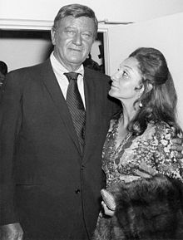  With wife Pilar Pallete | Yet, all three of Wayne’s wives were Mexicans. Wayne was married three times and divorced twice. He was fluent in Spanish and his three wives were Josephine Alicia Saenz, Esperanza Baur, and Pilar Pallete. He had four children with Josephine: Michael Wayne (November 23, 1934 – April 2, 2003), Mary Antonia "Toni" Wayne LaCava (February 25, 1936 – December 6, 2000), Patrick Wayne (born July 15, 1939), and Melinda Wayne Munoz (born December 3, 1940). He had three more children with Pilar: Aissa Wayne (born March 31, 1956), John Ethan Wayne (born February 22, 1962), and Marisa Wayne (born February 22, 1966).

His stormiest divorce was from Esperanza Baur, a former Mexican actress. She convinced herself that Wayne and co-star Gail Russell were having an affair, a claim which both Wayne and Russell denied. The night the film Angel and the Badman (1947) wrapped, there was the usual party for cast and crew, and Wayne came home very late. Esperanza was in a drunken rage by the time he arrived, and she attempted to shoot him as he walked through the front door. She missed!

Wayne had several high-profile affairs, including one with Marlene Dietrich that lasted for three years. After his separation from his wife, Pilar, in 1973, Wayne became romantically involved and lived with his former secretary Pat Stacy until his death in 1979. She published a biography of her life with him in 1983, titled Duke: A Love Story.

Wayne's hair began thinning in the 1940s and he started wearing a hairpiece. He was occasionally seen in public without the hairpiece (notably, at Gary Cooper's funeral). During an appearance at Harvard University, Wayne was asked by a student, "Where did you get that phony hair?" He responded, "It's not phony. It's real hair. Of course, it's not mine, but it's real.

Wayne was a very heavy smoker! He went through 5 packs of unfiltered Camels a day. He also liked to drink - his favorite drink was Sauza Commemorativo Tequila. He had been a chain-smoker of cigarettes since young adulthood and was diagnosed with lung cancer in 1964. He underwent successful surgery to remove his entire left lung and four ribs. Despite efforts by his business associates to prevent him from going public with his illness for fear that it would cost him work, Wayne announced he had cancer and called on the public to get preventive examinations. Five years later, Wayne was declared cancer-free. Wayne has been credited with coining the term “The Big C” as a euphemism for cancer.

Death
On 12 January 1979, Wayne entered the hospital for gall bladder surgery, which turned in to a nine and a half hour operation when doctors discovered cancer in his stomach. His entire stomach was removed. On 2 May 1979, Wayne returned to the hospital, where the cancer was found to have spread to his intestines. He was taken to the 9th floor of the UCLA Medical Center, where President Jimmy Carter visited him, and Queen Elizabeth II sent him a get well card. He went into a coma on 10 June, and died at 5:35 on the evening of the next day. Wayne was buried in the Pacific View Memorial Park cemetery in Corona del Mar, Newport Beach. He requested that his tombstone read "Feo, Fuerte y Formal", a Spanish epitaph Wayne described as meaning "ugly, strong, and dignified". But, Wayne was buried in secret and the grave went unmarked until 1999 because they worried about Vietnam War protesters desecrating the site. It is now marked with a quotation from his controversial 1971 Playboy interview, "Tomorrow is the most important thing in life. Comes into us at midnight very clean. It's perfect when it arrives and it puts itself in our hands. It hopes we've learned something from yesterday."

John Wayne facts, trivia, and other items of interest
Among the cast and crew who filmed the 1956 film “The Conqueror” on location near St. George, Utah, 91 people developed some form of cancer at various times, including stars Wayne, Susan Hayward, and Agnes Moorehead, and director Dick Powell. The film was shot in southwestern Utah, east of and generally downwind from the site of the U.S. Government nuclear weapons tests in southeastern Nevada. Many contend that radioactive fallout from these tests contaminated the film location and poisoned the film crew working there. Despite the suggestion that Wayne's 1964 lung cancer and his 1979 stomach cancer resulted from nuclear contamination, he believed his lung cancer to have been a result of his five-packs-a-day cigarette habit. I find this very interesting since thousands of people living in Utah died of cancer (including my brother) during this time period.

Wayne and his drinking buddy, actor Ward Bond, frequently played practical jokes on each other. In one incident, Bond bet Wayne that they could stand on opposite sides of a newspaper and Wayne wouldn`t be able to hit him. Bond set a sheet of newspaper down in a doorway, Wayne stood on one end, and Bond slammed the door in his face, shouting "Try and hit me now!" Wayne responded by sending his fist through the door, flooring Bond (and winning the bet).

The evening before a shoot he was trying to get some sleep in a Las Vegas hotel. The suite directly below his was that of Frank Sinatra (never a good friend of Wayne), who was having a party. The noise kept Wayne awake, and each time he made a complaining phone call it quieted temporarily but each time eventually grew louder. Wayne at last appeared at Sinatra`s door and told Frank to stop the noise. A Sinatra bodyguard of Wayne`s size approached saying, "Nobody talks to Mr. Sinatra that way." Wayne looked at the man, turned as though to leave, then backhanded the bodyguard, who fell to the floor, where Wayne knocked him out by crashing a chair on top of him. The party noise stopped.

Among his favorite leisure activities were playing bridge, poker, and chess.

He was a Master Mason. He was a good man who became a member of the Masonic Fraternity. What does this mean? I looked it up on the Internet. The qualifications to be a Mason are clear and distinct. There are physical, moral and spiritual qualifications. In California, the petitioner must be a man of at least 21 years of age. He must be free of any previous felonious criminal convictions and be of good moral character. He must also believe in a Supreme Being and the immortality of the soul. The physical qualifications are necessary because the person must be free to make his own life decisions and be responsible for himself. The moral qualifications are self-evident for the viability of any brotherhood and the lofty ideals of our society. The two spiritual qualifications not only inform the entire structure of Freemasonry but also align the Fraternity with the great Mystery Schools and religions of the world. It is the transition from belief to knowledge that seals the mark of true spiritual initiation.

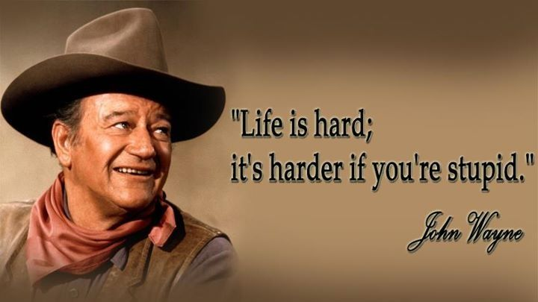

After undergoing major lung surgery in 1964, Wayne would sometimes have to use an oxygen mask to breathe for the rest of his life. An oxygen tank was always kept in his trailer on locations. His breathing problems were particularly severe on airplanes, and while filming True Grit (1969) and Rooster Cogburn (1975), due to the high altitude. No photographs were allowed to be taken by the press of the veteran star breathing through an oxygen mask.

In 1975, for the first time since his arrival in Hollywood 47 years earlier, he did not act in any movies. Production began in January of the following year for his last, The Shootist (1976).

He bought a 135-foot yacht called "The Wild Goose" in 1962. Wayne agreed to make Circus World (1964), a film he hated, just so he could sail the vessel to Europe.

Although never hailed as a great actor in the classic sense, Wayne was quite accomplished on stage in high school. He even represented Glendale High School in the prestigious 1925 Southern California Shakespeare Competition, performing a passage from "Henry VIII".

On 11 June 1979, the flame of the Olympic Torch at the Coliseum in Los Angeles was lit to honor his memory. It remained lit until the funeral four days later.

Fittingly, Wayne was buried in Orange County, the most Republican district in California. The conservative residents admired Wayne so much that they named their international airport after him. It is about four miles from the cemetery where he is buried.

In 1973 he was honored with the Veterans of Foreign Wars highest award - The National Americanism Gold Medal.

Just on his sheer popularity and his prominent political activism, the Republican Party in 1968 supposedly asked him to run for President of the USA, even though he had no previous political experience. He turned them down because he did not believe America would take a movie star running for the President seriously. He did however support Ronald Reagan's campaigns for governor of California in 1966 and 1970, as well as his bid for the Republican presidential nomination in 1976.

Of his many film roles, his personal favorite was that of Ethan Edwards from The Searchers (1956). Wayne even went so far as to name his son Ethan after that character.

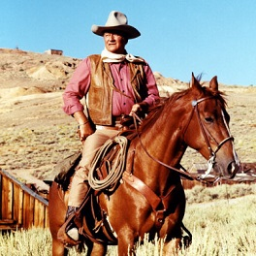

It was no surprise that Wayne would become such an enduring icon. By the early 1960s, his contemporaries Humphrey Bogart, Tyrone Power, Errol Flynn, Clark Gable and Gary Cooper were dead. James Cagney and Cary Grant both retired from acting at 62. The careers of other stars declined considerably - both Henry Fonda and James Stewart ended up working on television series which were canceled on them. Wayne however continued to star in movies until 1976, remaining one of the top ten stars at the US box office until 1974.

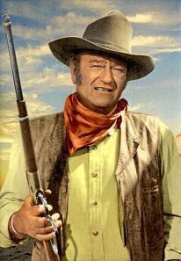 | 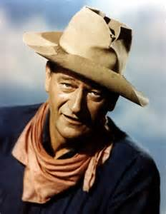 | 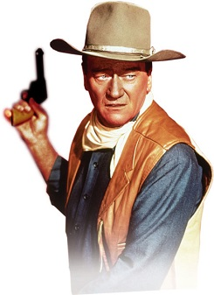

Increasingly by the early 1960s, Wayne used to wear three or four-inch lifts in his shoes, a practice that mystified friends and co-stars like Bobby Darin and Robert Mitchum because he stood 6'4" without them. It was possibly due to his increasing weight, health problems, and age that he wasn't able to loom as tall without lifts.

Wayne directed most of Big Jake (1971) himself because director George Sherman, an old friend from Wayne's days at Republic, was in his mid-60s and ill at the time, and not up to the rigors of directing an action picture in the wilds of Mexico, where much of the film was shot. Wayne refused to take co-director credit. In 1971, owing to the success of Big Jake, Wayne was Number 1 at the US Box Office for the last time.

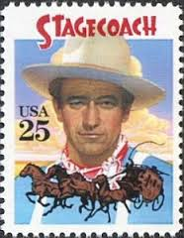 | 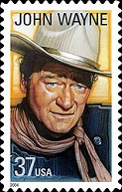 | Wayne was pictured on one of four 25¢ US commemorative postage stamps issued 23 March 1990 honoring classic films released in 1939. The stamp featured Wayne as The Ringo Kid in Stagecoach (1939). The other films honored were Beau Geste (1939), The Wizard of Oz (1939), and Gone with the Wind (1939).  He was also pictured on the 37 cent stamp in 2004 as part of the Legends of Hollywood series.

By the early 1960s, 161 of his films had grossed $350 million, and he had been paid as much as $666,000 to make a movie.

In December 1978, just a month before he was diagnosed with stomach cancer, he joined Bob Hope and Johnny Carson in offering his services to speak out publicly against government corruption, poverty, crime, and drug abuse.

Although it has often been written that Wayne was dying of cancer when he made The Shootist (1976), his final film, this is not actually true. Following the removal of his entire left lung in 1964, he was cancer-free for the next 12 years. It wasn't until Christmas 1978 that he fell seriously ill again, and in January of the following year the cancer was found to have returned.

In 1974, with the Vietnam war still continuing, The Harvard Lampoon invited Wayne to The Harvard Square Theater to award him the "Brass Balls Award" for his "Outstanding machismo and a penchant for punching people". Wayne accepted and arrived riding atop an armored personnel carrier manned by the "Black Knights" of Troop D, Fifth Regiment. Wayne took the stage and ad-libbed his way through a series of derogatory questions showing skill, cleverness, or resourcefulness in handling the situation. He displayed an agile wit that completely won over the audience of students.

After Ronald Reagan's election as Governor of California in 1966, Wayne was exiting a victory celebration when he was asked by police not to leave the building - a mob of 300 angry anti-war demonstrators were waiting outside. Instead of cowering indoors, Wayne confronted the demonstrators head on. When protesters waved the Viet Cong flag under his nose, Wayne grew impatient. "Please don't do that fellows," Duke warned the assembled. "I've seen too many kids your age wounded or dead because of that flag. So I don't take too kindly to it." The demonstrators persisted, so he chased a group of them down an alley.

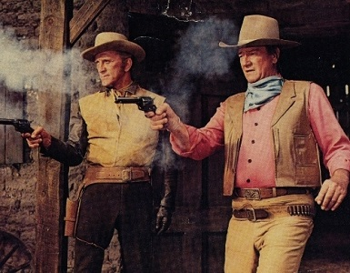
Kirk Douglas and John Wayne appeared in 4 movies together

Posthumously awarded the Presidential Medal of Freedom, the nation's highest civilian award, by President Jimmy Carter in 1980.

While filming True Grit (1969), Wayne was trying to keep his weight off with drugs - uppers for the day, downers to sleep at night. Occasionally, he got the pills mixed up, and this led to problems on a "The Dean Martin Show" (1965) taping in 1969. Instead of taking an upper before leaving for the filming, he took a downer - and was ready to crash by the time he arrived on the set. "I can't do our skit," Wayne reportedly told Martin when it was time to perform. "I'm too doped up. Goddamn, I look half smashed!" Naturally, Martin didn't have a problem with that. "Hell, Duke, people think I do the show that way all the time!" The taping went on as scheduled.

In 1978, after recovering from open heart surgery, Wayne had a script commissioned for a film called "Beau John" in which he would star with Ron Howard, but due to his declining health it never happened.

On 20 August 2007, the Republican Governor of California Arnold Schwarzenegger and First Lady Maria Shriver announced that Wayne will be inducted into the California Hall of Fame located at The California Museum for History, Women and the Arts in Sacramento on 5 December 2007.

His spoken word RCA Victor album "America: Why I Love Her" became a surprise best-seller, and Grammy nominee, when it was issued in 1973. Re-issued again, in the wake of September 11, 2001, it became a best-seller all over again.

Despite his association with being solely Irish, he was equal parts Scottish, Irish and English.

One of the most unusual Oscar moments happened when major liberal Barbra Streisand presented Vietnam War hawk Wayne with his Best Actor Oscar at the 42nd Annual Academy Awards (1970).

Wayne was a member of the National Rifle Association (NRA).

In 1973 he was awarded the Gold Medal from the National Football Foundation for his days playing football for Glendale High School and USC.

According to Michael Munn's "John Wayne: The Man Behind the Myth", in 1959, Wayne was personally told by Nikita Khrushchev, when the Soviet Premier was visiting the United States on a goodwill tour, that Joseph Stalin and China's Tse-tung Mao had each ordered Wayne to be killed. Both dictators had considered Wayne to be a leading icon of American democracy, and thus a symbol of resistance to Communism through his active support for blacklisting in Hollywood, and they believed his death would be a major morale blow to the United States. Khrushchev told Wayne he had rescinded Stalin's order upon his predecessor's demise in March 1953, but Mao supposedly continued to demand Wayne's assassination well into the 1960s.

While visiting the troops in Vietnam in June 1966, a bullet struck Wayne's bicycle. Although he was not within a hundred yards of it at the time, the newspapers reported he had narrowly escaped death at the hands of a sniper.

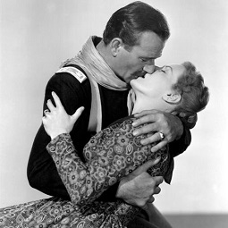  Maureen O'Hara presented him with the People's Choice Award for most popular motion picture actor in 1976 | 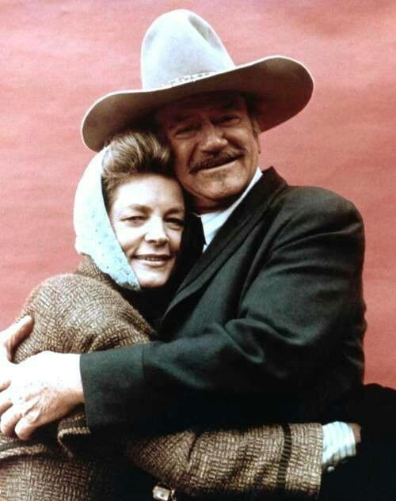  John Wayne and Lauren Bacall co-star together in Blood Alley and the Shootist

Maureen O’Hara starred with John Wayne in no less than 5 movies: Rio Grande (1950), The Quiet Man (1952), The Wings of Eagles (1957), McLintock! (1963) and Big Jake (1971). The first three were directed by their mutual pal John Ford.

Lauren Bacall once recalled that while Wayne hardly knew her husband Humphrey Bogart at all, he was the first to send flowers and good wishes after Bogart, a heavy smoker, was diagnosed with esophageal cancer in January 1956.

Wayne did not serve during World War II, unlike many of his peers including William Holden, James Stewart, Clark Gable, Tyrone Power, and Henry Fonda. This has long been controversial, especially in light of his right-wing political views and his unwavering support for the Vietnam War. This has led to accusations that he was a draft dodger. During the Vietnam War he criticized young men who went to Canada and Europe to dodge the draft, calling them cowards, and strongly criticized Jane Fonda and Donald Sutherland for their anti-war activism. America's entry into World War II resulted in a deluge of support for the war effort from all sectors of society, and Hollywood was no exception. Wayne was exempted from service due to his age (34 at the time of Pearl Harbor) and family status, classified as 3-A (family deferment). He repeatedly wrote John Ford saying he wanted to enlist but when he was reclassified as 1-A (draft eligible), he did not enlist. He was busy making movies and Republic Pictures threatened Wayne with a lawsuit if he walked away from his contract. Wayne toured U.S. bases and hospitals in the South Pacific for three months in 1943 and 1944 with the USO. By many accounts, Wayne's failure to serve in the military was the most painful experience of his life. He tried to make up for it by making a lot of World War II movies like the Green Berets (1968) and the Sands of Iwo Jima (1949). Five more of Wayne’s best war movies include In Harm’s Way, The Longest Day, They Were Expendable, Fly Leathernecks, and The Wings of Eagles.

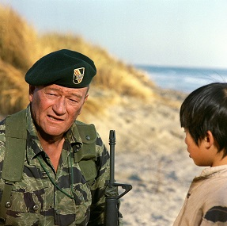 | 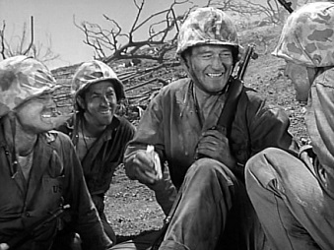

Well pilgrim, I hope you have learned a few things about John Wayne who I think was a great American and one of the most popular actors of all-time.

bigdrifter44@gmail.com

