My Drift | 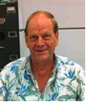  Jerry D. Petersen | March Madness  March 20, 2013  (156-2013-06)

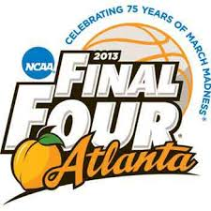 | 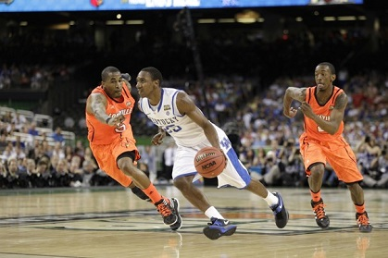
Sports Illustrated came out with a special edition magazine naming their picks for the 10 greatest NCAA Basketball Tournament players. They must have done a good job researching their picks because for once I agree with their selections. Most of these great basketball players played back in the 1950’s, 1960’s, and 1970’s. Hey, that was back in the old days when I used to play a little basketball!! Back then, the good basketball players went to college for four years. Back then, incoming college freshman had to play on the freshman team and could only play three years on the varsity team. Back then, you could not play in the NBA until your college class graduated (4 years). Back then, there was none of this “one and done” stuff like you are seeing now days at Kentucky and other big name programs. In fact, now days you don’t even have to attend college – great players like Kobe Bryant and LeBron James never went to college. I’m sure that if they had went to college for 3 or 4 years, they would be on the 10 greatest NCAA Tournament players list – but they didn’t. Back then, they played a better quality and higher level game of basketball in the NCAA “March Madness” Tournament. However, college basketball is still good and it is fun to watch and I think the NCAA Tournament is the greatest sporting event going.

The 2013 NCAA Men's Division I Basketball Tournament will involve 68 teams playing in a single-elimination tournament to determine the national champion of men's NCAA Division I college basketball. It is scheduled to begin on March 19, 2013 and will conclude with the championship game on April 8 at the Georgia Dome in Atlanta. This year will also mark the 75th edition of the NCAA Men's Basketball Tournament.

One of the primary reasons this is such a great tournament is the fact they let in the best teams from small and mid-major conferences. All 347 schools from the 32 Division I conferences have a chance to win the national championship. Well, it’s a very long shot for most teams but at least it is a chance and in that first week where all teams play, there are always big upsets. I enjoy this first week of basketball the most. In college football, there are only 2 or 4 teams that have a chance to win the national championship. If you are a mid-major conference football team, you have no chance to win a championship. We all know that most of the big basketball schools will win but every year there emerges a “Cinderella” team that knocks off the big boys in a few of the games. It is great entertainment.

We will get back to this year’s tournament and my bracket picks in a little while, but let’s list those 10 greatest NCAA Tournament players and provide a few statistics and some personal information about each one.

#10 Jerry West (6 feet 2 inches – 185 pounds – Guard/Forward)  College: West Virginia Mountaineers  NCAA Tournament Years: 1958, 1959, and 1960  Nickname: Zeke from Cabin Creek (Mr. Clutch come later in the pros)  Team Record:  1958 – Upset by Manhattan 89-84 in the first round.  1959 – Lost to California in the championship game 71-70.  1960 – Lost in the second round to NYU in overtime 82-81.  Accomplishments: In 1959, West averaged 32 points and 13.6 rebounds and was named the Most Outstanding Player of the NCAA Tournament. In 1960, he was first team All-American and let the lead the U.S. Olympic team to the gold medal.  Personal Note: In high school, I followed Jerry West and pattern my jump shot after his. I also decided I wanted number 44 on my jersey. | 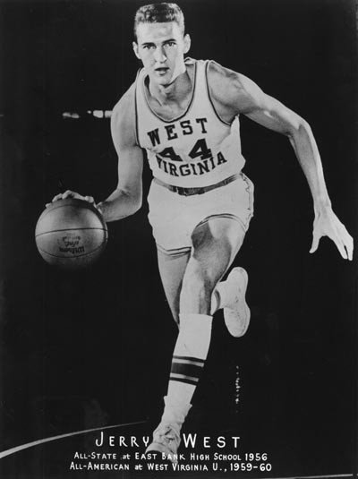

#9 Christian Laettner (6 feet 11 inches – 235 pounds – Forward/Center)  College: Duke Blue Devils  NCAA Tournament Years: 1989, 1990, 1991, and 1992  Team Record: Duke made it to the Final Four all four years Laettner played and he was a starter all four years.  1989 – Lost to Seton Hall 95-78: Michigan won the championship.  1990 – Lost to UNLV in championship game 103-73.  1991 – Beat Kansas 72-65 to win the NCAA championship.  1992 – Beat Michigan 77-71 to win the NCAA championship.  Accomplishments: Best known for that last-second, back-to-the-basket, turn-around, game-winning jump shot giving Duke a 104–103 victory over Kentucky in the 1992 East regional final – this game was picked as the "greatest college basketball game ever played." Laettner was the 1991 Final Four Most Outstanding Player and the 1992 AP player of the year. He was the only college player on the Olympics “Dream Team”. | 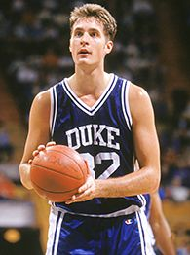

#8 Magic Johnson (6 feet 9 inches – 220 pounds – Point guard)  College: Michigan State Spartans  NCAA Tournament Years: 1978 and 1979  Team Record:  1978 – Lost to eventual national champion Kentucky.  1979 – Beat Indiana State University 75-64, which was led by Larry Bird in what was the most-watched college basketball game ever.  Accomplishments: Most Outstanding Player of the 1979 Final Four.  Personal Notes: The 1979 Final Four site was Salt Lake City on the University of Utah basketball court where I played college basketball for three years. I was routing for Indiana State and Bird who was white and a great shooter against Johnson who was flashy and a great all-around player. Magic had 24 points, 5 assists, and 7 rebounds leading Michigan State to victory. Over the years I grew to like the outgoing Magic more than the introverted grumpy Bird. | 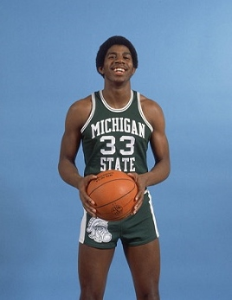

#7 Bill Bradley (6 foot 5 inches, 205 pounds, Guard/Forward)  College: Princeton Tigers  NCAA Tournament Years: 1963, 1964 and 1965  Team Record:  1963 – Bradley scored 40 in loss to St. Joseph's 82-81 in first round.  1964 – Again lost in the first round to Villanova 74-62.  1965 – Scored 58 points to beat Wichita State 118-82 for third place in the Final Four.  More Individual Accomplishments:  - 1965 National Player of the year  - 1965 Final Four Most Valuable Player  - Three time All-American and Olympics Team Captain  - NBA All-Star and two time NBA champion  - Rhodes scholar and elected to the U.S. Senate  Little Known Fact: Turned down Duke to attend Princeton. | 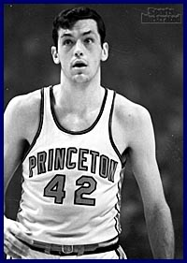

#6 Wilt Chamberlain (7 feet 1 inch, 275 pounds, Center)  College: Kansas Jayhawks  NCAA Tournament Years: 1957 and 1958  Team Record:  1957 – Lost to North Carolina 54-53 in triple overtime.  1958 – Failed to make the NCAA tournament.  Individual Accomplishments:  - Most Outstanding Player in the 1957 tournament  - Scored 52 points in his first college game  - Set many college and pro scoring and rebound records  - Four time Most Valuable Player in the NBA  Little Known Fact: In 1959, Wilt played for the Harlem Globetrotters.  Note: For more information about Wilt Chamberlain, read my article dated 13 Mar 2013. | 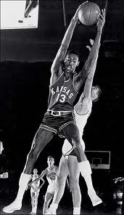

#5 Larry Bird (6 feet 9 inches, 220 pounds, Small Forward)  Nickname: "The Hick from French Lick”  College: Indiana State Sycamores  NCAA Tournament Years: 1977, 1978 and 1979  1977 and 1978 – Indiana State didn’t make it to the tournament  1979 – Lost 75-64 to Michigan State in the championship game.  Individual Accomplishments:  - Averaged 30.3 points a game for his 3 year college career  - 1979 college player of the year – 2 time All-American First Team  - 12 time NBA All-Star – 3 time NBA MVP  - Played on 3 NBA championship teams  - Scored over 20,000 points  Little Known Fact: Bird was recruited by Bob Knight to play at Indiana but he only lasted 24 days before deciding this was not the place he wanted to play basketball. | 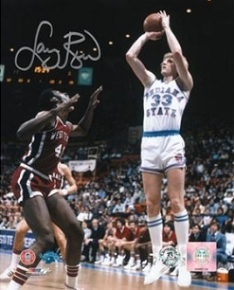

#4 Oscar Robertson (6 feet 5 inches, 220 pounds, Shooting Guard)  Nickname: “The Big O”  College: Cincinnati Bearcats  NCAA Tournament Years: 1958, 1959 and 1960  1958 – Lost to Kansas State 83-80 in the Midwest Regional  1959 – Lost to Cal 64-58 in first round of Final Four  1960 – Lost to Cal 77-69 in first round of Final Four  Accomplishments:  - Averaged 33.8 points a game for his 3 year college career  - 3 time All-American and college player of the year  - 1964 NBA MVP - 12 time NBA All-Star  - Teamed with as Kareem Abdul-Jabbar as the Milwaukee Bucks beat the Baltimore Bullets for his only NCAA or NBA title.  Little Known Fact - Robertson left college as the all-time leading NCAA scorer – this lasted until Pete Maravich topped him in 1970. | 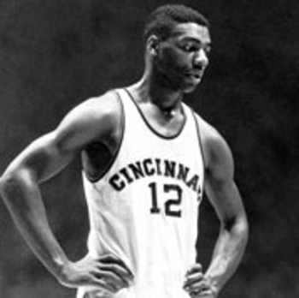

#3 Bill Russell (6 feet 10 inches, 220 pounds, Center)  College: University of San Francisco Dons  NCAA Tournament Years: 1954, 1955 and 1956  1954 – Did not play in tournament  1955 – Beat La Salle 77-63 to win the National Championship  1956 – Beat SMU 86-68 and Iowa 83-71 to win the Championship  Accomplishments:  - 1955 Final Four Most Outstanding Player  - Lead USF to 55 consecutive victories  - Averaged 20.7 points and 20.3 rebounds a game in college  - Once blocked 13 shots in one game  - 11 time NBA Champion playing for the Boston Celtics  - 5 time NBA MVP  Little Known Fact: Russell represented USF in track and field events where he run the 440 in 49.6 seconds. He was also one of the world’s best high jumpers with a mark of 6 feet 91⁄4 inches. | 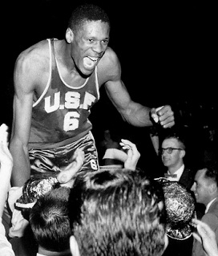

#2 Bill Walton (7 feet 0 inches, 250 pounds, Center)  Nickname: “The big redhead”  College: UCLA Bruins  NCAA Tournament Years: 1972, 1973 and 1974  1972 – Beat Florida State 81-76 to win the National Title  1973 – Beat Memphis State 87-62 to win the National Title  1974 – Lost to North Carolina State 80-77 in 2OT in semi-finals  Accomplishments:  - 3 time college player of the year and first team All-American  - 1972 and 1973 NCAA tournament Most Outstanding Player  - Part of the school's 88-game winning streak that ended with a 71–70 loss to the University of Notre Dame Fighting Irish  - 2 time NBA champion and MVP  Little Known Fact: Walton broke an ankle, a leg, and several bones in his feet and underwent knee surgery while in high school. He fought injuries and severe pain his entire basketball career. | 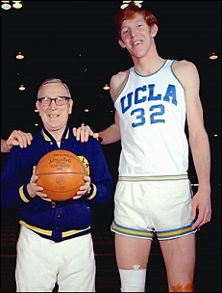

#1 Lew Alcindor (7 feet 2 inches, 225 pounds, Center)  College: UCLA Bruins  NCAA Tournament Years: 1967, 1968 and 1969  1967 – Beat Dayton 79-64 to win the National Title  1968 – Beat North Carolina 78-55 to win the National Title  1969 – Beat Purdue 92-72 to win the National Title  Accomplishments:  - 3 times NCAA Tournament Most Outstanding Player  - 3 times National player of the year and All-American  - His three-year record at UCLA was 88 wins and 2 losses  - 6 time NBA champion and MVP  - 19 time NBA All-Star  - 2 NBA scoring champion (1971–1972)  - NBA rebounding champion (1976)  - 4 time NBA blocks leader (1975–1976, 1979–1980)  Little Known Facts: He was born Ferdinand Lewis Alcindor, Jr., on April 16, 1947, and grew up in Manhattan in New York City. He was raised as a Roman Catholic and attended St. Jude School of Manhattan. Later in life, he converted to Islam and changed his name to Kareem Abdul-Jabbar. | 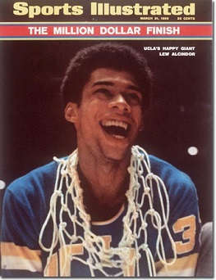

I listed these players in the exact same order they were listed in SI. The only change I would make is to move Christian Laettner up a few spots since his team (Duke) did win two championships during Laettner’s four years. However, Laettner was kind of a “jerk” and a lot of people didn’t like him or Duke during his years there. He was not the best player on the team most of those years. On second thought, let’s leave him where he is at on the list.

The NCAA tournament starts this week as I finish writing this article. The 68 teams were selected this past Sunday and the bracket madness has started. The #1 seeds this year are Louisville in the Midwest, Indiana in the East, Gonzaga in the West, and Kansas in the South. I think there are about 10 teams that could win the championship this year – in addition to the four one seeds, Miami, Georgetown, Florida, Ohio State, Duke, and New Mexico have a good chance. I’m picking Louisville, Miami, Georgetown, and New Mexico to make it to the Final Four and Louisville to win the tournament. My bracket sheet is attached to this article.

The games start tonight. Let’s go find a sports bar. It is going to be a great three weeks. Enjoy.

bigdrifter44@gmail.com

http://bigdrifter.com/



