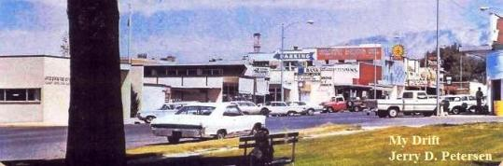

 | 90  November 21, 2007

I recently took a vacation to Utah to celebrate my mother’s 90th birthday. My sister Linda and her daughter Jolyn planned the Open House where family and friends of my mother could come and wish her a happy 90th birthday. They had invitations printed up and placed one in the local newspaper. The Open House was held at Jolyn and Mark Whittaker’s house where about 100 people showed up for the big shindig. Food and drinks were served, pictures were taken and many memories were exchanged. Jolyn and Mark have a beautiful large house and are the perfect hosts. They even insisted that my daughter Derrah stay at their house for the week.

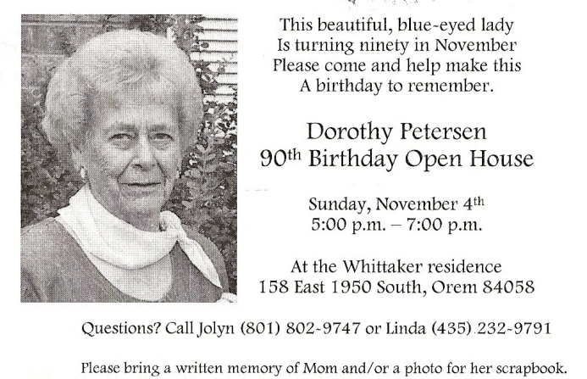

Derrah brought the Hawaiian Leis that mom, Linda, Jolyn, and Anne are wearing in the pictures below. My son Mike flew in for the event with a big box full of macadamia nuts and candy for all of the family. He had a rent-a-car and was our primary chauffeur for the week. In addition to the Open House, we had a family dinner at the Outback Steak House on her actual birthday - November 8th. Some of the things we did at the Outback were to give mom her birthday presents and sing Happy Birthday. We were also asked to write down on a piece of paper one memory of mom that stands out in our minds. Most of the people at the table wrote down a long sentimental story of how mom had touched their lives. Me, the non-sentimental son, wrote down, “Fishing at Gooseberry”.

Well, I decided to do a little better job of writing down a few memories of my mother.

My mother likes to play games. She plays with me, my sister Linda, the Grandkids, the Great Grandkids, and her friends. Whenever you go to my mother’s place, you get lots of good food to eat and play games. When I go home to Utah, we sit and play games for hours every day. The games we normally play are Up and Down, 3-13, Rook, Crazy Eight, Rack-o, Yahtzee, and Poker. We play Poker for money and all the games are very competitive. These sessions also give us a chance to talk about things happening in our life.

I usually put on an extra 5 or 6 pounds every time I visit my mother. She fixes three meals a day and I can’t pass up the deserts. A typical breakfast consists of scrambled eggs, bacon, hash brown potatoes, toast with home-made jelly, milk, juice, and coffee. (I make the coffee) At my mother’s house there is no such thing as lunch. We have breakfast, dinner, and supper. Mom makes a hamburger, potato, and bean casserole that is delicious. For supper we usually have something like soup and a sandwich. I can’t go to bed at night without having pie and a big bowl of ice cream.

My mother also likes to gamble. Hey, this is playing more games. When I’m in Utah, we usually take a trip out to Wendover, Nevada and spend the night at the Stateline Casino (it is now called the Nugget). Mom likes to play the slot machines the best and seems to do quite well. I like to play Blackjack and bet on the games in the Sports Bar. Mom takes the bus out to Wendover every once in awhile. A lot of older or retired people take the bus out in the morning, gamble all day, and return in the evening. I went with my mother on the bus one time. We caught the bus in Salt Lake and the trip out to Wendover was okay. They played Bingo and had drawings for small prizes on the trip out. But the trip back was pure hell. It snowed all day and our bus driver must have been drinking all day because he was all over the highway during the trip back to Salt Lake City. We were very lucky to make it. To make matters worse, when we reached Salt Lake, he pulled the bus into a parking lot of a restaurant and disappeared. This parking lot was about 10 miles from where we left the car and caught the bus. We were stranded and had to call a taxi to get to our car. I will never take the bus to Wendover again. My mother said that this was the first and only time in thirty years that something like that happened. Just my luck!

We also go to the Horse Races in Evanston, Wyoming whenever we can. Usually we would invite Uncle R and his wife Evelyn and meet them at the races. Mom would pack a lunch and we would drive to Evanston and have a picnic in the Park. The horse races are always fun and sometimes we would even win some money. After the races, we would have dinner at one of the local restaurants and the person who won the most money would pay the bill.

I think my mother used to catch more fish than me or my dad. I remember some of our fishing trips to Loa Ponds, Stinking Springs, Deer Creek, Fish Lake, and (my favorite) Gooseberry Lake. We always caught fish and had a good time. Most of the fish we caught were Rainbow Trout. I don’t like to eat fish that much but my mother fixes and cooks them in a way that makes them very good to eat. She removes all the bones and skin and rolls them in flour before frying.

For some reason, I don’t remember much about my early childhood but I do remember a few things like playing with our dog Jack, sleigh riding, milking the cow, and working in the garden. Every year it was my job to dig and clear the irrigation ditch above the pasture and garden. I remember our water turns in the middle of the night where mom, dad, and I were out there making sure everything gets water. We had a lot of animals at the old house like horses, chickens, pigs, cows, cats, and sheep. I remember one sheep that would follow mom around like it thought she was its mother. I remember a bull we had that kept getting out of the pasture and mom and I would chase it all over the neighborhood trying to get it back in the yard.

During the hot summers, our family would go up American Fork Canyon on a regular basis for picnics and sit around and play games where it was cool. Mom would put together the food and we put the drinks and the watermelon in the river to keep it cold. American Fork Canyon is very scenic and only a few miles away from Pleasant Grove where we lived.

I could always depend on my mother whenever I had a problem of any kind. Whether I needed advice or money, she was always there to help me. As you probably know, I’m not good at expressing my thanks or my feelings to anybody but I hope my mother knows that I love her.

Here are two pictures of mom with me and with my sister Linda that I like and took to the Open House for mom’s scrapbook.

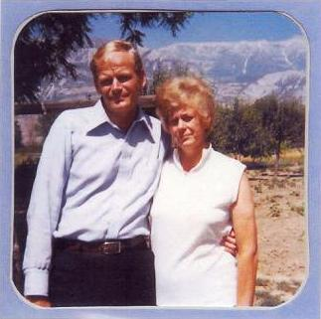 | 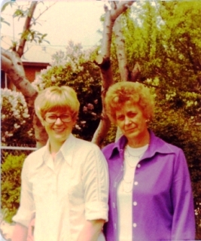

Now, 35 years later, mom still looks good at 90 and I got old. Here are a few pictures taken at the Open House.

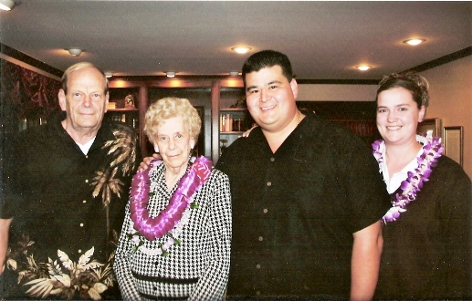
Me, Mom, Mike, and Anne

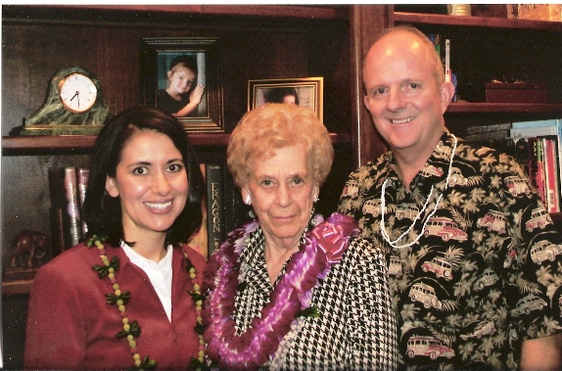 | 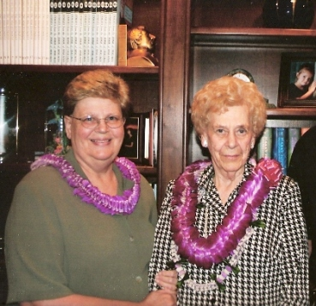
Jolyn, Mom, and Mark | Linda and Mom

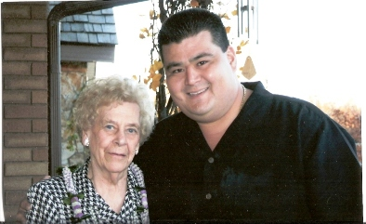 |  | 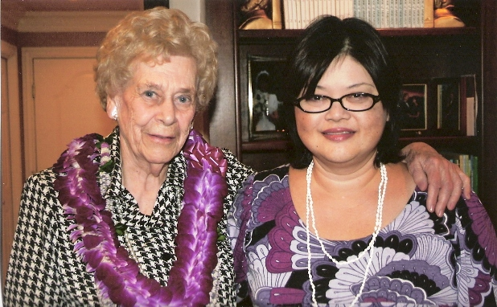
Mom and Mike | Mom and Derrah

We managed to work in several other activities during my 10 day visit. My friend Albert picked me up at the airport and we went out to Wendover for one night. We had a good time and I actually won a little money on my football bets. Mike, me and my friend Lew went out one night to play some pool. It was fun and was a close competition between me and Mike. We were tied at four games each until I went on to win the last two games. Mike got to see the inside of the Pleasant Grove Pool Hall for the first time. We drove up to Park City one day to check out a time-share property Mike is interested in buying. We met Uncle R and Aunt Eve at Maddox in Brigham City for lunch one day. Uncle R’s real name is Cambron and he is my dad’s brother. While we were eating, Aunt Eve (a big Utah Jazz fan) spotted Frank Layden (a former coach and president of the Jazz) at a nearby table and she went over to talk to him. She brought him back to our table and he told us a couple of funny stories.

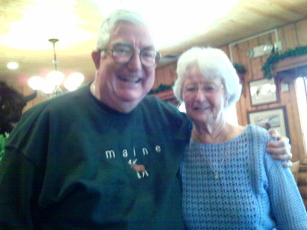 | 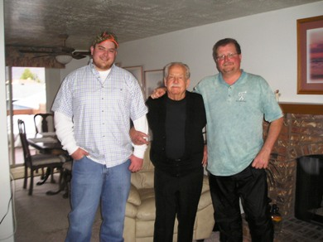
Frank Layden and Aunt Eve | Uncle R with Son and Grandson

Speaking of the Jazz, Mike purchased four tickets and we (Mike, me, Linda’s son Ryan, and Anne’s husband James) went to see the Jazz play the Cleveland Cavaliers. This was first time I ever saw LeBron James in person. We (Mike, me, Linda’s husband Bill, and Jolyn’s son Zach) also went to see BYU play TCU in football. It was a good game that BYU won.

Since this was Derrah’s first trip to Utah in 30 years, we took her sight seeing a couple of times. We purchased some flowers and went to the Pleasant Grove Cemetery and placed them on dads and my two brothers (John and Scott) graves. They have a new monument near the cemetery honoring all of the Pleasant Grove people who have served in the military. We found my name and my dads name there.

The rest of the time was spent visiting, playing games, and eating. It was a good trip. One closing thought - I hope I inherited my longevity genes from my mother’s side of the family.

bigdrifter44@gmail.com

