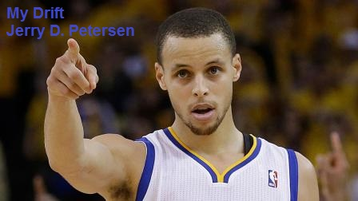

 | NBA MVP Players  22 May 2015 | 203-2015-10

The NBA playoffs are going on as I write this article. There have been many great games this year with many good players. One of my favorite teams is the Golden State Warriors and their best player is Stephen Curry (pictured at the top). They just announced that Curry has been named the National Basketball Association Most Valuable Player (MVP) for the 2014-2015 season. He beat out James Harden (Houston Rockets) and LeBron James (Cleveland Cavaliers) who came were second and third in the voting.

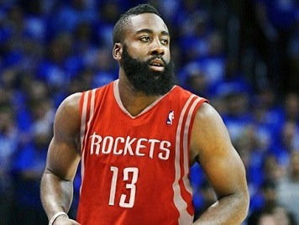 | 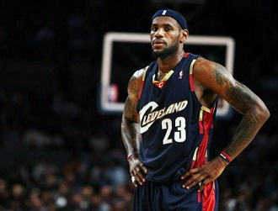
James Harden | LeBron James

A lot of people think the MVP award goes to the best player each year. This is not necessarily true. If it was, LeBron James would win it every year since he is considered the greatest player in the world currently playing basketball. Here is what it says on Wikipedia (the Internet online encyclopedia):

The National Basketball Association Most Valuable Player (MVP) is an annual National Basketball Association (NBA) award given since the 1955–56 NBA season to the best performing player of the regular season. The winner receives the Maurice Podoloff Trophy, which is named in honor of the first NBA commissioner (then president) of the NBA who served from 1946 until his retirement in 1963. Until the 1979–80 season, the MVP was selected by a vote of NBA players. Since the 1980–81 season, the award is decided by a panel of sportswriters and broadcasters throughout the United States and Canada, each of whom casts a vote for first to fifth place selections. Each first-place vote is worth 10 points; each second-place vote is worth seven; each third-place vote is worth five, fourth-place is worth three and fifth-place is worth one. Starting from 2010, one ballot was cast by fans through online voting. The player with the highest point total wins the award.

Here is a better definition of the NBA MVP:
The initials stand for Most Valuable Player. Get that? Most Valuable Player - not the Best Player. Otherwise, the award should have been called the “Best Player” award. This award is given to the Most Valuable Player of an NBA team. It is not given to the Best Player in the NBA. In summation, the most valuable player is the absolute best player on that team. No arguments. No negotiations. Cut and dry. Simple. Yet, this is where many people disagree with the final winner.

How do they determine who is the most valuable player on the team?
A) Statistics – points, rebounds, assists, steals, blocks, field goal percentage, free throw percentage, minutes played, games played, and three point shooting percentage. That along with PER (Player Efficiency Rating), EFF (efficiency), and TS% (True Shooting Percentage).
- The PER is a rating of a player's per-minute productivity.
- The EFF is a composite statistic derived from basic individual statistics: points, rebounds, assists, steals, blocks, turnovers and shot attempts.
- TS% measures a player's efficiency at shooting the ball - It is a more accurate shooting percentage because two-point and three-point field goals and free throws are all considered in its calculation. Here is the formula:
PTS
TS% = -----------------------------
2 (FGA + (0.44 X FTA))

Where:
PTS = points scored
FGA = field goal attempts
FTA = free throw attempts

Let’s compute the TS% for Steph Curry – He scored 1900 points on 1341 field goal attempts and 337 free throw attempts. Do the arithmetic and you will find out that Curry’s TS% is 63.8% which is 7th highest in the NBA. Harden was 24th with a TS% of 60.6% and James was 61st with a TS% of 57.7%.

B) Team record – The most valuable player has to be on a squad that has at least 55 wins at the end of the regular season. That team is usually one of the best teams in the NBA that year. The team record has to show win improvement from the previous year.

C) Impact – This is also known as the “EYE TEST.” Watch the games. Do not watch just one game. Watch as many as you can. Examine how the player is getting the job done. Look at his teammates. Then think, “Who does more with less?” Most importantly, observe how the player is taking over games. That is all. These are the ABCs of the MVP. Statistics tell 50% of the story. Watching the games gives the other half to form the entire picture.

How does one maintain MVP candidacy?
- Player has to make the All-Star team. If player does not make it, he is no longer an MVP candidate.
- If player misses 11 or more games by the end of the season, then he is not considered the MVP. The MVP doesn’t get hurt and miss games.

Lastly, just in case you were wondering, there is no such thing as “Co-MVPs”. If the point total comes out the same, the NBA has several tie-breakers.

The best players do win most of the MVP awards. Starting on the next page is a list of all of the MVP winners along with some of their statistics. You can look at this table or skip past it to where I will present more statistics.
MVP | All-  Star | NBA  Titles | Player Name | Position /  Height /  Weight | Team(s) /  Season(s)
6 | 19 | 6 | Kareem Abdul-Jabbar | Center  7-2  225 lbs | Los Angeles Lakers  1979-80, 1976-77, 1975-76  Milwaukee Bucks  1973-74, 1971-72, 1970-71
5 | 14 | 6 | Michael Jordan | Guard  6-6  216 lbs | Chicago Bulls  1997-98, 1995-96, 1991-92, 1990-91,  1987-88
5 | 12 | 11 | Bill Russell | Center  6-9  215 lbs | Boston Celtics  1964-65, 1962-63, 1961-62, 1960-61,  1957-58
4 | 13 | 2 | Wilt Chamberlain | Center  7-1  275 lbs | Philadelphia 76ers  1967-68, 1966-67, 1965-66  Philadelphia Warriors  1959-60
4 | 11 | 2 | LeBron James | Forward  6-8  250 lbs | Miami Heat  2012-13, 2011-12  Cleveland Cavaliers  2009-10, 2008-09
3 | 12 | 3 | Larry Bird | Forward  6-9  220 lbs | Boston Celtics  1985-86, 1984-85, 1983-84
3 | 12 | 5 | Magic Johnson | Guard  6-8  225 lbs | Los Angeles Lakers  1989-90, 1988-89, 1986-87
3 | 12 | 1 | Moses Malone | Center  6-10  220 lbs | Philadelphia 76ers  1982-83  Houston Rockets  1981-82, 1978-79
2 | 15 | 5 | Tim Duncan | Center  6-11  255 lbs | San Antonio Spurs  2002-03, 2001-02
2 | 14 | 0 | Karl Malone | Forward  6-9  250 lbs | Utah Jazz  1998-99, 1996-97
2 | 8 | 0 | Steve Nash | Guard  6-3  178 lbs | Phoenix Suns  2005-06, 2004-05
2 | 11 | 1 | Bob Pettit | Forward  6-9  205 lbs | St. Louis Hawks  1958-59, 1955-56
1 | 11 | 0 | Charles Barkley | Forward  6-9  220 lbs | Phoenix Suns  1992-93
MVP | All-  Star | NBA  Titles | Player Name | Position /  Height /  Weight | Team(s) /  Season(s)
1 | 17 | 5 | Kobe Bryant | Guard  6-6  205 lbs | Los Angeles Lakers  2007-08
1 | 13 | 6 | Bob Cousy | Guard  6-1  175 lbs | Boston Celtics  1956-57
1 | 8 | 2 | Dave Cowens | Center  6-9  230 lbs | Boston Celtics  1972-73
1 | 2 | 0 | Stephen Curry | Guard  6-3  185 lbs | Golden State Warriors  2014-15
1 | 6 | 0 | Kevin Durant | Forward  6-9  235 lbs | Oklahoma City Thunder  2013-14
1 | 11 | 1 | Julius Erving | Forward  6-6  200 lbs | Philadelphia 76ers  1980-81
1 | 15 | 1 | Kevin Garnett | Center  6-11  253 lbs | Minnesota Timberwolves  2003-04
1 | 11 | 0 | Allen Iverson | Guard  6-0  165 lbs | Philadelphia 76ers  2000-01
1 | 5 | 2 | Bob McAdoo | Forward  6-9  210 lbs | Buffalo Braves  1974-75
1 | 13 | 1 | Dirk Nowitzki | Forward  7-0  245 lbs | Dallas Mavericks  2006-07
1 | 15 | 4 | Shaquille O'Neal | Center  7-1  325 lbs | Los Angeles Lakers  1999-00
1 | 12 | 2 | Hakeem Olajuwon | Center  7-0  255 lbs | Houston Rockets  1993-94
1 | 7 | 2 | Willis Reed | Center  6-9  235 lbs | New York Knicks  1969-70
1 | 12 | 1 | Oscar Robertson | Guard  6-5  205 lbs | Cincinnati Royals  1963-64

MVP | All-  Star | NBA  Titles | Player Name | Position /  Height /  Weight | Team(s) /  Season(s)
1 | 10 | 2 | David Robinson | Center  7-1  235 lbs | San Antonio Spurs  1994-95
1 | 3 | 0 | Derrick Rose | Guard  6-3  190 lbs | Chicago Bulls  2010-11
1 | 5 | 1 | Wes Unseld | Forward  6-7  245 lbs | Baltimore Bullets  1968-69
1 | 2 | 2 | Bill Walton | Center  6-11  210 lbs | Portland Trail Blazers  1977-78

Did you take a look at the complete MVP player list? Since I love statistics, I took the time to analyze it and come up with some interesting facts:

- There have been five players that won the MVP four or more times:
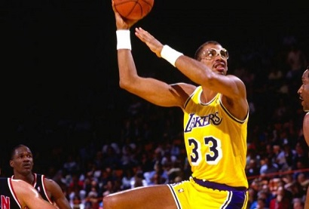  Kareem Abdul-Jabbar (6 MVPs) |  | 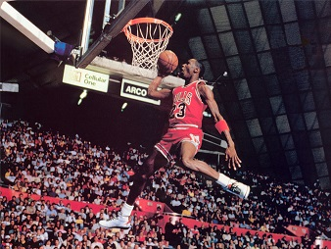  Michael Jordan (5 MVPs)
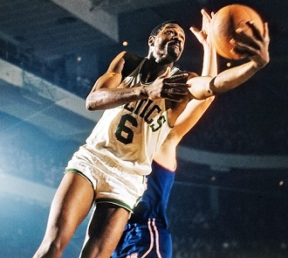  Bill Russell (5 MVPs) | 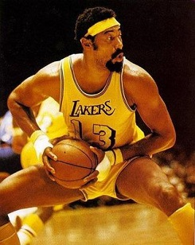  Wilt Chamberlain (4 MVPs) |  | 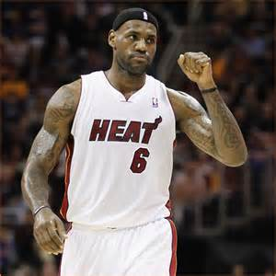  LeBron James (4 MVPs)

- There have been 31 different players who have won the MVP award since it started after the 1955-1956 season.
- Here is the breakout by player’s primary position:
  - 12 Centers
  - 10 Forwards
  - 9 Guards
- There are 7 MVP players who never won an NBA title during their career: Karl Malone, Steve Nash, Charles Barkley, Stephen Curry, Kevin Durant, Allen Iverson, and Derrick Rose.

- Two of the best players that never won an NBA title are Karl Malone and John Stockton who played for the Utah Jazz for 18 and 19 years respectively. | 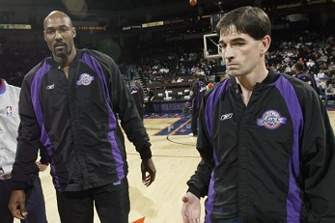

- The tallest MVP is Kareem Abdul-Jabbar at 7 feet 2 inches.

- The shortest and lightest MVP is Allen Iverson at 6 feet even and 165 pounds. The current MVP, Steph Curry, is the third smallest player at 6 feet 3 inches and 185 pounds. Second smallest MVP is Bob Cousy at 6 feet 1 inch and 175 pounds.

- The heaviest MVP is Shaquille O'Neal at 325 pounds. Second heaviest MVP is Wilt Chamberlain at 275 pounds.

- There are 3 MVP players that won it for 2 different teams:
  - Kareem Abdul-Jabbar (Milwaukee Bucks and Los Angeles Lakers)
  - Moses Malone (Houston Rockets and Philadelphia 76ers)
  - LeBron James (Cleveland Cavaliers and Miami Heat)

- MVP players who were NBA All-stars the most times are Kareem Abdul-Jabbar (19 times) and Kobe Bryant (17 times).
- MVP players who won the most NBA titles are Bill Russell (11 times), Bob Cousy, Kareem Abdul-Jabbar, and Michael Jordan (Each with 6 NBA titles).

- Best player to never win the NBA MVP is Jerry West. He led the Lakers to the NBA Finals in nine of his 13 seasons, was a 10-time All-Star and All-NBA First Team selection. During West’s prime years in the ’60s, no one was touching the NBA MVP Award unless your last name was Russell or Chamberlain, who combined for eight in 10 years (1960-69) with Oscar Robertson and Wes Unseld claiming the other two. | 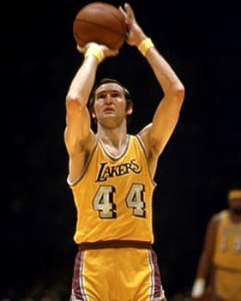

- Some other great players who never won the NBA MVP include Rick Barry, John Stockton, Elgin Baylor, and George Mikan (Where was no MVP award when he played).

My favorite NBA team is the Utah Jazz but they didn’t made the playoffs this year. Come to think about it, they have not made the playoffs for several years. My favorite teams that are in the playoffs are the Golden State Warriors and the Los Angeles Clippers. The Clippers have two players that could win a future MVP award – Chris Paul and Blake Griffin.

Enjoy the NBA Playoffs – Basketball is a great sport.

bigdrifter44@gmail.com

