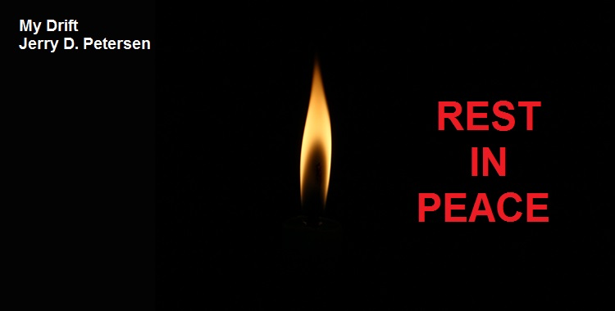

 | Obituaries  17 Sep 2015 | 210-2015-17

On Friday, September 4, 2015, I was going through the StarAdvertiser newspaper obituaries when I discovered something very rare and unusual – there were eleven (11) obituaries that stated, “There are no known survivors”. I see one or two of these every week or so but 11 in one day really got my attention and got me thinking about these poor souls with no family to take care of the funeral arrangements and other required death actions.

Here are the obituaries:
Curtis Allen  March 16, 2015  Curtis Allen, 71, of Kailua died in Kailua. There are no known survivors. Contact Moanalua Mortuary for more information.  Seth A. Bareiss  Oct. 5, 2014  Seth A. Bareiss, 90, died in Honolulu. There are no known survivors. Contact Moanalua Mortuary for more information.  Kady Kundet  Feb. 25, 2015  Kady Kundet, 61, died in Wahiawa. There are no known survivors. Contact Moanalua Mortuary for more information.  Elizabeth Malland  Jan. 2, 2015  Elizabeth Malland, 48, died in Honolulu. There are no known survivors. Contact Moanalua Mortuary for more information.  Limuel K. Nichols  Feb. 4, 2015  Limuel K. Nichols, 51, died in Honolulu. There are no known survivors. Contact Moanalua Mortuary for more information.  James Toves  April 9, 2015  James Toves, 55, of Waipahu died in Waipahu. There are no known survivors. Contact Moanalua Mortuary for more information. | Susan Anderson  Dec. 6, 2014  Susan Anderson, 55, died in Honolulu. There are no known survivors. Contact Moanalua Mortuary for more information.  Karen R. Hayashi  May 23, 2015  Karen R. Hayashi, 68, died in Honolulu. There are no known survivors. Contact Moanalua Mortuary for more information.  Robert Lievan  March 3, 2015  Robert Lievan, 71, of Wahiawa died in Wahiawa. There are no known survivors. Contact Moanalua Mortuary for more information.  Dena Marie Morris  Oct. 10, 2014  Dena Marie Morris, 67, died in Honolulu. There are no known survivors. Contact Moanalua Mortuary for more information.  John G. Petrosius  Feb. 27, 2015  John G. Petrosius, 72, of Waipahu died in Waipahu. There are no known survivors. Contact Moanalua Mortuary for more information.

Look at the ages of these people – (48, 51, 55, 55, 61, 67, 68, 71, 71, 72, and 90) It appears that people with no family die at a young age. There is only one person (Seth A. Bareiss) older than me. Yes, I do read the obituaries every day. I started doing this a few years ago when a couple of my friends died and I was looking for their obituaries in the newspaper every day. After that, I decided that me and most of my friends were getting old and could drop dead anytime. So, I go through the obituaries looking for people I might know and I check the ages to see if these people dropping dead are younger or older than me. Actually, when I started doing this, there were a lot more people older than me but now that I have turned 75, there are about an equal number of people younger than me. I also find somebody I know every two or three weeks. When I think about it, I do know a lot of people from friends, relatives, from working for the government and the private sector, playing basketball, ping pong, bowling, golf, and from all the bars I have stopped at for a cold beer or two.

What happens when a person dies who has no known survivors? As you might have guessed, most unclaimed bodies are homeless people. However, with that said, there are plenty of people out there with no immediate family, especially today, with the soaring rate of divorce, smaller family sizes and the increasing number of unmarried men and women. If you are one of these people and you have a home and some money, you better have a will or trust specifying who is going to get your stuff. Otherwise, all of the proceeds from your estate will go to the state and the assets will be distributed by the Probate Court according to the state's laws of descent. Usually, a notice of unclaimed property is published to give possible relatives an opportunity to respond. If no heirs are found, assets go into the state's general fund. The deceased's possessions are sold, with proceeds going to the fund and any real estate titles transferred to the state.

The moral of this story is – If you have a weird neighbor up the street who never seems to have any company (friends or family), you better be nice to this person because he or she may die with no known survivors and leave a million dollars, the house, and everything else to you.

At any given time, there are about 50 unclaimed bodies stashed away at Oahu’s mortuaries. Actually, there used to be a lot more bodies then that at these mortuaries. In 2013, a new law was passed that sets rules for unclaimed remains. Hawaii funeral homes, mortuaries and crematories are now protected from liability if they want to dispose of these unclaimed bodies. This law provides procedures and legal guidelines to dispose of remains. Funeral establishments had argued the problem needed to be addressed because no regulations existed and the bodies were stacking up. They were afraid of being sued if they disposed of a body and later a family member showing up to claim the body.

The average cost of a funeral in Hawaii is approximately $10,000. This includes the casket and the funeral service - It does not take into account cemetery plot costs. A full service cremation service costs approximately $4,000. However, a simple cremation without a service can be conducted for about $1,000. Well, that new law we talked about requires the state government to pay the mortuary $800 for each unclaimed body. For this amount, the mortuary must cremate and dispose of the remains. Spreading the person’s cremated dust in the ocean is the preferred method. As you have probably figured out by now, that money given to these mortuaries comes from us taxpayers. But, I am not complaining.

Honolulu’s homeless don’t usually die with dignity. Not only do they pass away at much younger ages than the rest of the population, but their demise is often the result of substance abuse, poor health or violence. It seems like every other week they are finding a dead homeless person floating in the ocean or the Ala Wai Canal. What happens to this body? Let’s do a little case study and find out:
1. The police are called to the scene and they try to determine if foul play was involved.
2. The body is then taken to the city Department of the Medical Examiner where they try to determine the cause of death.
3. The Medical Examiner has an investigator who attempts to identify the dead person and to locate any family or friends who might know this person.
4. Sometimes the deceased has left no trace of a past and finding next of kin can be impossible.
5. When all avenues are exhausted, the body is turned over to a local mortuary for cremation and disposal. The mortuary must follow the state law in doing this.

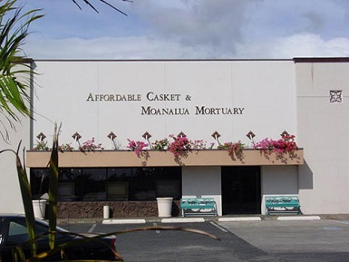 | The mortuary of choice for unclaimed bodies seems to be the Affordable Casket & Moanalua Mortuary located in Mapunapuna across the canal from the Kaiser Permanente Building (Formerly the CERIDIAN Building) and the closed Bob’s Big Boy restaurant. This is a big warehouse building that can hold a lot of dead bodies.

If the investigator determines that the dead unclaimed person is a US military veteran, their ashes are interred in a columbarium at the Oahu Veterans Cemetery in Kaneohe or at the National Memorial Cemetery of the Pacific at Punchbowl. Yes, the remains are placed in individual niches where they rest beside other veterans who have served their country. At least these remains can rest there in peace and with dignity.

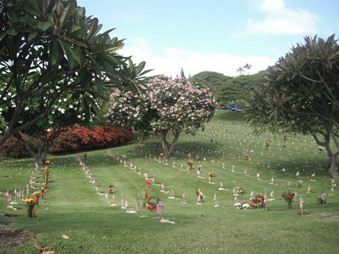
Oahu Veterans Cemetery in Kaneohe

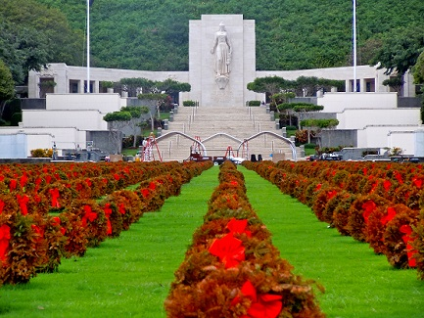
National Memorial Cemetery of the Pacific at Punchbowl

My obituary - Just for the record, I don’t plan on kicking the bucket anytime soon but here is a sample Obituary just in case. I guessed at the dates!!

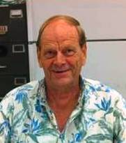
JERRY DELBERT PETERSEN

September 17, 2030
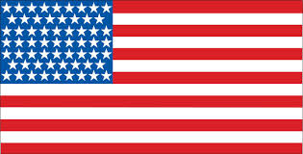
Jerry Delbert Petersen, age 90, passed away at his home in Mililani, Hawaii surrounded by his family (and dogs) on Tuesday, September 17, 2030. He was born on July 23, 1940 in American Fork, Utah to Delbert and Dorothy Petersen. Jerry grew up and attended grade and high school in Pleasant Grove, Utah. In 1958, he was an All-State basketball player for Pleasant Grove High School and went on to attend and play basketball for the University of Utah in Salt Lake City. He joined and served in the Navy from October 1961 to February 1966. After that, he went to work as a Computer Programmer for the Federal Government at Tooele Army Depot located in Tooele, Utah. In June 1970, Jerry took a job at Fort Shafter, Hawaii and moved to Honolulu. On December 9, 1972, he married Patsy Yashiki of Honolulu and together raised four children – Derrah, Toni, Tracy, and Michael. Jerry enjoyed traveling TDY to Korea and Japan as part of his job. He also enjoyed his trips back to Utah to visit family and friends. Jerry liked playing several sports including basketball, bowling, golf, swimming, and ping pong. Some of his other hobbies included programming his own computer games, maintaining his website, writing articles on various subjects, and handwriting analysis. He is survived by his son, Michael and daughters Toni and Tracy (Doleski) along with four grandchildren. Funeral services will be held on October 1, 2030 at the National Memorial Cemetery of the Pacific (Punchbowl) in Honolulu.

A Brief History of the Obituary
The word “obituary” is from the Latin word “obit”, meaning death. The word obituary has been used to refer to published death notices since the 18th century. An obituary is a short news article that reports the recent death of a person, typically along with an account of the person's life and information about the upcoming funeral. In large cities and larger newspapers, obituaries are written only for people considered significant. In local newspapers, an obituary (with a picture) may be published for any local resident upon death. Two types of paid advertisements are related to obituaries. One, known as a death notice, omits most biographical details and may be a legally required public notice, which is the case in Hawaii and most other states. The other type is a paid memorial advertisement, usually written by family members or friends, perhaps with assistance from a funeral home. This obituary contains a picture of the person and biographical details of the person’s life. Both types of paid advertisements usually appear in the Obituary Page of the newspaper.

Conclusions
Okay, I know that we married people with kids get a little jealous sometimes when we see our single friends out playing golf 3 or 4 times a week, bowling multiple nights a week, hitting the bars whenever they feel like it and going to Las Vegas on a regular basis. Here we are tied down trying to make a living, trying to keep the wife or husband happy, running the kids all over the island for different sports and various events, plus taking care of any pets we might have. Yes, much of the time, we are too busy living our lives to have much fun.

Well, cheer up folks, there are many joys to married life and raising a few kids can be quite enjoyable and interesting. There are also a few fringe benefits to being married with kids such as living longer than our single friends. It is also comforting to have family around to help you in your old age and to take care of the funeral arrangements when you die. Providing you treat your children well, you will not end up as an “unwanted body” stashed away for who knows how long in a dark back room at the Affordable Casket & Moanalua mortuary.

bigdrifter44@gmail.com

