 | Prostitution  31 Oct 2015 | 214-2015-21

Have you been following the Lamar Odom saga? Just in case you don’t know whom Lamar Odom is, here is a picture and a short recap:

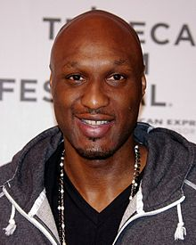 | The 6’10” Lamar Joseph Odom is a former professional basketball player. As a member of the Los Angeles Lakers, he won NBA championships in 2009 and 2010 and was named the NBA Sixth Man of the Year in 2011. Odom also played for the LA Clippers, Miami Heat, and the Dallas Mavericks.  He was born on November 6, 1979 (age 35), in South Jamaica, New York City, NY. Odom had three children, Destiny, Lamar Jr. and Jayden with his ex-girlfriend Liza Morales. He married Khloe Kardashian in 2009.

Lamar Odom was rushed to a Las Vegas hospital after being found unconscious and "foaming at the mouth" on Tuesday, October 13, 2015, at the Love Ranch Brothel in Crystal, Nevada where he had paid $75,000 for a four-day stay. The Love Ranch said Odom told at least one of the women when he arrived on Saturday that he had used crack cocaine earlier in the day. And he bought and used 10 different sexual stimulants plus herbal Viagra during his stay, according to a brothel spokesman.

The latest report I saw said Odom was in a coma and fighting for his life. His wife Khloe Kardashian and other family members were at his bedside. So, anyway, this incident got me thinking about prostitution in Nevada, the United States, and the World. In this article, I’m going to provide a lot of facts and statistics (as usual) along with a few comments including my views on legalizing prostitution in the United States.

State of Nevada Prostitution
There are currently 24 active legal brothels in Nevada. While prostitution is legal in parts of Nevada, it is illegal outside these licensed brothels. Prostitution is illegal under state law in Clark County, which contains Las Vegas and its metropolitan area. Other counties may choose to allow it, if they desire to. Currently Washoe County (which contains Reno and Carson City), Douglas County, and Lincoln County ban brothels. Eureka County has no law on the books either permitting or prohibiting licensed brothels and currently has no brothels. The other counties permit brothels, but some of them do not currently have any active brothels. Here is a list of active brothels by county and closest town (most of these brothels are out in the middle of nowhere):

County: Elko  Town: Carlin  Dovetail Ranch  Sharon's Brothel & Bar  Town: Elko  Inez's D&D Bar  Mona's Ranch  Sue's Fantasy Club  Town: Wells  Bella's Gentlemen's Club  (Previously called Hacienda Ranch)  Donna's Ranch  County Humboldt  Town: Winnemucca  Villa Joy brothel  Pussy Cat Saloon and Brothel  County: White Pine  Town: Ely  Big 4 Ranch  Stardust Ranch | County: Lander  Town: Battle Mountain  Calico Club  County: Lyon  Town: Mound House  The Love Ranch  Moonlite Bunny Ranch  Sagebrush Ranch  County: Mineral  Town: Mina  Wild Cat Brothel  County: Nye  Town: Amargosa Valley  Alien Cathouse  County: Storey  Town: Patrick  Mustang Ranch  County: Lander  Town: Crystal  Love Ranch Vegas  Town: Pahrump  Chicken Ranch  Sheri's Ranch

Nevada Brothel Map
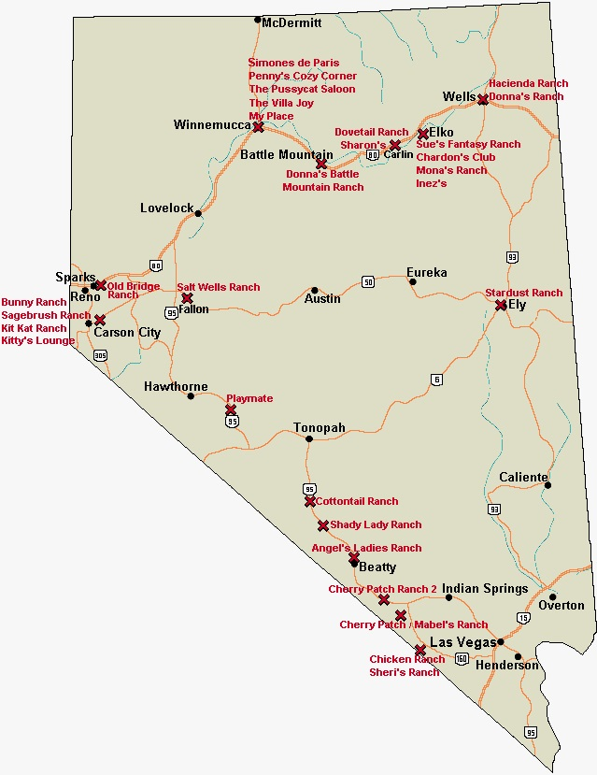

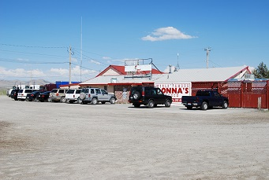 | 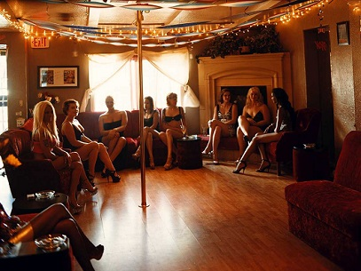
Donna’s Ranch in Wells, Nevada | Brothel Greeting Room

Just because prostitution is illegal in Las Vegas, it doesn’t mean there are no prostitutes. In Vegas, clients use expensive escort services which promise to have a sexy “escort” at your room in 30 minutes or less. Did you know that there are more escort services listed in the telephone book than any other category? There are 120 pages of them!! Attorneys and Lawyers are next with 4,290 entries. If you want to get out of your room and find your own entertainment, you can visit one of the 35 gentleman’s “strip” clubs. Plus, if you have a lot of money, don’t worry, the “call girls” will find you.

History of Prostitution in the United States
The Old West
In the nineteenth century (the 1800s), a woman who owned property, made high wages, had sex outside of marriage, used birth control, consorted with men of other races, danced, drank, or walked alone in public, wore makeup, perfume, or stylish clothes -- and was not ashamed -- was probably a prostitute.

In fact, prostitutes won virtually all the freedoms that were denied to women but are now taken for granted. Prostitutes were especially successful in the wild, lawless, thoroughly renegade boomtowns of the West. When women were barred from most jobs and wives had no legal right to own property, madams in the West owned large tracts of land and prized real estate. Prostitutes made, by far, the highest wages of all American women. Several madams were so wealthy that they funded irrigation and road-building projects that laid the foundation for the New West. Decades before American employers offered health insurance to their workers, madams across the West provided their employees with free health care. While women were told that they could not and should not protect themselves from violence, and wives had no legal recourse against being raped by their husbands, police officers were employed by madams to protect the women who worked for them, and many madams owned and knew how to use guns.

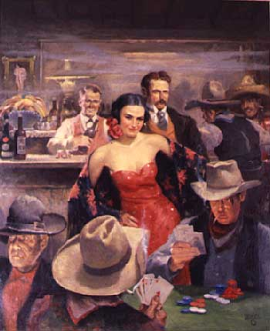

While feminists were seeking to free women from the "slavery" of patriarchal marriage, prostitutes married later in life and divorced more frequently than other American women. At a time when birth control was effectively banned, prostitutes provided a market for contraceptives that made possible their production and distribution. While women were taught that they belonged in the home, prostitutes traveled extensively, often by themselves, and were brazenly "public women." Long before social dancing in public was considered acceptable for women, prostitutes invented many of the steps that would become all the rage during the dance craze of the 1910s and 1920s. When gambling and public drinking were forbidden for most women, prostitutes were fixtures in western saloons, and they became some of the most successful gamblers in the nation. Most ironically, the makeup, clothing, and hairstyles of prostitutes, which were maligned for their overt sexuality (lipstick was "the scarlet shame of streetwalkers"), became widely fashionable among American women and are now so respectable that even First Ladies wear them.

Women who wished to escape the restrictions of Victorian America had no better place to go than the so-called frontier, where a particular combination of economic and demographic forces gave renegade women many unusual advantages.

San Francisco Gold Rush
The San Francisco Gold Rush conjures images of lavishly dressed women draping the arms of tough looking cowboys, gamblers, and miners drinking whiskey and throwing bags of gold dust on to the card table. Yes, I can picture those saloons and the bawdy pioneer prostitutes who were a big part of life back in those days. Prostitutes occupied a privileged place in the gold-rush society, with economic opportunity beyond that of any other working American females. And they certainly belonged to the pioneer, gold-miner elite, involved in legendary bar-fights and shoot-outs in the honor of their slighted lover. The Gold Rush era's most notorious madam, Belle Cora, had her lover Charles Cora, hung for such a crime.

With the development of gold mining in 1848-1849, San Francisco underwent many changes that led to a flourishing prostitution business. The most important factor was the influx of young men who came as gold-seekers. In 1849, miners migrated from the South and the East, with forty thousand immigrants arriving by ship alone. Because of the rough conditions and the transitory nature of gold speculation as a profession, women (particularly respectable women, such as wives with children) were scarce in San Francisco. One source cites a 50-1 male-to-female ratio. The surplus of lonely men comprised a plentiful market for prostitution.

The business opportunities of gold-rush San Francisco were also an important factor in the flourishing of prostitution. The prospect of gold brought both immigrants (new business) and wealth (expendable income) into the city, and therefore the profit potential for entrepreneurs was high. Financial growth was, indeed, enormous, and demand had so outdistanced supply that prices were going higher every day . . . wages, prices, and profits skyrocketed. In addition, there was no organized business class or established sex industry to thwart enterprising individuals. Consequently, the potential for upward mobility was great among all professions and in particular among prostitutes.

New York City
In the 19th century, parlor house brothels catered to upper class clientele, while bawdy houses catered to the lower class. At concert saloons, men could eat, listen to music, watch a fight, or pay women for sex. Over 200 brothels existed in lower Manhattan. Prostitution was illegal under the vagrancy laws, but was not well-enforced by police and city officials, who were bribed by brothel owners and madams. Attempts to regulate prostitution were struck down on the grounds that regulation would be counter to the public good.

In modern times, conventional wisdom suggests that prostitution is immoral, corrupt, and damaging to society. Yet, in nineteenth century New York, prostitution was a thriving enterprise for landlords, consumers, and prostitutes. Unregulated and unsupervised, the number of red light districts in Manhattan exploded throughout the 1800s. In 1839 there were more than ten thousand prostitutes in Manhattan. In 1869, this number jumped to between twenty and twenty-five thousand prostitutes. Between five and ten percent of women in New York City during the nineteenth century engaged in prostitution. A major reason for the high numbers of prostitutes during this time period was the low wages associated with most female occupations. Prostitution, because of its success, provided women with a better and more secure financial option.

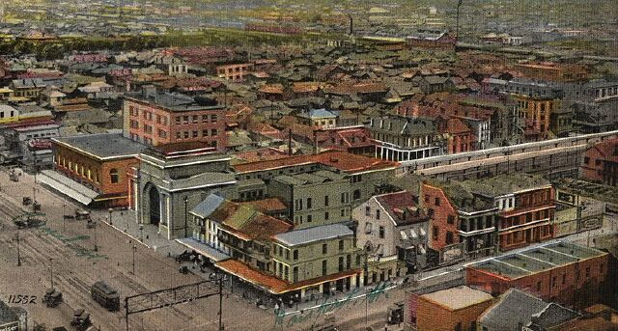
The District or Storyville in New Orleans (1897 – 1917)

New Orleans
New Orleans city alderman Sidney Story wrote an ordinance in 1897 to regulate and limit prostitution to one small area of the city, "The District", where all prostitutes in New Orleans must live and work. The District, or Storyville as most people called it, became the most famous area for prostitution in the nation. Storyville at its peak had more than 1500 prostitutes and 200 brothels. Storyville, the legalized Red Light District, was made up of only sixteen square blocks and lasted just 20 years. The echoes of the jazz music nurtured there can still be heard all over the world.

Wallace, Idaho
When the final occupants of the Oasis Bordello left in January 1988 (the last recorded date in the "hotel" registry), they seemed to have left in a hurry. Clothing, makeup, toiletries, food and personal items were all left behind. An accurate and tastefully-presented twenty-minute tour of the upper rooms explains the mystery of the ladies' hasty departure and gives a glimpse into the town's bawdy past with details that range from poignant to hilarious. The main floor is an unusual gift shop adorned with Robert Thomas murals that depict the realities of mining in an earlier era. The two-story brick building began its existence in 1895 as a hotel and saloon, and is one of the few structures in Wallace to survive the famous 1910 fire. The Oasis was one of five brothels operating without hindrance on Wallace's main street until the Federal Government came to town to close them down.

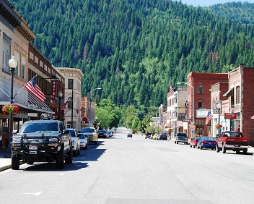 | 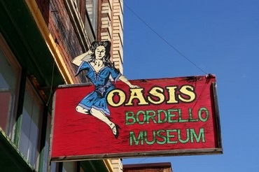
Downtown Wallace, Idaho | The OASIS Bordello Museum

I have some personal experience with the town of Wallace and the surrounding area. The University of Utah basketball coaching staff helped me get a summer job after high school graduation with a diamond core drilling company. The location of the job was in the mountains above Wallace, Idaho. I remember this well because the company wanted me to drive the truck, with the drilling rig on the back, up to Wallace from Salt Lake City by myself. This was the first time (and the last) I ever drove a big truck and it was quite an experience. I managed to make it to Wallace okay where I met my boss for the summer - the driller. We stayed at a motel in a small town near Wallace. The driller was a nice man and I had an enjoyable summer helping him drill for silver, gold, and other ores. We were close to Canada and this is a very pretty area with lots of mountains and pine trees.

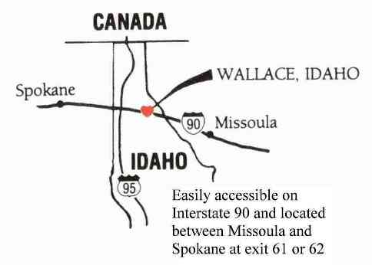 | The historic mining town of Wallace (population 960) is located in northern Idaho’s beautiful Silver Valley. The town has long been famous as the "Silver Capital of the World" with 1.5 billion ounces of silver produced in Shoshone County since 1884.

While I was living and working on the outskirts of Wallace, I learned some other interesting things. Since we worked six days a week and only had Sundays off, our only night out was Saturday. Back then in 1958, Wallace had four bars in the downtown area and we picked the one right across the street from the Police Station. The Lucky Bar was in the basement of a business and it had a pool table and some great country and western music. Yes, it was my kind of place. I made some friends and didn’t have to depend on the driller for transportation in my off time. On my second or third visit to the bar, I found out that there were five brothels operating on the main street of Wallace. One of them was right across the street on the second floor above the Police Station.

Back in the early 1900’s when silver mining in northern Idaho was at its peak, men outnumbered women by about 200 to 1. There was a need and some enterprising ladies setup shop in Wallace (with full support of the town government) to fill this demand. It was a sad day in 1988 when the feds come to Wallace and raided and closed down all of the brothels. The only remaining evidence of these brothels is the Oasis Bordello Museum in downtown Wallace.

I think they should legalize brothels nation-wide. It should be controlled by the state or city wherever brothels are needed. Currently, the only state with legal brothels is Nevada. It is a proven fact that in places with controlled brothels, the cases of AIDS and VD are almost non-existent. Condoms are required and the girls are checked and tested for VD on a weekly basis. It doesn’t take a genius to know that making prostitution illegal will make it go away. They don’t call it the “world oldest profession” for nothing.

So, where do you think the ladies in Wallace went after the feds closed down the brothels? They purchased RVs and trailers and setup shop in the hills a little closer to the mines and their primary customers.

When did Prostitution become Illegal in the United States?
In 1908, The Bureau of Investigation (BOI) was founded by the government to investigate "white slavery" by interviewing brothel employees to find out if they had been kidnapped. Out of about 1200 prostitutes interviewed in one city, six said they were victims of white slavery. The White-Slave Traffic Act (Mann Act) of 1910 prohibited so-called white slavery. It also banned the interstate transport of females for "immoral purposes". Its primary stated intent was to address prostitution and perceived immorality. The Supreme Court later included consensual debauchery (excessive indulgence in sensual pleasures), intemperance, adultery, and polygamy under "immoral purposes". (Just for your information, the BOI became the FBI in 1935)

In 1918, the Chamberlain-Kahn Act gave the government the power to quarantine any woman suspected of having a sexually transmitted disease (STD). A medical examination was required, and if it revealed an STD, this discovery could constitute proof of prostitution. The purpose of this law was to prevent the spread of venereal diseases among U.S. soldiers. During World War I, Storyville in New Orleans was shut down to prevent VD transmission to soldiers in nearby army and navy camps.

In 1967, New York City eliminated license requirements for massage parlors. Many massage parlors became brothels. In 1970, Nevada began regulation of houses of prostitution. In 1971, The Mustang Ranch became Nevada's first licensed brothel, eventually leading to the legalization of brothel prostitution in 10 of 17 counties of the state. In time, Mustang Ranch became Nevada's largest brothel, with more revenue than all other legal Nevada brothels combined.

In the early 20th century, widespread use of phones made call girls possible. This took prostitutes indoors and off the streets. They give their phone numbers on cards to customers. By World War II, prostitutes had increasingly gone underground as call girls.

Every large city in America has working prostitutes (mostly female but there are some males and a few that are Transgender). These people work in escort services, massage and relaxation parlors, bars, and on the streets. Now days, however, most prostitutes work as call girls from home using their computers (social media on the Internet) to find customers willing to pay for their services. From everything I have been reading while researching for this article, the prostitution and sex business is BOOMING!

Heidi Fleiss became one of America's best known madams in the late 1990s. She was also a columnist and television personality regularly featured in the media. She ran a prostitution ring based in Los Angeles, California, and is often referred to as the "Hollywood Madam". Federal charges were filed in 1994, and Fleiss posted $1,000,000 bail. The state trial began that same year and Fleiss was convicted. She wasn’t convicted of running a prostitution ring but was convicted of federal charges of tax evasion and sentenced to seven years in prison. Fleiss served 20 months at the Federal Correctional Institution located in Dublin, California.

Prostitution around the World
The laws on prostitution vary considerably around the world. They can vary from total prohibition of both the sale and purchase of sexual services, bans on either, regulation to varying extent of some or all aspects, to minimal regulation or no restriction of any sexual activity. In practice, neither capital punishment, incarceration, nor remedial training have had any appreciable effect on the trade. The issue of prostitution as a whole is socially and politically divisive, and difficult to form a consensus on. In North Korea, Sudan, Iran and Saudi Arabia, prostitution is a crime punishable by death.

Take a look at this map:

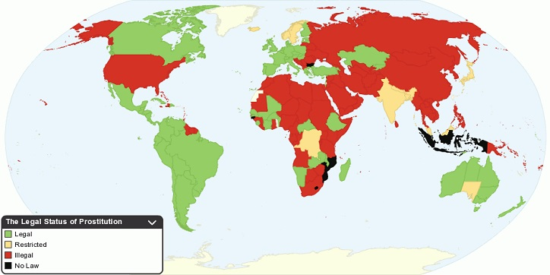

Did you know that prostitution is legal in Canada, Mexico, and most of Central and South America? It is also legal in Australia, Great Britain, Germany, France, Spain, Denmark, Sweden and most countries around the world.

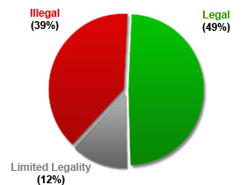
Percent of Countries where Prostitution is Legal and Illegal

Are you surprised about the number of countries where prostitution is perfectly legal? I was and I’m sure happy I don’t live in Saudi Arabia or North Korea!

Is Prostitution really the World's Oldest Profession? Contrary to the old cliché, prostitution is almost certainly not the world's oldest profession--that would be hunting and gathering, perhaps followed by farming--but it has been found in every civilization on Earth stretching back throughout all recorded human history. We can say with some confidence that wherever there have been money, goods, or services to be bartered, somebody has bartered them for sex.

WARNING

Next time you have an extra $75,000 in your pocket and you are planning to rent a Cathouse for a few days, try not to mix crack cocaine, Viagra, with around the clock sex. This combination could be hazardous to your health and it might kill you.

bigdrifter44@gmail.com

