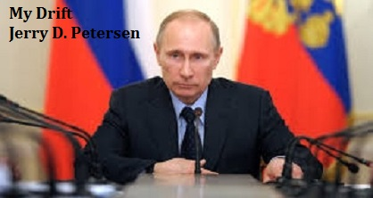

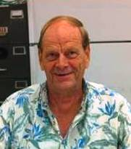 | Vladimir Putin  13 August 2014 | 182-2014-11

Vladimir Putin is one of the most recognizable, interesting, and powerful men in the world. Yes, Putin is the president of the largest country in the world – Russia. Since 1999 when Putin was appointed Prime Minister and later elected as the President, there have been many events that have really put Putin in the limelight. United States Presidents George W. Bush (2001-2009) and Barack Hussein Obama (2010-present) have not always agreed with the actions or policies of President Putin.

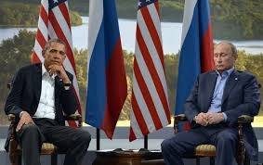 | 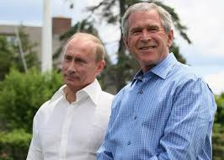

Actually, presidents Bush and Putin got along pretty good. Putin visited Texas and got the grand tour of Bush's ranch in a pickup truck. They agreed to reduce their nuclear stockpiles as they feasted on Texas mesquite-smoked beef. Bush also visited Russia. Bush, who famously said after his first meeting with Putin in 2001: "I looked the man in the eye ... I was able to get a sense of his soul." The one issue that they disagreed on was the U.S. invasion of Iraq. History will probably show that Putin was right and that this was an ill-advised action. Just recently, the Russian president sent a telegram to former U.S. counterpart George W. Bush, wishing him a speedy recovery from heart surgery. Russia's government disclosed the telegram a day after President Obama canceled a planned summit with Putin. President Obama and Putin do not get along – period.

Then we have good ole Vice-President Joe Biden who relates his 2011 visit with Putin, who at the time was prime minister, as follows: I found myself just inches away from the Russian leader’s face. I said, “Mr. Prime Minister, I'm looking into your eyes, and I don’t think you have a soul, - Putin looked back at me, and smiled, and said, 'We understand one another.'"

Below are a few President Putin quotes that might help us learn a little bit about how he thinks. The quote about Obama is not original but several sources confirm that Putin made a similar statement.

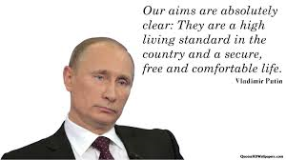 | 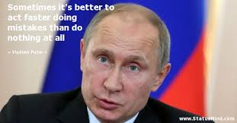
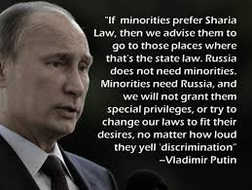 | 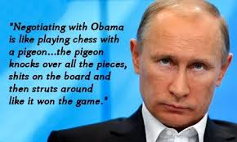

Let’s take a quick look at Putin’s life timetable up to where he is today:

Date | Event | Pictures

Born  7 Oct 1952  Childhood  1950s-1960s  Primary and High School  1960-1970  College  1971-1975  KGB  1975  Marriage  28 Jul 1983  Children  1985 and 1986  KGB Retirement  1991  Leningrad Deputy Mayor  1994  Moscow  1996  Head of Security  1998  Prime Minister 1999  President of  Russia  2000-2008  Prime Minister  2009-2011  President  2012 to Present  Divorce  June 2013  Winter Olympics  7-23 Feb 2014  Crimea Annexation  Mar 2014  Ukraine Crisis  17 Jul 2014 | Vladimir Vladimirovich Putin was born in Leningrad (now St. Petersburg).  Putin’s mother’s was Maria Shelomova and she was a factory worker - Putin describes her as was a very kind and benevolent person. Putin’s father had the same name Vladimir Putin and he was a soldier in World War II. After the war, he worked as a security guard and later as a foreman at the carriage works.  Putin says, “We lived simply – my mother fixed cabbage soup, cutlets, pancakes, and rice.”  Putin has stated on several occasions that, “I come from an ordinary family, and this is how I lived for a long time, nearly my whole life. I lived as an average, normal person and I have always maintained that connection.”  The family lived in a room in a communal apartment building in Leningrad. Vladimir Putin recalls, “It was a building with a well-lit yard – we lived on the fifth floor – there was no elevator – there were many rats in the stairwell.”  He attended primary School No. 193 and high school No. 281 in Leningrad.  While going to high school, Vladimir had a difficult time deciding what kind of career he wanted. At first, he wanted to be a pilot and then decided it would be more fun to be a sailor, but in the end he decided to be an intelligence officer.  Putin graduated from Leningrad State University in 1975.  Putin began his career in the KGB as an intelligence officer. He was stationed mainly in East Germany.  Vladimir Putin met Lyudmila Shkrebneva through a mutual friend. Lyudmila worked as a flight attendant on a domestic airline. They started dating and got married on July 28, 1983.  In 1985, Vladimir and Lyudmila Putin welcomed their first daughter, Maria. Their second daughter, Katerina, was born in 1986, in Dresden, East Germany. Both girls were named in honor of their grandmothers, Maria Putina and Yekaterina Shkrebneva. As adults, they have never been photographed by the Russian media and it's said that the Russian public would not recognize the women if they ran into them on the street. The girls have always been carefully guarded by the Russian government and were even pulled out of school and taught at home once their father hit the spotlight.  Putin was a KGB intelligence officer until the collapse of the Soviet Union in 1991. After that, Putin retired from the KGB with the rank of colonel and returned to Leningrad.  Putin become a big supporter of a liberal politician named Anatoly Sobchak who won the election for Mayor of Leningrad (1991).  Putin became his head of external relations and in 1994, he became Sobchak's first Deputy Mayor.  After Sobchak's defeat in 1996, Putin resigned his post and moved to Moscow.  Putin was appointed head of the Federal Security, an arm of the former KGB, as well as head of Bois Yeltsin's Security Council.  President Boris Yeltsin promoted Vladimir Putin to Prime Minister.  In December 1999, Putin run for President – he was elected and served as President of Russia from 2000 to 2008.  The Russian “term limit” law prevented him from running for President in 2008. But the incoming President Dmitry Medvedev assigned Putin as Russia's Prime Minister.  Putin was re-elected to the presidency in 2012. Soon after taking office, he nominated Medvedev as prime minister.  Russia confirmed the divorce of Russian President Vladimir Putin from his wife of 30 years.  The 2014 Winter Olympics held on 7–23 February 2014 in Sochi, Russia were a huge success. Host Russia was the leading medal winner with 33 – the United State came in fourth place with 28 medals. President Putin was there every day and attended many events cheering on Russian athletes. These games were a crowning moment for Putin and the people of Russia.  Russia sent troops into Ukraine’s Crimea to secure the region. Russian President Vladimir Putin signs a law making Crimea part of Russia during a ceremony in the Kremlin in Moscow on March 21, 2014.  A suspected Russian-made surface-to-air missile downed a Malaysia Airlines jet in a separatist-controlled corner of eastern Ukraine on Thursday, 17 July, prompting the Ukrainian government to denounce this as an “act of terror” that killed all 298 people on board. | 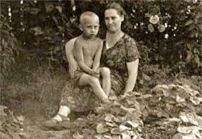  A young Putin with his mother  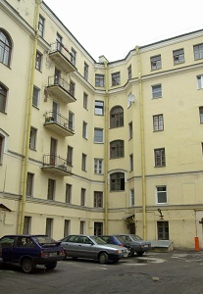  Apartment building where Putin grew up  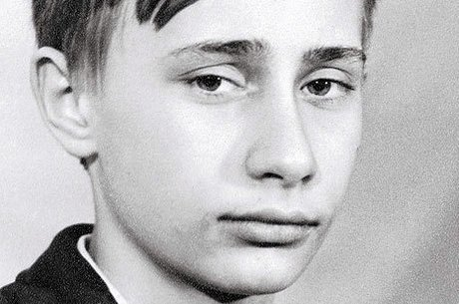  Vladimir’s school picture  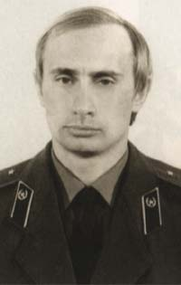  KGB photo  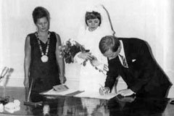  Vladimir and Lyudmila wedding day  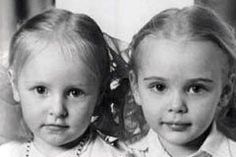  Maria and Katerina  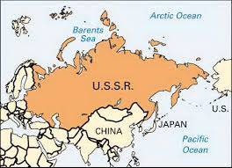  Collapse of the Soviet Union  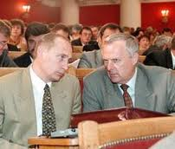  Putin and Anatoly Sobchak  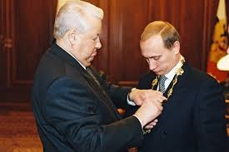  Boris Yeltsin promotes Putin  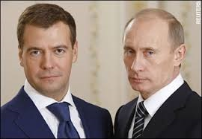  Dmitry Medvedev and Vladimir Putin  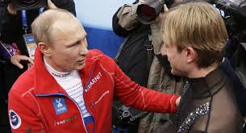  Putin congratulates Olympic winners  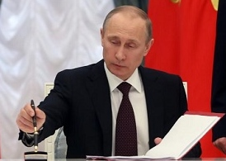  Crimea Annexation  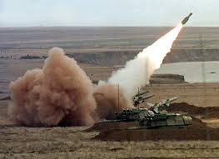  Ukraine Missile

Let’s see what Putin likes to do in his free time. What are his main interests, sports, hobbies, and leisure activities? There are a lot of things! Putin has stated on several occasions that likes to learn about new things. He says, “I just love everything new. I enjoy learning new things. The process itself gives me great pleasure.” Putin enjoys watching and participating in different sports – he has a great desire to promote an active lifestyle for the youth of Russia. He firmly believes that a change of activity is the best kind of rest.

Judo, Sambo, and Karate  Vladimir Putin firmly believes that martial arts teach such knowledge, abilities and skills that every politician needs. Putin believes that judo trains both your body and your mind. It develops strength, reaction, endurance, teaches self-control, the ability to feel the moment, to see the opponent’s strengths and weaknesses, to strive for the best results and constantly work on improving oneself. | 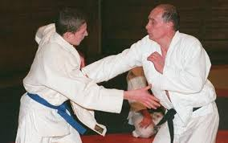

Putin has been practicing judo since he was 11 years old. “I was just a boy when I started judo. I became deeply interested in martial arts, their special philosophy, culture, relations with the opponent and the rules of combat,” says Putin, who holds the title of Master of Sports in judo. In September 2006 he became the honorary president of the European Judo Union, and in 2010 he received an honorary doctorate in judo from South Korea’s Yong In University.

Putin is a multiple champion of St Petersburg in Sambo and holds a black belt in karate.

Sambo?? I’m familiar with Judo and Karate but I had never heard of Sambo. After a little research on the Internet, I found out that Sambo is a Russian martial art and combat sport. The word "SAMBO" literally translates as "self-defense without weapons". Sambo began in the early 1920s by the Soviet Red Army to improve their hand-to-hand combat abilities. It is intended to be a merger of the most effective techniques of other martial arts.

It might not be a very good idea for Obama to pick a fight with Putin.

Ice Hockey  When Putin was young, he was into martial arts and didn’t play hockey. However, Putin promised a group of young hockey players that he would learn to play and participate in the Golden Puck youth hockey tournament to be held later at Luzhniki Stadium in Moscow. He was very busy but since he made the promise, he started training. He spent two months training under famous hockey player | 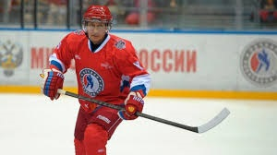
Alexei Kasatonov. Their sessions often happened after midnight, when Vladimir Putin finished his working day. In a few months, he felt confident on skates, and fulfilled his promise by taking part in a training session for the Golden Puck final, where he even scored a few goals. Putin enjoyed playing hockey so much that he later played in several senior hockey leagues.

Skiing  Vladimir Putin became interested in mountain skiing a long time ago. He admits he truly enjoys skiing. “This is a dynamic sport that requires mastering a technique and is a great opportunity for an active holiday, to stay fit and get a boost of energy and good spirits,” Putin says. A Soviet skiing champion says Putin’s technique is very stable and he descends from the mountain at a very high speed. | 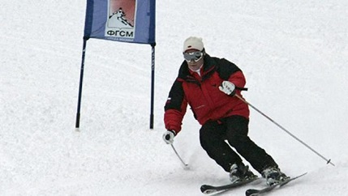

Whitewater Rafting  Putin related this story when he went whitewater rafting with his daughters down mountain rivers in Altai. “There we were in our raft, and some guys were standing on the bank. They were just standing there, nobody expected us to be there because we flew in quietly, boarded the raft and went down the mountain rivers. They were standing right on the bank, three of them, with these huge beer mugs. | 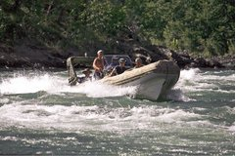
When they saw me, they called out: “Mr. President, join us!” I said no, I can’t, I’m in a hurry. “Well then, here is to your health.” As if they had been waiting for me like I go rafting there every day,” Putin recalled.

Horseback Riding  Vladimir Putin feels confident in the saddle so horseback riding for him is a chance to rest. He often takes a 1-day break to go horse riding. Recently, during his working visit to the Republic of Khakassia, Putin travelled to the foothills of Karatash, near Abakan. There, he hand-fed local horses and drank a cup of tea, cooked over a campfire, and then went riding with a few local citizens. | 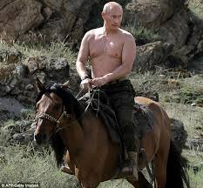

“Fishing is my kind of sport: I love it and I'm always happy to use any opportunity to sit down with a fishing rod.”

Vladimir Putin

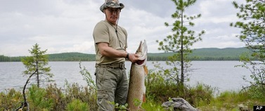
President Putin recently caught this 46 pound Pike while fishing in Siberia

Yes, fishing is one of Vladimir Putin’s favorite activities. He is particularly fond of fishing in the many lakes and rivers found in Russia. “Unfortunately, such occasions are quite rare these days,” he says. However, sometimes my work actually helps me in this. How else could I go fishing in America, in the company of two presidents? (Putin went fishing in Maine with George H.W. Bush and George W. Bush) “Seriously, the best fishing in the world, according to my personal rating, is in the Murmansk Region and in the delta of the Volga River near Astrakhan,” Putin says.

Vladimir Putin Loves Animals
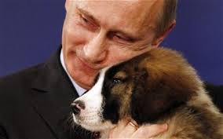 | 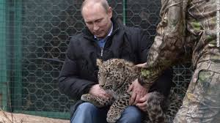

Animal Protection
Vladimir Putin enjoys watching animals in their natural habitat and taking part in scientific projects. He is Chairman of the Russian Geographical Society’s Board of Trustees, and is actively engaged in the protection of rare species by overseeing the respective programs. The animal species under his personal patronage are the Amur tiger, white whale, polar bear and snow leopard.

Anybody that likes dogs and fishing is okay in my book. Putin is a “strong” leader who has brought a sense of pride back to the Russian people. President Putin takes the actions he thinks are best for Russia and doesn’t care what the rest of the world thinks. He is very popular and enjoys an 83% approval rating in Russia. When was the last time an American president had this kind of approval rating? You guessed it – when Ronald Reagan was in the White House.

I’m not going to jump on my soapbox in this article, but I think the U.S. should stay out of the Ukraine crisis. Russia has a much greater stake in this since they have a large Navy base at Crimea and there are many Russian citizens living in eastern Ukraine. In my humble opinion, nothing happening in Ukraine should cause the United States to go to WAR against Russia. On the contrary, I think our government should be doing everything possible to be friends with Russia. Instead of cancelling scheduled meetings with Putin, maybe Obama should plan a nice little fishing trip where these two leaders can discuss world issues while drinking beer from large mugs.

One last thing. I believe that President Vladimir Putin has a soul. He may come across as being cold, indifferent, and heartless when talking to Joe Biden (and others) but as we have learned in this article, there is much more to this man than most people realized. Did you know that he belongs to the Russian Orthodox Church and always wears a cross around his neck?

bigdrifter44@gmail.com

