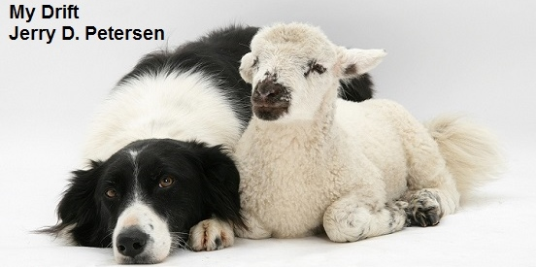

 | Sheep  20 May 2015 | 202-2015-09

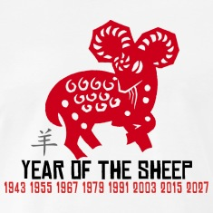 | Did you know that 2015 is the Year of the Sheep according to Chinese zodiac? Most of my readers are very smart and knew this fact. The Year of the Sheep started on Feb. 19, 2015 (the Lunar New Year / Spring Festival of China) and lasts to Feb. 7, 2016. The sheep is among the animals that people like most. Sheep are seen to represent righteousness, sincerity, gentleness, and compassion.
Let’s start out by getting our “sheep” terminology straight - An adult male sheep is known as a ram; a castrated male sheep is called a wether; an adult female sheep (14 months or older) is called a ewe (pronounced yooh), or - at lambing time - a dam, and a baby sheep of either sex is a lamb (under 14 months old). A group of sheep is known as a herd or a flock. Fleece is name of the woollen coat of a domestic sheep or long-haired goat. The difference between a sheepherder and shepherd is that a sheepherder is a person who herds sheep; a shepherd is a person who tends sheep, especially a grazing flock. As a verb, shepherd means to watch over.

My Grandfather (on my dad’s side of family) was a Sheepherder. He was a Sheepherder his whole life. Actually, my dad and his brothers herded a lot of sheep while growing up in Price, Utah. While I was growing up on a small farm in Pleasant Grove, Utah, my parents always seemed to have a few sheep roaming around on the place. I can remember several times that we had a lamb that would follow my mother around like it thought she was the mother sheep or something. So, I know a thing two about sheep but after researching the Internet for interesting information about sheep, I know a lot more now and I like sheep better than before.

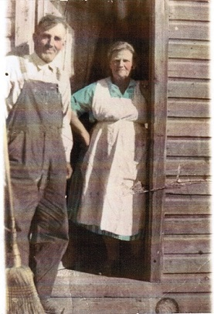 | 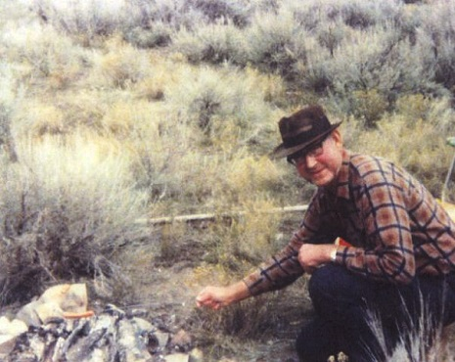
Grandpa and Grandma Petersen | This is my dad out in the “sticks” somewhere cooking lunch – he loved the outdoors

History
The history of the domesticated sheep goes back to about 10,000 BC when the domestication of the wild sheep occurred in ancient Mesopotamia. Sheep were the first animals domesticated by humans. These sheep were primarily raised for meat, milk, and skins. Woolly sheep began to be developed around 6000 BC in Iran, and cultures such as the Persians relied on sheep's wool for trading.

The Romans took their sheep with them to England and established a large wool industry in the country. Shortly thereafter Spain and England became the top two sheep-shearing countries. Spain developed the merino sheep, known for its highly prized wool. Herds of these sheep were controlled by the wealthy and allowed to migrate throughout the country; the sheep had the freedom to graze where they pleased and peasantry who interfered with the sheep could be brought to private tribunals.

In the 15th century, Spain's thriving wool trade financed the expeditions of its conquistadors, including the voyage Christopher Columbus made to the New World. Indeed, Columbus came from a family of wool traders. The first domestic sheep in North America arrived with Christopher Columbus' second voyage in 1493.

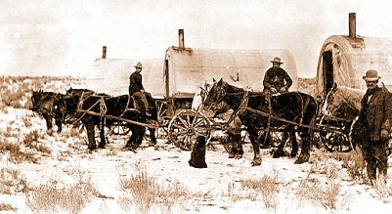 | 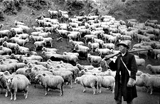
The Sheep and Cattle Wars

Gradually, beginning in the 19th century, sheep production in the U.S. moved westward. During this westward migration of the industry, competition between sheep and cattle operations grew more heated, eventually erupting into range wars. The Sheep and Cattle Wars were fought between sheepmen and cattlemen over grazing rights. The cattlemen saw the sheepherders as invaders, who destroyed the public grazing lands, which they had to share on a first-come, first-served basis. Between 1870 and 1920, approximately 120 engagements occurred in eight different states or territories. At least 54 men were killed and over 100,000 sheep were slaughtered. Today, the vast majority of flocks reside (in peace) on Western and Southwestern range lands.

Jesus and the Bible
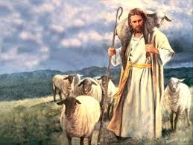 | Was Jesus a shepherd?  The word "shepherd" is used metaphorically. Jesus takes care of us people like a shepherd takes care of his flock.

- Sheep are mentioned in the Bible more than 500 times, more than any other animal. The prominence of sheep in the Bible grows out of two realities:
  - Sheep were important to the nomads and agricultural life of the Hebrews and other peoples of those times.
  - Secondly, sheep are used throughout the Bible to symbolically refer to God's people.
- The very first shepherd was Abel.
- Abraham and Moses were also shepherds.
- King David was the best known shepherd of Bible history. He wrote the beloved Psalm 23 - The Lord is my Shepherd.
- Shepherds were the first people to see the newborn Jesus Christ.
- The Prophet Mohammed worked as a shepherd when he was 8 years old.
- Many Christians traditionally refer to Jesus as the "Lamb of God."
- Many Christians serve lamb as part of their Easter dinner.
- Sacrificial lamb - Abraham was asked to sacrifice his son. He was willing to do so, but God gave him a sheep to sacrifice instead of his son.
- With regards to "judgement day," sheep and goats are used as metaphors in the Bible. Sheep are the followers of Christ, while goats chose not to follow Christ. The parable is based on the differences in behavior between sheep and goats. Sheep are gentle, quiet, innocent animals. They do not give their shepherds a lot of problems. They are easily led. Goats are rebellious and hard to handle.

Vital Statistics
- When sheep gives birth to an offspring, the process is called lambing.
- Ewes often give birth to twins but more than two lambs is unusual.
- At birth on an average, weight of a lamb is between 5 to 8 pounds.
- After their birth, healthy lambs can stand immediately, within minutes, and join the herd.
- Sheep do not have teeth in their upper front jaw but can have up to eight teeth on the bottom, which it grows at a rate of two per year.
- Before a lamb goes on a solid diet of grass, hay, and grain, it feeds solely on its mother’s milk for about 4 months.
- On an average, a sheep consumes 2 to 4.5 pounds of food daily.
- Domesticated sheep are allowed to graze green pastures during the summers, but during winters, they are fed hay.
- An adult ram weighs about 250 pounds – an adult ewe weighs about 200 pounds.
- Sheep emits a “Baa” sound - the goat emits a “Maa” sound.
- Sheep have poor eyesight but to compensate, they have been blessed with an excellent sense of hearing.
- An adult sheep’s fleece produces approximately 8 pounds of wool per year.
- The life expectancy of sheep is similar to large breeds of dogs, about 10 to 12 years.

Agricultural Products
Meat
The most important product we get from sheep is meat. Meat is an important component of our diets, and lamb and mutton supply us with many of the vital vitamins and proteins we need for healthy living. Lamb is the meat from a sheep that is less than one year old. Mutton is the meat from a sheep that is over one year of age. The terms yearling mutton are applied to the meat from a sheep that is between one and two years of age. Of all the red meats, lamb meat has the lowest cholesterol level.

Wool
Wool is the product for which sheep are best known. Wool is widely used in clothing from knitwear such as socks and jumpers to cloth used for suits and costumes. It is used in the furniture trade both for making chair covers and for upholstery. Many of the better carpets produced are made from wool. Wool is used to fill mattresses.

Skins
Sheep skins are removed from the carcasses after slaughter. They are treated in a process called tanning and made into soft leather. Sheep skin is commonly used for making the chamois cloth that you wash your car with. Some of the skins are preserved and sold as sheepskins with the wool still attached.

Milk
Sheep have been raised for milk for thousands of years and were milked before cows. The world's commercial dairy sheep industry is concentrated in Europe and the countries on or near the Mediterranean Sea. The dairy sheep industry is not that popular in the United States. There are approximately 100 dairy sheep farms in the U.S. that are mostly found in New England and the Upper Midwest.

Other Dairy Products
Some of the world's most famous cheeses are made from sheep's milk: Roquefort, Feta, Ricotta, and Pecorina Romano. Sheep's milk is also made into yogurt, butter, and ice cream.

By the Numbers
- There are over 40 breeds of sheep in US and about 900 different breeds found around the world.
- There are more than 1 billion sheep in the world.
- China has the most sheep by far with about 190 million.
- There are about 85,000 sheep farms in the United States.
- There are about 5.5 million sheep in the United States.
- States with the most sheep are:
  - Texas has the most sheep with about 720,000
  - California is second with about 600,000
  - Colorado is third with about 420,000
  - Wyoming is fourth with about 350,000
  - Utah is fifth with about 300,000
- New Zealand has the highest density of sheep in the world – it is home to 4.5 million people and 60 million sheep.

Other Interesting Things about Sheep
- Sheep are friendly – They can wag their tails like dogs, they know their names, and they form strong bonds with other sheep, goats, and with people.
- Sheep are able to experience emotions such as fear, anger, rage, despair, boredom, disgust, and happiness just like humans.
- Sheep make different vocalizations to communicate different emotions.
- Sheep have panoramic vision – They can see almost 360 degrees, including directly behind themselves!
- Sheep know how you feel – They can pick up emotional cues in both humans and other sheep. Not surprisingly, they strongly preferred smiling and relaxed expressions over angry ones.
- Sheep never forget a face – They have specialized mechanisms for visual recognition like humans do which allows them to remember the faces of at least 50 individual humans and other sheep for more than two years.
- Female sheep (ewes) are very caring mothers and form deep bonds with their lambs that can recognize them by their call (bleat) when they wander too far away. | 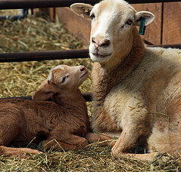
- Sheep are known to self-medicate when they have some illnesses. They will eat specific plants when ill that can cure them.
- Sheep and pigs are the smartest animals in the barnyard. They can learn how to solve puzzles and perform cognitive tasks that have never been shown previously to exist in any other large animals other than humans and some primates.
- Sheep lives outdoors and can bear bad weather as their fleece keep them warm.
- During World War I, President Woodrow Wilson had a flock of sheep trim the White House lawn.
- Sheep have a knack of huddling together and wherever one goes, others follow.
- Sheep cannot get themselves upright from laying on their back and if left unaided they will die within an hour.
- Wool is the most commonly used fiber in the world.
- Most sheep are timid and nervous by nature; they are easily frightened, because of which they flock together.
- However, there are sheep breeds that are not timid at all and would love to give you a head butt if you enter their territory. Mountain (Bighorn) Sheep are found in Utah and other western states.

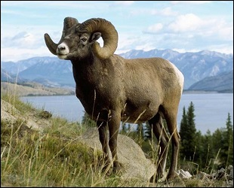 | 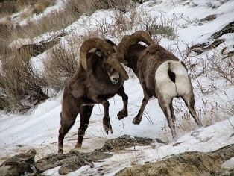
Famous Sheep
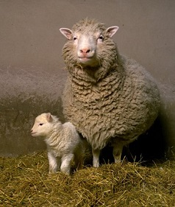 | Dolly became the most famous sheep in history when her birth was announced by the Roslin Institute in Scotland in 1997. Dolly was the world's first mammal to be cloned. She was born July 5, 1996, from three different mothers. Dolly gave birth to six lambs.
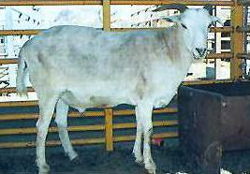 |  | An unusual case of a sheep-goat hybrid happened in Botswana in 2000. The animal was naturally born from the mating of a female goat with a male sheep that were kept together. Such pregnancies were not thought possible. Its features were halfway between sheep and goats. The hybrid had a very active sex life mounting both ewes and female goats even when they were not in heat. This earned him the name of “the rapist."

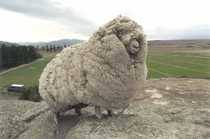 | The world's wooliest sheep was a renegade New Zealand sheep who managed to evade shearers for six years. Dubbed "Shrek," the Merino sheep was shorn live on television by top shearers David Fagan and Peter Casserly. The 10-year old sheep produced 60-pound of fleece, enough to make 20 large men's suits which was auctioned off over the internet for the benefit of children's medical charities. Shrek was euthanized June 6, 2011, at the age of 17.
Sayings and Quotes
“Black Sheep of the Family.” This is an idiom used to describe an odd or disreputable member of a group or family. The term stems from the genetic effect in sheep whereby a recessive gene occasionally manifests in birth with black rather than white coloring; these sheep stand out and their wool was traditionally considered less valuable. | 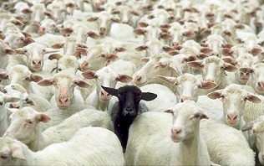

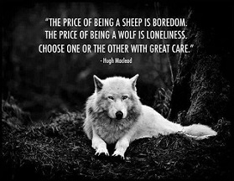 | 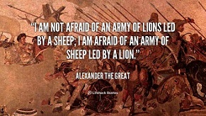
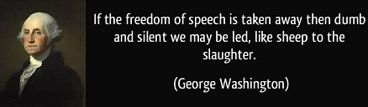

Livestock guardians
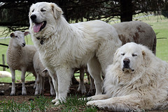  Great Pyrenees  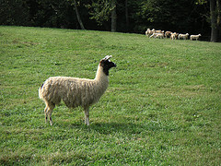  Llama | 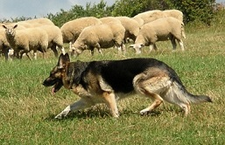  German Shepherd  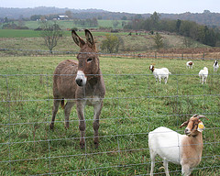  Donkey

Guardian dogs (or livestock protection dogs) are the most popular livestock guardian. Dogs have been used for centuries to protect livestock. Two of the most popular breeds of dogs typically used to guard sheep that originated in Europe are the Great Pyrenees and the German Shepherd. Guardian dogs work by staying near the sheep and aggressively repelling predators. Under range conditions or with large pastures, more than one dog may be necessary. Actually, guardian dogs work best in pairs.

A single llama should be used so that it will bond to the sheep and not other llamas. Llamas can offer an effective, long-term, economical alternative for predator control. They are particularly aggressive towards dogs and coyotes. Llamas do not require training. Human contact with a guard llama should be avoided.

A donkey's natural herding instinct and inherent dislike and aggressiveness towards coyotes and dogs make it a suitable guardian for sheep flocks. Given ample opportunity, most donkeys will bond with sheep and protect them from predators. Donkeys rely on sound and sight to detect predators. The donkey's loud bray and pursuit will scare away predators and may also alert the shepherd. If the predator does not quickly flee, the donkey will attack by rising up on their hind legs and striking with both front feet.

Predators
It is estimated that about 250,000 sheep and lambs are killed by predators in the United States every year, costing farmers and ranchers over $20 million dollars. Predation accounted for 37 percent of sheep and lamb death losses for the year. Below are the primary predators and percent of sheep losses:

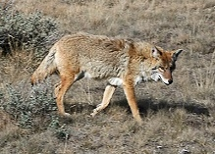  Coyote | Predator  Coyotes  Dogs  Mountain lions/Cougars  Bears  Other | Percent of losses  52  23  8  5  12

Sheepherding Dogs
Sheepherding dogs are usually a different breed from sheep tending dogs. The Border Collie is the best herding dog breed which was developed in the Anglo-Scottish border region for herding livestock, especially sheep. It was specifically bred for intelligence and obedience.

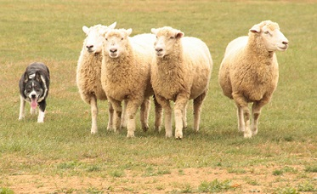 | 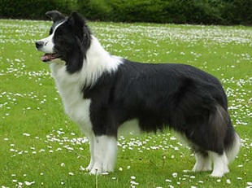

Ranked number one in Stanley Coren's The Intelligence of Dogs and typically extremely energetic, acrobatic, smart and athletic, they frequently compete with great success in dog sports, in addition to their success in sheepdog trials and are often cited as the most intelligent of all dogs. Yes, Border Collies remain employed throughout the world in their traditional work of herding sheep.

Sheep Herder
A sheepherder’s primary responsibility is the safety and welfare of the flock. Some herds may include as many as 1,000 sheep. The sheepherder will graze the animals, herding them to areas of good forage, and keeping a watchful eye out for poisonous plants and predators.

Sheepherders often work and live in remote areas with no other people around – they use their dogs to help get the job done. As the sheep eat all the forage in an area, the sheepherder will move the sheep to a fresh range. In most cases, the sheepherder and his dogs will move the sheep out to fresh grazing each day and bring them back to bed down in the same area each night. Like other animals, sheep are susceptible to diseases, and they must also be monitored during the lambing process. They may also be bothered by insects, some of which carry disease. Sheepherders are often responsible for fixing minor injuries or basic medical treatment, especially since they work in isolated areas far from veterinary services.

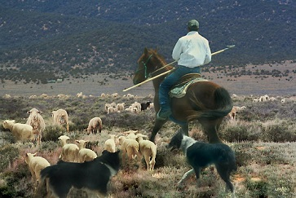 | 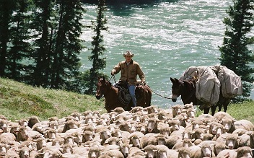

So, what do you think? Are you ready to quit your office job and become a sheepherder where you can get out in mountains, get some fresh air, and get back in touch with Mother Nature? I looked on the Internet and there are jobs available. They are listed under, “Farm and Ranch Managers”, and it looks like you can make up to $70,000 a year.

Let’s see now, I like being out in the mountains, I like dogs, horses, and sheep, and I’m kind of a loner and don’t mind being out away from other people for long periods of time. Maybe I should have been a sheepherder. But then I remember some of the stories my dad told me about his experiences up on the mountains above Price. Here is one story:

Every summer during my dad’s school years, his dad would drop him and his two brothers off up at Indian Canyon on top of the mountain near Price. They would spend the entire summer up there herding and tending sheep until fall.  His father was always late coming to get them so they never returned back to Price in time for the start of the school year. They did have a cabin up there to sleep in with a wood stove to cook things. However, | 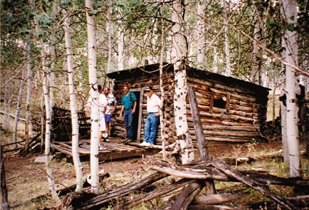  Sheep herding cabin located in mountains near Indian Creek – That is dad’s brother and my Uncle “R” on the right.
they grew tired of eating mutton, cabbage, and biscuits. But, except for shooting a deer once in a while, that was their primary diet. One summer, dad’s brother “R” fell off of his horse and broke his arm. Dad had to take him on a horse all the way to Price in order to get medical attention. Back then, up on the mountain, there was no electricity, no running water, no toilet, no phones or any other way to communicate with the outside world. If something bad happened, they just had to deal with it. They did have guns, dogs, horses, and a lot of sheep. Somehow dad and his brothers survived their childhood.

On second thought - No thanks - The sheepherding business is too big of a hardship for me.

bigdrifter44@gmail.com

