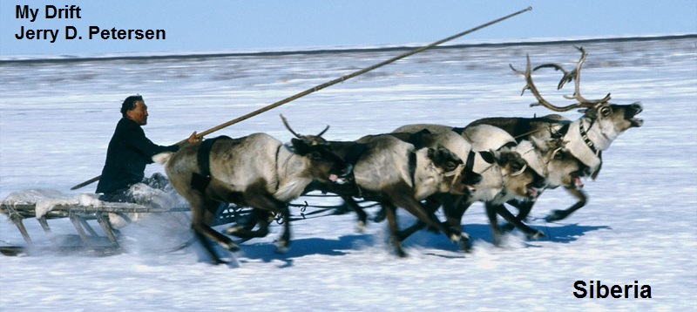

 | Siberia  26 June 2014 | 179-2014-08

I was wondering the other day if there was a more desolate place on earth than the Outback that I wrote about earlier this year. It didn’t take much research to discover Siberia. We all know that Siberia is part of Russia but did you know just how big it is, who lives there, what animals/birds/plants are there, how cold it gets, and that the Trans-Siberian Railway (the Moscow-Vladivostok line) is the longest railway in the world?

History of Siberia
Siberia has a long history that dates back to prehistoric times. Evidence of some of the earliest human species has been found in southern Siberia that dates back to about 40,000 years ago. These species include Homo neanderthalensis, the species before humans, and Homo sapiens, humans, as well as a currently unidentified species whose fossils were found recently.

In the early 13th century, the area of present-day Siberia was conquered by the Mongols. Prior to that time, Siberia was inhabited by various nomadic groups. In the 14th century the independent Siberian Khanate was established after the break-up of the Golden Horde in 1502.

In the 16th century, Russia began to grow in power and it started to take lands from the Siberian Khanate. Initially, the Russian army began to establish forts farther east and eventually it developed the towns of Tara, Yeniseysk and Tobolsk and extended its area of control to the Pacific Ocean. Outside of these towns however, most of Siberia was sparsely populated and only traders and explorers entered the region.

In the 19th century, Imperial Russia and its territories began sending prisoners to Siberia. After World War II, the number of inmates in prison camps (Gulags) reached approximately 2.5 million people. Today, Russia has about a million prisoners serving time in its 840 prisons. Only the United States has a higher incarceration rate (737 per 100,000 population) versus Russia with 615 per 100,000 population.

Before and during the construction of the Trans-Siberian Railway (1891-1916), about seven million people moved from European Russia to Siberia. In 1893, Novosibirsk was founded, which today is Siberia's largest city, and in the 20th century industrial towns grew throughout the region as Russia began to exploit its many natural resources. Today, the total population of Russia is about 143 million. Siberia has a population of about 40 million people (about 27% of Russia’s total).

Geography and Climate of Siberia
Siberia is an extensive geographical region, consisting of almost all of North Asia. The territory of Siberia extends eastwards from the Ural Mountains to the watershed between the Pacific and Arctic drainage basins. Siberia stretches southwards from the Arctic Ocean to the hills of north-central Kazakhstan and to the national borders of Mongolia and China. So, the area west of the Ural Mountains (including Moscow and St. Petersburg) is considered to be part of Europe – the area east of the Ural Mountains (Siberia) is in Asia.

If Siberia was a country by itself, it would still be the largest country in the world by a lot. The second largest country in the world is Canada with 3.86 million square miles and the United States is third with 3.8 million square miles. Without Siberia, Russia would be the seventh largest country with 1.5 million square miles. The total area of Russia is about 6.6 million square miles. Siberia has a total area of over 5.1 million square miles which is 77% of Russia’s total area. Siberia has a highly varied topography that covers several different geographic zones including the West Siberian Plateau and the Central Siberian Plateau.

The West Siberian Plateau is a large plain (975,000 square miles) that occupies the western portion of Siberia, between the Ural Mountains in the west and the Yenisei River in the east, and by the Altay Mountains on the southeast. Much of the plain is poorly drained and consists of some of the world's largest swamps and floodplains. The northern portions of the plateau are dominated by soil that is at or below the freezing point of water (permafrost) while the southern areas are mostly comprised of grasslands.

The Central Siberian Plateau is a vast upland area (600,000 square miles) located in north-central Siberia. It is bounded by the Yenisey River to the west, the North Siberian Lowland to the north, the Lena River to the east, and the Eastern Sayan Mountains and the Baikal region to the south. Vegetation in the plateau varies from tundra in the north to steppe-grasslands in the south. This is an ancient volcanic region that is rich in natural materials and minerals like manganese, lead, zinc, nickel and cobalt. It also has areas with deposits of diamonds and gold. However, most of this area is under permafrost and the dominant landscape type outside of the extreme high northern areas is taiga (a biome coniferous forest).

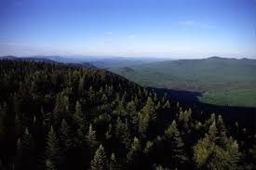 | 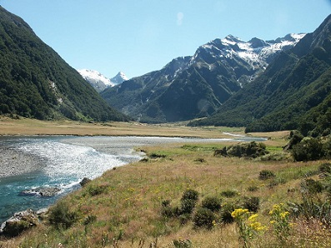
Taiga - Biome Coniferous Forest | Ural Mountains
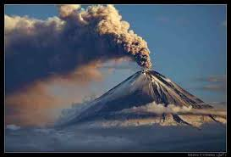 | 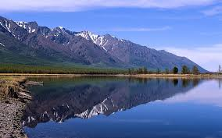
Klyuchevskaya Sopka Volcano | Lake Baikal

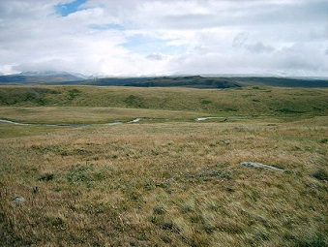 | 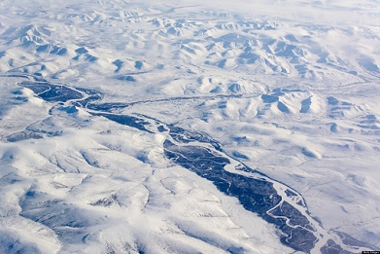
Ukok Plateau Pristine Grasslands | Northern Siberia Arctic Ice

Outside of these major regions, Siberia has several rugged mountain ranges that include the Ural Mountains, the Altai Mountains and the Verkhoyansk Range. The highest point in Siberia is Klyuchevskaya Sopka, an active volcano on the Kamchatka Peninsula, at 15,253 feet. Siberia is also home to Lake Baikal - the world's oldest and deepest lake. Lake Baikal is estimated to be around 30 million years old and at its deepest point it is 5,387 feet. It contains about 20% of the Earth's non-frozen water.

The coldest town on earth is located in Siberia. It is so cold that low temperatures in the minus 60s are "normal" in the winter months. Oymyakon, a village of just under 500 residents in northeast Siberia, is widely considered the World's coldest permanently inhabited town. On Feb. 6, 1933, an observer, there, measured a temperature of -89.8 degrees Fahrenheit! This is a full 10 degrees colder than the U.S. cold record of -79.8 degrees at Prospect Creek, Alaska on Jan. 23, 1971. In December, 2010, it was -44 degrees when I was TDY to Fairbanks, Alaska. I can tell you right now that it was COLD! So, anyway, that is probably why most Siberian people live in the southern part of the region near the Trans-Siberian Railroad. The average January low temperature of Novosibirsk, Siberia's largest city, is -4˚F while the average July high is 78˚F. Now that is a little better.

Largest Cities
Novosibirsk is the third largest city in Russia behind Moscow (11.5 million) and St. Petersburg (4.9 million) with 1.4 million people. The only other cities in Siberia with over a million people are Omsk (located in southwestern Siberia) with 1.15 million and Krasnoyarsk (located in south-central Siberia on the Yenisei River) with a little over a million people.

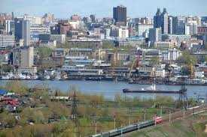 | 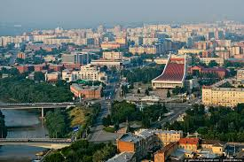
Novosibirsk | Omsk

National Sport of Siberia
Bandy is a team sport played on ice, in which skaters use sticks to direct a ball into the opposing team's goal. The sport has common background with football, ice and field hockey. Like football, the game is played in halves of 45 minutes each, there are eleven players on each team, and the Bandy field is about the same size as a football field. It is played on ice like ice hockey, but like field hockey, players use bowed sticks and a small ball.

People of Siberia
Today, Siberia is dominated by native speakers of Russian. But, there remain a considerable number of indigenous groups, between them accounting for about 10% of total Siberian population. Russia is home to 160 different ethnic and indigenous groups. This diverse population has influenced everything from Russian language and literature to the arts, music and dance to the Russian lifestyle and traditions, food, and architecture. Some native indigenous group ladies are pictured on the next page.
 | 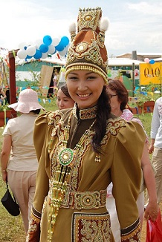 | 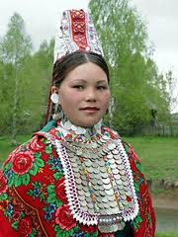

Some Other Tourist Attractions
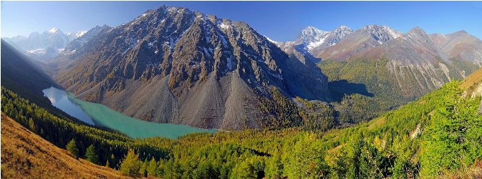
Shavlinskoe Lake Region. Altai, Siberia, Russia

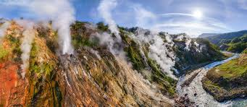
Valley of Geysers, Kamchatka, Siberia, Russia

Siberian Animals and Birds
Since Siberia has the largest forest on planet earth, it is the home to many different animals and birds such as reindeer, long-horned goats, ibex, musk deer, polar bears, seal, walrus, many fish species, wolves, ermine (weasels), several large birds of prey, falcons, red-breasted geese, ducks, mice, rabbits, burrowing small rodents, lynx, and arctic foxes. Siberia's bird population is one of its most diverse and interesting, due to the great variety of feathered inhabitants and visiting species. There are approximately 400 different types of birds that live in or migrate to Siberia.
Animals and Birds
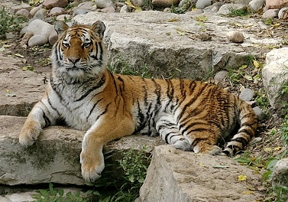
Siberian Tiger  (The largest cat in the world) | Siberian Cat  (Is twice the size as US domestic cats)
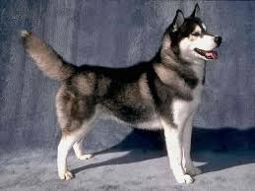 | 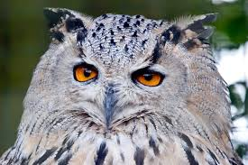
Siberian Husky  (Descended from oldest known Eskimo dogs) | Siberian Eagle Owl  (Diet includes medium-sized mammals)
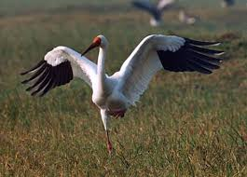 | 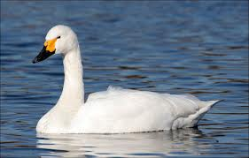
Siberian Crane  (Migrates to the Siberian Arctic tundra) | Siberian Swan  (Makes a high-pitched honking sound)

The Trans-Siberian Railway
If I ever get to Russia, the thing I would most want to do is to ride the Trans-Siberian train from Moscow to Vladivostok. Actually, this would be a big part of my 30-day dream trip around the world. Here is my itinerary:

Number of Days | Location | Events
2  7  3  1  6  8  3 | Mililani, Hawaii  San Francisco, CA  Salt Lake City, Orem, and Wendover, NV  Erie, PA  New York City  Denmark and Sweden  Russia (Siberia)  Seoul, Korea  Mililani, Hawaii | Leave Honolulu International Airport  Do some sightseeing and play some ping pong with my friend Howard Lee who lives in San Jose.  Spend some time with my Utah family. Visit my friend Lew Deveraux and maybe go fly fishing on the Provo River. Go to Wendover with my friend Albert Martinez to do some gambling and play some pool.  Visit my daughter Tracy and her family.  One night stay in Times Square.  I have always wanted to visit these 2 countries.  Moscow to Vladivostok on the Trans-Siberian Train.  Stay at the Hamilton Hotel in Itaewon. Visit some of the bars I used to hang out at while on TDY. Spent some time with my friends Mr. Son and Miss Kim and play some Korean Billiards.  Leave Korea and fly back to Hawaii

Okay, we got a little off-track there – sorry about that - let’s get back to the Trans-Siberian train trip. My trip would follow the blue line (in the map below) without going into Mongolia or China.

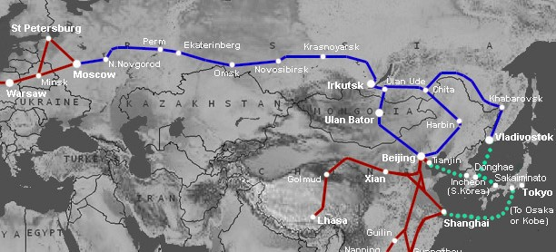
Trans-Siberian Railway Routes

The construction of the Trans-Siberian Railway between 1891 and 1916 ended the era of great transcontinental railway building. The Trans-Siberian stretches 5,776 miles between Moscow's Yaroslavsky Station and Vladivostok. This is over one third of my trip around the globe. It takes a minimum of a week to traverse that distance by train. Yes, this is the longest railway in the world.

I have been fascinated with trains for as long as I can remember. While growing up in Pleasant Grove, Utah, I could hear the Union Pacific trains go through town. The tracks were only a couple of blocks west of our house and the train would blow its horn before crossing every road. The Rio Grande railroad also went through Pleasant Grove but this was further west closer to Utah Lake where we could not hear the trains. In the summer of 1960, I got one of the best jobs in the World. I was hired as a Fireman on the Rio Grande Railroad. My primary duty was to sit in the engine and wave at the kids as we went by. Actually, I had to walk back through the diesel engines every two hours and check the oil and water gauges. Back in the old days, the fireman had to shovel coal into the engine to make steam. They give me enough training so that I could operate and stop the train just in case the Engineer dropped dead. I worked out of Salt Lake City and the primary run was to Helper, Utah (about 100 miles) and back to Salt Lake. Most of the time, I worked in the yard switching train cars around. I worked two years on the railroad while I was going to the University of Utah. This was a great “no stress” job and I had rehiring rights for that job when I got out of the Navy. But, while I was in the Navy, advanced technology and the need to cut operating costs caused the railroad industry to eliminated the Fireman, the Flagman, the Brakeman and take off the caboose from all railroad freight trains. The Conductor who used to ride in the caboose was moved to the engine. The railroad industry had really gone to hell while I was away fighting the war. So, instead of this great job, I got a $2000 severance check. Just think - I might have ended up an Engineer on the railroad instead of coming to Hawaii and working on computers.

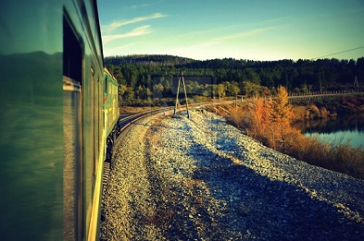 | 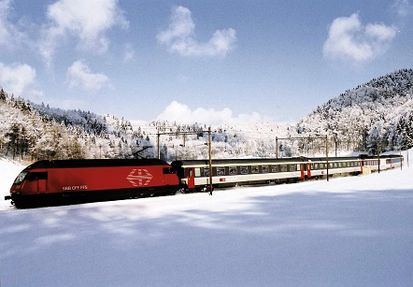

I think I would enjoy this train ride very much. A great part of the pleasure of riding in a train is simply sitting back and watching the land go by. This train also has a sleeping, dining and bar car where I’m sure I would be spending a lot of time. The interaction with other passengers, both Russians and tourists, would make the trip an unforgettable experience. I do like to talk to other people especially after drinking a few brews. There are several stopovers in many Russian cities and towns along the route, from the historic Volga port of Yaroslavl to Irkutsk and the scenic Lake Baikal region. You can buy snacks and try different brands of beer whenever the train stops. I have already learned a little bit about Russian money. One Russian Ruble equals .03 US Dollars or 3 cents. 100 hundred Rubles equals about $3 US Dollars. 1,000 Rubles equals $30 Dollars. One US Dollar equals about 34 Rubles.

I also need to learn at least two words in Russian:

“Beer” in Russian is spelled “пиво” or “Pivo” and is pronounced [PEE-vah]

The most popular beer in Siberia is Jellen Pivo.

The other word I need to learn is “Thank You”
It is spelled “Спасибо” or “spasiba” - Russians pronounce it as [spa-SEE-ba]

For anything else, I can just point at it and offer a hand full of money.

Well, I hope you have learned something about Siberia and my “dream” trip on the Trans-Siberian Railway.

bigdrifter44@gmail.com

