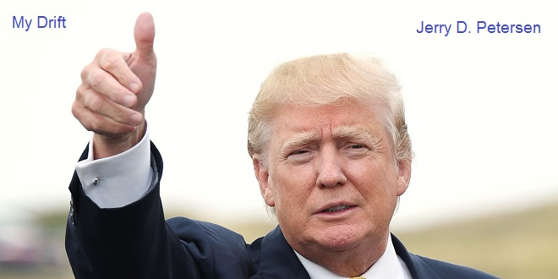

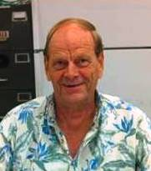 | Donald John Trump  16 Oct 2015 | 213-2015-20

"THE DONALD"
Trump, or "the Donald," as he is nicknamed, has finely crafted his persona over the years with an intense drive to place "Trump" on everything he owns. He issues a stream of news bulletins about his every move, putting himself constantly in the public eye. He is a hands-on businessman who likes to know every detail of his ventures. Considered driven, arrogant, and intelligent, Trump understands the psychology of real estate speculation. He made himself famous with his flamboyant skills at selling himself to the media and personified the American business success story. He thrives on conflict and the ultimate challenge, doing his best when problems seem insurmountable to others.

This pretty much sums up The Donald. Oh, by the way, you might have heard, Trump is running for President of the United States. In fact, he is the Republican Party frontrunner. As I write this article, Trump continues to lead the crowded field of GOP hopefuls with a favorable rating of 23%, up 6 points from the survey in July. Ben Carson, a retired neurosurgeon, and Carly Fiorina, an ex-CEO, tie for second at 13%, both big jumps from the last poll. That means about half of the GOP electorate back candidates who have never served in elective office. No other candidate breaks into double digits. Marco Rubio is at 9%, Jeb Bush at 8%, Ted Cruz at 6% and John Kasich at 2%.

There is no doubt about it – Donald Trump is an interesting person and since he might be our next President, it is about time we learn more about this man.

SOME GENERAL INFORMATION
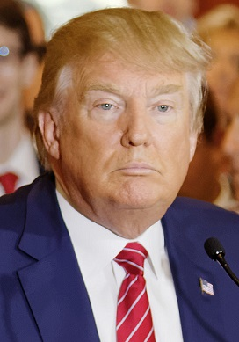 | Born:  Donald John Trump  June 14, 1946 (age 69)  Queens, New York City, U.S.  Current Residences:  Trump Tower  Manhattan, New York City  Mar-A-Lago  Palm Beach, Florida  Alma mater:  Fordham University (transferred)  University of Pennsylvania (B.S.)  Estimated Salary:  About $250 million a year  Net worth:  About $4.5 billion (Forbes estimate)  (Trump says he is worth $9 billion)
Signature:  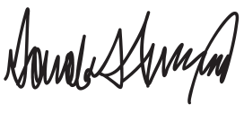 | Religion:  Presbyterianism  Parents:  Fred Trump  Mary Anne MacLeod Trump

Donald Trump is an American real estate developer, television personality, business author, and political candidate. He is the chairman and president of The Trump Organization, and the founder of Trump Entertainment Resorts. Trump's career, branding efforts, lifestyle and outspoken manner helped make him a celebrity, a status amplified by the success of his NBC reality show, The Apprentice.

NATIONALITY
Yes, Donald Trump is an American but what nationality are his parents and grandparents? His father (Frederick Christ "Fred" Trump (Jr.)) was born in Woodhaven, New York. Donald Trump's grandfather Friedrich Drumpf immigrated to New York City in 1885 from Germany. He changed his name to Trump and became a naturalized U.S. citizen in 1892. The elder Trump operated hotels and restaurants in the Klondike (the Yukon in north-western Canada) during the Gold Rush. In 1901, sensing the end of the gold rush, Trump Sr. sold his investments and used the proceeds to return to Germany where he married his old neighbor Elizabeth Christ. After which, they returned to live in Woodhaven.

Donald Trump's mother, Mary Anne MacLeod, was born in the village of Tong, in the parish of Stornoway on 10th May 1912, to a fisherman named Malcolm MacLeod and his wife, Mary Smith. Mary Anne lived on the Hebridean Island of Lewis, off the west coast of Scotland, from where she emigrated to America. MacLeod is one of the most common surnames on the island.

So, Donald Trump is of German and Scottish decent. I wonder if The Donald would have been so successful using his real last name, “DRUMPF”!

EARLY YEARS
Trump attended the private Kew-Forest School in Forest Hills, Queens, where Fred Trump, Donald's father, was a member of the Board of Trustees. Some of his siblings also attended Kew-Forest. However, young Donald was a very rowdy boy who got into a lot of fights. This prompted his dad to enroll him in the New York Military Academy (NYMA) starting in the eighth grade for the duration of his high school education. Trump participated in marching drills and wore a uniform, attaining the rank of "cadet captain" in his senior year. He told a biographer in 2015 that NYMA gave him "more training militarily than a lot of the guys that go into the military".

Trump attended Fordham University in the Bronx for two years, before transferring to the University of Pennsylvania, because they had one of the few real estate studies departments in U.S. He graduated in 1968, with a Bachelor of Science degree in economics.

Trump came of age for the draft during the Vietnam War. He got lucky by drawing a very high draft number and having student deferments (2-S) while attending college. After college graduation, Trump received a medical deferment (1-Y, later converted to 4-F) which kept him out of the military. Trump attributed his medical deferment to "heel spurs" in both feet but recently he told an Iowa campaign audience that he suffered from a spur in one foot, though he could not remember which one.

Is The Donald a draft dodger? You decide.

LEARNED FROM HIS FATHER
Trump learned his deal-making and entrepreneurial skills from his father, Frederick, who was forced at eleven years of age—upon his father's death—to run the family business. He acquired the ability to recognize good deals when he constructed and operated 24,000 affordable housing units in Brooklyn, Queens, and Staten Island.

As a child, Trump assisted his father with the rental property business; at age five he was taken along to inspect building sites, and at thirteen he drove a bulldozer. Even at this early stage, Trump was described as self-assured, determined, and positive. He was strongly influenced by his father in his decision to make a career in real estate, but he envisioned buying and selling rather than collecting rents. He learned showman-ship and how to advertise himself from his mother, Mary, who liked to be in the center of the spotlight.

Upon graduation in 1968, Trump joined his father's company, with a clear view of what he wanted to do: develop real estate in the biggest way possible. He persuaded his father to expand the company's holdings by taking loans against their equity, which then stood at $200 million. Trump became president in 1975 and changed the company's name to Trump Organization. The climate in Queens was competitive, and profit margins were narrow, so Trump decided that he could make more money in elegant Manhattan.

FAMILY (WIVES, GIRL FRIENDS AND CHILDREN)
In 1977, Trump married Ivana Zelníčková, a native of the Czech Republic, and together they have three children: Donald, Jr. (born December 31, 1977), Ivanka (born October 30, 1981), and Eric (born January 6, 1984). Ivana Trump became a naturalized U.S. citizen in 1988, with Trump at her side. By early 1990 Trump's troubled marriage to Ivana and long-running affair with actress Marla Maples had become tabloid fodder and the couple divorced in 1991.

Trump married Maples on December 21, 1993, two months after the birth of their child, Tiffany (born October 13, 1993). They divorced on June 8, 1999. Trump dated model Kara Young in the mid to late 1990s and reportedly "bombarded" Princess Diana with expensive floral arrangements after her 1996 divorce from Prince Charles. "I only have one regret in the women department — that I never had the opportunity to court Lady Diana Spencer", Trump wrote in his 1997 book, The Art of the Comeback. "I met her on a number of occasions ... She was a genuine princess — a dream lady."

 |  | 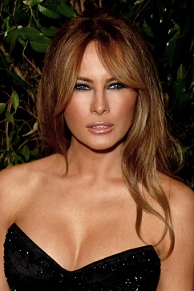
Ivana Trump  Born in 1949 (Age 66)  Socialite | Marla Maples  Born in 1963 (Age 51)  Actress | Melania Knauss-Trump  Born in 1970 (Age 45)  Model

On April 26, 2004, Trump proposed to model Melania Knauss, a native of Slovenia. The couple had met and begun a relationship in September 1998. Trump and Knauss married on January 22, 2005, at Bethesda-by-the-Sea Episcopal Church, on the island of Palm Beach, Florida, followed by a reception at Trump's Mar-A-Lago estate. Melania gave birth to a boy named Barron William Trump, Trump's fifth child, in 2006 and became a naturalized U.S. citizen that same year.

Did you notice that Trump’s wives keep getting younger as he is gets older? Melania would make an attractive First Lady!

WHAT DOES DONALD TRUMP OWN?
Office buildings and residential real estate
(Estimated value: $2.9 billion)
Donald Trump started out as a real estate developer, and property holdings do make up the lion’s share of his holdings (aside from his brand). The Trump Organization said it has a total of $2.9 billion worth of commercial and residential real estate. In addition to more than $74 million in real estate licensing deals, that includes $1.38 billion in New York City commercial buildings, $351.55 million in New York residential buildings and $823.3 million worth of real estate in joint ventures.

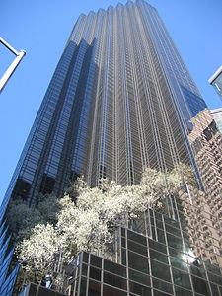 | 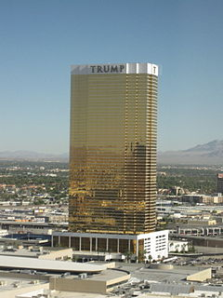 | 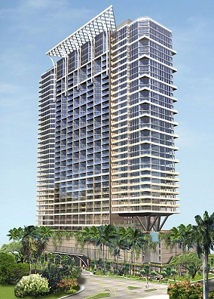
Trump Tower  New York | Trump Hotel & Casino  Las Vegas | Trump Hotel  Waikiki, Hawaii

Trump’s best-known — and likely most valuable — commercial real estate asset is his headquarters, Trump Tower, a 68-story mixed-use tower at 725 Fifth Avenue. The building, which is now 100 percent leased, was developed by a partnership of Trump and the Equitable Life Assurance Society of the United States in 1983, but Trump now has full control of the tower. Trump Organization’s offices are on the 26th floor and at the top of the building lies Trump’s personal residence, a gold and marble clad Louis XIV style penthouse spread over three floors, where the real estate developer lives with his wife Melania and their son, Barron.

Residential real estate
The Trump Organization values its holdings in New York City residential properties at more than $350 million. Here is an example: Trump owns 23 apartments at Trump Park Avenue, which he rents for rates as high as $100,000 per month.

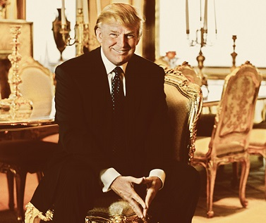
Donald Trump at his apartment in New York

The Trump Brand
Trump’s estimated value: $4 billion
In the Trump Organization’s eyes, its most valuable asset is the Trump name itself. For decades, Donald Trump has diligently cultivated his brand, and he’s now a TV star in his own right due to the ongoing success of “The Apprentice”.

The Apprentice (now in its 13th season) is an American reality game show hosted by real estate magnate, businessman and television personality Donald Trump. Billed as "The Ultimate Job Interview", it has sixteen to eighteen business people competing in an elimination competition. The prize is a one-year, $250,000 starting contract to run one of Trump's companies. Each episode typically ends with Trump eliminating one of the contestants with the words, "You're fired" (which has become a famous expression of the program and Trump himself).

It’s not all theoretical. Trump has found numerous ways to monetize his brand. Most notably, he’s licensed his name to no less than 17 different kinds of products, from clothing and perfume to vodka and mattresses, as well as glassy high-rise towers as far away as Istanbul and the Philippines.

Resorts, country clubs and golf courses
Trump’s estimated value: $1.57 billion
In recent years, Trump has invested heavily in “lifestyle properties” such as golf courses, resorts and country clubs. He owns at least 13 golf courses across the globe, including the 1,200-acre Trump International Golf Links in Scotland. Putting a dollar figure on the value of these assets is tricky, however, because many of them come with development rights or the potential for other uses.

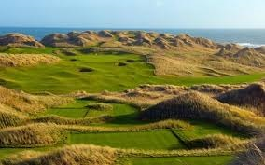
Trump International Golf Links in Scotland

Entertainment and other assets
Trump’s estimated value: $317.6 million

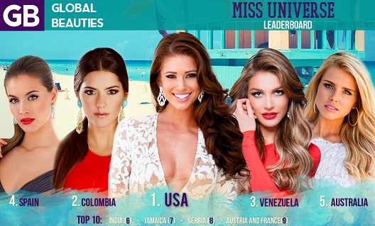

Trump also owns a wide variety of other enterprises outside the realm of real estate. For example, the real estate magnate owns the Miss Universe, Miss USA and Miss Teen USA pageants, which the Trump Organization said are collectively worth a total of $15 million.

In addition, he owns a talent and modeling agency, Trump Model Management, and 50 percent of the value of the rights to “The Apprentice,” which he shares with producer Mark Burnett and on which he’s been focusing much of his time and attention of late. He also owns several airplanes, including a Boeing 757 and a Cessna Citation X.

But regardless of how many planes or buildings he has, Trump has made one thing clear over the years, which accounts for a significant portion of his wealth: he knows how to stay in the spotlight.

So, as you can see, Trump owns a lot of stuff. Most financial experts estimate his worth at about $4 billion but The Donald says his name alone is worth over $4 Billion and his total worth is more like $9 billion. Whatever the real amount is, it is a lot of money.

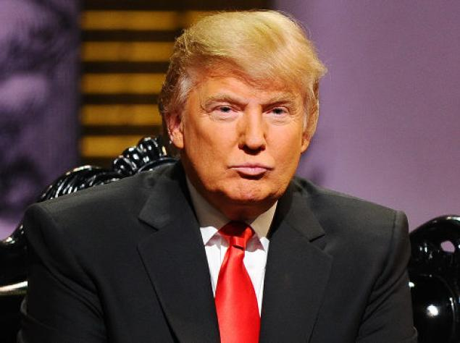

BANKRUPTCIES
Just for the record, Donald Trump, official presidential candidate, has never personally declared bankruptcy. The business ventures that bear his name, however, are a different story.

Since 1991, Trump-related companies have filed for corporate bankruptcy four separate times. Filing for Chapter 11 bankruptcy allows a corporation—which is legally distinct of its shareholders, owners, board, and C.E.O.—to stay in business while it re-structures and attempts to reduce its debt. So, while he’s been able to keep his personal finances in order, the businesses that so proudly trumpet his billion-dollar name are something of a different story. Here are a few details concerning those four bankruptcies:

1991, Trump’s Taj Mahal in Atlantic City
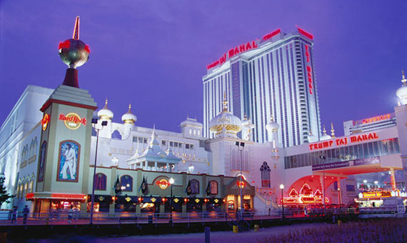

This is the only one where The Donald’s fortune was actually in any danger. After financing much of the construction of the casino with junk bonds, the luxurious facility was in debt, and so was he. (Exactly how much is up for debate; the Times pegged his personal liabilities at $900 million.) In order to escape potential doom, Trump’s corporation filed for Chapter 11 bankruptcy, which allowed him to reorganize the debt while the casino remained open. The real-estate tycoon ended up taking a substantial hit this time, as he was forced to relinquish half his stake in the casino and sell his yacht and airline to pay back loans.

1992, Trump Plaza Hotel in Atlantic City
In his second swing at bankruptcy, Trump was able to insulate himself from any real harm, for the most part. This time it was the Trump Plaza Hotel that was hemorrhaging cash, having lost over $550 million. Ever the negotiator, the entrepreneur agreed to give up a 49 percent stake in the hotel to Citibank and other lenders, according to ABC News. In exchange, he received more favorable repayment terms on the debt. The celebrity developer also managed to hold onto his C.E.O. title, even though it meant giving up his salary and any role in the day-to-day operation of the hotel.

2004, Trump Hotels and Casinos Resorts
Just over a decade later, a Trump corporation was filing for Chapter 11 yet again. With the company nearly $1.8 billion dollars in debt, the businessman was back to making deals, this time agreeing to reduce his stake in the company to about 25 percent in exchange for lower interest rates and a new loan, the Associated Press reported at the time. The move meant that Trump surrendered much of his control in the company, but considering what had been going on under his watch, that was probably a good thing. (Time magazine claims Trump was also forced to pump $72 million of his own money into the company to keep it going.)

2009, Trump Entertainment Resorts
In his most recent dalliance with bankruptcy, Trump’s company declared Chapter 11 after missing a $53.1 million bond interest payment. Trump and the rest of the board of directors could not reach an agreement over whether or not to file for bankruptcy, resulting in his resignation as head of the board. The move also saw his stake in the company reduced even further on what Trump called a now “worthless” investment that he assured was less than one percent of his net worth.

Trump managed to come out of all these bankruptcies with much more money than he had to start with. The man is unafraid to take chances, fail, and lose a lot of money when he thinks his projects will succeed in the long run.

2016 PRESIDENTIAL CAMPAIGN
Is Trump really a Republican? Well, he is now.
Political party:
Republican (Before 1999; 2009–10; 2013–present)
Reform (1999–2000)
Democratic (2001–08)
Independent (2011–12)
"Make America Great Again"

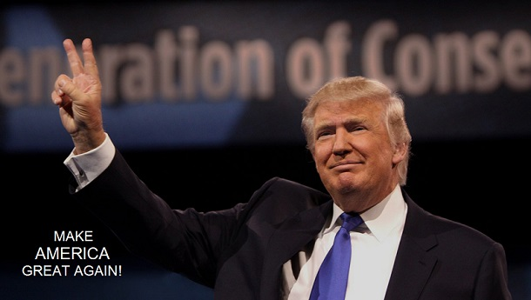

Donald Trump wants to make America great again. This is how he wants to do it:

If Trump were elected president, he says, he would launch the U.S. government into a massive building project.

On the U.S.-Mexico border, Trump would build a long, impenetrable wall. In the rest of the country, he would pressure the estimated 11 million illegal immigrants to “self-deport” — and, if they don't, round them up to deport en masse. Later, Trump says, “the good ones” could come back.

He also wants to go on a building spree. Modern new VA hospitals. Better bridges, highways, railroads, etc. A new floor at LaGuardia Airport, to replace that shabby terrazzo Trump hates. And, to pay for it all, Trump would not raise taxes. He’d lower them.

Instead, Trump would get other countries to start paying the United States large new sums of money — and agree to receive nothing in return. China, for instance, would pay for new tariffs. Mexico would even pay for America’s new border wall.

WHERE DOES TRUMP STAND ON MAJOR ISSUES?
Budget: Government must cut spending more. Congress must reduce spending and address impending increases in the deficit.

Entitlements: Do not cut Social Security or Medicare benefits. Grow the economy to save those programs.

Gun Control: Limit restrictions on guns. Ban some assault weapons and extend the waiting period for purchase.

Global Warming: It is a hoax. Trump does not believe climate change is real.

Entitlements: Do not cut Social Security or Medicare benefits. Grow the economy to save those programs.

Gun Control: Limit restrictions on guns. Ban some assault weapons and extend the waiting period for purchase.

Immigration: No path to citizenship for undocumented workers. Allow more European immigration and a legal status to those graduating from U.S. colleges. Trump called for securing the southern border and indicated that he believes half of the undocumented residents in America are criminals.

Obamacare: Repeal it. Replace it!

Social Issues: Abortion should be limited. Marriage is between a man and a woman and should be defined state by state.

Taxes: End corporate taxes. Lower individual rates. Consider a one-time tax on the wealthy to pay down the debt.

Iran and Israel: Walk away from nuclear talks. Increase sanctions.

Islamic State and Iraq: Send a limited number of combat troops on the ground.

IN CONCLUSION
Most Democrats and a few Republicans are calling Trump an “egoistical blowhard” and want the clown out of the Presidential Race. I think Trump will make things interesting since we finally got somebody running who is not afraid to tell it like it is and is not worried about being politically correct. Most politicians lie, promise you the world, and tell you what they think you want to hear. Then when they get elected, it is business as usual and those campaign promises are long forgotten.

I like most of Trump’s ideas. We need a strong leader with new ideas and the guts to implement them. I think it would be great for all these countries that we have been giving millions of dollars to every year in foreign aid to start paying money back to America instead.

So, in conclusion, Yes, I would vote for Donald Trump especially if his opponent is Hillary Clinton. If you have not read my article on Hillary, you may want to do so before Election Day.

bigdrifter44@gmail.com

Foot Note #1: There have been one or two readers who complained that my articles are too long and they don’t time to read the whole thing. For this article only, I have highlighted in yellow some of the more important stuff. However, I recommend that you read the whole article so that you might learn a little more.

Foot Note #2: MY PREDICTION – Donald Trump will drop out of the presidential race early next year (2016). He will leave the race on top of the polls and probably would have won the presidency. Trump realizes that he would be dealing with a bunch of “do-nothing” politicians currently in Congress and the Senate. Pushing through his plans to get things done would be almost impossible. He is also starting to lose money on some of his real estate ventures and some other things he owns. Some large company sponsors have dropped the “Trump” brand because they don’t like what he is saying about immigration and other topics. Yes, the Donald goes back to doing what he does best, “wheeling and dealing” in the America’s business market place.

