 | Jerry D. Petersen | The United States Senate and House of Representatives  October 16, 2013  (169-2013-19)

United States Capitol Building, Washington D.C.

I’m extremely disappointed in our Government!! This is the most dysfunctional group of lawmakers this country has ever had. These Senators and Congressman/Congresswomen were elected to serve the people of the United States but it appears that they are only serving their own “huge” egos and the wishes of Special Interest Groups. Their primary job every year is to prepare and pass the budget bill to fund the Government for the next fiscal year – they have to do this by midnight on 30 September. In the past with only a couple of exceptions, the Republicans and Democrats have been able to work together long enough to get this important job accomplished. But not this year! All we are getting is arguing, bickering, blaming, threats, and a bunch of grown men and women acting like five year olds. Nothing good ever seems to come out of Washington D.C. any more. The American people are sick and tired and fed up with our Government doing nothing but hurting the average U.S. citizen.

I have planned to write about this problem several times in the past year but every time I start thinking about it, I can feel my blood pressure going up and decide not to do it. But, I can’t stand it any longer so I’m going to express some of my views on the subject and present a few recommendations on how to fix our broken Government. I’m writing this article during the “Great” Government Shutdown in October of the year 2013.

But first, I’m going to provide you with a refresher course and some basic information about how the United States Government is supposed to work. The chart below shows the three branches of our Government and their basic functions.

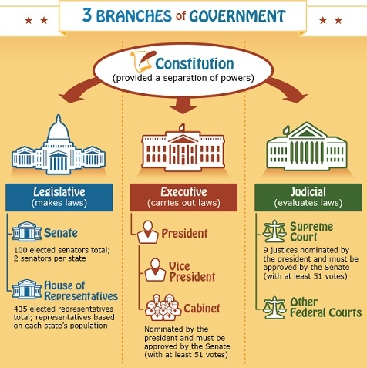

Our Founding Fathers, the framers of the Constitution, wanted to form a government that did not allow one person to have too much control. With this in mind, they wrote the Constitution to provide for a separation of powers, or three separate branches of government. Each has its own responsibilities and at the same time they work together to make the country run smoothly and to assure that the rights of citizens are not ignored or disallowed. This is done through checks and balances. A branch may use its powers to check the powers of the other two in order to maintain a balance of power among the three branches of government. On 21 June 1788, New Hampshire became the ninth state to ratify the Constitution, making it the official form of government for the United States.

The United States Congress is the legislative branch of the federal government and consists of two houses: the lower house known as the House of Representatives and the upper house known as the Senate. The words "Congress" and "House" are sometimes used to refer to the House of Representatives. Democrats currently have a majority in the Senate and Republicans control the House.

Seats in the Senate vs House of Representatives
The original concept in the Constitution was that the House represents the people and the Senate represents the states. Up until 1913 when the 17th amendment was ratified, each state legislature elected the states two Senators. The 17th amendment changed it to allow the citizens to elect them. While there are 100 seats in the Senate (two from each state), there are currently 435 seats in the House of Representatives, one each from the various congressional districts (the number of congressional districts in each state is determined based on the population). All of these people work (and I use this term loosely) in the United States Capitol Building in Washington D.C.

Role of the Senate and House
In a nutshell, the Senate possesses the power to review and debate bills, treaties, and proposed legislation to provide some oversight to the president’s administration. They must approve House legislation by at least 51 votes before it goes to the President to be signed and become law. Their chief job is to represent the interests of each state in the political process versus the House, which is charged to represent the interests of the people.

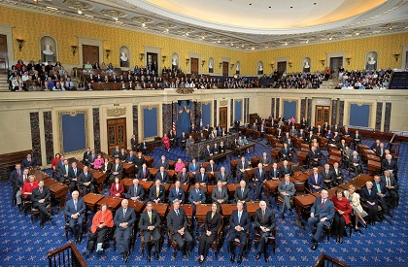 | 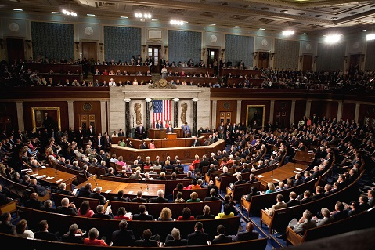
Senate Chamber | House of Representatives Chamber

How a Bill Becomes a Law
- Creating laws is the U.S. House of Representative’s most important job.
- A House Representative writes a bill and gets another Representative to sponsor it.
- The bill is introduced to the House and placed in the hopper.
- The bill clerk assigns it a number that begins with H.R. and then reads the bill to all members of the House.
- Then the bill goes to a committee which is a group of House Representatives who are experts on the topic.
- Once the committee has approved the bill, it is sent to the House floor to be debated.
- The bill is then voted on and if a majority of the Representatives say “aye” or “yes”, the bill passes in the U.S. House of Representatives.
- The bill then goes to the U.S. Senate where it is discussed by a Senate committee and then sent to the Senate floor to be voted on.
- If a majority of the Senators say “yea,” the bill passes in the U.S. Senate and it goes to the President.
- If the President signs the bill - the bill becomes a law.
- If the President does nothing – the bill becomes a law in 10 days.
- If the President vetoes it - the bill is sent back to the U.S. House of Representatives.
- If two-thirds of the House Representatives and Senators support the bill, the President’s veto is overridden and the bill becomes a law.

House vs Senate Terms
Senators are elected for a six-year term but House Representatives only get a two-year term before they need to seek re-election. The six-year terms were supposed to have a stabilizing effect on the national government and control turnover in the legislature, allow senators to take responsibility for measures over time, and make senators largely independent of public opinion. Senate terms (elections) are staggered over a 6 year period. 1/3 of senate seats are up for election every 2 years, meaning it is impossible to vote out the entire Senate in less than any 6 year period. The entire House is up for election and can be replaced over a 2 year period.

Salaries
As of January 2010, the annual salary of each Representative (the Senate and the House) is $174,000. The only exceptions include the Speaker of the House ($223,500) and the President of the Senate and the majority and minority leaders in the House and Senate ($193,400). Outside pay is limited to 15% of congressional pay, and certain types of income involving a fiduciary responsibility or personal endorsement are prohibited.

I think these salaries are reasonable considering that most of our Representatives have to maintain two houses – one in Washington D.C. and one in their home state. My question is – How did the vast majority of these people became millionaires? More on that later.

Pension
All members of Congress are automatically enrolled in the Federal Employee’s Retirement System (FERS), a pension system for civil servants. They become eligible to receive benefits after five years of service (3 terms in the House or one term in the Senate). Members of Congress may retire with full benefits at age 62 after five years of service, at age 50 after twenty years of service, and at any age after twenty-five years of service. They may retire with reduced benefits at ages 55 to 59 after five years of service, and age 50 after 20 years of service. Depending on birth year, they may receive a reduced pension after ten years of service if they are between 55 years and 57 years of age.

Health and life insurance
Members of Congress are eligible to participate in the Federal Employees Health Benefits Program and the Federal Employees Life Insurance Program. They exempted themselves so that they don’t have to sign up for Obamacare.

Some Statistics on the current U.S. Senate and House of Representatives:
- 66% (66 out of a hundred) of our U.S. Senators are millionaires.
- 42% (184 out of 435) of our U.S. House members are millionaires.
- 47% (250 out of 535) of our total Government Legislators are millionaires.
- The richest person in the Senate is John Kerry (D-Mass) with $240 million.
- The richest person in the House is Darrell Issa (R-Calif) with $304 million.
- John Boehner (Speaker of the House) has a net worth of $5 million.
- Nancy Pelosi (Minority Leader of the House) has a net worth of $58 million.
- Tulsi Gabbard (D-Hawaii) has a net worth of $350,000.
- Approximately 1% of the general U.S. population are millionaires.
- Average age of the members of the Senate is 62 years old.
- Average age of the members of the House is 57 years old.
- Oldest Senators are Dianne Feinstein (D-Calif) and Chuck Grassley (R-Iowa) at 80 years old.
- Youngest Senators are Brian Schatz (D-Hawaii) and Chris Murphy (D-Conn) at 40 years old.

John Boehner | Tulsi Gabbard | Brian Schatz

- Oldest member of the House is Ralph Hall (R-Texas) at 90 years old.
- Youngest member of the House is Patrick Murphy (D-Florida) at 30 years old.
- The average length of service for House Representatives at the beginning of the 113th Congress was 9.1 years (4.6 terms); for Senators, 10.2 years (1.7 terms).
- There are 101 women in Congress: 81 serving in the House and 20 in the Senate.
- There are 44 African American Members: 43 serving in the House and 1 in the Senate.
- There are 38 Hispanic Members: 34 serving in the House and 4 in the Senate.
- There are 11 Asian American Members: 10 in the House and 1 in the Senate.
- There are 85 members of the House and 14 Senators who have a master’s degree.
- There are 169 Members of the House and 57 of the Senators who have law degrees.
- There are 20 House Representatives (but no Senators) who have doctoral degrees.
- 56% of the Members (247 in the House, 52 in the Senate) are Protestant.
- 31% of the Members (136 in the House, 27 in the Senate) are Catholic.
- 6.2% of the Members (22 in the House, 11 in the Senate) are Jewish.
- 2.8% of the Members (8 in the House, 7 in the Senate) are Mormon (Church of
Jesus Christ of Latter-day Saints).
- 3 Members (2 in the House, 1 in the Senate) are Buddhist.
- 2 House Members are Muslim and 1 House Member is Hindu.
- 108 Members (20% of the total membership of 535) ever served in the military.

What is the Real Cause of the Government Shutdown?
The Democrats and the Republicans are fighting over the Affordable Care Act (Obamacare). John Boehner (Speaker of the House) and most Republicans refuse to fund Obamacare and want it removed from the budget bill. President Obama and most Democrats want Obamacare and want the funding left in the bill. Neither side is willing to compromise (at this writing) so they are holding the entire country hostage during this shutdown.

Key Federal Provisions of the Affordable Care Act (ACA) according to the Democrats
The ACA is intended to expand access to insurance, increase consumer protections, emphasize prevention and wellness, improve quality and system performance, expand the health workforce, and curb rising health care costs.

The Affordable Care Act (ACA) according to the Republicans
The ACA forces all Americans and/or businesses to pay for health care insurance or else pay penalty fines. This concept ends up giving health care insurance to the poor, non-workers, and those who just cannot afford it and making the hardworking middleclass public pay for it. This is a form of welfare or "socialized medicine" that will cost the Government more money than it can afford. Reference chart below:

What do I think about Obamacare?
I like the part about increasing consumer insurance protections such as:
- Prohibit lifetime monetary caps on insurance coverage and limit the use of annual caps.
- Prohibit insurance plans from excluding coverage for children with preexisting conditions.
- Prohibit insurance plans from cancelling (rescinding) coverage, except in cases of fraud.
- Establish state-based rate reviews for “unreasonable” insurance premium increases.

But, I think these things can be legislated and put into law outside of Obamacare. I disagree with most other parts of the act such as forcing people or businesses to buy health insurance. Our Government should not be in the health insurance business.

Donald Trump Explains Obamacare. No one can sum it up better...
“Let me get this straight… We're going to be ‘gifted’ with a health care plan we are forced to purchase (from a website that doesn’t work) and fined if we don't, which purportedly covers at least ten million more people, without adding a single new doctor... but, provides for 16,000 new IRS agents, who have recently demonstrated their objective and professional integrity... written by a committee whose chairman says he doesn't understand it, passed by a Congress
that didn't read it, but exempted themselves from it, and signed by a President who smokes... with funding administered by a treasury chief who didn't pay his taxes, for which we'll be taxed for four years before any benefits take effect, by a government which has already bankrupted Social Security and Medicare, Fannie Mae and Freddy Mac, and the Post Office, all to be overseen by a surgeon general who is obese, and financed by a country that's broke!!! What could possibly go wrong?”

What do I think about the Government Shutdown?
The U.S. Government should never ever be “shutdown” for any reason! The U.S. House of Representatives and Senate have one big job to do every year and that is to get the damn budget bill passed so that the United States Government can stay in business to provide the required services to the American people that they promised to do before they got voted in. I’m afraid that most of these millionaire law makers have long forgotten what it is like to be a hard-working American just trying to get by. Many of them have been in office so long that they have lost touch with reality and are only interested in obtaining more power and more money. I blame both the Democrats (including the President) and the Republicans for this Government shutdown mess. These people need to do their jobs!! Since it would be a little hard to fire all 535 representatives, I think that “we the people” should fire their leaders starting with John Boehner (R - Speaker of the U.S. House of Representatives) and Nancy Pelosi (D - Minority Leader of the U.S. House of Representatives).

Here are a few more Recommendations:
- There needs to be term limits in the U.S. House of Representatives and the U.S. Senate. I recommend three (3) 2-year terms in the House and two (2) 6-year terms in the Senate. Let’s face it – once these people get into office, it is almost impossible to get them out no matter how bad a job they do. They never get voted out of office because they will promise voters the world (along with lots of free stuff), they have millions of dollars for advertising, they have enough money to buy key endorsements, and they know that most of the public (voters) are very gullible, have short memories, and will believe almost anything. Yes, the only way to get these idiots out of office is term or age limits.
- There needs to be an age limit for people serving in the U.S. House of Representatives and the U.S. Senate. I think people in their 80’s and 90’s are too old to perform the important functions and duties required by our Government representatives. I recommend that the age limit be 80 years old. If they turn 80 while in office, they can finish out their term but must retire after that. Let’s face it, many of these old farts are not as sharp as they used to be and are off sick or taking naps when they should be working. Actually, I think 80 years old should be the mandatory maximum retirement age for all Government employees.
- There needs to be a yearly audit of finances for all people serving in the U.S. House of Representatives and the U.S. Senate. Can somebody explain to me how some of these people can spend millions of dollars to get elected and basically have no money when they start work in Washington D.C. – then, a few years later while working for us American taxpayers, they are suddenly millionaires? Their current base salary is $174,000 and most representatives are maintaining two households. This does not equate to becoming a millionaire unless they are receiving a lot of money from other sources. If anyone breaks the law or current rules, they should be fired.
- There will be no more Government shutdowns. Period!! If the U.S. House of Representatives and the U.S. Senate and the President cannot pass a budget bill by the 30 September deadline, then the previous year’s budget will automatically be adjusted for inflation and put into law. The Government can continue to function and serve the people while our lawmakers squabble. The budget can be amended later if they ever come to an agreement.
- If all else fails, I recommend a WWE type “Last Man or Women Standing” Battle Royale. Here are the rules:
- They rope off one of the Capitol’s parking lots.
- All 535 representatives (House and Senate) must participate.
- All of the Democrats will be dressed in blue tights.
- All of the Republicans will be dressed in red tights.
- No weapons are allowed – participants must use their fists and feet. Head butts are legal.
- There are no other fight rules – anything goes including eye-gouging and kicks to the groin.
- If the last man or women standing is a Democrat, their budget bill becomes law.
- If the last man or women standing is a Republican, their budget bill becomes law.

Seriously, I believe there are many bright people in Washington D.C. serving the American people who are doing a good job and trying to make life better for all of us. Our form of Government has served this country well for many years and we don’t need to make any major changes to it. We just need to “tweak” it a bit so that our Government never shuts down again.

bigdrifter44@gmail.com

http://bigdrifter.com/

