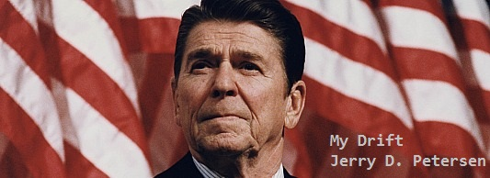

 | U.S. Presidents  10 April 2014 | 175-2014-04

There have been 13 presidents in my lifetime – so far. Yes, I’m old but I would like to live long enough to see a couple more. People that know me could probably guess who my favorite president of all my time is. Maybe the picture at the top of this page will give you other people a clue. In this article, I’m going to provide some facts and other information (good and bad things) about each of these presidents and assign them a grade (F through A). I already know that many of my readers will disagree with my conservative opinions but that’s okay – this is my article.

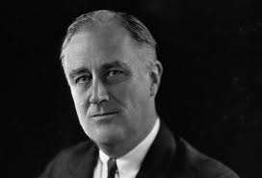  Franklin D. Roosevelt  Nickname: FDR  Born: January 30, 1882  City/State: Hyde Park, NY  Died: April 12, 1945  Party: Democratic  Age when inaugurated: 51  32nd President  Term: 1933–1945  Quote: “The only thing we have to fear is fear itself.” | FDR was our president when I was born and just a young boy so I don’t remember much about him. But, he was a popular president since he is the only one to be elected four times. Paralyzed from the waist down after suffering polio at age 39, he required a wheelchair. Roosevelt led the nation out of the Great Depression of the 1930s. He led the U.S. into WWII after the Japanese attack at Pearl Harbor in December 1941 and also formulated strategy as part of the "Big Three" with Churchill and Stalin to defeat Hitler and the Axis powers. He also greatly expanded the size and role of the federal government through his New Deal social programs. These included Social Security, the Securities and Exchange Commission (SEC), and the Federal Deposit Insurance Corporation (FDIC). Unemployment was reduced from 25% to 2% during his time in office. I’m not usually in favor of the government creating a lot of social programs but at that point in our history, they were necessary. FDR was a very good president and I’m giving him a B+ grade.

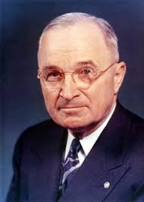  Harry S. Truman | Our 33rd President  Born: May 8, 1884  City/State: Lamar, Missouri  Died: December 26, 1972  Party: Democratic  Age when inaugurated: 60  Term: 1945–1953  Quote: “It is amazing what you can accomplish if you don’t care who gets the credit.” | His decision to drop the atomic bombs on Japan ended World War II. His policy of communist containment started the Cold War and led to the U.S. involvement in the Korean War (1950-1953) after the communist North invaded the South. He supported the state of Israel when it declared itself a nation. He also helped in the founding of the United Nations. On his desk, Truman had a plaque that said "The Buck Stops Here."
I think Truman was a strong no non-sense leader who did what he thought was the right thing to do. I don’t agree with everything Truman did so I’m giving him a C+ grade.

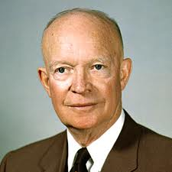  Dwight D. Eisenhower  Nickname: “Ike” | Our 34rd President  Born: October 14, 1890 City/State: Denison, Texas  Died: March 28, 1969  Party: Republican  Age when inaugurated: 62  Term: 1953–1961  Quote: “A people that values its privileges above its principles soon loses both.” | A former World War II 5-star general and hero, Eisenhower helped end the Korean War and steered a moderate course during the Cold War. He launched the Interstate Highway System and the National Aeronautics and Space Administration (NASA). Signed civil rights legislation to protect the right to vote by African-Americans.
He established the U.S. policy of defending Taiwan from Chinese communist aggression. I think Ike did many good things for America and I’m giving him a B grade.

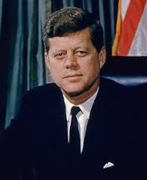  John F. Kennedy - JFK  Nicknames: “Jack”  Party: Democratic  College: Harvard  Military: U.S. Navy | Born on May 29, 1917, in Brookline, Massachusetts, Kennedy served in both the U.S. House and U.S. Senate before becoming the 35th president in 1961. Quote: "Ask not what your country can do for you, but what you can do for your country.”  As president, Kennedy had a number of foreign crises such as facing down Soviet Premier Kruschev during the Cuban Missile Crisis and supporting West Berlin after the Soviet Union hastily erected the Berlin Wall. He signed the Nuclear Test-Ban Treaty and the Alliance for Progress. He created the Peace Corps and initiated Project Apollo as the first manned expedition to the Moon. JFK began American involvement in Vietnam by sending military advisors. On Nov 22, 1963, Kennedy was assassinated while riding in a motorcade in Dallas, Texas. Do you remember where you were at when this happened? I was in the Navy at Lakehurst, NJ. JFK was a very popular president and brought pride to all Americans. I’m giving Jack a Grade B+.

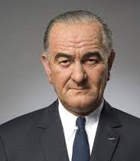  Lyndon B. Johnson | Our 36th President  Born: August 27, 1908 in Stonewall, Texas  Died: January 22, 1973  Party: Democratic  Age when inaugurated: 55  Term: 1963–1969  Nickname: “Bull” “LBJ”  Quote: “Being president is like being a jackass in a hailstorm. There's nothing to do but stand there and take it.” | Johnson was committed to winning the fight against the Communist insurgency in Vietnam. The U.S. had 550,000 combat troops there in 1968. This war was very unpopular and resulted in antiwar protests across the country. Johnson created programs to tackle poverty such as Medicare, Medicaid, and food stamps. He presided over the Apollo 8 program planning for the first manned flight to the Moon. I didn’t like the way he handled the Vietnam War – he was too bullheaded. Grade is D+.

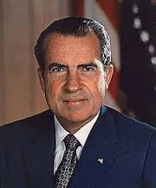  Richard M. Nixon | Our 37th President  Born: January 9, 1913 in Yorba Linda, California  Died: April 22, 1994  Party: Republican  Age when inaugurated: 56  Term: 1969–1974  Nickname: “Tricky Dick”  Quote: “A man is not finished when he is defeated. He is finished when he quits.” - “No more Vietnams.” | Nixon improved relations with the Soviet Union and China and wound down the Vietnam War. He ended the military draft and signed into law a broad range of environmental programs. He brought peace to America. One of the most dramatic events of his first term occurred in 1969, when American astronauts made the first moon landing. Nixon accomplished a lot of great things but the “Watergate” scandal forced him to resign before Congress could impeach him. I think “Tricky Dick” was a very good president before that. Grade B.

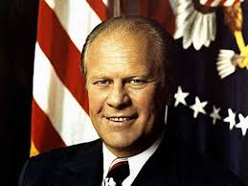  Gerald “Jerry” R. Ford  Born: July 14, 1913  City/State: Omaha, Nebraska  Died: December 26, 2006  Party: Republican  Age when inaugurated: 61  Term: 1974–1977 | Quote: "A government big enough to give you everything you want, is a government big enough to take away everything that you have."  Our 38th president was known as “Mr. Nice Guy” in Washington DC because of his clean-cut and non-partisan image. His pardon of Nixon was unpopular and probably cost him reelection. He presided over the worst economy since the Great Depression - His Whip Inflation Now (WIN) crusade urging the public to rein in spending and consumption failed badly. He officially ended the Vietnam War. Ford also established special education throughout the United States. Jerry Ford was the most accomplished athlete ever to grace the Oval Office. He was a football star who won college football national championships in 1932 and 1933 with the University of Michigan. He was also an expert skier. I think Ford was a good man and I’m giving him a C for his efforts.

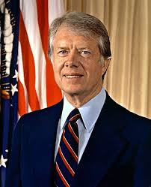  James E. Carter  Nicknames: “Jimmy” and  “The Peanut Farmer” | Our 39th President  Born: October 1, 1924 in Plains, Georgia  Party: Democratic  Age when inaugurated: 52  Term: 1977–1981  Quote: “The love of liberty is a common blood that flows in our American veins” – “We have no desire to be the world's policeman. But America does want to be the world's peacemaker.” | Carter had some success promoting Middle East peace. But, soaring oil prices, high inflation, and the Iran hostage crisis made him look weak and ineffectual. Do you remember when 52 American citizens were held hostage for 444 days (Nov 4, 1979, to Jan 20, 1981)? Do you remember the 1979 oil crisis that caused long lines at every service station that had gas? His championing of human rights was coldly received by the Soviet Union and China. Not much good happened during Carter’s time in office so he is getting a D Grade.

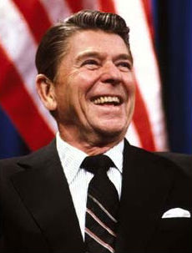  Ronald W. Reagan | Our 40th President  Born: February 6, 1911  City/State: Tampico, Illinois  Died: June 5, 2004  Party: Republican  Age when inaugurated: 69  Term: 1981–1989  Nickname: “Ronnie” – “Dutch” –  “The Great Communicator” and  “The Gipper”  Quote: “Politics is supposed to be the second-oldest profession. I have come to realize that it bears a very close resemblance to the first." | 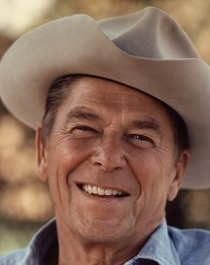

On January 20, 1981, at the moment Reagan completed his 20-minute inaugural address after being sworn in as President, the 52 American hostages were released by Iran into U.S. custody. Iran was not about to mess with Ronnie! He revived national pride and our sense of humor after the turmoil of the 1960s and 1970s. He enjoyed great popularity, though a lot of literal democrats didn’t like his conservative policies. His innovative program known as the Reagan Revolution, was aimed to reinvigorate the American people and reduce their reliance upon Government. He did fulfill his campaign pledge of 1980 to restore "the great, confident roar of American progress and growth and optimism." Dealing skillfully with Congress, Reagan obtained legislation to stimulate economic growth, curb inflation, increase employment, and strengthen national defense. He embarked upon a course of cutting taxes and Government expenditures.

On March 30, 1981, Reagan was shot by a would-be assassin, John Hinckley, after exiting the Washington Hilton Hotel. The bullet pierced one of the president's lungs and narrowly missed his heart. Reagan, known for his good-natured humor, later told his wife, "Honey, I forgot to duck." Reagan was back at work in a few weeks.

Everything was not always good during his time in office. Reagan sent 800 U.S. Marines to Lebanon as part of an international peacekeeping force in June 1982. Nearly one year later, in October 1983, suicide bombers attacked the Marine barracks in Beirut, killing 241 Americans. That same month, Reagan ordered U.S. forces to invade the Caribbean island of Granada after Marxist rebels overthrew the government. In addition to the problems in Lebanon and Grenada, the Reagan administration had to deal with an ongoing contentious relationship between the United States and Libyan leader Muammar al-Gaddafi. Then there was the Iran–Contra political scandal where senior administration officials secretly facilitated the sale of arms to Iran.

Reagan instituted the Strategic Defense Initiative, a plan aiming to develop space-based weapons to protect America from attacks by enemy nuclear missiles – especially from Russia. In 1987, Reagan spoke at Germany's Berlin Wall, a symbol of communism, and famously challenged Gorbachev to tear this wall down. Twenty-nine months later, Gorbachev allowed the people of Berlin to dismantle the wall, ending Soviet domination of East Germany.

Ronald Reagan Bio: He grew up in Dixon, Illinois, where he was an athlete and student body president at Dixon High School. Reagan attended Eureka College in Illinois on an athletic scholarship where he played football, ran track, captained the swim team, served as student council president and acted in school plays. After graduating in 1932, he found work as a radio sports announcer in Iowa.

Reagan moved to Hollywood in 1937 and appeared in more than 50 films. His most famous role was that of the Notre Dame football star George Gipp in the 1940 movie, ” Knute Rockne, All American”. I enjoyed watching Reagan on the TV show Death Valley Days where he hosted and acted on the series from 1964 to 1965. The series was sponsored by the Pacific Coast Borax Company (20 Mule Team Borax). Hosting the series was Reagan's final work as an actor

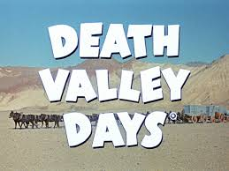 | 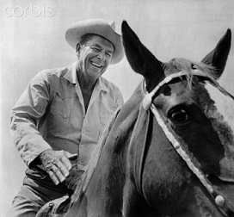 | 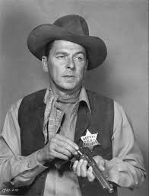

In 1940, Reagan married actress Jane Wyman, with whom he had daughter Maureen and adopted a son, Michael. The couple divorced in 1948. During World War II, Reagan was disqualified from combat duty due to poor eyesight and spent his time in the Army making training films. He left the military ranked as a captain. He married actress Nancy Davis in 1952 and the pair had two children, Patricia and Ronald.

In 1966, in his first race for public office, Reagan defeated Democratic incumbent Edmund "Pat" Brown Sr. by almost 1 million votes, winning the California governorship. He was re-elected to a second term in 1970. After making unsuccessful bids for the Republican presidential nomination in 1968 and 1976, Reagan finally received his party's nod in 1980. In that year's general election, he defeated Democrat incumbent President Jimmy Carter, winning the Electoral College (489 to 49).

After leaving the White House in January 1989, Reagan and wife Nancy returned to their home in Los Angeles, California. In 1991, the Ronald Reagan Presidential Library and Museum opened in Simi Valley, California. In November 1994, Reagan revealed to the American people that he had recently been diagnosed with Alzheimer's disease. Nearly a decade later, on June 5, 2004, he died at his Los Angeles home at age 93.

Yes, Ronald Reagan was my favorite president and I’m giving him my highest grade of an A-. No president has been perfect!!

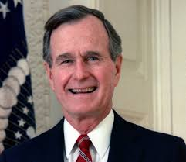  George H. W. Bush  Born: June 12, 1924 in  Milton, Massachusetts  Party: Republican  Age when inaugurated: 64  Term: 1989–1993  Quotes: “Read my lips: no new taxes.” – “The anchor in our world today is freedom, holding us steady in times of change, a symbol of hope to all the world.” | Our 41st President George H. W. Bush brought to the White House a dedication to traditional American values and a determination to direct them toward making the United States "a kinder and gentler nation." In his Inaugural Address he pledged to use American strength as "a force for good." During Bush's term, the Soviet Union collapsed and the Cold War ended after 40 bitter years and the Communist empire (USSR) broke up. President Bush sent American troops into Panama to overthrow the corrupt regime of General Manuel Noriega, who was threatening the security of the canal and the Americans living there. Bush's greatest test came when Iraqi President Saddam Hussein invaded Kuwait, then threatened to move into Saudi Arabia. Bush rallied the United Nations, the U. S. people, and Congress to sent 425,000 American troops to Kuwait. They were joined by 118,000 troops from allied nations. After a week of air and missile bombardment, the 100-hour land battle dubbed Desert Storm routed Iraq's million-man army. In my humble opinion, Bush should have went into Iraq and captured Saddam. This would have prevented the later Iraq War. Economic troubles at home cost him his reelection bid. Grade is a B-.

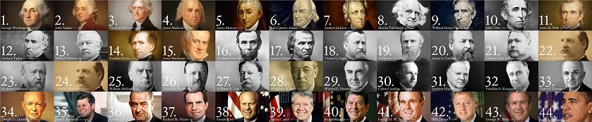

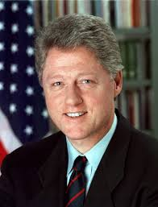  William J. Clinton  Nicknames: “Bill” “Bubba” and  “Slick Willie” | Our 42th President  Born: August 19, 1946 in Hope, Arkansas  Party: Democratic  Age when inaugurated: 46  Term: 1993–2000  Quotes: “America just works better when more people have a chance to live their dreams.” “The best social program is a good job.” “I did not have sexual relations with that woman." | During the Clinton years, the U.S. enjoyed more peace and economic wellbeing than at any time in our history. We had a low unemployment rate, the lowest inflation in 30 years, the highest home ownership in our history, dropping crime rates, and reduced welfare rolls. He proposed the first balanced budget in decades and achieved a budget surplus. Yes, Bubba was very smart (a Rhodes Scholar) and a good saxophone player. If not for being naughty with Monica Lewinsky, Clinton could have been considered to be a great President - I’m giving him a firm B.

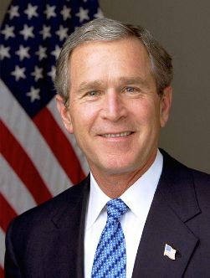  George Walker Bush  Our 43rd President  Born: July 6, 1946 in  New Haven, CT  Party: Republican  Age when inaugurated: 54  Term: 2001–2008  Nickname: “Dubya” (Texas pronunciation of "W") | “Never Ever Forget 9-11-2001”  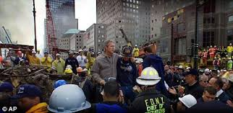  Quote: “Terrorist attacks can shake the foundations of our biggest buildings, but they cannot touch the foundation of America. These acts shatter steel, but they cannot dent the steel of American resolve.”
Boy, there was sure a lot of Bush “bashers” during his time in office! In fact, many of my friends and people I know were in the Bush “hating” camp. Here are some of the comments I used to hear:
“I keep wondering how our kids and grandchildren will pay for the deficit that George Bush created. The government spent more than $500 billion for the war in Iraq. That money could have been spent to help Americans.”
“Our hard earned money is being misappropriated left and right under false cries of terror“
“Dubya has pissed off most countries of the world with his stupidity and arrogance.”

Me, I liked President Bush - The radical Islamic terrorists want to kill all Americans and non-Muslims in the World. We need a President who has enough guts to stand up against these idiots. We just can’t sit back and wait for the terrorists to hit America again. Next time they might be dropping nuclear bombs on our major cities. I supported the invasions of both Afghanistan and Iraq - Osama bin Laden and the Taliban in Afghanistan were directly responsible for the 9-11 attacks on the U.S. and we had to deal with Saddam Hussein sooner or later. The only problem I had with Bush was he didn’t get our troops out of these countries fast enough. Establishing democratic government in these radical Islamic countries is impossible. I think President Bush did an excellent job of uniting a mournful country after the September 11th terrorist attacks.

Before I jump off of my soapbox, let me address the popular notion that George W. Bush was dumb. Think about it - you don’t earn a bachelor’s degree from Yale and a Master of Business Administration from Harvard if you are a moron. Bush served as an F-102 fighter pilot in the Texas Air National Guard. He made millions of dollars in the Texas oil business. He purchased the Texas Rangers baseball franchise in 1989. He was able to court and marry a very classy lady named Laura Welch. You just can’t do these things if you are a complete idiot. You also don’t become a 2-term Governor of Texas and a 2-term President of the United States if nobody likes you. Bush’s IQ based on his SAT score of 1206 (566 Verbal, 640 Math) is 125 which rates him in the mid-range of all American Presidents. Having a high IQ doesn’t always relate to having good common sense. Case in point – Bill Clinton has the highest IQ of all rated Presidents. Bush believed that the strength of America lies in the hearts and souls of our citizens - he supported programs that encourage individuals to help their neighbors in need. I’m giving him a B grade.

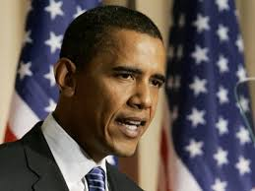  Barack Hussein Obama  Born: August 4, 1961 in  Honolulu, Hawaii  Party: Democrat  Age when inaugurated: 47  Terms: 2009–2013; 2013–2017  Quote: “I consider it part of my responsibility as President of the United States to fight against negative stereotypes of Islam wherever they appear.” | Obama (our 44th President) has done some good things like ending the Iraq War and planning to get our troops out of Afghanistan by the end of 2014. He ordered the military operation that resulted in the death of Osama bin Laden. However, his socialistic agenda is not helping America. Here are the actions required to create a social state:  - The Government controls health care.  - Increase taxes on the rich and working middleclass.  - Give the poor, non-working, non-taxpaying people welfare, food stamps, Medicaid, and other free stuff.  - Remove prayer and all reference to “God” and “Jesus” from our schools and government.  - Controlling what our young people are learning in school.  - The last step in making America a Social State is taking away our guns.  Does any of this sound like what is happening today in the United States? Our national debt has increased from approximately $11 trillion to $17.6 trillion dollars since Obama took office. His socialist policies and “out-of-control” spending must be stopped! I’m giving our current president a D+ Grade.

Well, there you have it – my view of our last 13 Presidents. Here is the list from the best to the worst in my lifetime:

President Name | Party | Grade
Ronald Reagan  John F. Kennedy  Franklin D. Roosevelt  Bill Clinton  George W. Bush  Richard M. Nixon  Dwight D. Eisenhower  George H. W. Bush  Harry S. Truman  Gerald Ford  Lyndon B. Johnson  Barack Obama  Jimmy Carter | Republican  Democrat  Democrat  Democrat  Republican  Republican  Republican  Republican  Democrat  Republican  Democrat  Democrat  Democrat | A-  B+  B+  B  B  B  B  B-  C+  C  D+  D+  D

The number one factor in compiling my list is – “How good a job did the President do in making the American people feel good about themselves and having great pride in our nation.”

Any comments? Do you want to provide your list?

bigdrifter44@gmail.com

