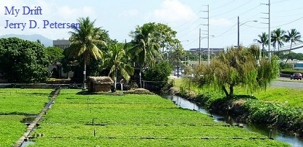

 | Sumida Watercress Farm  (Aiea, Hawaii)  3 December 2014 | 191-2014-20

The other day I decided to go to Monterey Bay Canners Restaurant bar for a beer. They have a nice bar with a patio area with tables overlooking the Sumida Watercress Farm that is located in Aiea, Oahu, Hawaii not far from where I work. I like to sit where I can watch the farm workers harvest the watercress. It is an interesting process that I will describe in more detail later.

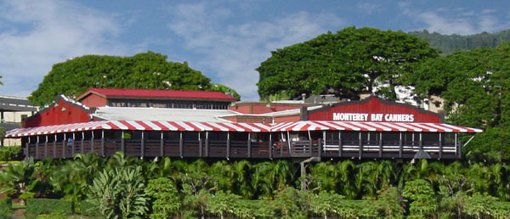
Monterey Bay Canners Restaurant

This is a family farm surrounded on three sides by the Pearlridge Shopping Center Mall and Kamehameha Highway on the other side. Back in the old days (before the 1950s), there were many farms in the Pearl Harbor area due to the abundance of spring water. This area includes the cities of Halawa, Aiea, Pearl City, Waipahu, and Ewa Beach. The Sumida Watercress Farm is the only farm to survive the suburban building frenzy that started in the late 1950s. The Pearlridge Mall developers attempted to acquire this farm land but after a long court battle, the Sumida family won the right to keep their property.

Pearl Harbor Area | Pearlridge Shopping Center  (Sumida Watercress Farm is in green)

The Sumida Farm has been around since 1928. The third and current generation of owners are David Sumida and his sister, Barbara. This small 10 acre farm produces five tons of watercress a week and provides about 75 percent of Hawaii’s demand for watercress. The spring water that the watercress grows in is clean enough to drink. This is important for having delicious watercress since it does not grow in dirt - instead it grows directly in the water with the aid of a little gravel so that the roots of the plants can grab onto something. In fact, a crop can be planted by just tossing watercress cuttings into the water. After eight weeks of cool water and abundant sunshine, the crop is ready to hand harvest. One-pound bunches are formed in the field, washed, bundled, then chilled to preserve their crispness and increase shelf life. Because there is no soil depletion, there is no need for crop rotation, making the farm very efficient. They can grow a large amount of food in a small area.

The farm also has a history of innovation. It has the first vacuum chilling machine on Oahu that can extend the shelf life of the watercress to one week (versus the usual three days). The machine is specially designed to chill up to 1000 pounds at time to 36 degrees in less than an hour. This process allows the watercress to be shipped to the outer islands. The watercress grown on this farm is not shipped to the continental United States or Alaska or anywhere else. The demand in Hawaii has always exceeded the supply.

Although the Sumida Farm is not a certified organic farm, it employs many progressive and sustainable practices, which benefit the farm workers, the farm land, and of course, the product itself. The farm does not use pesticides unless it is absolutely necessary to save the corps. Instead, they use “integrated pest management”—i.e. “good bugs fighting bad bugs”—to minimize various threats to the crop. For instance, they have brought in surfeit flies to kill their primary pest, the diamond-back moth. Another nuisance is the local Akekeke, a bird that destroys the patch in search of food. Scarecrows and low-tech clappers made from bamboo are the primary means of warding them off.

 | 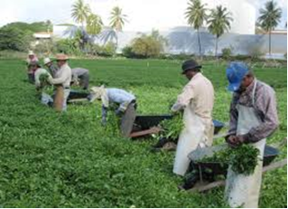
Scarecrows and clappers are used to chase away the birds | Workers use knifes to harvest the watercress

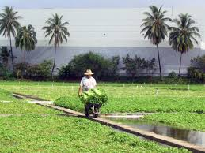 | 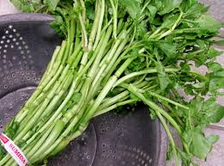
Wheel barrels are used to take the watercress to the packing/distribution building |  | The final product – Look for the red and white Sumida Farm twist tie

While sitting there at the Monterey Bay bar enjoying my cold beer, I usually try to count the number of workers in the watercress field. There are usually 9 or 10 workers slaving away in the hot sun planting, controlling the water flow, and harvesting the watercress corp. The Sumidas employ several full-time workers, most of them over 60 years of age and all of them immigrants from the Philippines. I’m always glad that I’m in the air conditioned bar and not down there in the fields working.

Let’s learn a little more about watercress.

Watercress is an aquatic plant known for its vivid green color and unique peppery flavor. Nasturtium Officinale, watercress’s scientific name, has been eaten as part of the human diet as far back as history is recorded. This delicate leafy green is eaten around the world and currently translated into 34 languages…a sure sign that it is a part of a country’s cuisine. Oh, by the way, the Hawaiian word for watercress is “Leko”.

In the United States watercress is most frequently used in salads, soups, and on sandwiches, where its distinctive flavor stands above the flavor profile of the traditionally muted flavors of most greens.

The History of Watercress
Watercress is the most ancient of green vegetables known to man and its use can be traced back to the Persians, Greeks and Romans. In fact, a famous Persian chronicler advised Persians to feed watercress to their children to improve bodily growth. He also strongly recommended its use to the Greek and Persians soldiers of that time.

Although these eminent rulers knew nothing of such matters as mineral content and vitamins, they did observe that their soldiers were in better condition when this plant was made part of their daily diet. The Romans, too, looked with favor upon watercress as a salad. The common method of preparation in those days was with oil and vinegar.

When Hippocrates, the father of modern medicine, founded the first hospital on the Island of Kos around 400 BC, he grew wild watercress in the natural springs nearby and used it to treat blood disorders and other diseases.

According to the book 'James Cook and the Conquest of Scurvy', Captain James Cook was able to circumnavigate the globe three times, due in part, to his use of watercress in his sailor’s diets. And did you know that watercress was on the menu for the very first Thanksgiving dinner with the Pilgrims and the American Indians.

In modern times it is increasingly seen as a powerful cancer fighting superfood, with a growing body of supportive scientific studies and discoveries. In addition, watercress is one of Mother Nature’s most nutrient dense vegetable, capturing a perfect 100 score on the ANDI nutrient density scale. It is as close to a perfect food as there is! Did you know that?

Just how healthy is watercress?
Well, researchers at William Paterson University in New Jersey have done all of us a big favor by producing a list of 41 "powerhouse fruits and vegetables" ranked by the amounts of 17 critical nutrients they contain. In this recent study published in the CDC journal "Preventing Chronic Disease," the foods are scored by their content of fiber, potassium, protein, calcium, folate, vitamin B12, vitamin A, vitamin D and other nutrients, all considered important to public health.

Atop the list? Watercress, long known as a superfood because it packs large amounts of a wide variety of these important substances, with a perfect score of 100. The next five in the elite category: Chinese cabbage (91.99), chard (89.27), beet greens (87.08), spinach (86.43) and chicory (73.36). You can read about the complete list at this website:
http://www.washingtonpost.com/news/to-your-health/wp/2014/06/05/finally-a-list-of-powerhouse-fruits-and-vegetables-ranked-by-how-much-nutrition-they-contain/

Watercress nutrition facts (Nutritional value per 100 grams)
Energy  Carbohydrates  Sugars  Dietary fiber  Fat  Protein  Sodium  Potassium 330 mg | 46 kJ  1.29 g  0.2 g  0.5 g  0.1 g  2.3 g  41 mg  330 mg | Beta-carotene  Lutein  Thiamine  Riboflavin  Pantothenic acid  Vitamin B6  Folate  Phosphorus | 1914 μg  5767 μg  0.09 mg  0.12 mg  0.31 mg  0.13 mg  9 μg  60 mg | Vitamin A  Vitamin C  Vitamin E  Vitamin K  Calcium  Iron  Magnesium  Manganese | 160 μg  43 mg  1 mg  250 μg  120 mg  0.2 mg  21 mg  0.25 mg

Watercress Health Benefits:
- Contains antioxidants that serve to counteract free radicals and boost the immune system.
- Boost the body's metabolism and increase stamina.
- Detoxification of body toxins.
- Reduce the risk of cancer and tumors.
- Protect the lungs from the dangers of nicotine (smokers active / passive), as an herb for nicotine.
- Protect against lung, mouth and throat cancer.
- Antidote to inflammation of mucous membranes of the respiratory tract.
- Cleansing the blood / blood purifying.
- For beauty can be used as a face mask for acne, spots, or black spots.
- Helps reduce the risk of heart problems and stroke, also help the healing process for patients who had a stroke and heart problems.
- Reduce the risk of cataracts and vision impairment.
- Helps reduce the risk of spina bifida (a type of disorder abnormalities of the spine).
- Assist the work of digestion; as a laxative and launched bowel movements, as well as to maintain the health of the liver.
- Help reduce anemia disorders.
- Helps relieve insomnia (sleeplessness) due to nervous tension.
- Helps with the formation of white blood cells and red blood cells in the bone marrow composition.
- Act to stimulate bile production and assists in detoxification of the liver.
- Reduce fever, prevent thrush, antiseptic, increase sexual desire, shed urine (diuretics), eliminates phlegm.
- Can cure, asthma, bronchitis, skin diseases, diabetes, eczema, edema, hair loss, headache, infection, kidney stones, obesity, and tuberculosis.
- Useful in dealing with ulcers and warts because it is rich in antioxidants.
- Treat patients with chronic metabolic disorders and asthenia (weakness).

In Hawaii, Sumida watercress is available at Safeway, Foodland, and Times grocery stores, as well as Whole Foods and Hawaii Farm Bureau farmers markets. Look for the red and white twist tie, which designates a bunch of watercress as Sumida Farms.

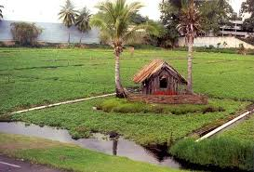 | 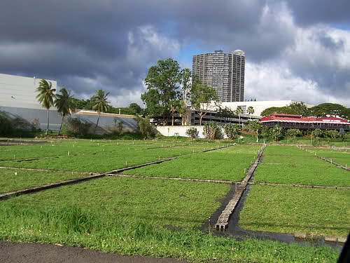

Next time you are in Aiea driving by the Pearlridge Shopping Center on Kam Highway and see this wonderful farm right there in the middle of the concrete jungle, you will know all about the Sumida Watercress Farm.

I have not been a big eater of green vegetables but after researching all of the benefits of watercress for this article, I think I will start eating it – probably in soup. It appears to be good for most of my current ailments.

bigdrifter44@gmail.com

